1. Usecase diagram

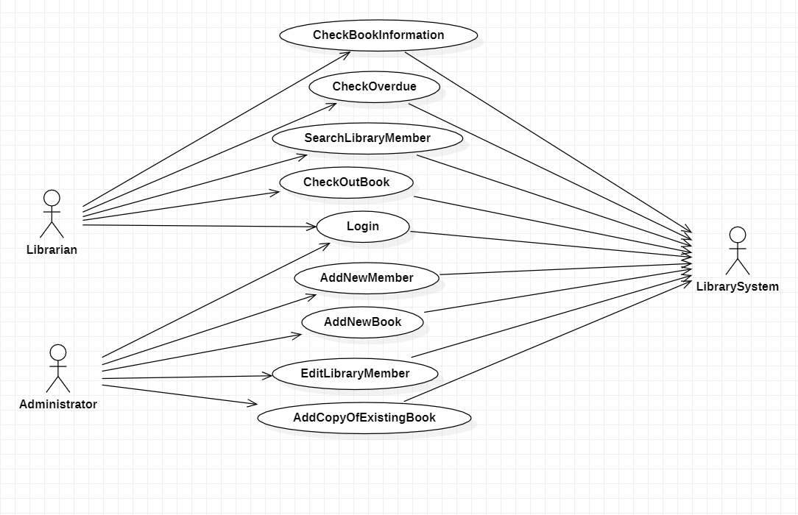

1. Class diagram

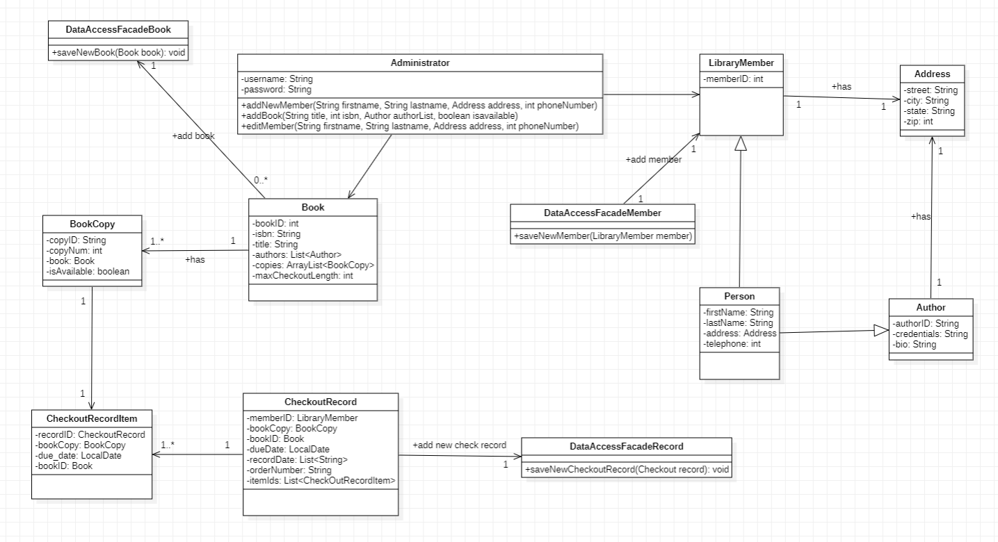

1. Login Sequence diagram

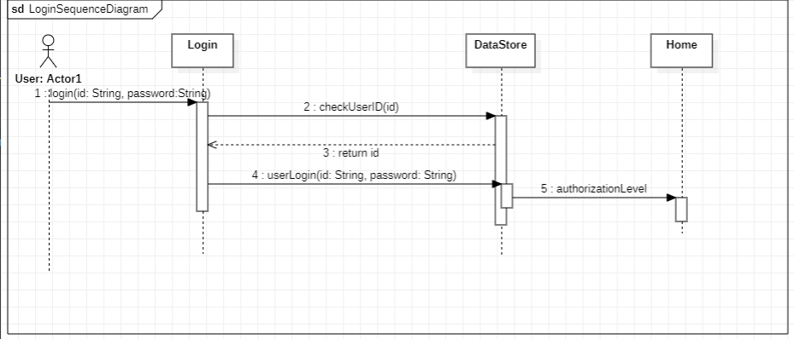

1. Add New Library Member Sequence diagram

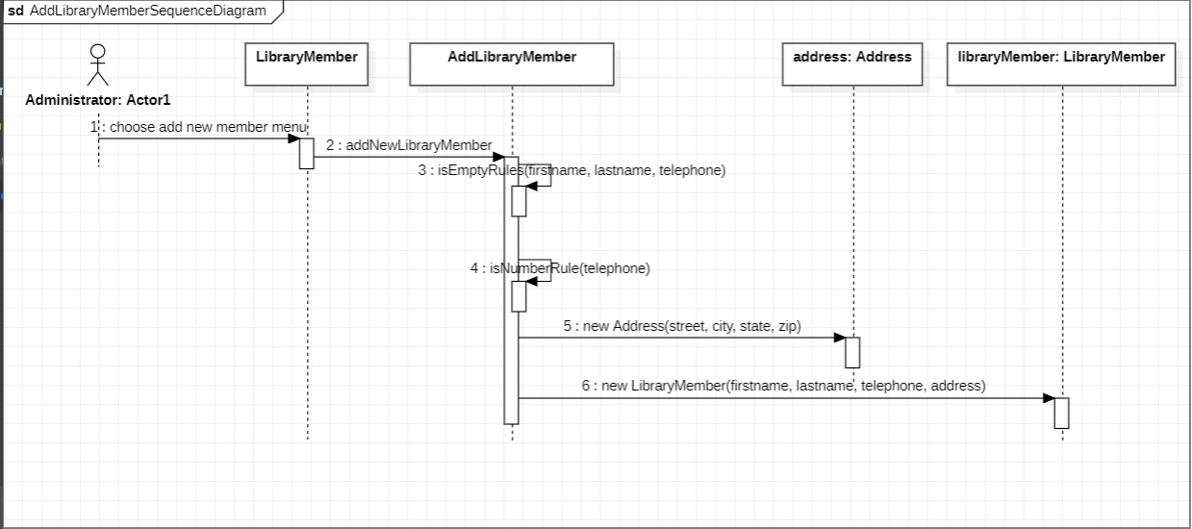

1. Checkout Book Sequence diagram

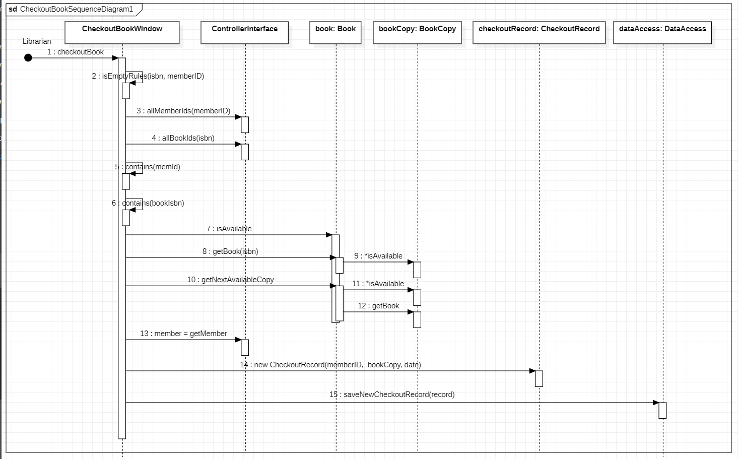

1. Add Book Copy into Collection Sequence diagram

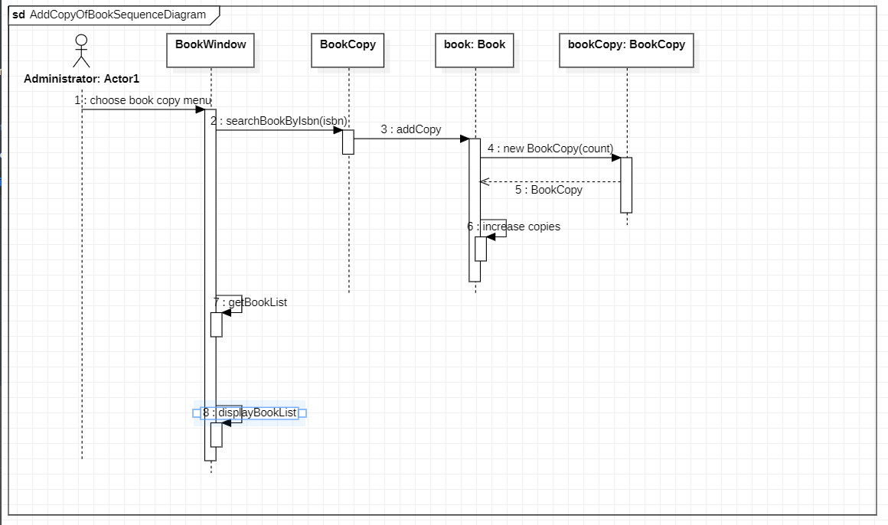

1. Add Book Sequence diagram

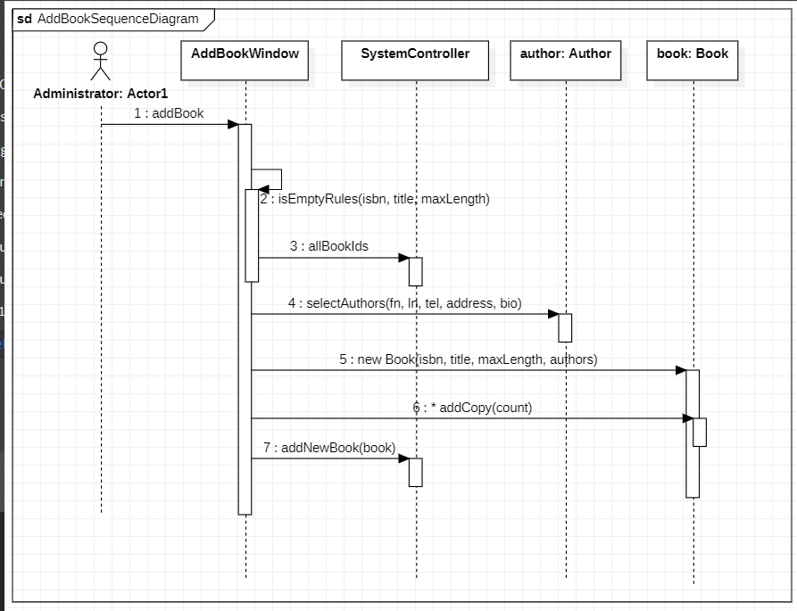

1. Get Checkout Record Sequence Diagram

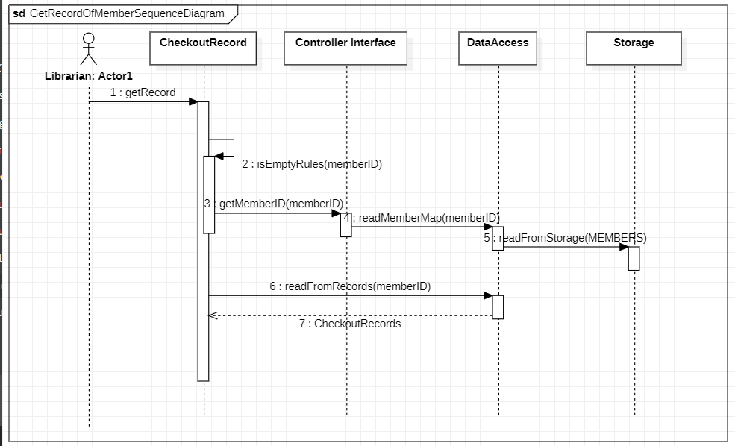

1. Check OverDue Book Sequence diagram

