# Addressing list of corrections

*! Please double check the spelling, and carefully proof-read the whole thesis.*

I proof-read the entire thesis and manually checked every word while also using a spell checker.

*Please decide on consistent abbreviations in the thesis, check that they are defined before first used, and used consistently. Moreover, please add a list of the abbreviations at the start of the thesis.*

**Added the following abbreviations (p1):**

ORN - Olfactory Receptor Neuron

PN - Projection Neuron

LN - Local Neuron

KC - Kenyon cell

APL neuron – anterior paired lateral neuron

MB – mushroom body

MBON - Mushroom body output neurons

STDP - Spike-timing dependent plasticity

DAns - Dopaminergic neurons

*Please add to the table of parameters (Table 2.1) all model parameters including e.g. connectivity parameters and LN synapse parameters with the goal to allow readers to reproduce all your results.*

**Added connectivity parameters for LN synapses (highlighted in blue) (p35).**

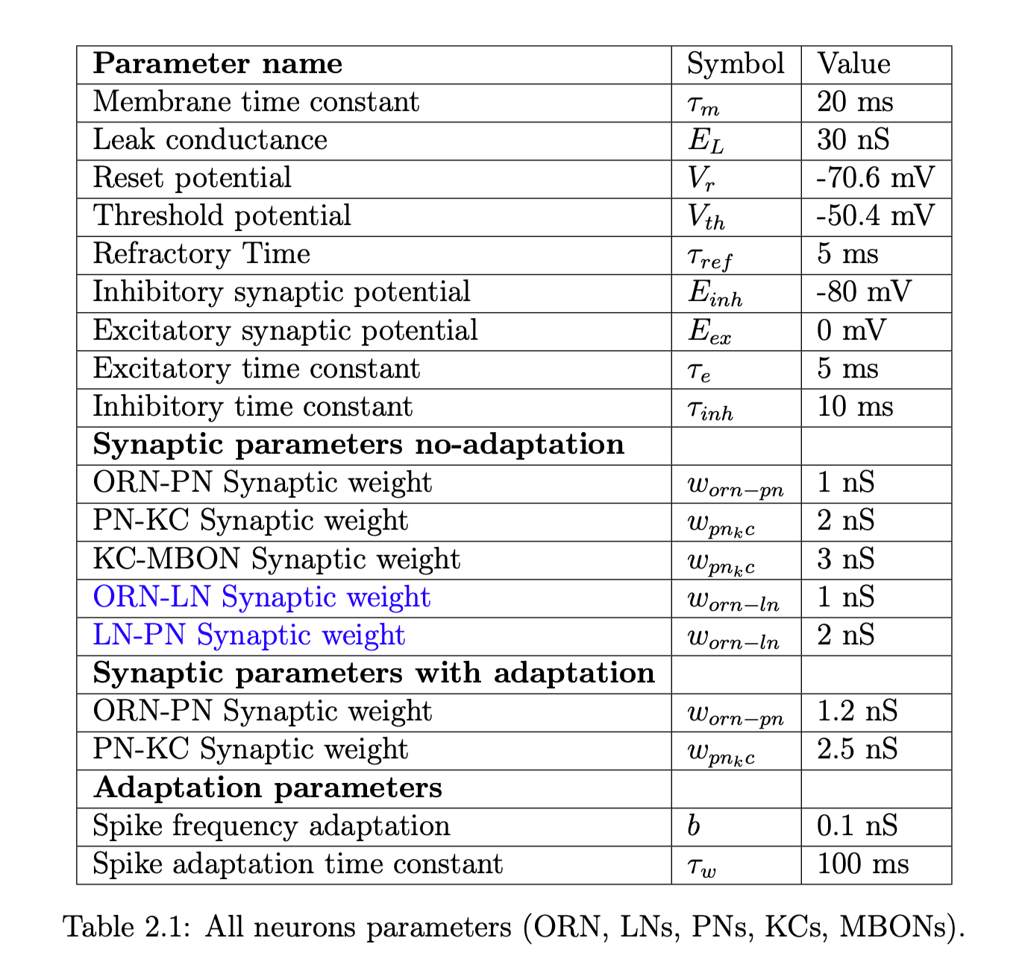

*! All figures: If a figure includes error bars, please clarify in the caption what they show.*

**Added description to each figure that contains an error bar. Example (p78):**

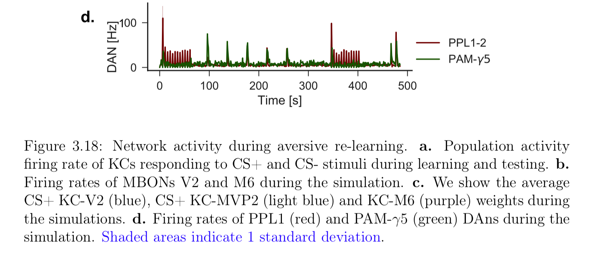

*! p.3 Clarify other features and functions, which are characteristic for neuromodulators such as triggering plasticity, receptor modulation and changes in gain.*

**Added following paragraph (p3):**

Neuromodulators cause alteration of the response properties and synaptic efficiency of individual neuron of one or more neurons (\citealp{marder2002cellular}).

Multiple classes of neuromodulators have been shown to affect the gain of input-output responses in the neurons of mammals and flies (\citealp{thurley2008dopamine}, (\citealp{Waddell:2013fu}). They have also been implicated in facilitating synaptic plasticity in visual, auditory and olfactory learning (\citealp{gu2002neuromodulatory}).

! p.4 While discussing the modulation of STDP by dopamine, please include the key study of Shen et al. (2008).

**Added following paragraph to cite Shen et al. 2008 (p4):**

A separate study has shown that high DA receptor activation promotes potentiation of corticostriatal synapses onto the direct pathway and learning from positive experiences, while low DA receptor activation promotes potentiation of corticostriatal synapses onto the indirect pathway and learning from negative experiences (\citealp{shen2008dichotomous}).

*! p.5 Please clarify the meaning of V(s’), and correct the sentence describing the role of this term in describing the responses of dopaminergic neurons during conditioning.*

**Clarified that V’(s) is in the estimate of the new state (p6):**

V is a value function, $V(s)$ represents the agent's estimate for the value of being in state $s$. The estimate from the value of being in state $s$ in update based on the current value. $\alpha$ determines what the impact of new information will be. $r$ is the reward for the action taken in the previous time step, and $V(s')$ is the estimated value of the new state, so $r_{t}$ - $V(s)$ is the difference between the actual and expected reward. $\gamma$ is a discount factor used to discount expected future value to present value: $\gamma V(s')$ is the discounted expected value of the next state.

*! p.6 Please distinguish between and properly explain the concepts of eligibility and of distal reward.*

**Defined distal reward and eligibility traces before presenting equations (p7)**

The distal reward problem represents the problem of associating a reward with an earlier action when the neural activity that caused that action is no longer present is called the distal reward problem.

In \citealp{izhikevich2007solving} the distal reward problem is approached by a framework that combines STDP and dopamine together.

One key component of the learning paradigm are eligibility traces to represent a stimulus. Eligibility traces are used to represent the degree to which a stimulus is eligible for consideration when attempting to attribute rewards to actions or stimuli. When a stimulus is detected, an eligibility trace for that action is initiated and immediately begins to decay with time.

*! p.7 Please add relevant citations when introducing the concept of the eligibility trace in section 1.1.4 with respect to the basic concept (e.g. Legenstein, Pecevski & Maass, 2008; Clopath et al., 2008) and its previous use in insect models of learning (e.g. Helgadottir et al., 2013; Schmuker et al., 2014)*

**Added new paragraph that presents other papers that use eligibility traces and modified STDP learning rules (Legenstein 2008; Clopath 2008, Cassenaer 2012, Helgadottir 2013) (p7-8):**

Other studies have proposed modified versions of the STDP learning rule that use a third factor to represent reward. For example, \cite{legenstein2008} have shown that they can learn a biofeedback task and showed the ability to memorize temporal spike patterns.

In a separate study \citealp{clopath2008tag} have proposed a learning framework that can explain pharmacological experimental performed on neurons (\citealp{frey1997synaptic}).

The learning mechanism has three stages: tagging (when the synapse is in either high or low state which depends on Hebbian mechanisms it gets tagged), trigger (dopamine level above a certain threshold) and consolidation (if plasticity related proteins are available and if the synapse is tagged, the weight can change to a stable state allowing for consolidation).

Three factor learning rules using eligibility traces have also been used in insect models of learning. In \cite{helgadottir2013} the authors have implemented a spiking model of the olfactory circuit using a learning rule inspired by experimental findings in the locust (\citealp{cassenaer2012conditional}) to implement a learning rule in which octopamine gates learning. Importantly, this learning rule requires only presynaptic activity and a reward signal for learning to occur. The authors show that using this simple learning rule allows them to implement a SNN platform for biologically inspired closed-loop robotic control using sensors to learn object association with colours (\citealp{helgadottir2013}).

*! Figure 1.2: Please add line at 0 to make the figure easier to read.*

**Added line at Fig 1.2 (p12)**

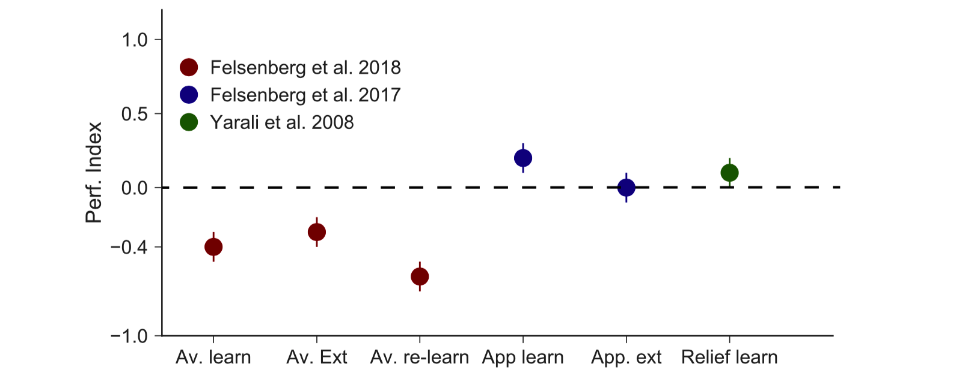

*! Figure 1.3: The given citation (Dylla et al., 2017) for the diagram does not provide any diagram of this sort. Please provide the correct reference****.***

**• Figure 1.3 was adapted from Figure 2 Dylla et al. 2013, not 2017. (p14)**

*Please distinguish between uniglomerular (excitatory) PNs that project to the MB and multiglomerular (inhibitory) PNs that project to the LH and make sure that the same abbreviations are use throughout the thesis.*

**Added the following paragraph (p13):**

In flies PNs can be devided in two major categories. Multigomerular PNs are GAGAergic and inhibitory and the majority of them project to the Lateral Horn and other region within the lateral protocerebrum (Galizia, 2014) . Uniglomerular PNs are excitatory are project to both the lateral horn and the mushroom body calyx (Galizia 2014). We only model uniglomerular PNs that project to the mushroom body.

*! p.28: Clarify the correct connectivity statistics for PN->KC connections, the current description on p. 28 disagrees with the presentation on p.29.*

Changed wrong sentence at page 29, now paragraphs are in agreement:

**Each KC receives input from approximately 10 PNs (p29, p31).**

*! p.29: Clarify how your approach differs from the previous models, and what question it addresses which has not been addressed before. Furthermore, please discuss how the role of inhibition in reducing correlation has been discussed in theoretical papers in computational neuroscience e.g. by O’Reilly & McClelland (1994). Relate to relevant papers that have used feedback and lateral inhibition in models of the insect olfactory system.*

**Added following paragraph to highlight important paper that modelled lateral inhibition (p29).**

Previous modelling studies have shown that the sparse coding caused by lateral inhibition within in the dentate girus of the hippocampus results in improved pattern separation (\citealp{o1994hippocampal}) which is useful for distinguishing highly similar patterns.

Pattern separation, or orthogonalization, is characterized by creating distinct, non-redundant representations in an attempt to reduce the likelihood of interference during retrieval (\citealp{o1994hippocampal} ).

**Added paragraph to explain how our model differs from previous models (p30):**

To improve previous models (Wessnitzer et all 2011, Betkiewicz et al., 2017) based on recent experimental data (Aso et al. 2014, Lin et al. 2014) we added APL mediated feedback inhibition in the mushroom body and separated our MBONs into two categories: approach and retreat MBONs to calculate the valence of an odour in the naive state before learning.

*! p.30/p.53: Clarify how Poisson spike trains were simulated or approximated (e.g. through a Bernoulli approach) in your simulations.*

*Provide the temporal resolution of your simulations.*

Added the following paragraph that explains Poisson spike train generation (p32-33):

To efficiently generate Poisson spike trains from such a configuration we consider a grid spanned by N rows corresponding to the Poisson neurons (y-axis) and discrete-time with bins of size Δt =0.1 seconds (x-axis). To create Poisson spikes, we fill each column at each time step during the simulation by drawing exponentially distributed inter-spike-intervals.

(Auryn citation)

When a jump leads beyond N it is simply continued in the next time step. This way every random number yields a spike.

*! p.32: Explain the mechanism of spike frequency adaptation through Ca2+ gated K+ channels, and explain how this mechanism is encoded in Eq. 2.1 and 2.2.*

*Cite papers that describe the role and function of spike frequency adaptation relevant in your context, e.g. Lundstrom et al., 2008; Farkhooi et al., 2013; Betkiewicz et al., 2018.*

*Please provide a reference for the “AdEx” neuron model.*

**Added the following paragraph:**

There are several that can cause spike-frequency adaptation is believed to be explained by multiple biophysical mechanisms which trigger a form of slow negative feedback to the excitability of the cell (Benda and Herz 2003)

In our model the adaptation variable $g_a(t)$ represents spike dependent activation potassium currents such as the calcium-activated K+ current that is activated by the increase in Ca2+ at the peak of each action potential.

Therefore, this current is only activated after spiking activity. These currents cause an after-hyperpolarizing potential (AHP) after a spike or burst of spikes.

***Cite papers that describe the role and function of spike frequency adaptation relevant in your context, e.g. Lundstrom et al., 2008; Farkhooi et al., 2013; Betkiewicz et al., 2018.***

*! p.32/33: Correct text description of eqn. 2.2 and Table 2.1. with respect to the nature and physical unit of parameter b, which describes a conductance and not a current****.***

**Corrected b in Table 2.1 and in description of eqn 2.2 (p35):**

When the membrane voltage reaches a predefined threshold a spike is fired which resets the membrane voltage to a reset value and $g_a(t)$ is the adaptation of the neuron, modelled by a change in conductance which increased by $b$ at each spike.

**! p.34: In chapter 2.4 add quantitative analysis of population sparseness and temporal sparseness.**

We calculated temporal and spatial sparseness of KC responses to odours in our simulations using the Treves-Rolls sparseness measure (\citealp{treves1991determines}, see Methods).

Our results show that spike-frequency adaptation increases temporal sparsenss (Fig \ref{f:sparse_measure} a) while APL mediated feedback inhibition facilitates population sparseness (Fig \ref{f:sparse_measure} b).

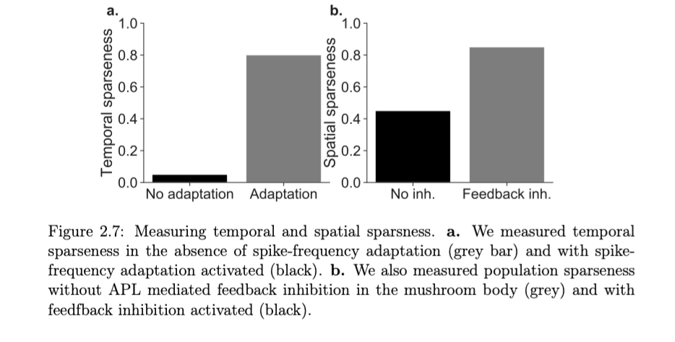

**! Figure 2.5: Please check correctness of time scale in panels b and d. Effective time constant of SFA appears on a multi-second scale despite a short time constant of tau=0.1s.**

Timescale corrected. I simulated 2 seconds not 20 seconds (p39).

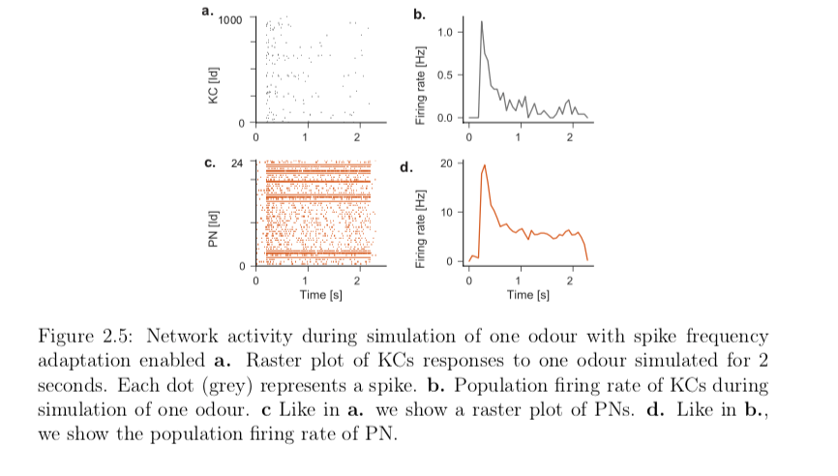

*! Figure 2.6: Erase repeated panel descriptions in caption.*

Deleted repeated panel description.

*! p. 39: Clarify that Figure 2.8 shows simulations.*

Changed the text in figure 2.8 caption:

ORN, PN and KC responses to odours based on ORN responses in the \citealp{Hallem:2006} data set. \textbf{a.} We show a color map of ORN responses to 110 different odours in the data set (\citealp{Hallem:2006}). \textbf{b.} Shown here are 24 PN responses after **simulating** PN responses to the same odours show in A \textbf{a.} and in the same format. Each group of three PNs receive input from one out of 24 ORN types. \textbf{c.} Shown here are **simulated** responses of 1000 KCs responses to the odours in the data set with the same format as in \textbf{a.} and \textbf{b.}. \textbf{d.} Histogram showing how many KC an odour activates.

! Figure 2.9c and 2.10: Please perform statistical analyses (e.g. ANOVA) to show that the effect is indeed present in these simulations.

Used 1-way ANOVA analysis and found that for Fig 2.9c and 2.10 p-value > 0.05.

*! p.53: Please add units to parameter tau_KC. Please clarify whether and why this time constant is much longer than the adaptation time constant for KCs used in the full spiking model.*

$\tau_{kc}$ is 1 $second$.

We used a longer time constant for KC responses because we discovered that we needed sustained MBON responses to last for at least 1 second to match duration of reward or punishment activation of DAns.

*! p.56: Clarify whether synaptic weights are bound such that they cannot assume values smaller than zero.*

In our model weights are bounded and cannot go below zero}

*! Caption of Figure 3.8g: Explain meaning of making parts of the diagram bleak.*

Lines with circle arrow ends represent excitatory connections (KCs to MVP2 or M6 or M4). Lines with vertical line end are inhibitory connections, while lines with triangle ends are modulatory connections.

! p.69: Add a simulation with a virtual lesion to the studied connection.

To study which connections are required for aversive extinction we simulated the learning protocol with a virtual lesion to the MVP2-M6 connection. Exactly like in Figure \ref{f:avext_M6}, we activated CS+ KCs both during aversive learning and extinction (Fig \ref{f:avext_fail} a). M6 and MVP2 MBON initially responded with equal firing rates. After aversive learning the firing rates of MVP2 decreased (Fig \ref{f:avext_fail} b). The firing rate of PAM-$\gamma5$ remained the same (Fig \ref{f:avext_fail} d). After aversive learning, when we re-exposed the odours, the average KC-M6 CS+ remained unchanged as the MVP2-M6 connection was lesioned (Fig \ref{f:avext_fail} c).

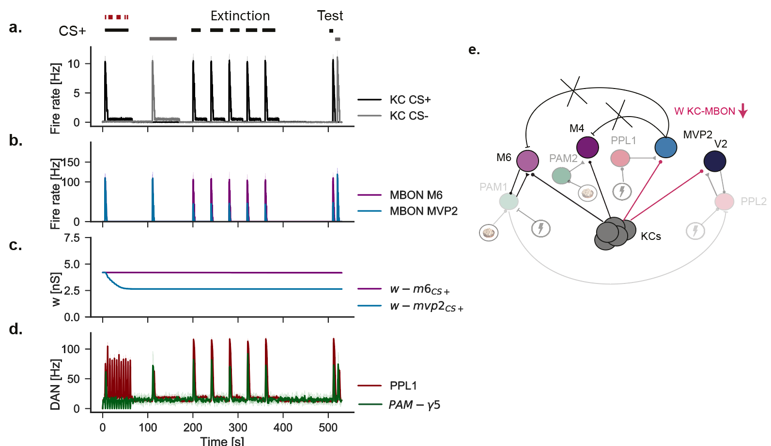

*! p.72: Use consistent naming of learning rules throughout and disambiguate PRE-dopa LTD rule vs. HIGH-dopa LTD rule.*

Replaced all references to the learning rule to pre-dopa LTD

*! p. 83: Please add more clarification in the text for the pattern observed in Figure 4.3.*

After appetitive learning we simulated extinction by re-exposing the CS+ odour five times (Fig \ref{f:net_appext} a).

Reward learning led to the decrease of PAM-$\gamma5$ firing rate in response to CS+ (Fig \ref{f:net_appext} d green). After reward learning we note that when the CS+ odour was re-exposed both the M6 and PAM-$\gamma5$ responses decreased, while PPL1-2 firing rate increased (Fig \ref{f:ned_appext} b, d).

Each time the CS+ odour was re-exposed CS+ KC-V2 weights decreased (Fig \ref{f:net_appext} c).

After aversive extinction V2 MBON CS+ response decreased to a level similar to M6 MBON CS+ response (Fig \ref{f:net_appext} b).

To test whether appetitive extinction in our model is caused by a reduction in odour response of PAM-$\gamma5$ DAN which inhibits PPL1-2, we exposed an odour while blocking PAM-$\gamma5$ (Fig \ref{f:blockpam} a, d). Blocking PAM-$\gamma5$ led to an increase of PPL1-2 DAn activity (Fig \ref{f:blockpam} d) and the decrease in the CS+ KC-V2 weights and the firing rate of MBON V2 in response to CS+, similar to the pattern observed during appetitive extinction (Fig \ref{f:blockpam} b, c). We propose that our simulation result can be tested in an experiment by blocking PAM-$\gamma5$ DAns.

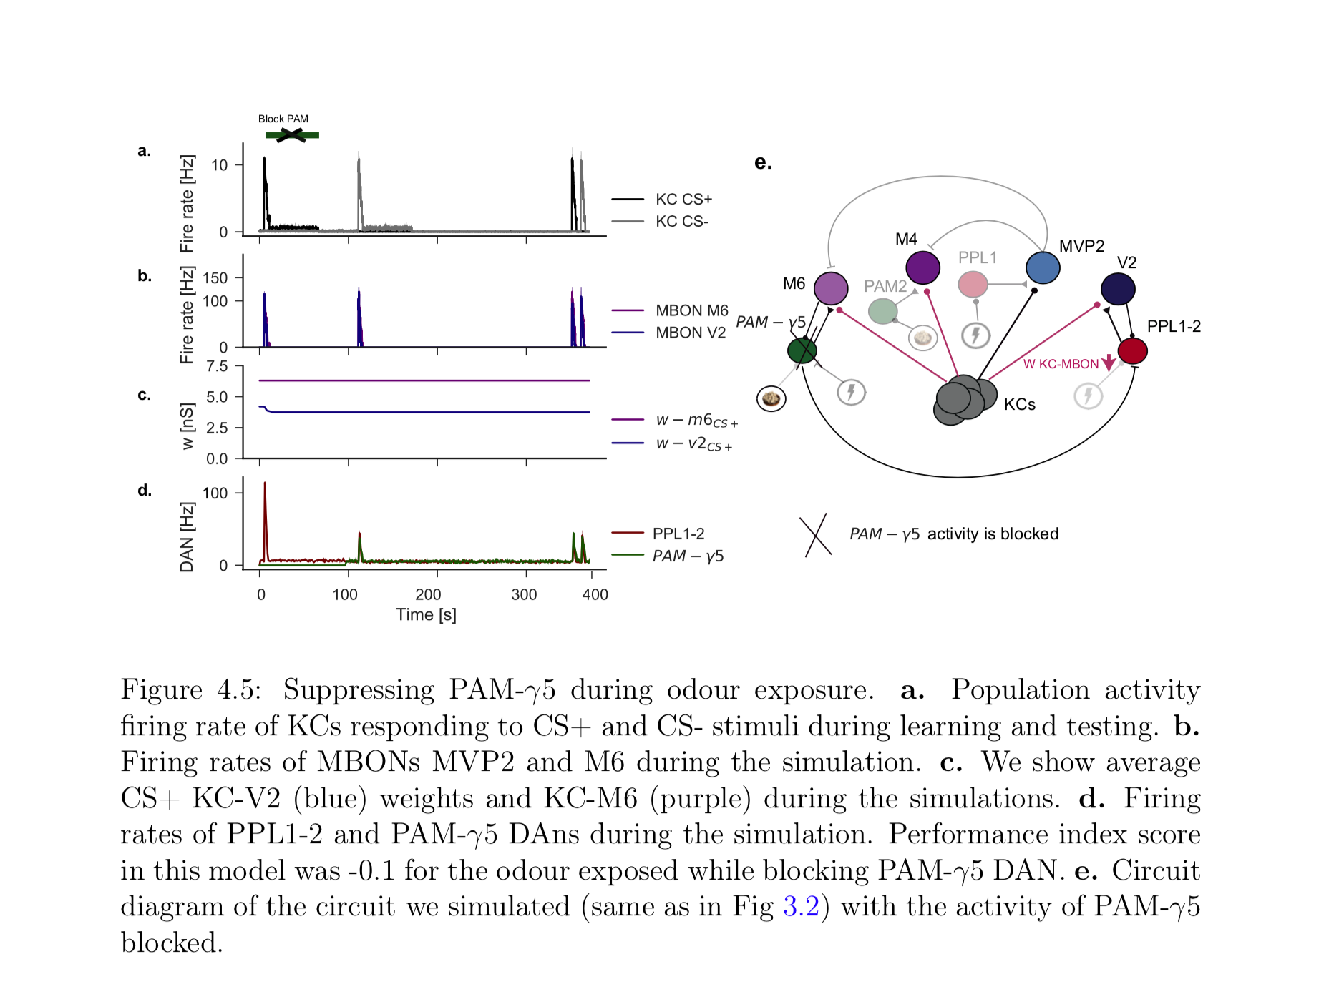

**! Figure 5.1: Please remove the inset, and instead add labels on x-axis: “shock then odour” and “odour then shock”. Also, please add line at 0.**

**Added dashed line at zero and a visual depiction of what negative and positive ISI means (p97)**

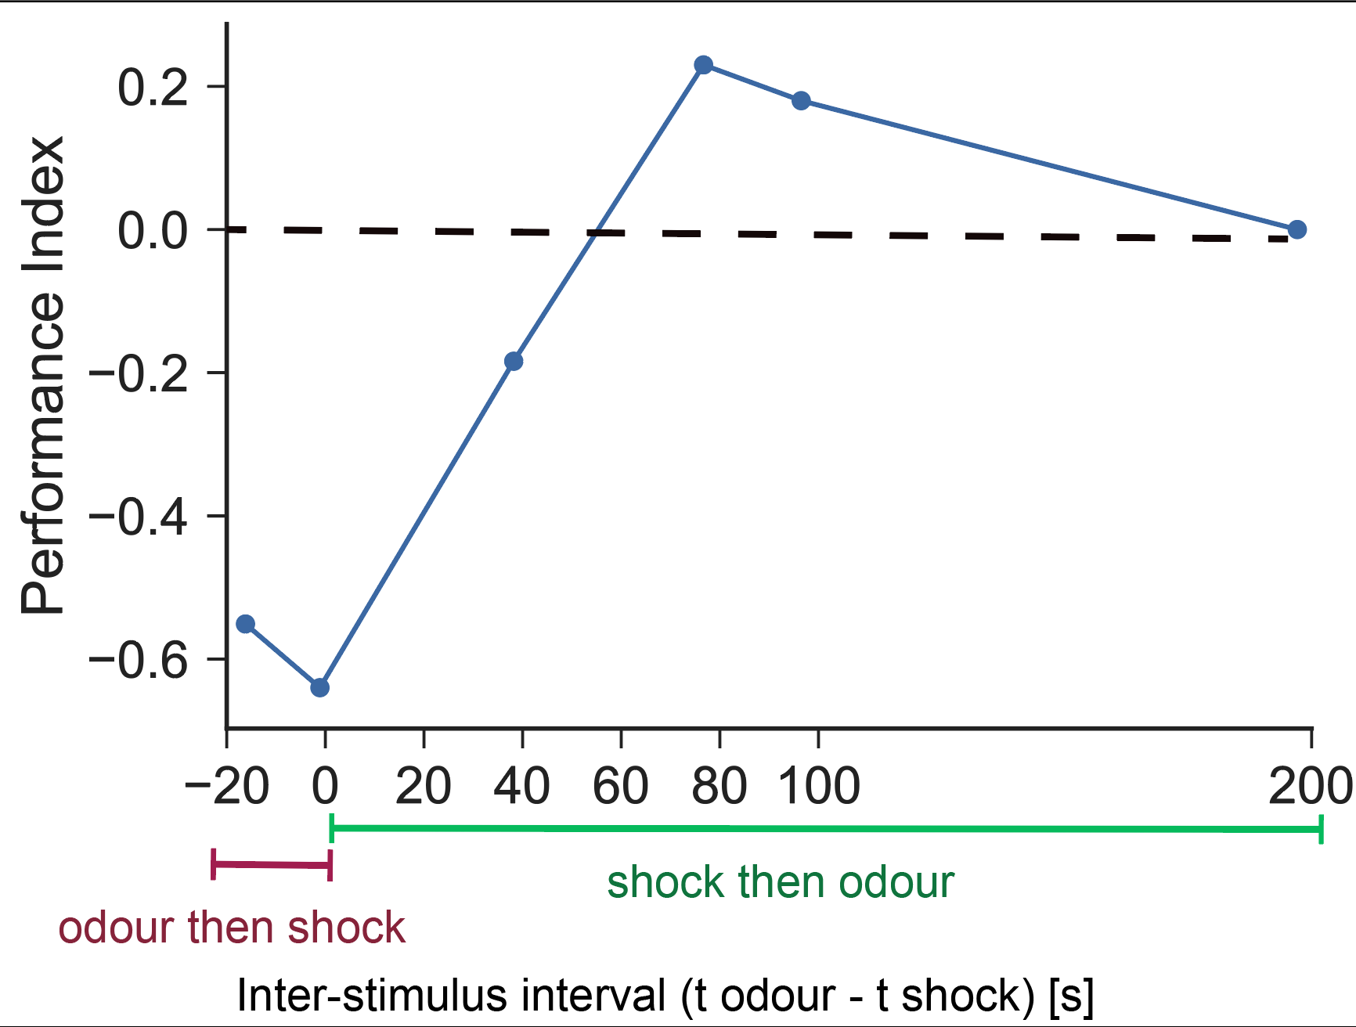

**! Figure 5.3: Please correct caption.**

**Changed caption to reflect actual conents**

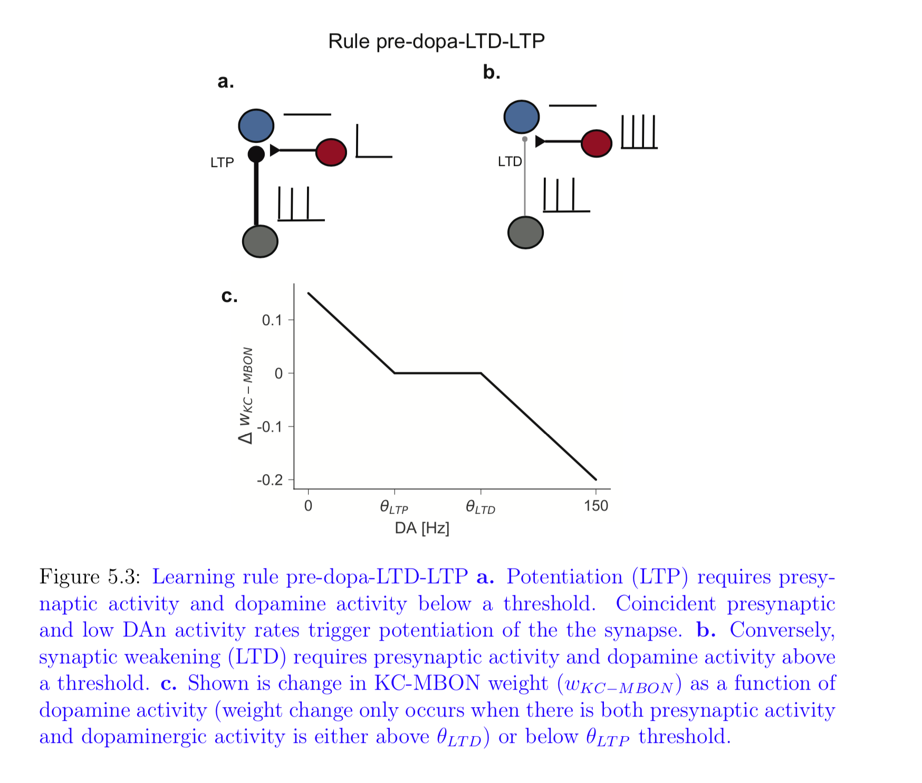

! p. 94: Move the bottom paragraph and Figure 5.4 to the start of section 5.4.5.

I moved references to the four-layer model and the 4 layer circuit diagram and the start of section 5.4.5.

! Figure 5.13: Caption of panel j is missing.

**Added to caption (p114):**

j. Firing rates elicited by MBONs after aversive re-learning.

! Throughout the thesis, it would be useful to add panels illustrating causality of changes occurring in the model in various paradigms.

**Added illustrations to show the changes in MBONs at each stage of the learning protocol (p113):**

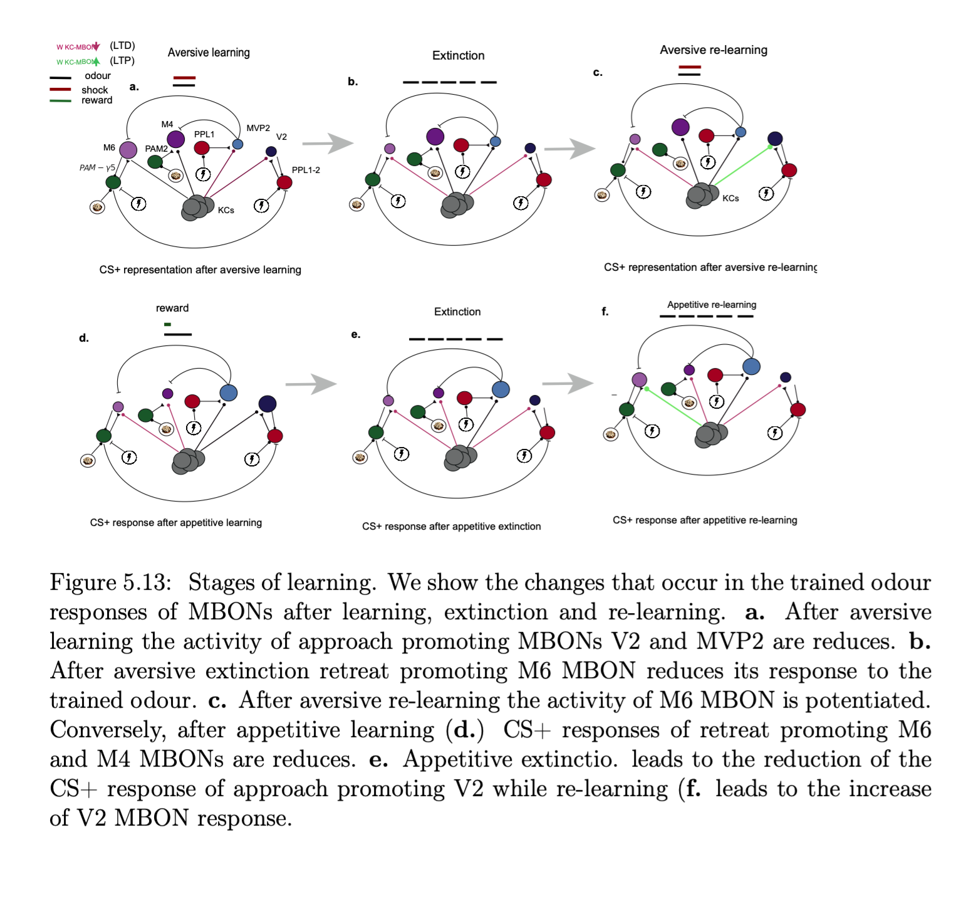

The cited literature is narrowly focused on Drosophila melanogaster only, relevant literature on experimental and importantly on theoretical studies of olfactory processing, learning and plasticity in other insects is scarce.

→ honeybee, locust

This is also true for literature that would allow comparison with the situation in vertebrates. This should be improved.

In addition to publications already mentioned above, the following topics should be better referenced:

**TO DO:**

*! p.32: Explain the mechanism of spike frequency adaptation through Ca2+ gated K+ channels, and explain how this mechanism is encoded in Eq. 2.1 and 2.2.*

*Cite papers that describe the role and function of spike frequency adaptation relevant in your context, e.g. Lundstrom et al., 2008; Farkhooi et al., 2013; Betkiewicz et al., 2018.*

*Please provide a reference for the “AdEx” neuron model.*

**- Effect of lateral inhibition on odour separation, e.g. in the insect AL: Linster et al., 2005; Schmuker et al., 2011, 2014; Diamond et al., 2019; in the fish: Wick et al. 2010.**

**- Broad odour tuning and valence coding in MBONs: e.g. Strube-Bloss et al., 2011,2016**

**.**

**- Please cover important model studies of reinforcement learning in the insect olfactory system including relevant publications authored/co-authored by M. Bazhenov, Th. Nowotny, R. Huerta, M. Schmuker, M.P. Nawrot.**

# Typos, grammar and style

I used Word 2018 spell checker and double checked every line in thesis to check for spelling.

All of the typos, grammar and style points in the last page of corrections were addressed and whenever a word was added it was added in red colour.

p.2 “dopamine … a type of cell” – dopamine is a neuromodulator rather than a type of neurons.

p.4 “performed… performed” – please correct grammar

p.5, line just under equation 1.2 – “V” needs to be italic. Similarly, variables under Eq. 1.5 need to be italic. Please check throughout the thesis.

p. 7 “tau_c is the variable” -> “tau_c is a parameter”

p.9: “taht" -> “that”; please use spell checker throughout the thesis.

p.12: “5-10 KCs” -> “5-10 PNs”

p.14: “The\alpha’\beta’” -> “The \alpha’\beta’”; analogous typo on page 15, line 2.

p.16 “promote” -> “promote.”

p.16, line 4 from the bottom: Sentences is not grammatically correct – please delete “they”

p.17 “We define bi-directional as the ability” – does not make sense, please reword.

p. 17: “that that”

p.24: “All though” -> “Although”

p.25, line 5: “+” in the ion symbols should be a superscript.

p.25: “three result chapters” -> “four result chapters”

p.27: “each of each”

p.28, first sentence in section 2.2: grammar: “it” does not match “Flies”.

p.30: “We removed” -> “We removed the following odours from simulations”

p.32, bracket missing at the end of Eq. 2.1.

p.37: Delete irrelevant part of caption of Figure 2.6.

p.45: “In in”

p.48: “a neural in a a” -> “a neural network in a”

p.54: “based which is based” – does not make sense

p.61: “of of”

p.64: “2018” -> “2018)”

p.67: “MVP2 After aversive learning” – the sentence does not make sense.

p. 69: “).” in caption of Figure 3.12 should be moved to the line above.

p.70: “can extinction” – grammar

p. 72: “High-dopa-LTD” -> “Pre-dopa-LTD”

p. 73: “postsynaptic activity” -> “MBON activity”

p. 75: “leboth” – should this be just “both”?

p.79: last sentence in section 4.1 does not make sense; similarly 2nd sentence in Section 4.2 does not make sense.

p.91: “rule in which potentiates” – grammar

p. 94: “as spike” - > “a spike”

p.97: “its fire” -> “its firing”

p. 104: “to to”

All subsection numbers in Section 6 have “.0” -> please remove it

p.108: “Dan excitatory” – grammar

p. 109: “When we simulated” – grammar it is not a sentence

p. 109: “orchestre” -> “orchestrate”

p. 110: correct order of the authors in Betkiewicz et al., 2017: Betkiewicz, Lindner, Nawrot