1: What it takes

Link:

Notes:

**What it Takes**

Completing a Udacity Nanodegree program takes perseverance and dedication, but the rewards outweigh the challenges. Throughout your Nanodegree program, you will develop and demonstrate specific skills that will serve you for a lifetime. Congratulations on taking the first step towards developing the skills you need to power your career through tech education!

The videos, text lessons, and quizzes you encounter in the classroom are optional but recommended. In order to graduate, you need to pass every project. Projects will test your ability to apply the skills and strategies you have learned in the classroom to real-world problems. They will also provide tangible outputs you can use to demonstrate your skills for current and future employers.

Projects are designed to be challenging. Many students initially struggle, but with a little grit they are able to learn from their mistakes and build their skills. Data from nearly 100,000 Udacity graduates show that commitment and persistence are the highest predictors of whether or not a student will graduate.

At some point, nearly every student will get stuck on a new concept or skill, and doubt may set in. Don’t panic. Don’t quit. Be patient, and work through the problem. Remember that you are not alone and the problem that you are encountering is likely one that many others have experienced as well. Whether you are stuck or simply looking for encouragement, you’ll find Udacity Mentors and students there to help.

2: Getting help

Link:

Notes:

# Getting Help

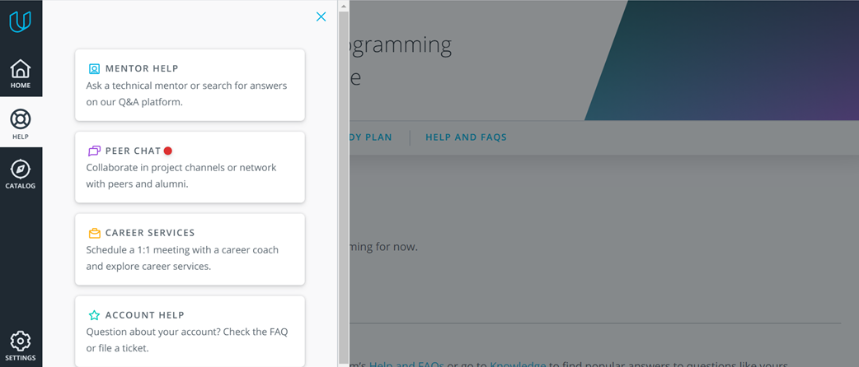

As questions come up during your Nanodegree program, click on the “help” button on the left-hand side of your classroom. You’ll see four options, each for a separate type of support:

* **Technical Mentor Support**: is provided through our [Knowledge](https://knowledge.udacity.com/) platform. On Knowledge, you can search for answers to questions similar to yours or post new questions related to your project or lessons. Udacity’s expert technical mentors answer all-new questions.
* **Peer Chat**: is available through our [Student Hub](https://hub.udacity.com/) platform. In Student Hub, you can chat with other students in general community channels or trade technical tips and ideas in project-specific channels. To access Student Hub, click on the option for “Peer Chat.”
* **Career Support**: is available for all students and alumni and includes 1:1 Career Coaching sessions, expert feedback on your application materials profiles, and lessons on “How to Network Successfully” to “Rehearsing for Interviews” and more. Click on “Career Services” to get started.
* **General Account Help**: This is where you can get details on non-technical issues such as billing, deadlines, or reach out to our support team with specific questions. Just click on “[Account Help](https://udacity.zendesk.com/hc/en-us)” to get started.

3: Knowledge

Link:

Notes:

# Technical Support on Knowledge

**Technical Mentor Support**: is provided through our [Knowledge](https://knowledge.udacity.com/) platform. On Knowledge, you can search for answers to questions similar to yours or post new questions related to your project or lessons. **Udacity’s expert technical mentors answer all-new questions.**

### How to Use Knowledge

To ensure you’re getting the quality and prompt support you need, it’s helpful to follow these best practices and guidelines for Knowledge.

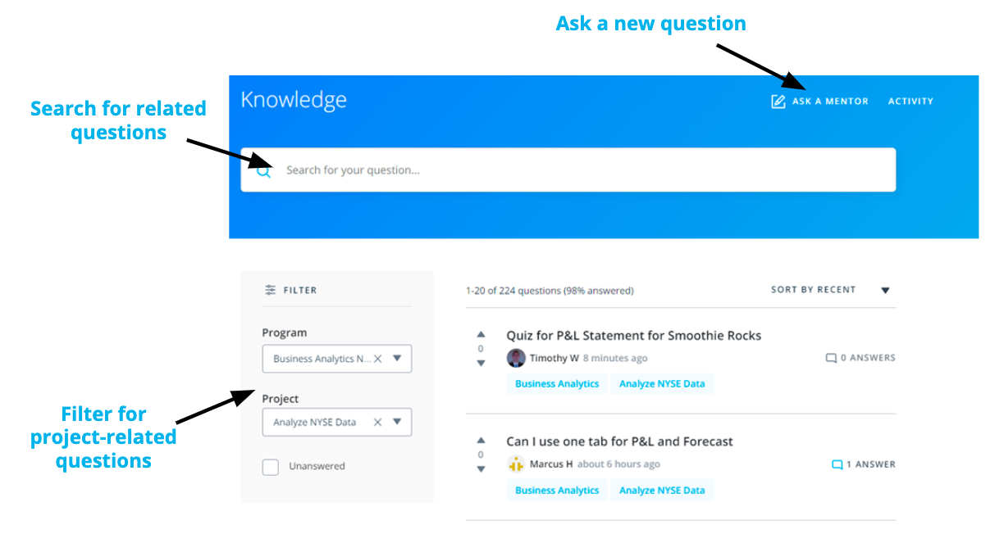

* **Search for Similar Existing Questions**: with tens of thousands of students enrolled in Nanodegree programs, many of your questions may have already been asked and answered. To look for existing answers to similar questions that may provide the immediate support you need, use the **filter on the left side of your screen** to select your Nanodegree and related project or write in the key terms related to your question in the **search bar** at the top of the page.
* **Ask a New Question**: if you want to ask a new question, select “Ask a Mentor” at the top of the page. Kindly remember that Knowledge is for technical questions only; for other types of support and feedback, please write to support at [support@udacity.com](mailto:support@udacity.com).

When you ask a new question, the platform immediately assigns it to one of our expert mentors spread across the globe to ensure prompt replies. Of note, when a mentor answers your question, you will see “Mentor” next to their name to differentiate their support from comments your fellow learners may also provide.

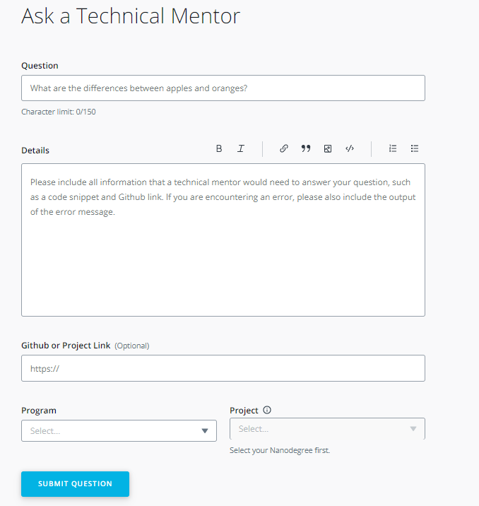

If you don't see your question, simply create a new post. You are likely to get an answer within 24 hours and you'll be helping future students who may encounter the same problem.

### How to Ask a Good Question?

Students that follow these tips typically receive the strongest initial support and avoid back-and-forth with mentors:

* **Ask Specific Questions**: if you have closely related questions that form part of a general theme, it’s okay to ask them all together. But consider using bullet points to separately list each of the questions in your post. Keeping your questions organized helps ensure mentors provide clear answers to each specific question. If your questions are less closely connected, it’s best to submit new, separate questions for each one.
* **Provide Details and Links:** explaining what (if anything) you’ve already attempted to solve the problem helps mentors know where to start when answering your question. Likewise, if your question is not related specifically to a project, but rather to an exercise, quiz, or lesson, it’s helpful to include information such as lesson or quiz name, screenshots, and classroom links.

*Overall the key to asking a good question is to imagine yourself trying to answer your own question. Imagine you were coming to it without any prior knowledge. Does the question make complete sense? Or are there gaps around the context?*

* **Start with a Clear Question Title**: attempt to summarize your entire question in one sentence. You may even write the title at the end, just before posting the question. This will help you summarize the issue before you include details in the question itself.
* **Share Code Correctly**: by using the “Code Block” option to properly format your code. If your question concerns a piece of external code, include a link to the file on Github.

*In fact, Github lets you create a link to a specific line in a file. To do so, just click to the left of the line number, and then select*copy permalink*in the ellipsis that appears in the margin. Paste the*permalink*right into the Github box on your question submission form.*

* **Figuring out Errors**: if your question is about an error message or stack trace, include the entire error message, by either formatting the error message using the “Code Block” option or creating a Gist or a Paste on Pastebin, and including a link to it in the description.
* **Avoid Screenshots of Code or Error Messages**: do not use screenshots of code or error messages. They are hard to read and the text cannot be copied to debug it.

If you receive a helpful answer, kindly select it as the “accepted answer.” For questions from other students, if you see other helpful answers kindly select the “upvote” option. Conversely, if you don’t think an answer strongly answers a question, select the “downvote” option.

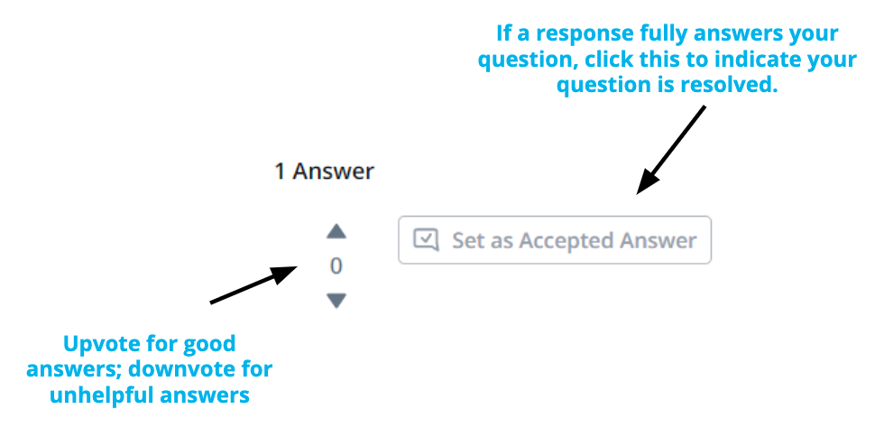

### Getting Additional Support

At times, students want support from a different mentor. As everyone learns differently, we want to make this a simple process for learners like you.

If you receive an answer that you are not satisfied with and want a different mentor to chime in, kindly select the option at the top of the page in Knowledge. If you reply directly in the comments section, without clicking on the link at the top of the page, your question will not be answered by another mentor.

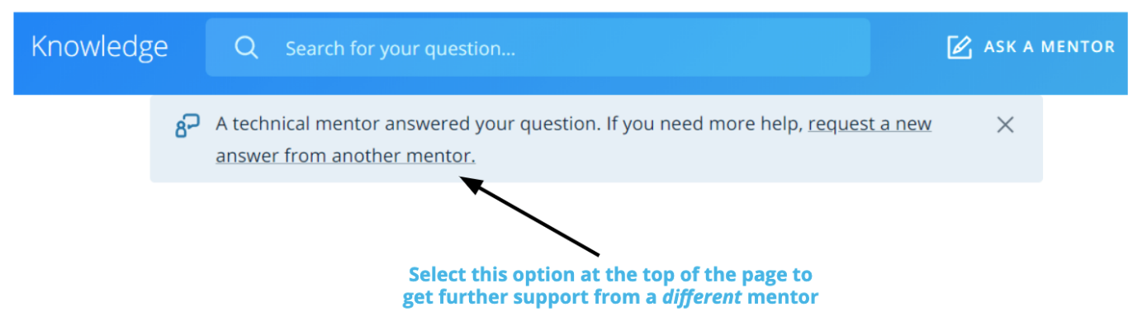

NEXT

4: Student Hub

Link:

Notes:

# Student Hub

[**Student Hub**](https://study-hall.udacity.com/) is your real-time collaboration platform where you can communicate with Udacity Community Managers and staff, as well as chat with peers from your Nanodegree Program. It operates similarly to Slack, and is your main community space.

You can access Student Hub by clicking **“Peer Chat”** under the Help section in your classroom!

## Peer Collaboration

Student Hub provides different channels for you to collaborate with your fellow students and alumni. You can ask them questions, share interesting articles, or just drop in to offer your fellow students some motivation!

#### Communities

Udacity Community channels are shared rooms between all Udacity students to help you correspond with the broader community. Please note that the community channels do not have technical mentors present. However, you can receive help from mentors in [**Knowledge**](https://knowledge.udacity.com/)!

#### Peer Project Channels

In your Peer Project Channels, you can connect with all students in your Nanodegree program. There is a channel for each of the projects in your Nanodegree program with helpful links, tips and tricks, and other information!

In the member lists, you can identify your peers who have passed that particular project by a green checkmark that's been added to their names in the right-side panel.

Please note that project channels do not have technical mentors present.

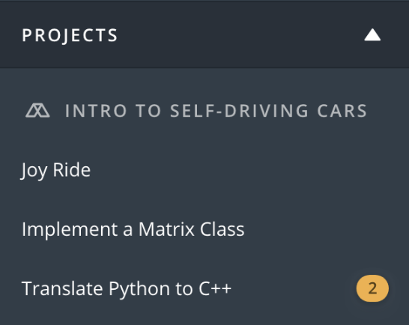

Project channels are provided for discussion on specific projects.

#### Direct Messages

The last section of Student Hub houses any direct message conversations you may be a part of. You can send a fellow student a direct message by clicking on their name, and then Send Direct Message in the side-bar.

Pro-tip: You can also see some stats on your fellow students' projects and Nanodegree programs by clicking on their name as well!

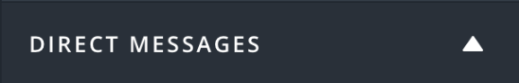

Direct messages will populate once you send your first one!

5: Career services

Link:

Notes:

You’re probably in this Nanodegree program to advance your career - whether looking for a new job, learning new skills for your current job, or just exploring.

If you want career support during you program, career coaches provide personalized feedback on your resume, cover letter, LinkedIn profile, and GitHub.

You'll get honest, concise feedback from career coaches, including industry professionals.

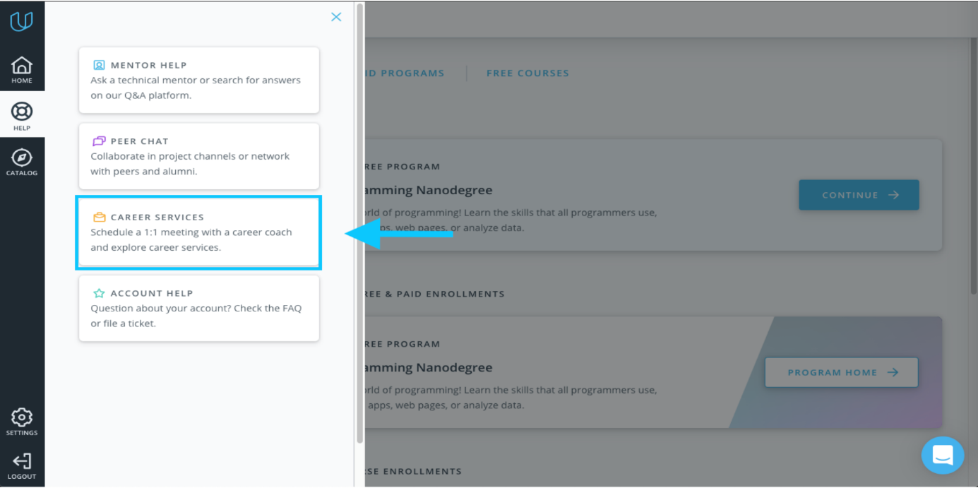

**Click on Career Services in the Classroom sidebar.**

Join our [Careers channel](https://hub.udacity.com/rooms/community:hqb2c-b2a03e2d-0900-477f-beab-d7956cd29451) to connect with other job-seeking students, and get support from career coaches as you begin to search for your dream job! Receive daily career tips, resources, and stay up to date on all the [Career Events](https://www.udacity.com/events) Udacity offers.

The Udacity Careers team is here to help you figure out what you're looking for, plan for it, and work with you to move forward in your career. You can always contact us at [career-support@udacity.com](mailto:career-support@udacity.com).