1: FAQ

Link:

Notes:

**FAQ**

Before creating a support request for a question about your account or a general question about your Nanodegree program, please see our [FAQ](https://udacity.zendesk.com/hc/en-us).

You can search or browse by category for commonly asked support questions.

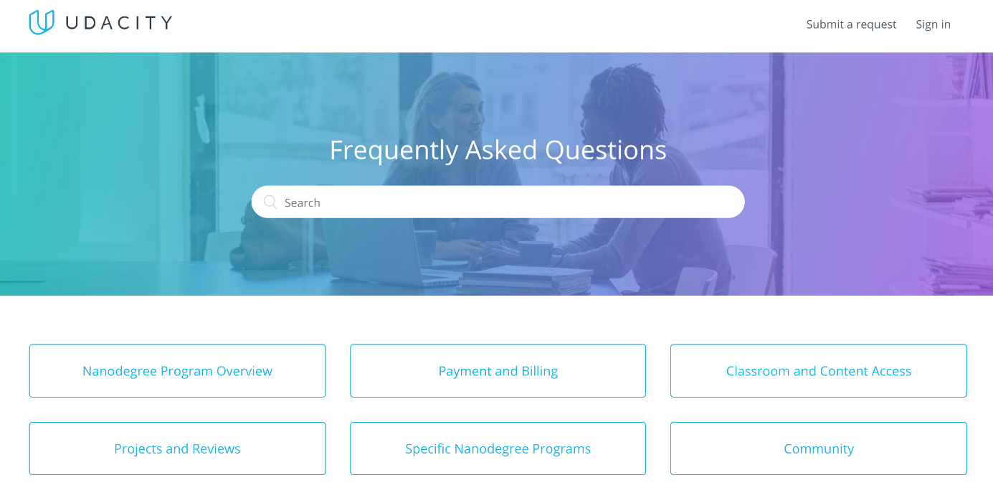

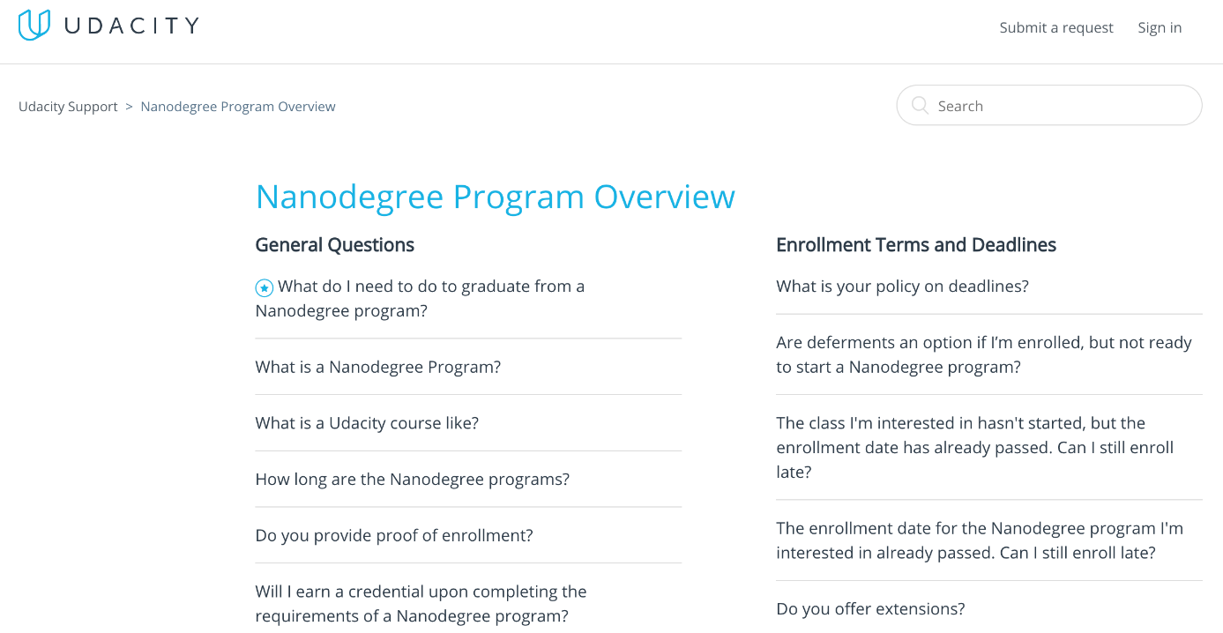

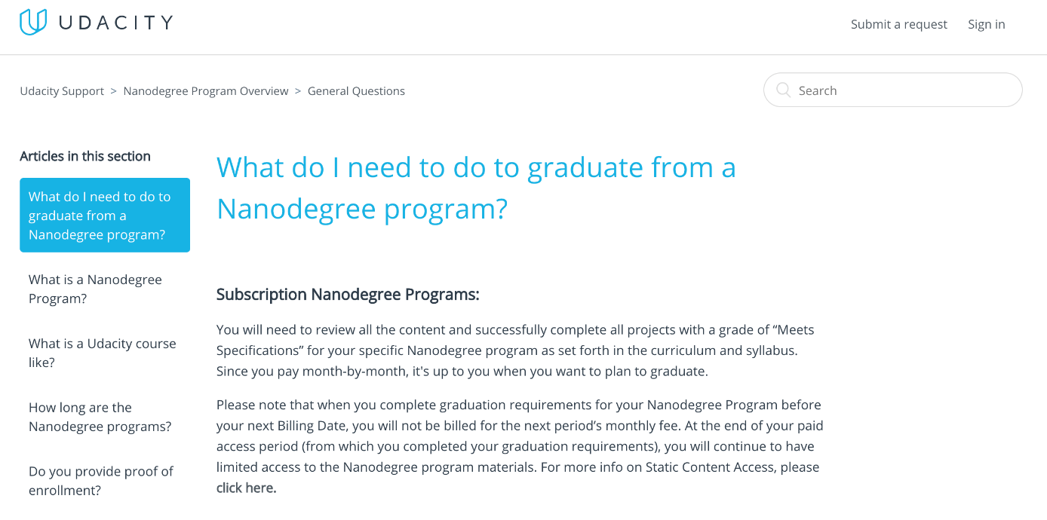

NEXT

2: Support

Link:

Notes:

**Support**

If you have reviewed our FAQ and still have a question, you can submit a support ticket from our [Help Center](https://udacity.zendesk.com/hc/en-us/requests/new?ticket_form_id=110806).

When submitting a ticket, please select the most relevant category for your request and give as much detail as possible so we can solve your issue quickly and efficiently! We will do our best to respond within around 24 hours.

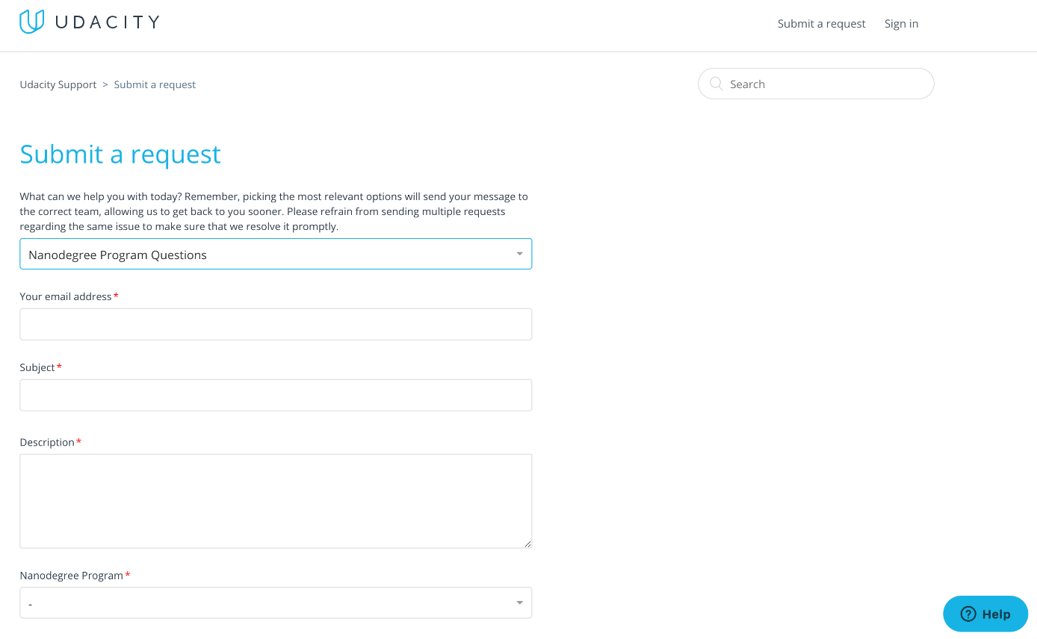

NEXT