1: Meet the careers team

Link: <https://www.youtube.com/watch?v=cuKecPpZ7PM>

Notes:

**Career Service: No Resubmission Required**

In this Nanodegree program, you can get personalized feedback on your LinkedIn and GitHub profiles. **Unlike other Nanodegree projects, you submit to a Career Service once to get feedback and do not need to meet specifications to continue on in your program.**

The value of Career Service reviews is not in meeting specifications on subjective rubric items, but in getting honest, personalized guidance from a Career Mentor. Learning from this guidance is what will guide you on the path to truly improving your job search materials.

We highly encourage you to take advantage of this guidance. Most Alumni who report jobs and other opportunities (such as collaboration) attribute their success to networking.

2: Career Services

Link:

Notes:

You’re probably in this Nanodegree program to advance your career - whether looking for a new job, learning new skills for your current job, or just exploring.

If you want career support during you program, career coaches provide personalized feedback on your resume, cover letter, LinkedIn profile, and GitHub.

You'll get honest, concise feedback from career coaches, including industry professionals.

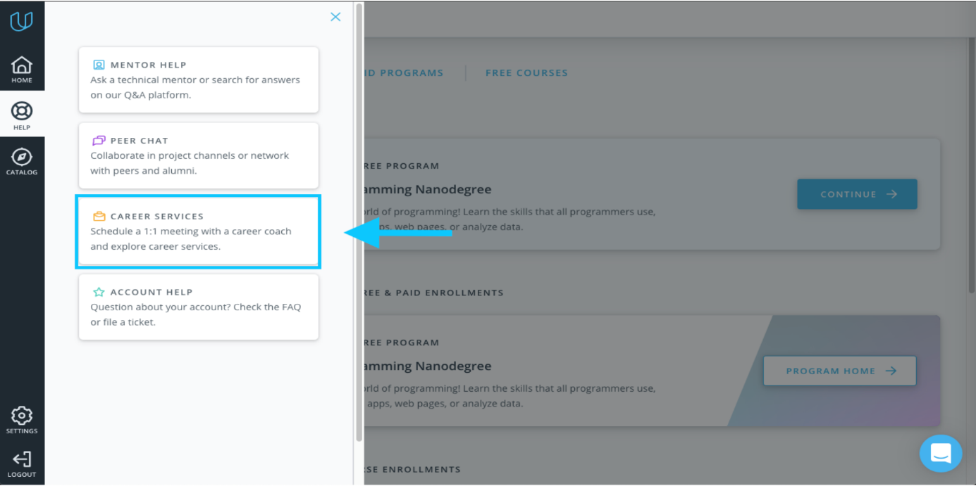

**Click on Career Services in the Classroom sidebar.**

Join our [Careers channel](https://hub.udacity.com/rooms/community:hqb2c-b2a03e2d-0900-477f-beab-d7956cd29451) to connect with other job-seeking students, and get support from career coaches as you begin to search for your dream job! Receive daily career tips, resources, and stay up to date on all the [Career Events](https://www.udacity.com/events) Udacity offers.

The Udacity Careers team is here to help you figure out what you're looking for, plan for it, and work with you to move forward in your career. You can always contact us at [career-support@udacity.com](mailto:career-support@udacity.com).