1: Learning objective

Link: <https://www.youtube.com/watch?v=S1G7BurtYJ0>

Notes:

2: Databases

Link: <https://www.youtube.com/watch?v=EvjmD7mTqQM>

Notes:

### Rule 1: The information rule:

All information in a relational database is represented explicitly at the logical level and in exactly one way – by values in tables.

### More information on Codd's 12 Rules can be found here:

[**Wikipedia link**](https://en.wikipedia.org/wiki/Codd%27s_12_rules)

3: Importance of relational databases

Link: <https://www.youtube.com/watch?v=QgBHz0bL1Sw>

Notes:

#### Importance of Relational Databases:

* **Standardization of data model:**Once your data is transformed into the rows and columns format, your data is standardized and you can query it with SQL
* **Flexibility in adding and altering tables:**Relational databases gives you flexibility to add tables, alter tables, add and remove data.
* **Data Integrity:**Data Integrity is the backbone of using a relational database.
* **Structured Query Language (SQL):**A standard language can be used to access the data with a predefined language.
* **Simplicity :** Data is systematically stored and modeled in tabular format.
* **Intuitive Organization:**The spreadsheet format is intuitive but intuitive to data modeling in relational databases.

4: OLAP vs OLTP

Link: <https://www.youtube.com/watch?v=ocoyWgYllFE>

Notes:

**Note - Correction from video:**

At the 1:04 mark of the video, the instructor mistakenly says:

* "OLTP queries will have little aggregations really, if any, while OLTP will heavily focus on aggregations."

The instructor misspoke here. **The CORRECT statement is:**

* **"OLTP queries will have little aggregations really, if any, while OLAP will heavily focus on aggregations."**

**Online Analytical Processing (OLAP):**  
Databases optimized for these workloads allow for complex analytical and ad hoc queries, including aggregations. These type of databases are optimized for reads.

**Online Transactional Processing (OLTP):**  
Databases optimized for these workloads allow for less complex queries in large volume. The types of queries for these databases are read, insert, update, and delete.

The key to remember the difference between OLAP and OLTP is analytics (A) vs transactions (T). If you want to get the price of a shoe then you are using OLTP (this has very little or no aggregations). If you want to know the total stock of shoes a particular store sold, then this requires using OLAP (since this will require aggregations).

#### Additional Resource on the difference between OLTP and OLAP:

This **[Stackoverflow post](https://stackoverflow.com/questions/21900185/what-are-oltp-and-olap-what-is-the-difference-between-them" \t "_blank)** describes it well.

**Note:** We will also be going more in depth with OLAP vs OLTP in **Course 3. Cloud Data Warehouses**

5: Quiz 1

Link:

Notes:

**QUESTION 1 OF 2**

True or False: OLTP queries are read heavy and focus primarily on analytics.

* 

True

* False

SUBMIT

**QUESTION 2 OF 2**

What makes data modeling for relational databases different?

* The ability to model data in a way that is intuitive
* 

You must model for your queries first

* 

There is no flexibility or agile nature to this process

SUBMIT

NEXT

6: Structuring the database: Normalization

Link: <https://www.youtube.com/watch?v=92dREpe9SLg>

Notes:

7: Objectives of normal form

Link: <https://www.youtube.com/watch?v=B_JtLJbhszM>

Notes:

#### Objectives of Normal Form:

1. To free the database from unwanted insertions, updates, & deletion dependencies
2. To reduce the need for refactoring the database as new types of data are introduced
3. To make the relational model more informative to users
4. To make the database neutral to the query statistics

See this [**Wikipedia page**](https://en.wikipedia.org/wiki/Database_normalization) to learn more.

8: Normal Forms

Link: <https://www.youtube.com/watch?v=ZUnI99efjJQ>

Notes:

1. **How to reach First Normal Form (1NF):**
   * Atomic values: each cell contains unique and single values
   * Be able to add data without altering tables
   * Separate different relations into different tables
   * Keep relationships between tables together with foreign keys
2. **Second Normal Form (2NF):**
   * Have reached 1NF
   * All columns in the table must rely on the Primary Key
3. **Third Normal Form (3NF):**
   * Must be in 2nd Normal Form
   * No transitive dependencies
   * Remember, transitive dependencies you are trying to maintain is that to get from A-> C, you want to avoid going through B.

**When to use 3NF:**

* + When you want to update data, we want to be able to do in just 1 place. We want to avoid updating the table in the Customers Detail table (in the example in the lecture slide).

**QUIZ QUESTION**

**What is the maximum normal form that should be attempted while doing practical data modeling?**

* 

First normal form

* 

Second normal form

* Third normal form
* 

Fourth normal form

SUBMIT

NEXT

9: Demo 1: creating normalized tables

Link: <https://www.youtube.com/watch?v=zdonkmTttaI>

Notes:

Again, the **goal of the demo**was to **maintain data integrity and reducing data redundancy.**

Here is the link to the demo file.

#### **Supporting Materials**

[**L1\_Demo\_1\_Creating\_Normalized\_tables**](https://video.udacity-data.com/topher/2019/March/5c9eaee6_lesson-2-demo-1-creating-normalized-tables/lesson-2-demo-1-creating-normalized-tables.ipynb)

10: Exercise 1: Creating normalized tables

Link:

Notes:

11: Solution: Exercise 1: Creating normalized tables

Link:

Notes:

12: Denormalization

Link: <https://www.youtube.com/watch?v=jJezt6YGweA>

Notes:

**Denormalization:**

JOINS on the database allow for outstanding flexibility but are extremely slow. If you are dealing with heavy reads on your database, you may want to think about denormalizing your tables. You get your data into normalized form, and then you proceed with denormalization. So, denormalization comes after normalization.

**Citation for slides:** [**https://en.wikipedia.org/wiki/Denormalization**](https://en.wikipedia.org/wiki/Denormalization)

### QUIZ QUESTION

True or False: Denormalization is just allowing data to come in as it is with no organization or planning.

* 

True

* False

SUBMIT

NEXT

13: Demo 2: Creating denormalized tables

Link: <https://www.youtube.com/watch?v=Wm11Mq8ez-A>

Notes:

Here is the link to the demo notebook.

#### **Supporting Materials**

[**L2\_Demo\_2\_Creating\_Denormalized\_Tables**](https://video.udacity-data.com/topher/2019/March/5c9eb1d2_lesson-2-demo-2-creating-denormalized-tables/lesson-2-demo-2-creating-denormalized-tables.ipynb)

14: Denormalization vs. Normalization

Link:

Notes:

Let's take a moment to make sure you understand what was in the demo regarding denormalized vs. normalized data. These are important concepts, so make sure to spend some time reflecting on these.

**Normalization** is about trying to increase data integrity by reducing the number of copies of the data. Data that needs to be added or updated will be done in as few places as possible.

**Denormalization** is trying to increase performance by reducing the number of joins between tables (as joins can be slow). Data integrity will take a bit of a potential hit, as there will be more copies of the data (to reduce JOINS).

## Example of Denormalized Data:

As you saw in the earlier demo, this denormalized table contains a column with the Artist name that includes duplicated rows, and another column with a list of songs.

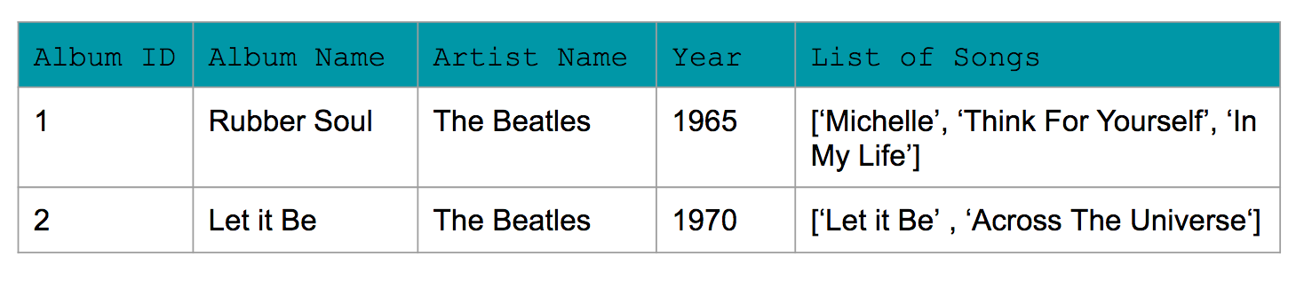

## Example of Normalized Data:

Now for normalized data, Amanda used 3NF. You see a few changes:  
1) No row contains a list of items. For e.g., the list of song has been replaced with each song having its own row in the Song table.  
2) Transitive dependencies have been removed. For e.g., album ID is the PRIMARY KEY for the album year in Album Table. Similarly, each of the other tables have a unique primary key that can identify the other values in the table (e.g., song id and song name within Song table).

#### Song\_Table

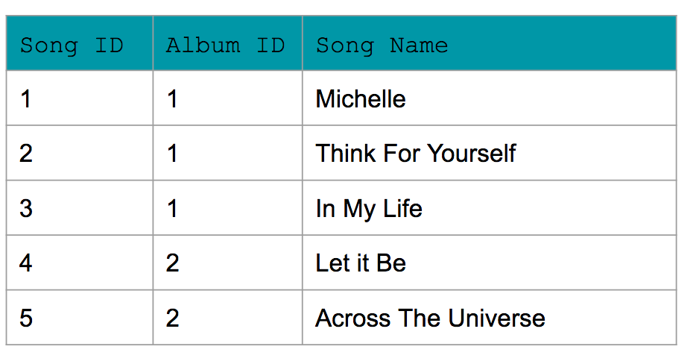

#### Album\_Table

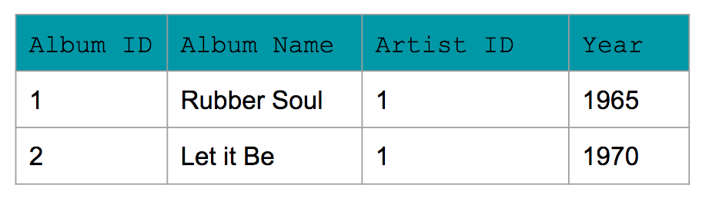

#### Artist\_Table

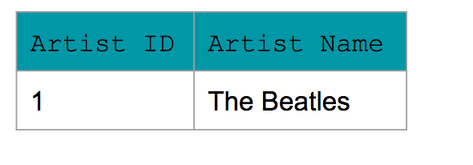

NEXT

15: Exercise 2: creating denormalized tables

Link:

Notes:

**Troubleshooting:**

* If you get an error for the insert statements: Error: Inserting Rows column "transaction\_id" of relation "transactions" does not exist make sure you have dropped the table transactions first.

16: Solution: Exercise 2: creating denormalized tables

Link:

Notes:

17: Fact and dimention tables

Link: <https://www.youtube.com/watch?v=3ala0SDBCyY>

Notes:

**Citations for slides:**

* [**https://en.wikipedia.org/wiki/Dimension\_(data\_warehouse)**](https://en.wikipedia.org/wiki/Dimension_(data_warehouse))
* [**https://en.wikipedia.org/wiki/Fact\_table**](https://en.wikipedia.org/wiki/Fact_table)

The following image shows the relationship between the fact and dimension tables for the example shown in the video. As you can see in the image, the unique primary key for each Dimension table is included in the Fact table.

In this example, it helps to think about the **Dimension tables** providing the following information:

* **Where** the product was bought? (Dim\_Store table)
* **When** the product was bought? (Dim\_Date table)
* **What** product was bought? (Dim\_Product table)

The **Fact table** provides the **metric of the business process** (here Sales).

* **How many** units of products were bought? (Fact\_Sales table)

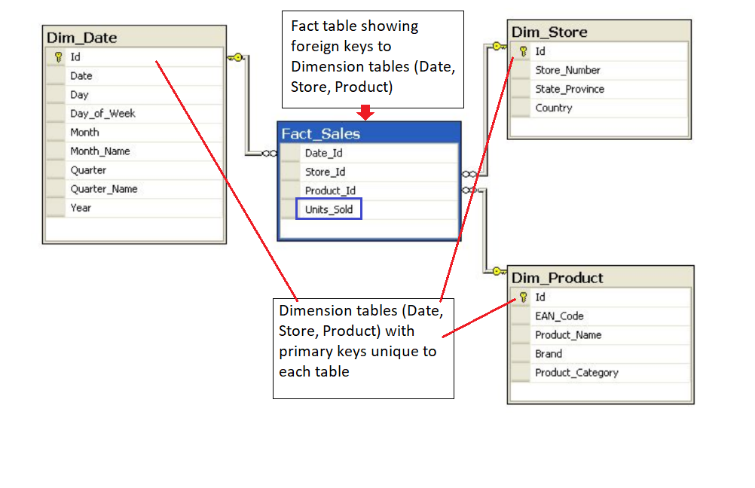

If you are familiar with **Entity Relationship Diagrams** (ERD), you will find the depiction of STAR and SNOWFLAKE schemas in the demo familiar. The ERDs show the data model in a concise way that is also easy to interpret. ERDs can be used for any data model, and are not confined to STAR or SNOWFLAKE schemas. Commonly available tools can be used to generate ERDs. However, more important than creating an ERD is to learn more about the data through conversations with the data team so as a data engineer you have a strong understanding of the data you are working with.

More information about ER diagrams can be found at this [**Wikipedia**](https://en.wikipedia.org/wiki/Entity%E2%80%93relationship_model) page.

18: Star Schemas

Link: <https://www.youtube.com/watch?v=i_0hq6KsjMo>

Notes:

**Reference for image in slides:**[**https://en.wikipedia.org/wiki/Star\_schema**](https://en.wikipedia.org/wiki/Star_schema)

#### Additional Resources

Check out this Wikipedia page on [**Star schemas**](https://en.wikipedia.org/wiki/Star_schema).

19: Benefits of star schemas

Link: <https://www.youtube.com/watch?v=sfsnFmE74yY>

Notes:

**Citation for image above:** [**https://en.wikipedia.org/wiki/Star\_schema**](https://en.wikipedia.org/wiki/Star_schema)

20: Snowflake Schemas

Link: <https://www.youtube.com/watch?v=UAceZsZSyUs>

Notes:

#### Additional Resources

Check out this Wikipedia page on [**Snowflake schemas**](https://en.wikipedia.org/wiki/Snowflake_schema).

This [**Medium post**](https://medium.com/@BluePi_In/deep-diving-in-the-world-of-data-warehousing-78c0d52f49a) provides a nice comparison, and examples, of Star and Snowflake Schemas. Make sure to scroll down halfway through the page.

21: Demo 3: Creating fact and dimention tables

Link: <https://www.youtube.com/watch?v=GVRAWaESxfk>

Notes:

Here is the link to the Demo notebook

#### **Supporting Materials**

[**L2\_Demo\_3\_Create\_Fact\_Dimension\_Tables**](https://video.udacity-data.com/topher/2019/March/5c9eb3c7_lesson-2-demo-3-creating-fact-and-dimension-tables-with-star-schema/lesson-2-demo-3-creating-fact-and-dimension-tables-with-star-schema.ipynb)

**22: Exercise 3: Creating fact and dimension tables**

**Link:**

**Notes:**

**23: Solution: Exercise 3: creating fact and dimention tables**

**Link:**

**Notes:**

**24: Data definition and constrains**

**Link:**

**Notes:**

## Data Definition and Constraints

The CREATE statement in SQL has a few important constraints that are highlighted below.

### NOT NULL

The **NOT NULL** constraint indicates that the column cannot contain a null value.

Here is the syntax for adding a NOT NULL constraint to the CREATE statement:

CREATE TABLE IF NOT EXISTS customer\_transactions (

customer\_id int NOT NULL,

store\_id int,

spent numeric

);

You can add **NOT NULL** constraints to more than one column. Usually this occurs when you have a **COMPOSITE KEY**, which will be discussed further below.

Here is the syntax for it:

CREATE TABLE IF NOT EXISTS customer\_transactions (

customer\_id int NOT NULL,

store\_id int NOT NULL,

spent numeric

);

### UNIQUE

The **UNIQUE** constraint is used to specify that the data across all the rows in one column are unique within the table. The **UNIQUE** constraint can also be used for multiple columns, so that the combination of the values across those columns will be unique within the table. In this latter case, the values within 1 column do not need to be unique.  
  
Let's look at an example.

CREATE TABLE IF NOT EXISTS customer\_transactions (

customer\_id int NOT NULL UNIQUE,

store\_id int NOT NULL UNIQUE,

spent numeric

);

Another way to write a **UNIQUE** constraint is to add a table constraint using commas to separate the columns.

CREATE TABLE IF NOT EXISTS customer\_transactions (

customer\_id int NOT NULL,

store\_id int NOT NULL,

spent numeric,

UNIQUE (customer\_id, store\_id, spent)

);

### PRIMARY KEY

The **PRIMARY KEY** constraint is defined on a single column, and every table should contain a primary key. The values in this column uniquely identify the rows in the table. If a group of columns are defined as a primary key, they are called a **composite key**. That means the combination of values in these columns will uniquely identify the rows in the table. By default, the **PRIMARY KEY** constraint has the unique and not null constraint built into it.  
  
Let's look at the following example:

CREATE TABLE IF NOT EXISTS store (

store\_id int PRIMARY KEY,

store\_location\_city text,

store\_location\_state text

);

Here is an example for a group of columns serving as **composite key**.

CREATE TABLE IF NOT EXISTS customer\_transactions (

customer\_id int,

store\_id int,

spent numeric,

PRIMARY KEY (customer\_id, store\_id)

);

To read more about these constraints, check out the [**PostgreSQL documentation**](https://www.postgresql.org/docs/9.4/ddl-constraints.html).

**25: Upsert**

**Link:**

**Notes:**

## Upsert

In RDBMS language, the term upsert refers to the idea of inserting a new row in an existing table, or updating the row if it already exists in the table. The action of updating or inserting has been described as "upsert".

The way this is handled in PostgreSQL is by using the INSERT statement in combination with the ON CONFLICT clause.

### INSERT

The **INSERT** statement adds in new rows within the table. The values associated with specific target columns can be added in any order.

Let's look at a simple example. We will use a customer address table as an example, which is defined with the following **CREATE** statement:

CREATE TABLE IF NOT EXISTS customer\_address (

customer\_id int PRIMARY KEY,

customer\_street varchar NOT NULL,

customer\_city text NOT NULL,

customer\_state text NOT NULL

);

Let's try to insert data into it by adding a new row:

INSERT into customer\_address (

VALUES

(432, '758 Main Street', 'Chicago', 'IL'

);

Now let's assume that the customer moved and we need to update the customer's address. However we do not want to add a new customer id. In other words, if there is any conflict on the customer\_id, we do not want that to change.

This would be a good candidate for using the **ON CONFLICT DO NOTHING** clause.

INSERT INTO customer\_address (customer\_id, customer\_street, customer\_city, customer\_state)

VALUES

(

432, '923 Knox Street', 'Albany', 'NY'

)

ON CONFLICT (customer\_id)

DO NOTHING;

Now, let's imagine we want to add more details in the existing address for an existing customer. This would be a good candidate for using the **ON CONFLICT DO UPDATE** clause.

INSERT INTO customer\_address (customer\_id, customer\_street)

VALUES

(

432, '923 Knox Street, Suite 1'

)

ON CONFLICT (customer\_id)

DO UPDATE

SET customer\_street = EXCLUDED.customer\_street;

We recommend checking out these two links to learn other ways to insert data into the tables.

* [**PostgreSQL tutorial**](http://www.postgresqltutorial.com/postgresql-upsert/)
* [**PostgreSQL documentation**](https://www.postgresql.org/docs/9.5/sql-insert.html)

**26: Conclusion**

**Link:** [**https://www.youtube.com/watch?v=fxIslVJSbo0**](https://www.youtube.com/watch?v=fxIslVJSbo0)

**Notes:**

#### What we learned:

* What makes a database a relational database and Codd’s 12 rules of relational database design
* The difference between different types of workloads for databases OLAP and OLTP
* The process of database normalization and the normal forms.
* Denormalization and when it should be used.
* Fact vs dimension tables as a concept and how to apply that to our data modeling
* How the star and snowflake schemas use the concepts of fact and dimension tables to make getting value out of the data easier.