1: Course introduction

Link: <https://www.youtube.com/watch?v=W5xxQEk4yZM>

Notes:

**Welcome To The Data Warehouses Course**

In this course, we'll cover the following:

1. Introduction to Data Warehouses
2. Introduction to the Cloud and AWS
3. Implementing Data Warehouses on AWS

2: Lesson Introduction

Link: <https://www.youtube.com/watch?v=Ahg8ehawvfc>

Notes:

# Introduction To Data Warehouses

Welcome to this lesson on Introduction to Data Warehouses!

### Objective

Students will be able to understand the purpose, architecture, and technologies used in a data warehouse.

### Prerequisites

* Relational database design & SQL
* Programming in Python
* Basic familiarity with dimensional modeling

### Lesson Overview

* What is a Data Warehouse? A Business Perspective
* What is a Data Warehouse? A Technical Perspective
* Dimensional Modeling (Recap)
* DWH Architecture
* OLAP Cubes
* DWH Storage Technology

3: Data warehouse: Business Perspective

Link: <https://www.youtube.com/watch?v=wMN48PtXnow>

Notes:

**What Is A Data Warehouse? A Business Perspective**

You are in charge of a retailer’s data infrastructure. Let’s look at some business activities.

* Customers should be able to find goods & make orders
* Inventory Staff should be able to stock, retrieve, and re-order goods
* Delivery Staff should be able to pick up & deliver goods
* HR should be able to assess the performance of sales staff
* Marketing should be able to see the effect of different sales channels
* Management should be able to monitor sales growth

Ask yourself: Can I build a database to support these activities? Are all of the above questions of the same nature?  
Let's take a closer look at details that may affect your data infrastructure.

* Retailer has a nation-wide presence → **Scale?**
* Acquired smaller retailers, brick & mortar shops, online store → **Single database? Complexity?**
* Has support call center & social media accounts → **Tabular data?**
* Customers, Inventory Staff and Delivery staff expect the system to be fast & stable → **Performance**
* HR, Marketing & Sales Reports want a lot information but have not decided yet on everything they need → **Clear Requirements?**

Ok, maybe one single relational database won’t suffice :)

4: Operational vs. Analytical Processes

Link: <https://www.youtube.com/watch?v=2WZaa1jGTE8>

Notes:

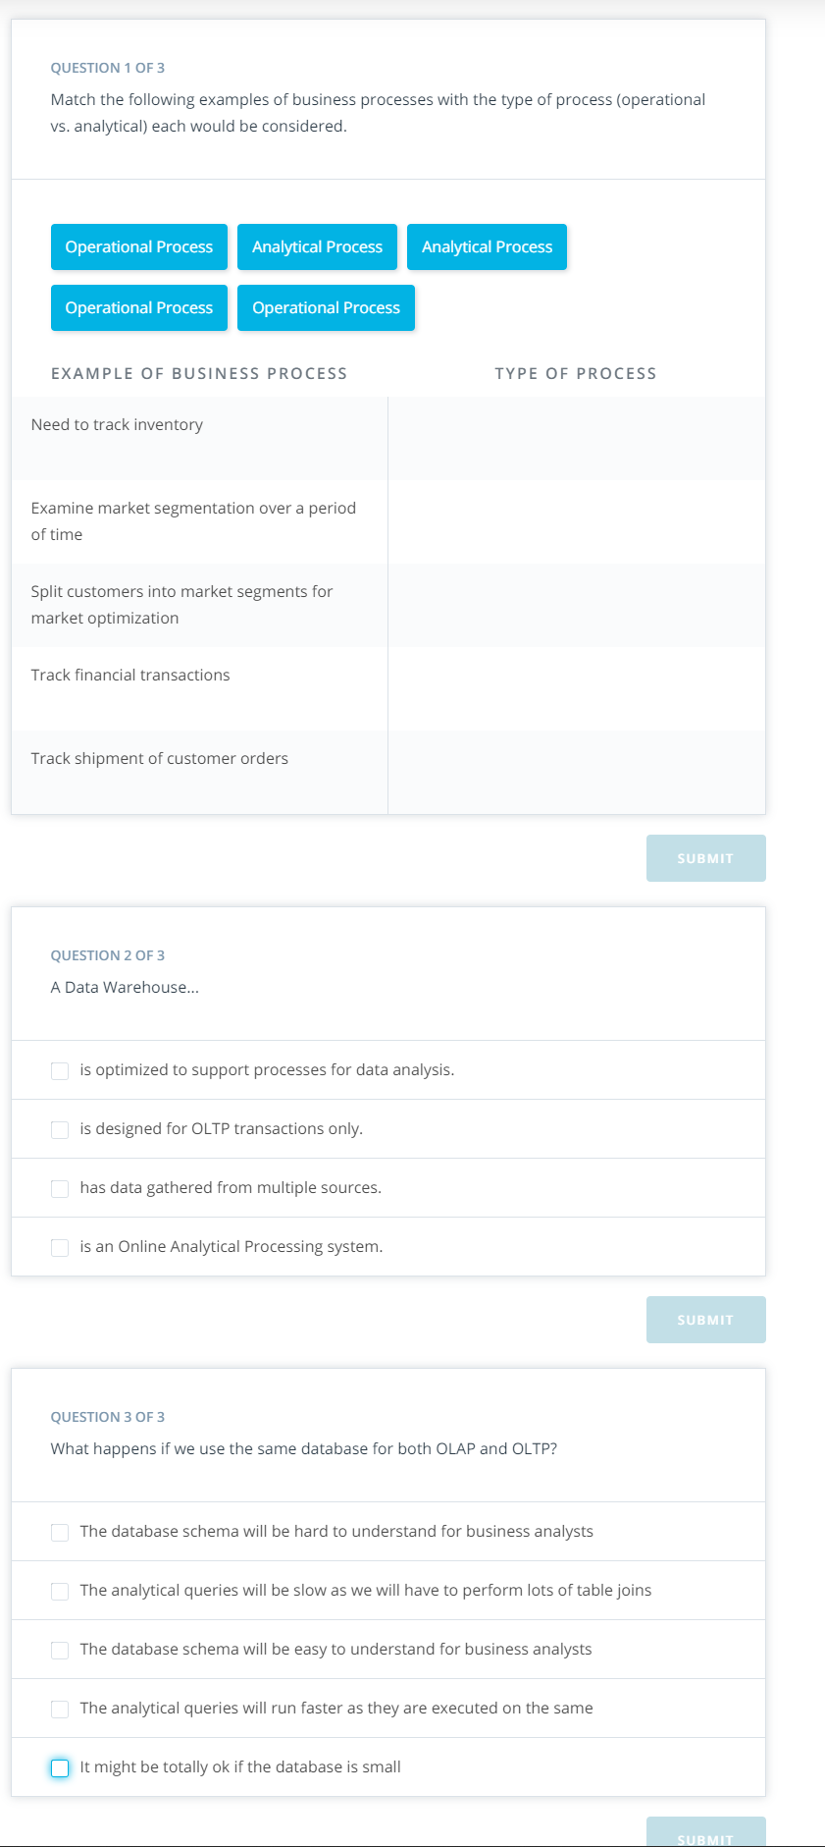

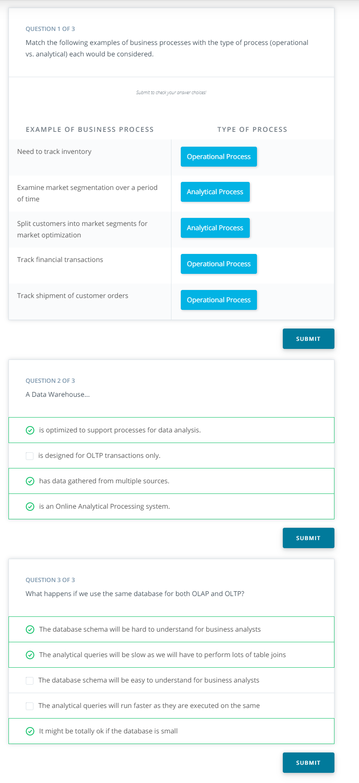

5: Data warehouse: Technical Perspective

Link: <https://www.youtube.com/watch?v=tGO-aGPyt68>

Notes:

6: Dimensional Modeling

Link1: <https://www.youtube.com/watch?v=ony5hGkSo78>

Link2: <https://www.youtube.com/watch?v=GR29jiNw0XE>

Notes:

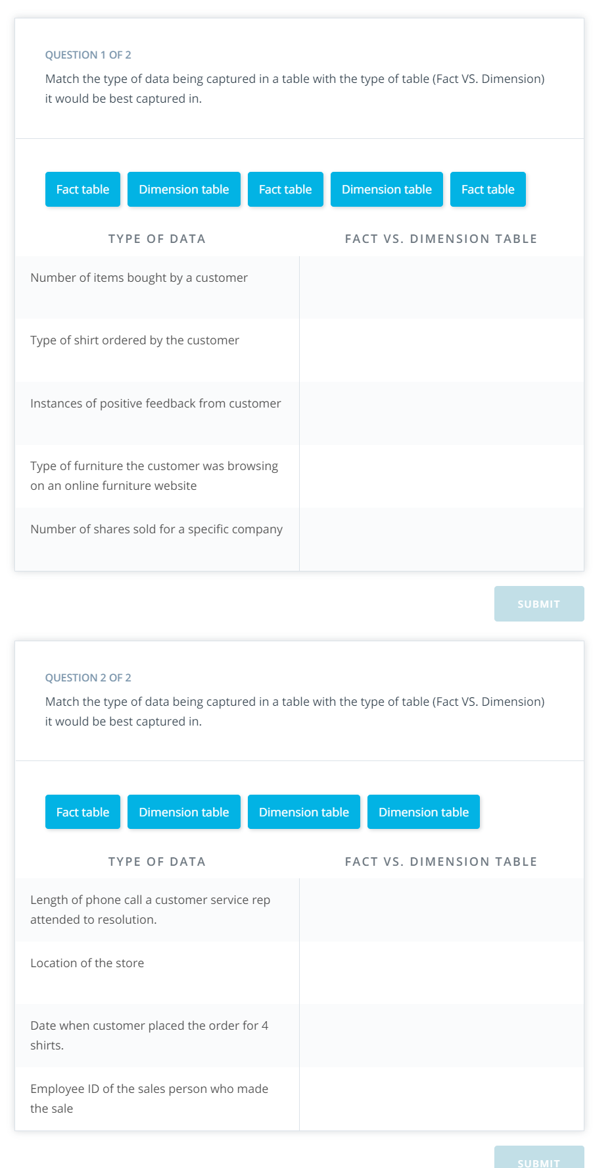

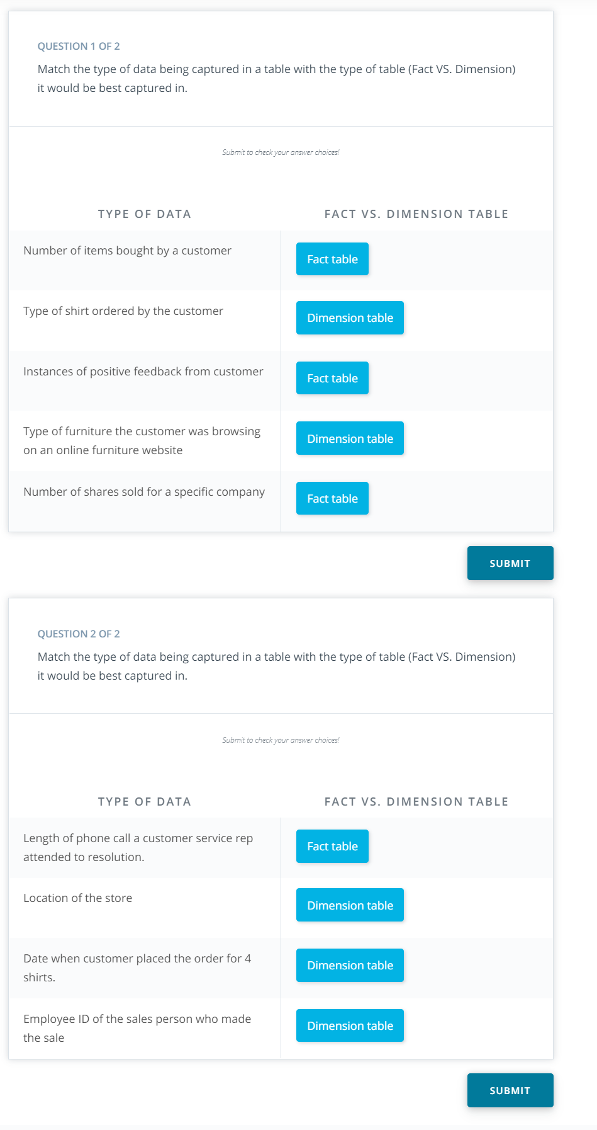

7: ETL Demo: Step 1 & 2

Link: <https://www.youtube.com/watch?v=qDbyxiKFrLE>

Notes:

8: Exercise 1: Step 1 & 2

Link:

Notes:

9: ETL Demo: Step 3

Link1: <https://www.youtube.com/watch?v=AckKPNjW17A>

Link2: <https://www.youtube.com/watch?v=SRHmqx4fGmU>

Link3: <https://www.youtube.com/watch?v=Ls1-xCiqHiI>

Notes:

10: Exercise 1: Step 3

Link:

Notes:

11: ETL Demo: Step 4

Link: <https://www.youtube.com/watch?v=HHuhptPD7Kc>

Notes:

12: Exercise 1: Step 4

Link:

Notes:

13: ETL Demo: Step 5

Link: <https://www.youtube.com/watch?v=IimfrD6lnu8>

Notes:

14: Exercise 1: Step 5

Link:

Notes:

15: ETL Demo: Step 6

Link: <https://www.youtube.com/watch?v=fHAALyRwGC0>

Notes:

16: Exercise 1: Step 6

Link:

Notes:

17: Exercise Solution 1: 3NF to Star Schema

Link:

Notes:

18: DWH Architecture: Kimball’s Bus Architecture

Link: <https://www.youtube.com/watch?v=cBK4T9LhD-A>

Notes:

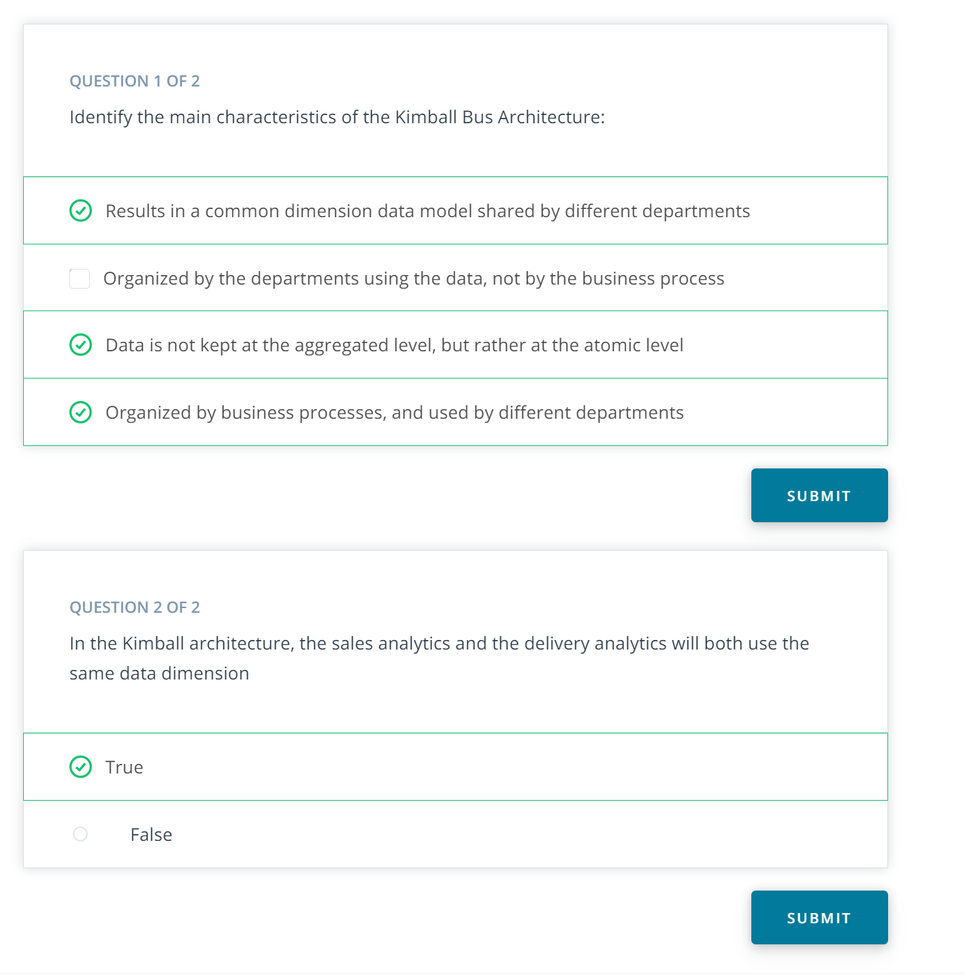

19: DWH Architecture: Independent Data Marts

Link: <https://www.youtube.com/watch?v=5ItLNcoZMSs>

Notes:

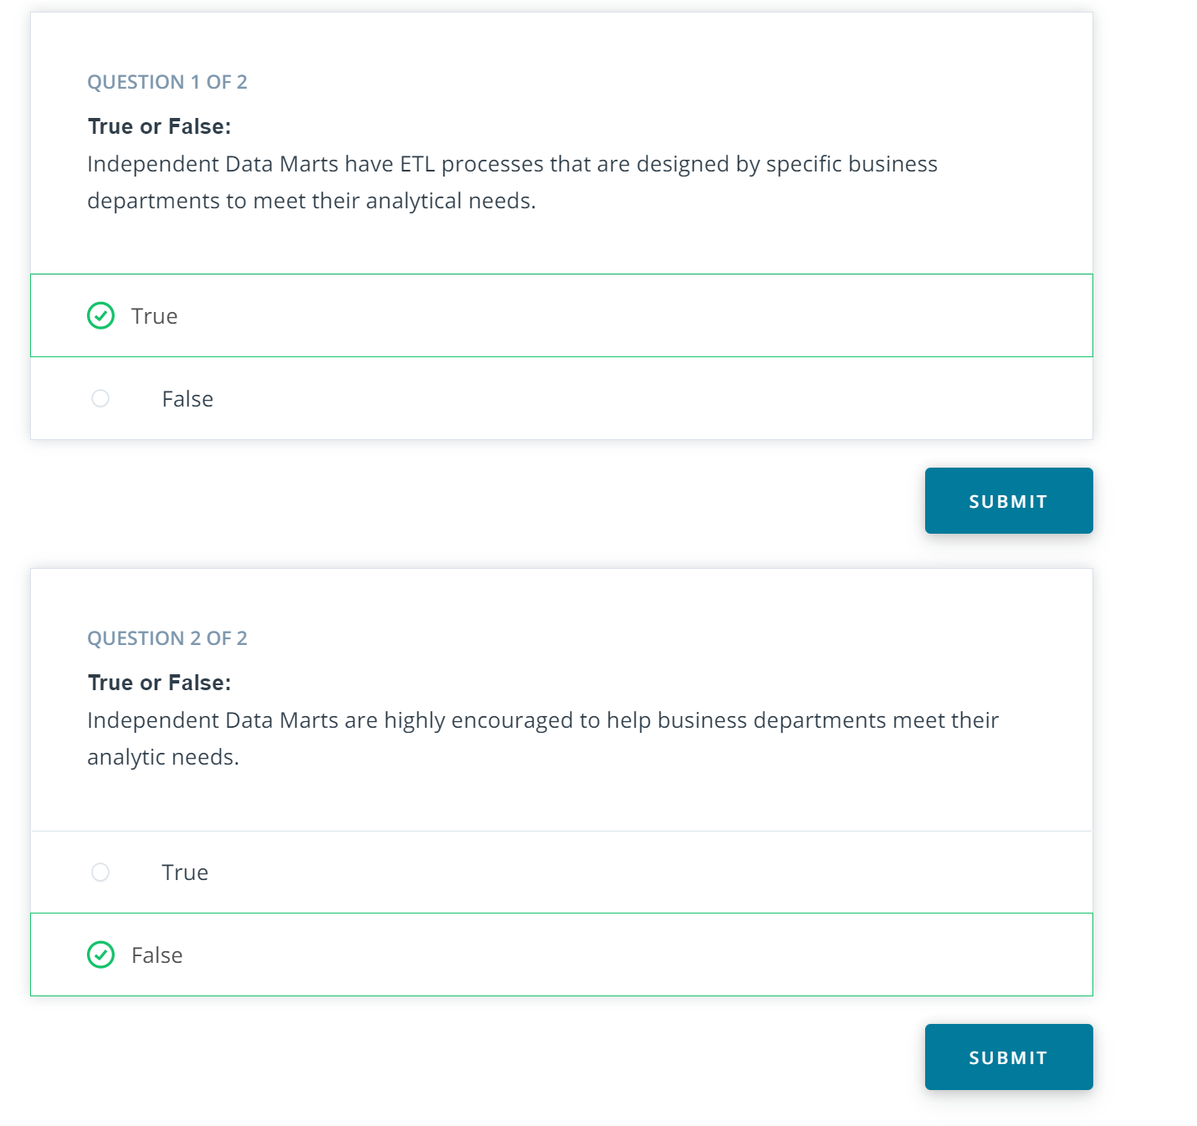

20: DWH Architecture: CIF

Link: <https://www.youtube.com/watch?v=mVqWU7jzbAc>

Notes:

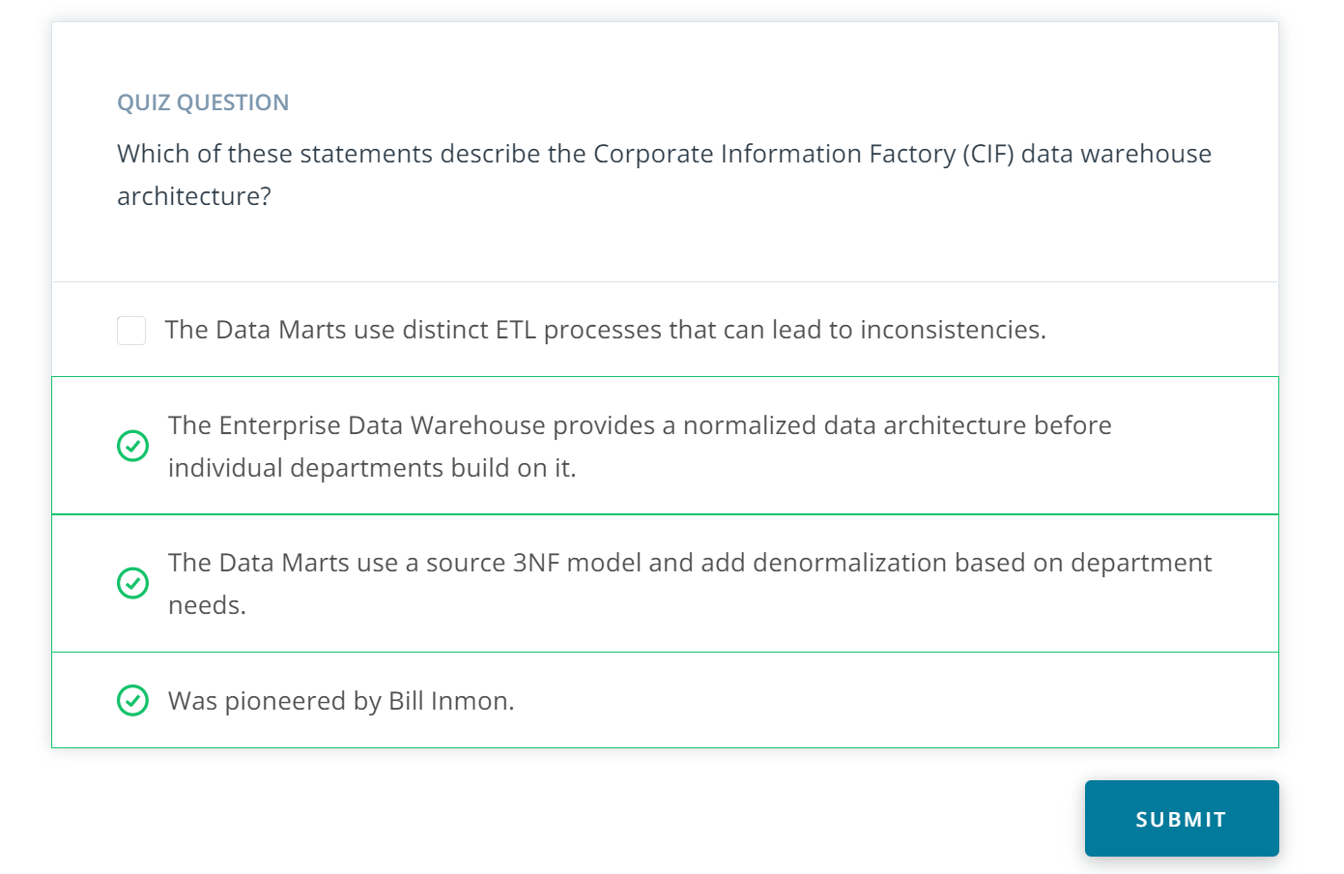

21: DWH Architecture: Hybrid Bus & CIF

Link: <https://www.youtube.com/watch?v=6DnHS6gVqIY>

Notes:

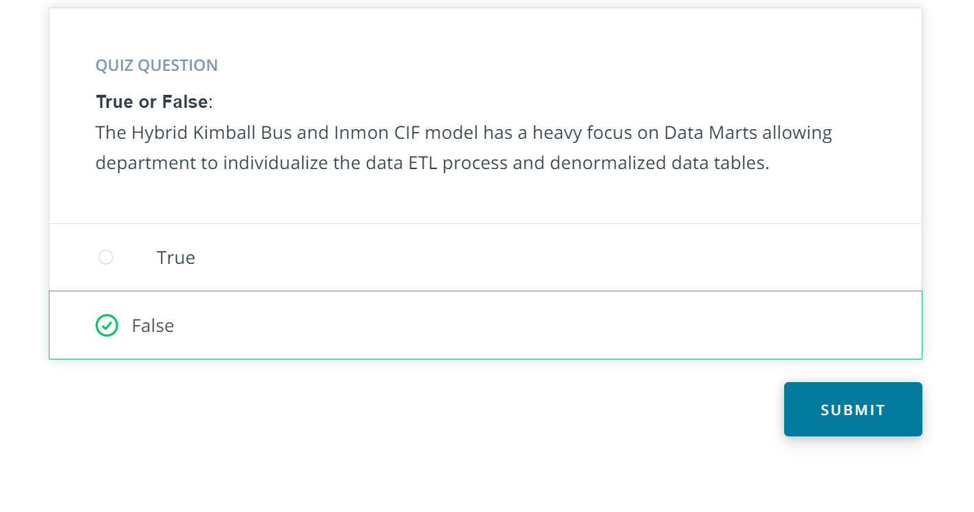

22: OLAP CUBES

Link: <https://www.youtube.com/watch?v=modd7NmChic>

Notes:

23: OLAP Cubes: Roll-Up and Drill Down

Link: <https://www.youtube.com/watch?v=scJR8EpV82A>

Notes:

24: OLAP Cubes: Slice and Dice

Link: <https://www.youtube.com/watch?v=ezSrpOeHG1Y>

Notes:

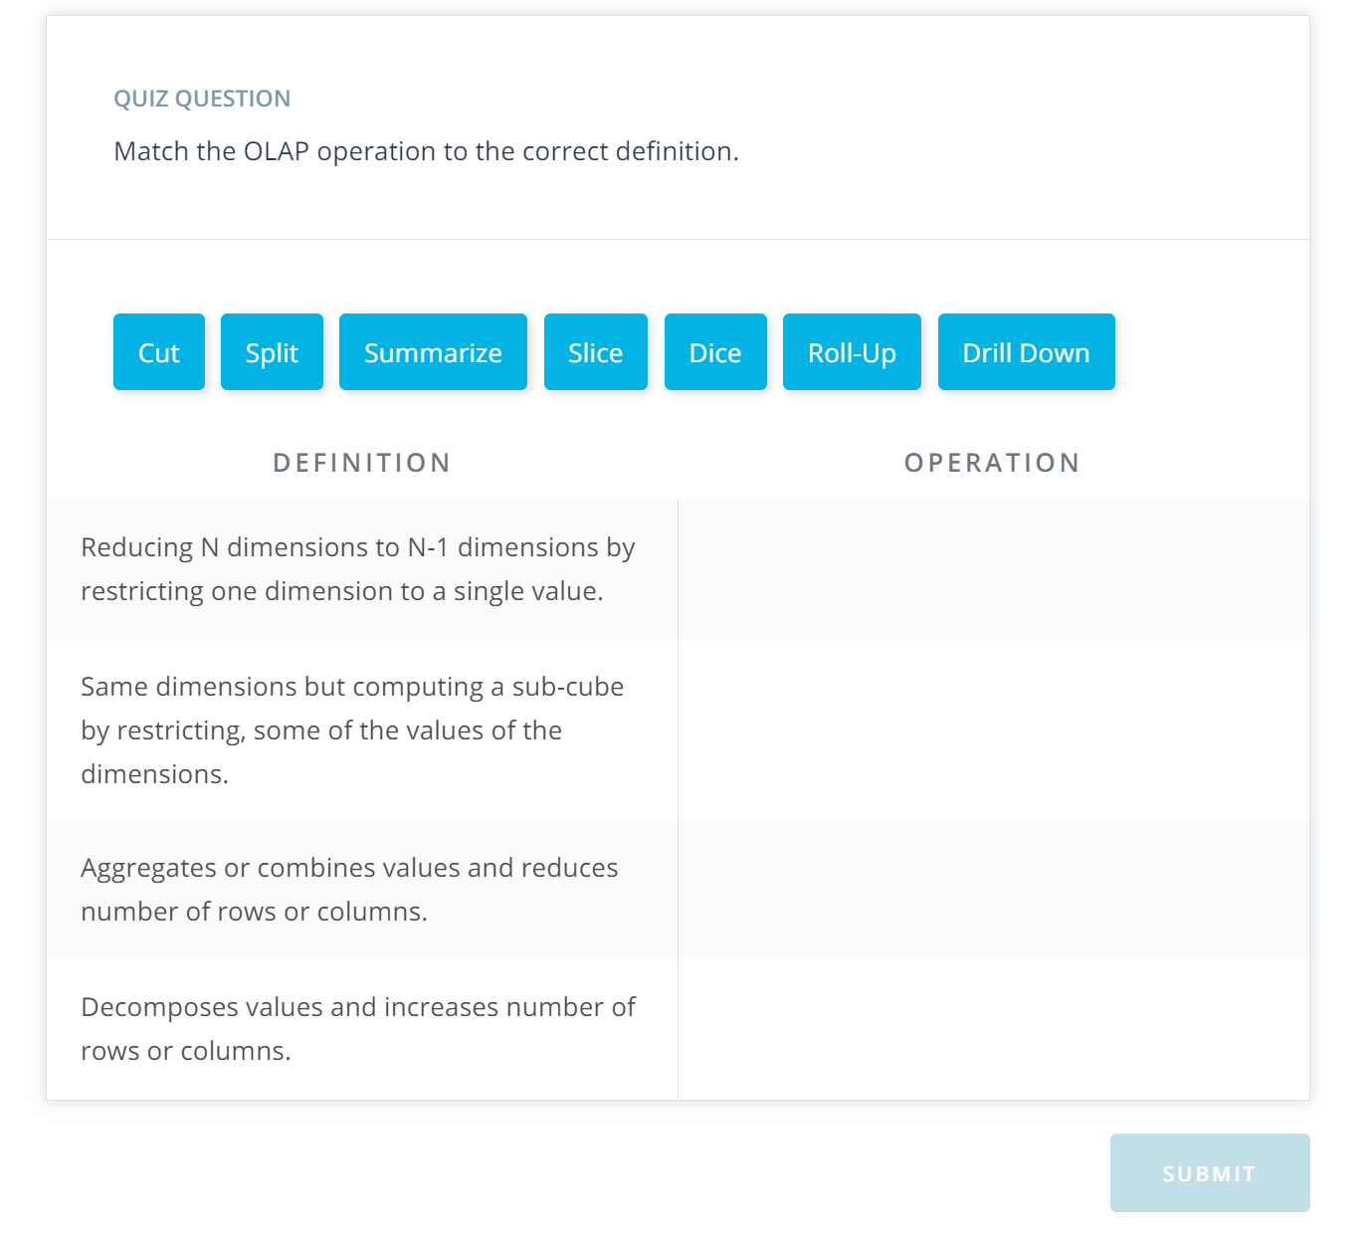

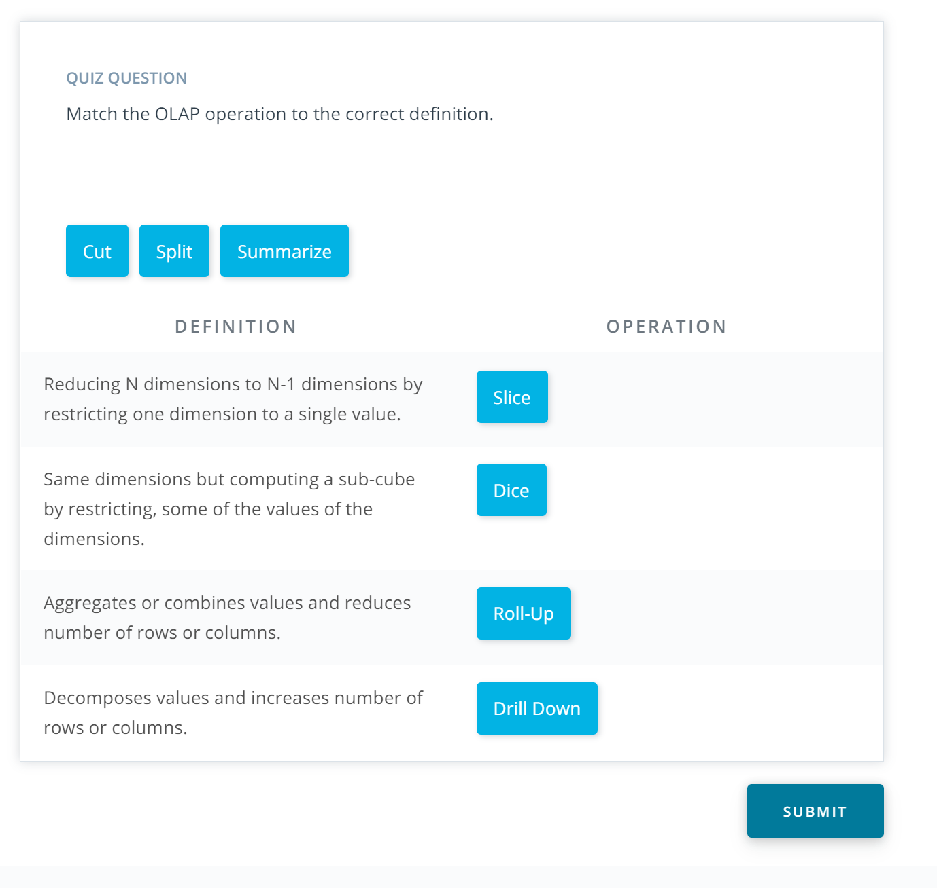

25: OLAP Cubes: Query Optimization

Link: <https://www.youtube.com/watch?v=pe0-17CSuLs>

Notes:

26: OLAP Cubes Demo: Slicing & Dicing

Link1: <https://www.youtube.com/watch?v=ZyHRUErDOrQ>

## OLAP Cubes Demo Introduction

Link2: <https://www.youtube.com/watch?v=_9zZ_vIZZ0A>

## OLAP Cubes Demo: Slicing

Link3: <https://www.youtube.com/watch?v=j9umvBak-jY>

OLAP Cubes Demo: Dicing

Notes:

27: Exercise 2: Slicing & Dicing

Link:

Notes:

28: OLAP Cubes Demo: Roll-Up

Link1: <https://www.youtube.com/watch?v=eUGQrKKiQ2M>

## OLAP Cubes Demo: Roll-Up

Link2: <https://www.youtube.com/watch?v=JPtPNtb3vnE>

## OLAP Cubes Demo: Drill-Down

Notes:

29: Exercise 2: Roll-Up & Drill Down

Link:

Notes:

30: OLAP Cubes Demo: Grouping Sets

Link: <https://www.youtube.com/watch?v=58nWFb-AJU8>

Notes:

31: Exercise 2: Grouping Sets

Link:

Notes:

32: OLAP Cubes Demo: CUBE

Link: <https://www.youtube.com/watch?v=fMkaZuxCCqw>

Notes:

33: Exercise 2: CUBE

Link:

Notes:

34: Data Warehouse Technologies

Link: <https://www.youtube.com/watch?v=v7QX4w2kC-4>

Notes:

## Book References

Here are links to the three books referenced in the video:

* [**The Data Warehouse Toolkit: The Complete Guide to Dimensional Modeling (Kimball)**](https://www.amazon.com/Data-Warehouse-Toolkit-Complete-Dimensional/dp/0471200247)
* [**Building the Data Warehouse (Inmon)**](https://www.amazon.com/Building-Data-Warehouse-W-Inmon/dp/0764599445)
* [**Building a Data Warehouse: With Examples in SQL Server (Rainardi)**](https://www.amazon.com/Building-Data-Warehouse-Examples-Experts/dp/1590599314)

35: Demo: Column format in ROLAP

Link: <https://www.youtube.com/watch?v=ELlnfNRn8Rw>

Notes:

### Try it yourself

As in other exercises, open up the Workspace on the next page (Workspace: Column format in ROLAP) and try this out for yourself.

36: Exercise 3: Column format in ROLAP

Link:

Notes: