1.1 Logical Scheme
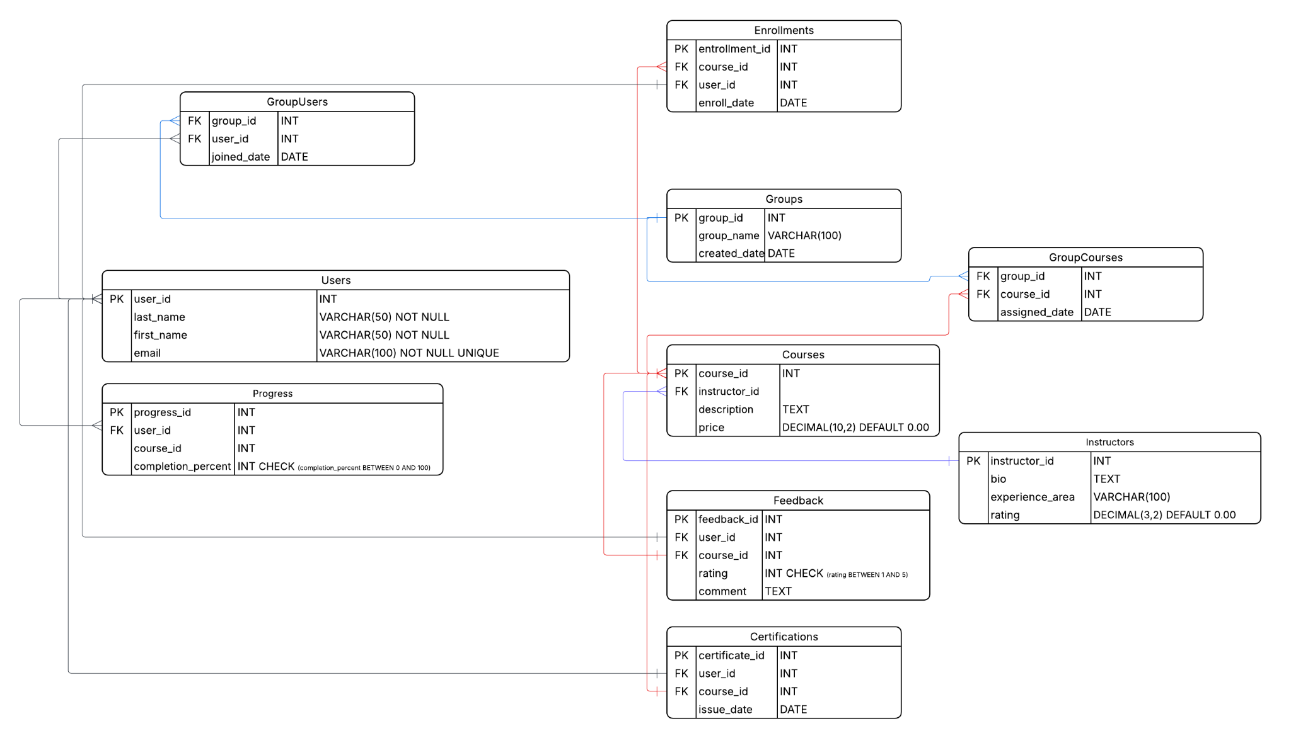

1.2 Objects

Table Description
<description>

Table Name | Field name | Field Description | Data Type / Constraints
Table 1 | Field Name 1 | <description> | Int, PK/FK
 | Field Name N | <description> | Text

Comments on table relationships

Example with data

Field Name 1 | Field name 2 | Field name 3 | Field name N
1 | aaa | 123 | 1234
Users table
The Users table stores information about people registered on the learning platform. Each user can enroll in courses, join groups, leave feedback, track course progress, and receive certificates after completing courses.

Table Name | Field name | Field Description | Data Type / Constraints
Users | user_id | Unique identifier assigned to each user in the system. | INT, PK
 | last_name | Last name of the user. | VARCHAR(50) NOT NULL
 | first_name | First name of the user. | VARCHAR(50) NOT NULL
 | email | Email address of the user used for communication and account identification. Must be unique | VARCHAR(100) NOT NULL UNIQUE

Comments on table relationships
Users can enroll in courses through the Enrollments table, join groups through GroupUsers, leave course reviews in Feedback, track learning progress in Progress, and receive course completion certificates in Certifications.
user_id | last_name | first_name | email
1 | Porkinson | Daniel | daniel.porkinson@email.com
Groups table
The Groups table stores information about groups of users. Groups can be used to organize learners who participate in the same courses.

Table Name | Field name | Field Description | Data Type / Constraints
Groups | group_id | Unique identifier of the group. | INT, PK
 | group_name | Name assigned to the group. | VARCHAR(100)
 | created_date | Date when the group was created. | DATE

Comments on table relationships
Groups contain users through the GroupUsers table and can be assigned courses through the GroupCourses table.
Example with data

group_id | Field name 2 | created_date
1 | Beginner Programmers | 2024-01-10

GroupUsers table
The GroupUsers table connects users and groups, implementing a many-to-many relationship between them.

Table Name | Field name | Field Description | Data Type / Constraints
GroupUsers | group_id | Identifier of the group the user belongs to. | INT, FK
 | user_id | Identifier of the user who is part of the group. | INT, FK
 | joined_date | Date when the user joined the group. | DATE

Comments on table relationships
This table links Users and Groups. A user can belong to multiple groups, and a group can contain many users.
Example with data

group_id | user_id | joined_date
1 | 1 | 2024-03-01

Courses table
The Courses table stores information about educational courses offered on the platform.

Table Name | Field name | Field Description | Data Type / Constraints
Courses | course_id | Unique identifier assigned to each course. | INT, PK
 | instructor_id | Identifier of the instructor who teaches the course. | INT, FK
 | description | Text description explaining the course content and objectives. | TEXT
 | price | Price of the course. Default value is 0.00 if the course is free. | DECIMAL(10,2) DEFAULT 0.00

Comments on table relationships
Courses are taught by instructors stored in the Instructors table. Users enroll in courses through the Enrollments table. Courses can also be assigned to groups through GroupCourses.
Example with data

course_id | instructor_id | instructor_id | price
1 | 1 | Introduction to Python Programming | 49.99

GroupCourses table
The GroupCourses table connects courses and groups, allowing courses to be assigned to groups.

Table Name | Field name | Field Description | Data Type / Constraints
GroupCourses | group_id | Identifier of the group assigned to the course. | INT, FK
 | course_id | Identifier of the course assigned to the group. | INT, FK
 | assigned_date | Date when the course was assigned to the group. | DATE

Comments on table relationships
This table implements a many-to-many relationship between Groups and Courses.
Example with data

group_id | course_id | assigned_date
1 | 1 | 2024-03-01

Instructors table
The Instructors table stores information about instructors who teach courses on the platform.

Table Name | Field name | Field Description | Data Type / Constraints
Instructors | instructor_id | Unique identifier assigned to each instructor. | INT, PK
 | bio | Short biography describing the instructor's background. | TEXT
 | experience_area | Area of expertise or specialization of the instructor. | VARCHAR(100)
 | rating | Average instructor rating based on course feedback. | DECIMAL(3,2) DEFAULT 0.00

Comments on table relationships
Each instructor can teach multiple courses. Courses reference instructors through the instructor_id foreign key.
Example with data

instructor_id | bio | experience_area | rating
1 | Software engineer with 10 years experience | Programming | 4.70

Enrollments table
The Enrollments table stores records of users enrolling in courses.

Table Name | Field name | Field Description | Data Type / Constraints
Enrollments | enrollment_id | Unique identifier of the enrollment record. | INT, PK
 | course_id | Identifier of the course in which the user enrolled. | INT, FK
 | user_id | Identifier of the user who enrolled in the course. | INT, FK
 | enroll_date | Date when the user enrolled in the course. | DATE

Comments on table relationships
This table implements a many-to-many relationship between Users and Courses.
Example with data

enrollment_id | course_id | user_id | enroll_date
1 | 1 | 1 | 2024-03-10

Progress table
The Progress table tracks the learning progress of users in specific courses.

Table Name | Field name | Field Description | Data Type / Constraints
Progress | progress_id | Unique identifier for the progress record. | INT, PK
 | user_id | Identifier of the user whose progress is tracked. | INT, FK
 | course_id | Identifier of the course being tracked. | INT, FK
 | completion_percent | Percentage of the course completed by the user. | INT CHECK (completion_percent BETWEEN 0 AND 100)

Comments on table relationships
Progress records are associated with both Users and Courses, indicating how much of a course a user has completed.
Example with data

progress_id | user_id | course_id | completion_percent
1 | 1 | 1 | 40

Feedback table
The Feedback table stores user reviews and ratings for courses.

Table Name | Field name | Field Description | Data Type / Constraints
Feedback | feedback_id | Unique identifier for each feedback entry. | INT, PK
 | user_id | Identifier of the user who left the feedback. | INT, FK
 | course_id | Identifier of the course being reviewed. | INT, FK
 | rating | Numerical rating given to the course by the user. | INT CHECK (rating BETWEEN 1 AND 5)
 | comment | Text review describing the user's opinion about the course. | TEXT

Comments on table relationships
Each feedback record connects a user and a course.
Example with data

feedback_id | user_id | course_id | rating | comment
1 | 1 | 1 | 5 | Excellent course

Certifications table
The Certifications table stores certificates issued to users after they complete courses.

Table Name | Field name | Field Description | Data Type / Constraints
Certifications | certificate_id | Unique identifier of the issued certificate. | INT, PK
 | user_id | Identifier of the user receiving the certificate. | INT, FK
 | course_id | Identifier of the completed course. | INT, FK
 | issue_date | Date when the certificate was issued. | DATE

Comments on table relationships
Certificates are issued to users after completing courses. Each record links a user and a course.
Example with data

certificate_id | user_id | course_id | issue_date
1 | 3 | 2 | 2024-04-01

