Bai 01:

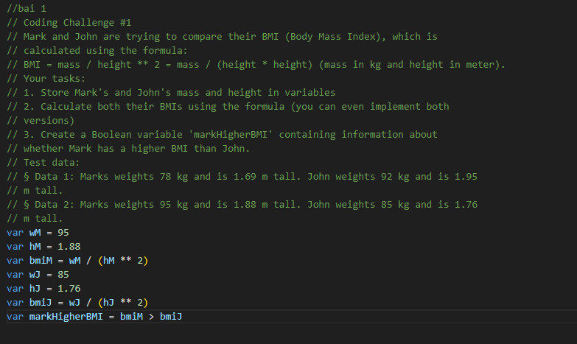

Bai 02:



Bai 03:



Bai 04:



Bai 05:



Bai 06:



Bai 07:



Bai 08:



Bai 09:

