JPA

Slide 05:

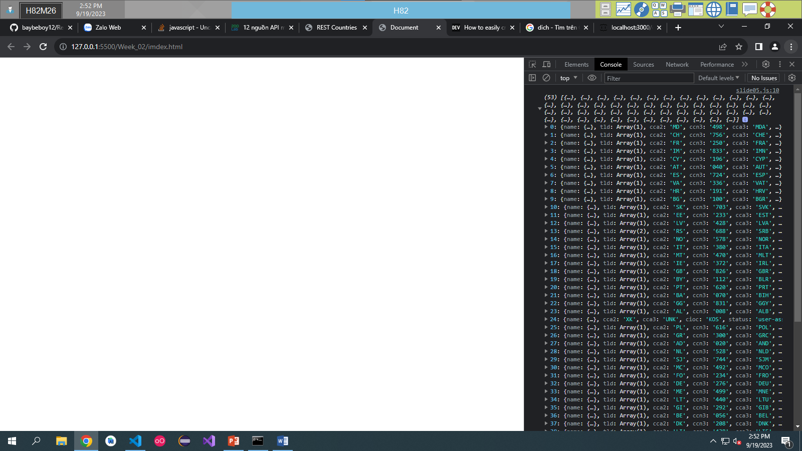

Slide 06:

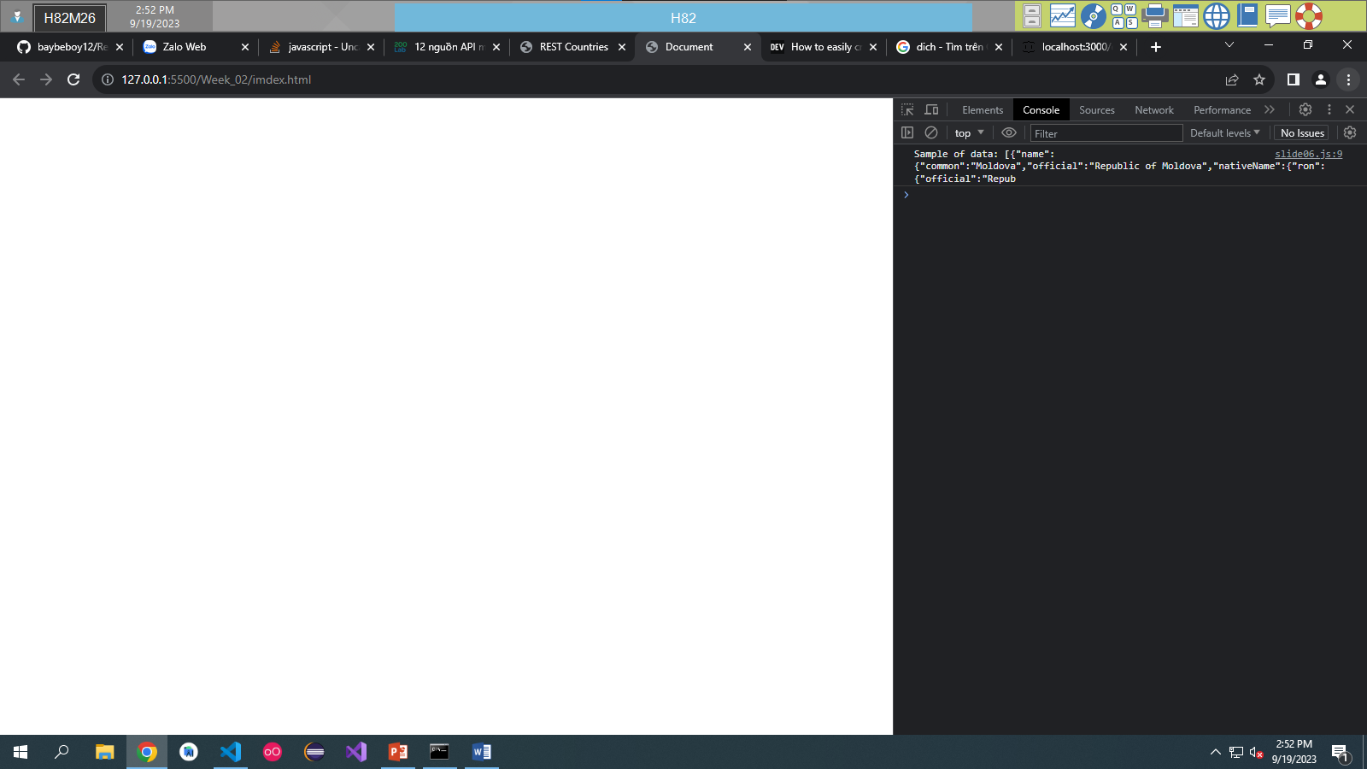

Slide 07:

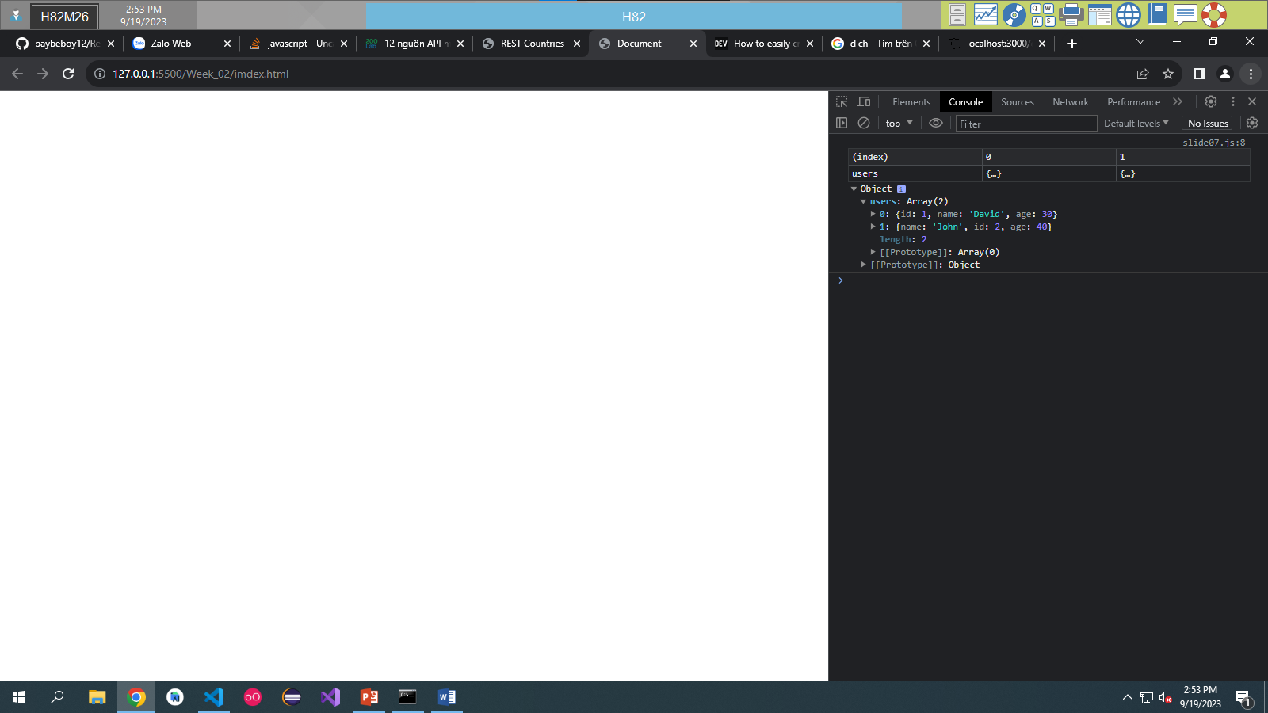

Slide 08:

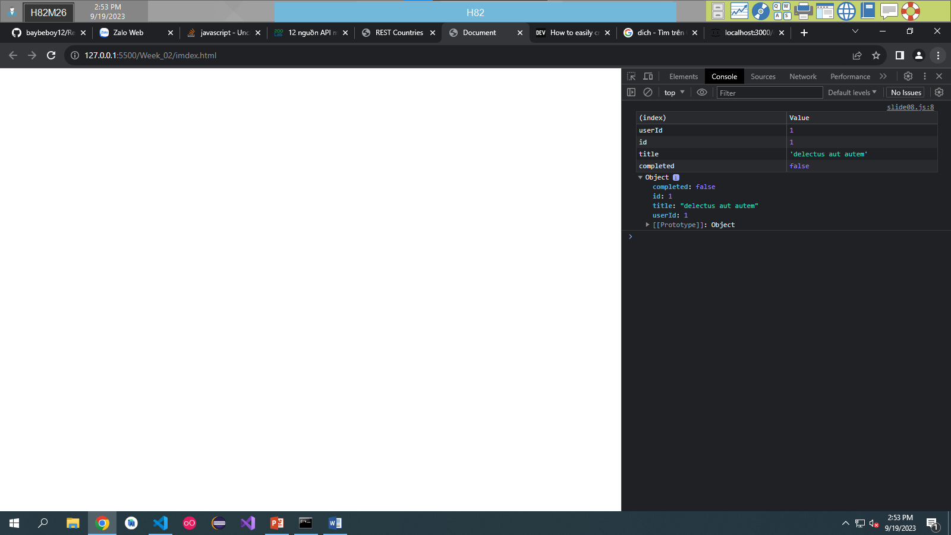

Slide 09:

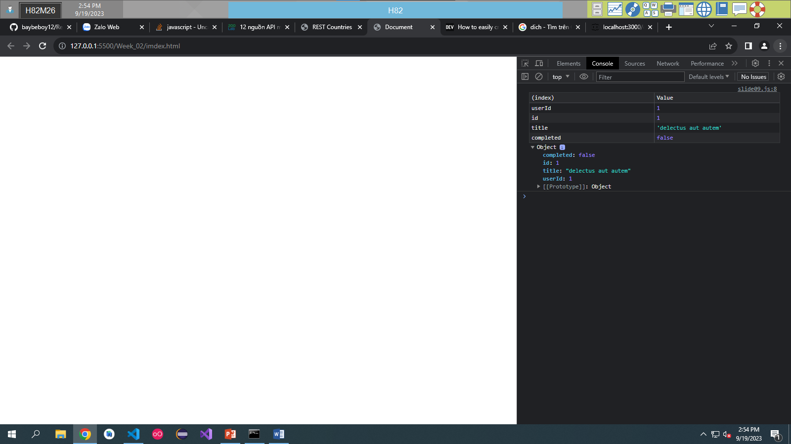

Slide 10:

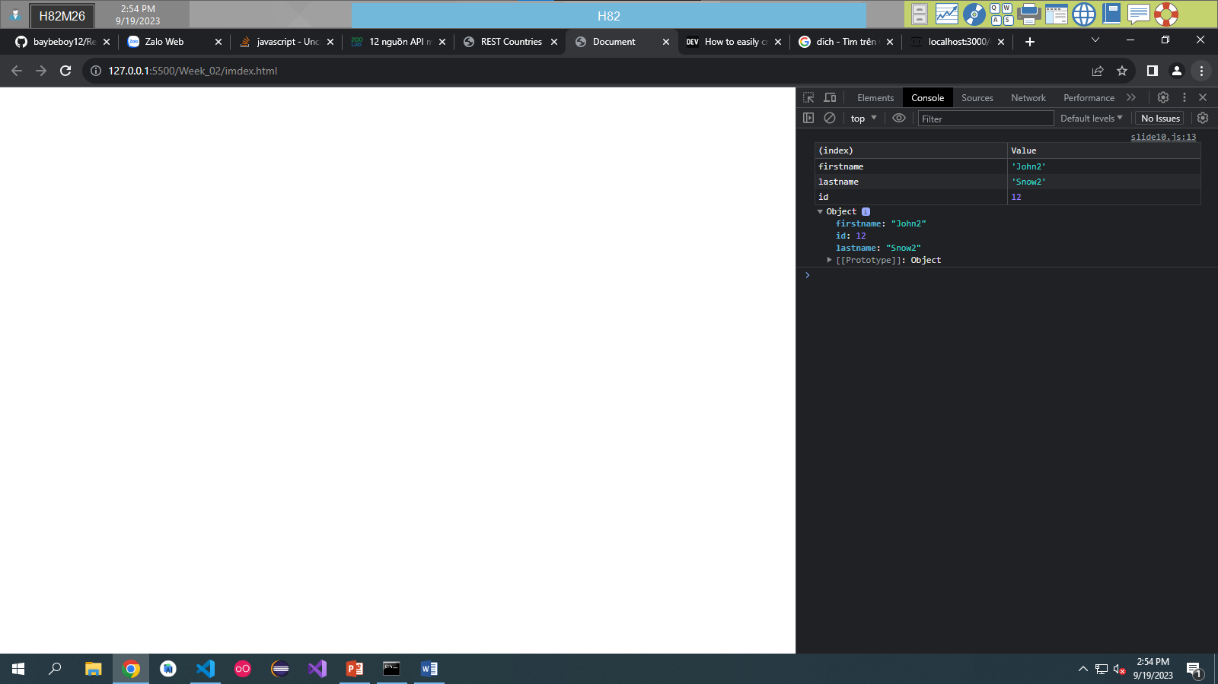

Slide 11:

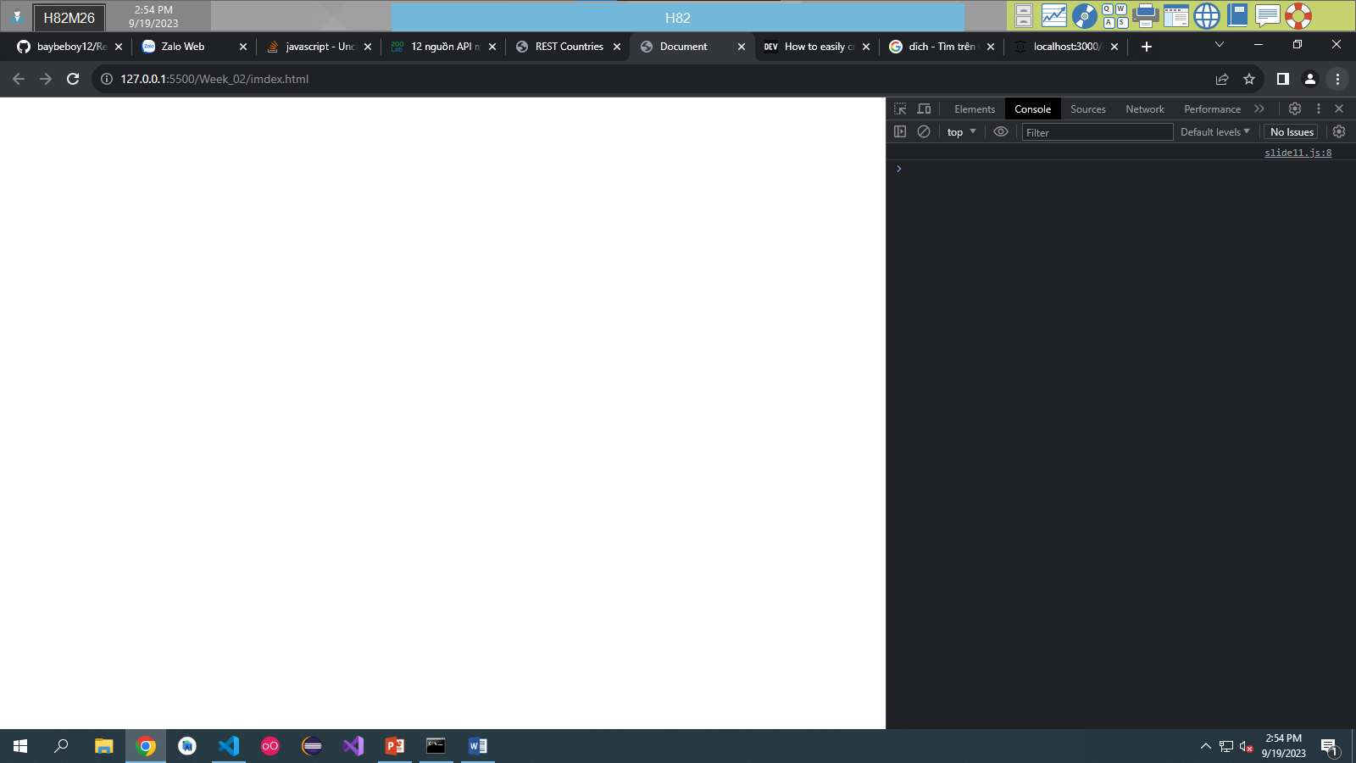

Promise

Slide 13-18:

Slide 19:

Slide 20:

slide 21:

