Implementation of an Open
World Recognition-capable
Network Intrusion Detection
System
Software Architecture Document

1. Introduction
[The introduction of the Software Architecture Document provides an overview of the entire Software Architecture Document. It includes the purpose, scope, definitions, acronyms, abbreviations, references, and overview of the Software Architecture Document.]
This Software Architecture Document describes how the project “Implementation of an Open World Recognition-capable Network Intrusion Detection System” (IOWR-NIDS) is implemented in structure and code. This document will show how each function of the IOWR-NIDS system interacts with the rest.
The scope of this document is the interface, data collection, and packet tagging parts of the implementation. This will not include the inner functions of the neural network within the implementation as that is within the scope of the research, not the implementation.
This document will use the following terms and abbreviations, more information and terms are available in the Glossary document included in the project files:
Interface – A implementation of Dash to display various metrics and outputs of the model.
Model – An implementation of the artificial neural network with unknown detection seen here.

2. Architectural Representation
[This section describes what software architecture is for the current system, and how it is represented. Of the Use-Case, Logical, Process, Deployment, and Implementation Views, it enumerates the views that are necessary, and for each view, explains what types of model elements it contains.]
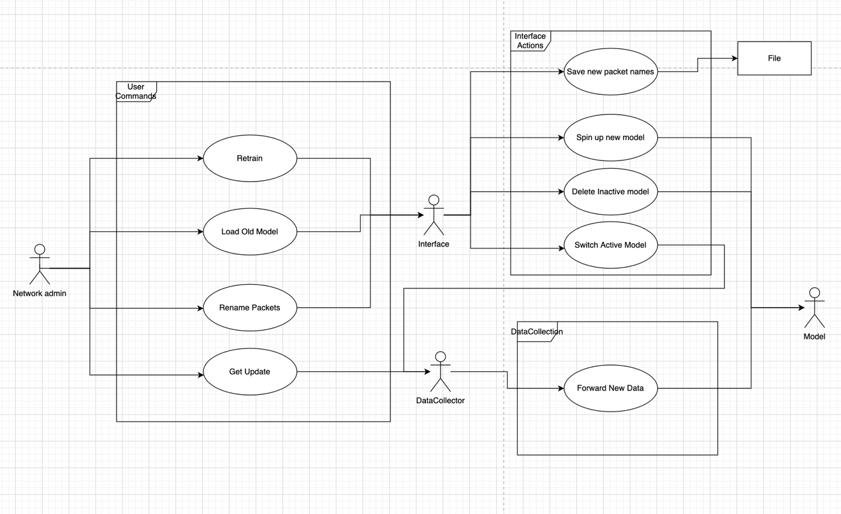
This is the use case view, it shows the network admin and the four base actions that they can take, Retrain, Load Old Model, Rename Packets, and Get Update.

3. Architectural Goals and Constraints
[This section describes the software requirements and objectives that have some significant impact on the architecture; for example, safety, security, privacy, use of an off-the-shelf product, portability, distribution, and reuse. It also captures the special constraints that may apply: design and implementation strategy, development tools, team structure, schedule, legacy code, and so on.]

4. Use-Case View
[This section lists use cases or scenarios from the use-case model if they represent some significant, central functionality of the final system, or if they have a large architectural coverage—they exercise many architectural elements or if they stress or illustrate a specific, delicate point of the architecture.]
Main use cases:
- Network Administrator wants to view the incoming packets.
- Network Administrator wants to get an update for the packets.
- Network Administrator wants to change out the model.

5. Logical View
[This section describes the architecturally significant parts of the design model, such as its decomposition into subsystems and packages. And for each significant package, its decomposition into classes and class utilities. You should introduce architecturally significant classes and describe their responsibilities, as well as a few very important relationships, operations, and attributes.]

5.1 Overview
[This subsection describes the overall decomposition of the design model in terms of its package hierarchy and layers.]

5.2 Architecturally Significant Design Packages
[For each significant package, include a subsection with its name, its brief description, and a diagram with all significant classes and packages contained within the package.
For each significant class in the package, include its name, brief description, and, optionally, a description of some of its major responsibilities, operations, and attributes.]

5.3 Use-Case Realizations
[This section illustrates how the software actually works by giving a few selected use-case (or scenario) realizations, and explains how the various design model elements contribute to their functionality.]

6. Process View
[This section describes the system's decomposition into lightweight processes (single threads of control) and heavyweight processes (groupings of lightweight processes). Organize the section by groups of processes that communicate or interact. Describe the main modes of communication between processes, such as message passing, interrupts, and rendezvous.]

7. Deployment View
[This section describes one or more physical network (hardware) configurations on which the software is deployed and run. It is a view of the Deployment Model. At a minimum for each configuration it should indicate the physical nodes (computers, CPUs) that execute the software and their interconnections (bus, LAN, point-to-point, and so on.) Also include a mapping of the processes of the Process View onto the physical nodes.]

8. Implementation View
[This section describes the overall structure of the implementation model, the decomposition of the software into layers and subsystems in the implementation model, and any architecturally significant components.]

8.1 Overview
[This subsection names and defines the various layers and their contents, the rules that govern the inclusion to a given layer, and the boundaries between layers. Include a component diagram that shows the relations between layers. ]

8.2 Layers
[For each layer, include a subsection with its name, an enumeration of the subsystems located in the layer, and a component diagram.]

9. Data View (optional)
[A description of the persistent data storage perspective of the system. This section is optional if there is little or no persistent data, or the translation between the Design Model and the Data Model is trivial.]

10. Size and Performance
[A description of the major dimensioning characteristics of the software that impact the architecture, as well as the target performance constraints.]

11. Quality
[A description of how the software architecture contributes to all capabilities (other than functionality) of the system: extensibility, reliability, portability, and so on. If these characteristics have special significance, such as safety, security or privacy implications, they must be clearly delineated.]

