International Economics

Homework 1 (CH1-CH5), due on Oct 15th

1) Historians of economic thought often describe ________ written by ________ and published in ________ as the first real exposition of an economic model.

A) "Of the Balance of Trade," David Hume, 1776

B) "Wealth of Nations," David Hume, 1758

C) "Wealth of Nations," Adam Smith, 1758

D) "Wealth of Nations," Adam Smith, 1776

E) "Of the Balance of Trade," David Hume, 1758

2) Cost-benefit analysis of international trade

A) is basically useless.

B) is empirically intractable.

C) focuses attention primarily on conflicts of interest within countries.

D) focuses attention on conflicts of interest between countries.

E) never leads to government intervention in international trade.

3) Approximately what percent of all world production of goods and services is exported to other countries?

A) 10%

B) 30%

C) 50%

D) 100%

E) 90%

4) Since the period following World War II (the early 1950s), the proportion of most countries' production being used in some other country

A) remained constant.

B) increased.

C) decreased.

D) fluctuated widely with no clear trend.

E) increased slightly before dropping off.

5) Trade between two countries can benefit both countries if

A) each country exports that good in which it has a comparative advantage.

B) each country enjoys superior terms of trade.

C) each country has a more elastic demand for the imported goods.

D) each country has a more elastic supply for the exported goods.

E) each country produces a wide range of goods for export.

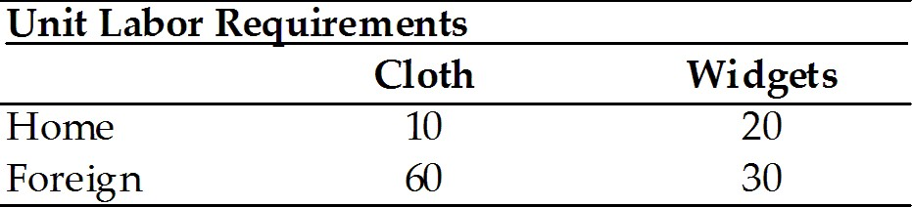

6) Given the information in the table above

A) neither country has a comparative advantage in cloth.

B) Home has a comparative advantage in cloth.

C) Foreign has a comparative advantage in cloth.

D) Home has a comparative advantage in both cloth and widgets.

E) neither country has a comparative advantage in widgets.

7) If a production possibilities frontier is bowed out (concave to the origin), then production occurs under conditions of

A) constant opportunity costs.

B) increasing opportunity costs.

C) decreasing opportunity costs.

D) infinite opportunity costs.

E) uncertain opportunity costs.

8) Which of the following has been confirmed by empirical tests of the Ricardian model?

A) All predictions of the model for a multi-product, multi-country world are highly unrealistic.

B) The existence of nontraded goods results in a high degree of specialization among countries.

C) International trade has no impact on income distribution.

D) The unimportance of economies of scale as a cause of trade.

E) Companies tend to export goods in which they have a relatively high level of productivity.

9) The Ricardian model of international trade demonstrates that trade can be mutually beneficial. Why, then, do governments restrict imports of some goods?

A) Trade can have substantial effects on a country's distribution of income.

B) The Ricardian model is often incorrect in its prediction that trade can be mutually beneficial.

C) Import restrictions are the result of trade wars between hostile countries.

D) Imports are only restricted when foreign-made goods do not meet domestic standards of quality.

E) Restrictions on imports are intended to benefit domestic consumers.

10) In the specific factors model, the effects of trade on welfare are ________ for mobile factors, ________ for fixed factors used to produce the exported good, and ________ for fixed factors used to produce the imported good.

A) positive; ambiguous; ambiguous

B) ambiguous; negative; positive

C) ambiguous; positive; negative

D) negative; ambiguous; ambiguous

E) positive; positive; positive

11) Those who will lose from free trade are ________ factors in sectors that produce goods that are ________.

A) immobile; also imported

B) mobile; also imported

C) immobile; exported

D) mobile; exported

E) mobile; untraded

12) In modern economies,

A) restrictions on international labor mobility are common.

B) labor is far more mobile internationally than capital.

C) restrictions on international labor mobility are rare.

D) labor is far more mobile internationally than it is intra-nationally.

E) outsourcing increases international labor mobility.

13) In the 2-factor, 2 good Heckscher-Ohlin model, an influx of workers from across the border would

A) move the point of production along the production possibility curve.

B) shift the production possibility curve outward, and increase the production of both goods.

C) shift the production possibility curve outward and decrease the production of the labor-intensive product.

D) shift the production possibility curve outward and decrease the production of the capital-intensive product.

E) shift the possibility curve outward and displace preexisting labor.

14) In the 2-factor, 2 good Heckscher-Ohlin model, trade will ________ the owners of a country's ________ factor and will ________ the good that uses that factor intensively.

A) benefit; abundant; export

B) harm; abundant; import

C) benefit; scarce; export

D) benefit; scarce; import

E) harm; scarce; export

15) The Leontief Paradox

A) proved that the U.S. economy is different from all others.

B) supported the validity of the Ricardian theory of comparative advantage.

C) supported the validity of the Heckscher-Ohlin model.

D) failed to support the validity of the Ricardian theory.

E) failed to support the validity of the Heckscher-Ohlin model.

16) An examination of the Ricardian model of comparative advantage yields the clear result that trade is (potentially) beneficial for each of the two trading partners since it allows for an expanded consumption choice for each. However, for the world as a whole the expansion of production of one product must involve a decrease in the availability of the other, so that it is not clear that trade is better for the world as a whole as compared to an initial situation of non-trade (but efficient production in each country). Are there in fact gains from trade for the world as a whole? Explain.

17) International trade leads to complete equalization of factor prices. Discuss.