|  |
| --- |
| Lewis university |
| WEEK 1 ASSIGNMENT |
| BY BENJAMIN A |
| **GITHUB URL: username-bayirifa** |
| **DATE** |
| **7/12/2022** |

|  |
| --- |
|  |

PART I

In this program I would be designing a database for my online business named “CloudMart”. The business would be virtual representation of a physical retail store with several items in their respective departments. The business would have 3 main stakeholders and they are 1) customers, 2) employees who will be working in the warehouse, 3) Suppliers.

The CloudMart would have a physical warehouse location however its services would be accessed online. The operation of the business would also involve collection several personal identifiable information (PIIs), in addition to credit card information from customers.

This CloudMart business is going to be similar the popular online market giant Amazon which had an annual revenue report of $469.822 billion (macrotrends, 2022) with over 1.6 million employees (Coppola, 2022).

PART II

Based on the size of the intended company, I would implement an n-tier development to give me flexibility and the ability to scale my resources at anytime. It will enable servers to interact with other applications hence I would introduce a middleware. However, if the company size increases and multiplies to several locations, I would build my own cloud based infrastructure and provide database as a service to the various company locations.

My n-tier archecture design

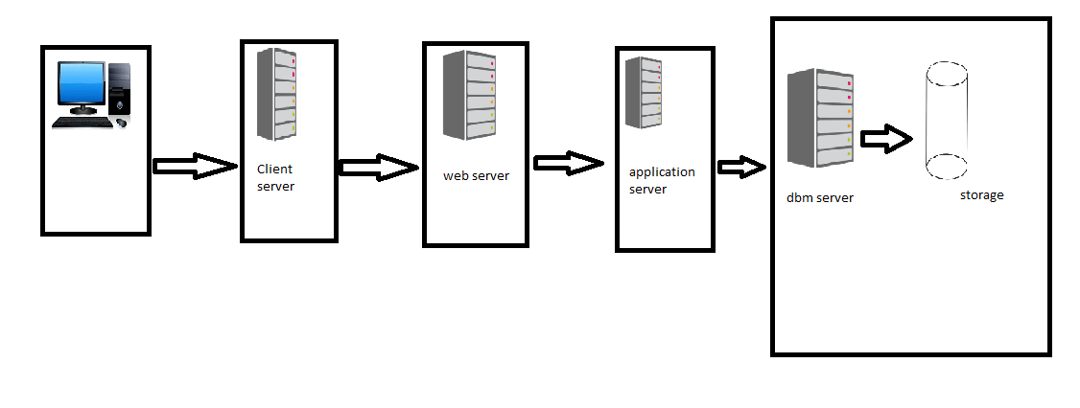

|  |  |
| --- | --- |
| CLIENT SERVER | It will handle shared resources for user interface |
| WEB SERVER | It will handle internet traffic and HTTP request |
| APPLICATION SERVER | IT will handle the processing business and logic |
| DATABASE SERVER | It will handle database access |

4) Types of data

* Order History
* Inventory History
* Customer Information (PII and credit card information)
* Employee information (PII)
* Delivery Truck Information

5. Assume that your business is more than 10 years old and needs to communicate with your new Cloud database setup. The file formats that represent the data are incompatible. Write your answers in your report.

* What kind of tool do you need?

Ans: You will need a data migration tool such as ETL for extract, transform and load (Phaujdar, 2021).

* What is the name of a current example of that tool? (You can google for examples)

Ans: There several examples of ETL which include Hevo data, which is an end –end pipeline which can be used for transforming data from one format to another (Phaujdar, 2021).

* Name three common file formats that computer systems use to transfer data between systems.

Ans: They are .csv (delimiter text file), Json, and xml.

# Reference

Coppola, D. (2022, February 14). *Number of Amazon.com employees 2007-2021.* Retrieved July 12, 2022, from statista: https://www.statista.com/statistics/234488/number-of-amazon-employees/#:~:text=In%202021%2C%20the%20American%20multinational,%2D%20and%20part%2Dtime%20employees.

macrotrends. (2022, April 1). *Amazon revenue 2010-2022.* Retrieved July 12, 2022, from macrotrends: https://www.macrotrends.net/stocks/charts/AMZN/amazon/revenue#:~:text=Amazon%20annual%20revenue%20for%202021,a%2020.45%25%20increase%20from%202018.

Phaujdar, A. (2021, September 21st). *11 Best Data Migration Tools for 2022*. Retrieved July 12, 2022, from Hevo: https://hevodata.com/learn/data-migration-tools/