The Doorman: Game Script

Character List:

|  |  |  |  |
| --- | --- | --- | --- |
| **Character** | **Location** | **Description** | **File** |
| Jim | All scenes | Playable character | None (POV) |
| Madame Feline | Lobby, Room | Hotel Guest | Char_MadamFeline.png |
| Chris | Lobby, Room | Hotel Guest | Char_Chris.png |
| Jason | Lobby, Room | Hotel Guest | Char_Jason.png |
| Coach | Lobby, Room | Hotel Guest | Char_Coach.png |
| Sir Edmond | Lobby, Room | Hotel Guest | Char_Edmond.png |
| Kim | Lobby, Room | Hotel Guest | Char_Kim.png |
| Colonel Ketchup | Lobby, Room | Hotel Guest | Char_Colonel.png |
| Hotel Manager | Jim’s Room, Lobby | Hire’s Jim, Overseer | None (unseen) |
| Police Officer | Jail, Floor, Room | Arrests Jim | None (unseen) |
| Pawn Shop Owner | Pawn Shop | Prices goods stolen | None (unseen) |

Location List:

|  |  |  |
| --- | --- | --- |
| **Name** | **Description** | **BG File(s)** |
| Jim’s Room | Start of game where Jim finds out he is hired. | Bg_Jimroom.jpg(?) |
| Hotel Lobby | The lobby of the hotel, where the main dialogue portion of the game takes place. | Bg_Lobby.jpg  Bg_LobbyBlur.jpg |
| Hotel Elevator | Scene where the player decides which floor to go to. | Bg_Elevator.jpg  Bg_Buttons.jpg |
| Hotel Floor Hallway | Scene where the player decides which room to go into. | Bg_Hall.jpg |
| Hotel Room | Scene where the player decides what hiding spot to investigate. | Bg_Room.jpg |
| Jail | Lose state scene. | Bg_Jail.jpg(?) |
| Pawn Shop | Win state scene. | Bg_Shop.jpg(?) |

Practical Screen List:

|  |  |  |
| --- | --- | --- |
| **Name** | **Description** | **BG File(s)** |
| Main Menu | Screen where the player can choose to hit play, options, credits, etc… | Bg_Menu.jpg(?) |
| Options | Screen where players can adjust the game options. | Bg_Options(?) |
| Difficulty Select | Screen where players can select the difficulty. | Bg_Difficulty(?) |
| Game Menu | Screen during gameplay, where players can quit the game, change options, etc… | Bg_GMenu(?) |
| Credits | Screen that displays the game’s credits. | Bg_Credits(?) |

Master flowchart:

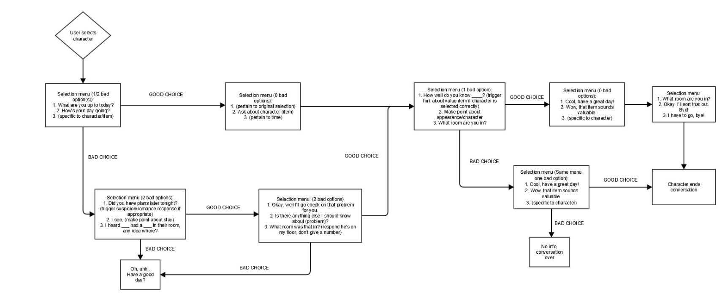Conversation Flowchart:

Scene Scripts:

* **Scene scripts.** Write a complete script for every scene in your game. Typically, a "scene" is everything that happens in a single location until the location changes. Each scene script should include:
  + Scene and location name.
  + List of all characters appearing in the scene.
  + Narration/dialog. Write down every line spoken by the narrator (if any) and by each character. Lines should be clearly labeled with the name of the character speaking. Your writing can be first-pass and rough at this point, but try to capture *all* of the narration and dialog essential to the game.
  + Changes/animation/sound cues. If the appearance of something changes during the course of your narrative (somebody enters or leaves a scene, a character moves, smiles or frowns, a door opens or closes, etc), note the change and when it should take place. Also explain when sound effects/music should be played or changed.
  + Menu/Dialog choices. If the player is presented with choice(s) during a scene, show what choices are available and how the scene will proceed after each choice is made.

Cut Scene Descriptions:

Jim’s Room:

* Jim wakes up when his cell phone rings. The person on the other end is the manager of Le Grand Mone, who has accepted Jim’s job offer to become a doorman, and tells him to come in the next day.
* Uses Bg_Jimroom and Item_Phone.
* Music_Intro will play throughout the scene.
* Sound_Phone will play as Item_Phone appears on the screen.
* Dialogue:

Manager: "*ring* *ring*"

Jim: "!!"

Jim: "He-Hello?"

Manager: "Hello there young lad!"

Jim: "Uh, who is this?"

Manager: "Hey, this is the employer, you know, the one from the Le Grand Mone?"

Jim: "Oh! Uh, that's great!"

Manager: "It is indeed chap, I'm here to say that you're hired for the doorman position you applied for!"

Jim: "Sweet! When do I start?"

Manager: "Tomorrow is a good time! Be in at 5 o'clock sharp!"

Jim: "Cool, I will see you then!"

Manager: "*click*"

Jim: "... He meant 5pm, right?"

Cityscape:

* Jim is taking in the view of the street/city leading up to Le Grand Mone, commenting how the whole things seems unreal to him.
* Uses Bg_City. This will “pan” across the screen at the beginning of the scene.
* Music_Intro will still be playing in this scene.
* Dialogue:

Jim: "Well here it is Le Grand Monè"

Jim: "Wow this place is beautifull"

Jim: "I never though that I would ever be able to set foot in a building like this!"

Jim: "And to think that I get to live here during the week now, this is so fortunate for me."

Pawn Shop:

* Jim has stolen the goods from people’s hotel rooms and has taken them to a pawn shop to sell for profit.
* Bg_Shop, Text_Win and the item image(s) of the item(s) stolen will appear.
* Text_Win will pop up on the screen after the shop owner’s dialogue.
* Sound_Win will play after the shop owner’s dialogue.
* Dialogue:

Owner: "That's a very nice item you have there, that is worth a fortune!"

Jim: "Nice!"

Jail:

* Jim has failed to steal goods and was caught, and is now in a jail cell, much to his despair.
* Bg_Jail and Text_Lose will appear.
* Text_Lose will appear after the officer’s dialogue.
* Sound_Lose will play after the officer’s dialogie.
* Dialogue:

Officer: "You're going to be in jail for a long time for what you've done kid."

Jim: "Drat."