Health Nutrition and Population Statistics using power-bi

Prepared by: Sedra Mohammad Abo-Househ-2300908140

Baylasan Saleh Al-Haj Saleh - 2300908090

Instructor: Dr. Najah Al-Shanableh

Date: December – 2025


Project goal :
The goal of this project is to develop an interactive Power BI dashboard to analyze Health, Nutrition and Population Statistics across four Arab countries: Saudi Arabia, Egypt, Tunisia, and Yemen. By use World Bank data over a five-year period, the report aims to transform raw indicators into meaningful insights through visualization and interactivity , particularly exploring the relationship between financial expenditure and healthcare outcomes.
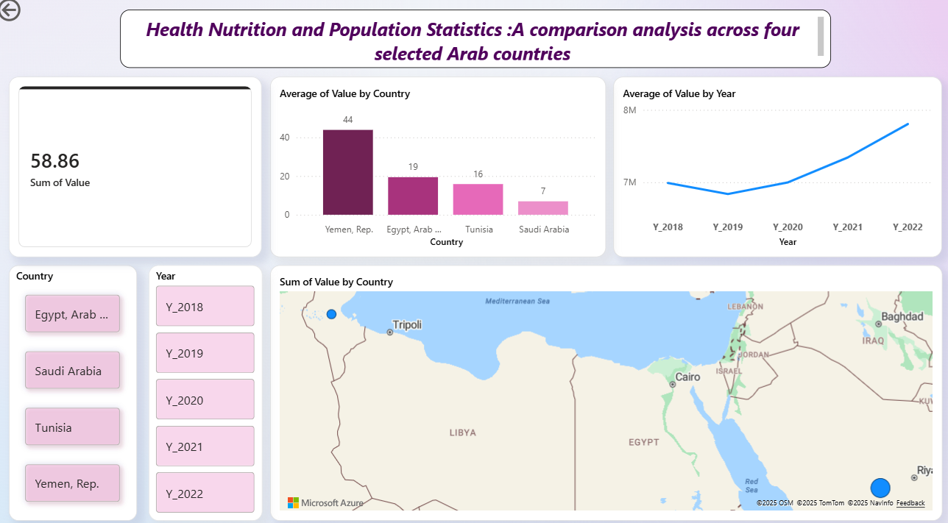
So this is our final dashboard page-1 & page-2

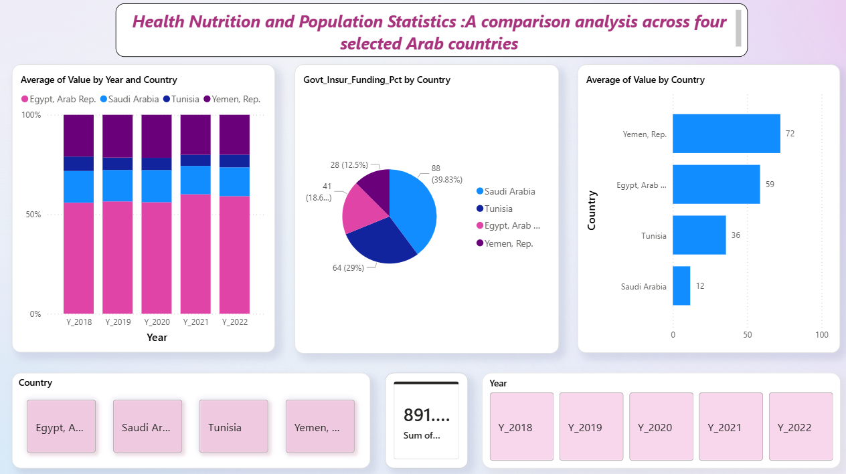

First : We download data from World Bank Open Data :
The data base we chose Health Nutrition and Population Statistics
A comparison analysis across four selected Arab countries :
Saudi Arabia, Egypt, Tunisia, and Yemen to highlight clear difference between these countries in the Health Nutrition and Population Statistics
Indicators:
- Life expectancy at birth, total (years)
- Mortality rate, under-5 (per 1,000 live births)
- Population, total
- Out-of-pocket expenditure (% of current health expenditure)
- Fertility rate, total
- Population growth(annual)
- Physicians (per 1,000 people)

Time (5 years): 2018,2019,2020,2021,2022
------------------------------------------------------------------------------------------------------------------
Data Preparation and Transformation (Power Query)
To ensure the dataset was ready and accurate for analysis, the following preprocessing steps we were performed:
- Data Cleaning: Removed empty rows (29 and 30) and handled missing values by replacing null (…) markers with gaps to maintain data integrity.
- Column Simplification: Dropped unnecessary columns like Series Code and Country Code because Series Name & Country Name were enough for better clarity.
- Renaming: Indicators were renamed to shorter, descriptive titles for better readability in charts.
- Data Restructuring (Unpivoting): We transformed the dataset from a wide format to a long format by unpivoting the year columns (2018–2022) , This process combination all years into a single “Year” column and their related values into a “Value” column, which is essential for creating active time-series visualizations and enabling the Year Slicer.

- Data Type Formatting: Set “Value” as a decimal number and “Year” as a full number to enable correct calculations and filtering.
- Filtering: Focused the dataset particularly on the four target countries: Saudi Arabia, Egypt, Tunisia, and Yemen.

Measures and Calculations
To make the data clearer, the following calculations were used:
- Total & Average Metrics: Created measures to show the Average of Value for health indicators to get accurate yearly results.
- Funding Percentages: Calculated percentages for Government Insurance Funding to compare support levels between countries.
- Out-of-Pocket Expenditure: Measured Out-of-Pocket Expenditure to show how much citizens pay directly for health.
- Temporal Comparisons: Used measures to link the Year Slicer with all charts for active updates.
---------------------------------------------------------------------------------------------------------
Dashboard Visualizations and Interactivity
We use two visualization pages in the dashboard and use different charts for them:
Page 1: Line Chart, Clustered Column Chart, Map Visualization, Card Visualization, Button Slicer

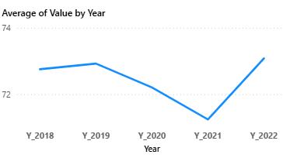
- Line Chart (Average of Value by Year):
What it represents: Changes in life expectancy
over the 5-year period.
Why we chose it: It is the best way
to show trends and patterns over time.

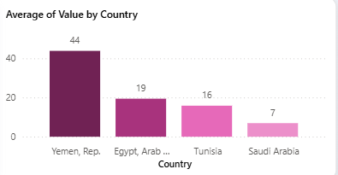
2.Clustered Column Chart (Average of Value by Country):
What it represents: This chart highlights
the differences in health outcomes,
Mortality rate, under - 5 (per 1,000 live births)
between the selected countries.
Why we chose it: It provides a clear ranking
and direct comparison between different countries.
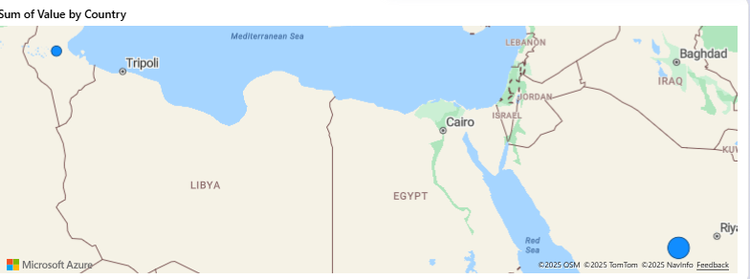

3. Map Visualization:
What it represents: The geographic
spread of health indicators across
the 4 Arap country.
Why we chose it: It helps to see partial patterns and identify performance based on location
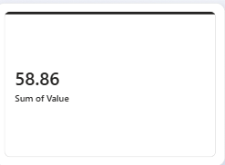
4. Card Visualization (Fertility Rate - Sum of Value):
What it represents: It shows the total Fertility
Rate (Sum of Value) for the selected countries and years.
Why we chose it: It is the best visual for highlighting a
single essential metric

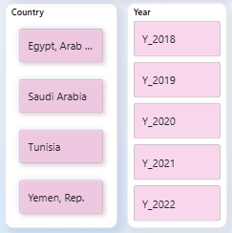
5.Button Slicer (Country & Year)
What it represents: This visual acts as an
interactive control group that allows users
to filter the entire dashboard by specific countries
(Egypt, Saudi Arabia, Tunisia, and Yemen)
and by the five selected years.
Why we chose it: We chose the Button Slicer format rather than a traditional dropdown to give the dashboard a modern
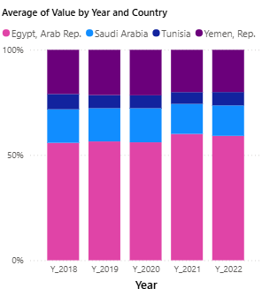
1. Stacked Column Chart (Average of Value by Year and Country)
What it represents: It shows the total health
expenditure across the five-year period,
with each column divided to show the
v of each country.
Why we chose it:
It allows us to see how the total financial spending is
distributed among the countries and how that total
changes year over year.

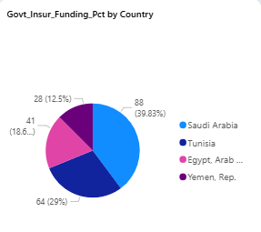
- Pie Chart
What it represents: It displays the percentage
distribution of government insurance funding
across the four selected countries.
Why we chose it: It is the perfect visual for
showing parts of a whole. Since this indicator
is a percentage (totaling 100%), the pie chart
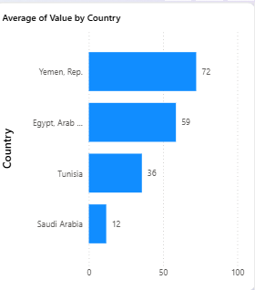
clearly highlights which country receives the
largest share of public health support.

3.Clustered Bar Chart (Average of Value by Country)
What it represents: It ranks countries based on
financial metrics, such as out-of-pocket costs or
average spending
values.
Why we chose it: We chose the horizontal bar format because it provides better readability for country names.

