Domains of scale in cumulative effects of energy sector development on boreal birds

Authors

Andrew D. Crosby,1 Lionel Leston,2 Erin M. Bayne,2 Péter Sólymos,3 C. Lisa Mahon,4 Judith D. Toms,5 Teegan D.S. Docherty,2 Samantha Song5

1Department of Biological Sciences, University of Alberta, Edmonton, Alberta Canada. email: [crosby@ualberta.ca](mailto:crosby@ualberta.ca)

2Department of Biological Sciences, University of Alberta, Edmonton, Alberta Canada

3Alberta Biodiversity Monitoring Institute, University of Alberta, Edmonton, Alberta Canada

4Environment and Climate Change Canada, Whitehorse, Yukon Canada

5Environment and Climate Change Canada, Edmonton, Alberta Canada

ORCID ID

Andrew D. Crosby: 0000-0002-9740-8453

Erin M. Bayne: 0000-0002-0679-4521

Lionel Leston: 0000-0001-7964-8421

Péter Sólymos: 0000-0001-7337-1740

C. Lisa Mahon: 0000-0003-0283-057X

Judith D. Toms: 0000-0002-8492-3384

Teegan D.S. Docherty: 0000-0002-7007-4115

Acknowledgements

This publication is a contribution of the Boreal Avian Modelling Project, and was funded through a Natural Sciences and Engineering Research Council of Canada Collaborative Research Development Grant (446660-12), and the Oil Sands Monitoring Program. Special thanks to H. Lankau. A. MacPhail, and the many field technicians and audio transcribers for collecting, processing, and managing data. The authors also thank B. Stevens for assistance with Bayesian Lasso implementation.

Abstract

*Context* Many forested areas of the globe are undergoing increased industrial development. At large spatial extents, this development creates multiple individual human footprint disturbances that can interact across space and time, resulting in cumulative effects on ecosystem patterns and processes. Effective regulation of industrial development requires understanding cumulative effects on biodiversity. However, species may exhibit scale-dependent responses to disturbance, leading to uncertainty in our understanding of cumulative effects.

*Objectives* We estimated cumulative effects of energy sector development on sixteen migratory passerine species at multiple spatial scales within the boreal region of Alberta, Canada. We used a hierarchical, multi-scale modelling approach to compare effects of human footprint across scales, and evaluate evidence for scale domains in species responses.

*Methods* We collected data on bird species occurrence from a large-scale, grid-based sampling design using autonomous recording units (ARU), and developed a hierarchical occupancy model that estimated effects of human footprint at multiple grid sizes while accounting for point-level habitat effects. We used Bayesian Lasso to estimate parameters and directly compare estimates across scales, and used Kruskall-Wallis and Wilcoxon tests to test for differences in grouped parameter estimates among species.

*Results* We found variable responses to human footprint among species, disturbance types, and spatial scales, but a consistent scale-dependent pattern showing the most variable responses occurring at the smallest scale, little effect at intermediate scales, and stronger, mainly positive effects on open habitat and generalist species at the largest scales. Model selection among additive, interactive, and total HF models followed the same pattern, with total human footprint models increasingly dominant at the largest scales. The Kruskall-Wallis and Wilcoxon tests showed significant differences in grouped parameter estimates among scales.

*Conclusions* We found evidence for domains of scale in bird species responses to energy sector development, reflecting local scale habitat selection and landscape scale distributional effects. Our analysis synthesizes theory and application to demonstrate scale-dependent effects of energy development on boreal birds, and provides a sampling and modelling framework for understanding effects of land-use change on biodiversity across multiple spatial scales. We show that limiting cumulative area of disturbance within a given management unit is the most likely path towards conserving avian biodiversity in this region. The sampling design and novel hierarchical model are widely applicable across taxa and study systems.

Keywords: anthropogenic disturbance, biodiversity, boreal conservation, bird habitat, human footprint, land use change, population change, scale dependence

Introduction

Many forested areas of the globe are undergoing increased industrial development, leading to changes in biodiversity and degradation of ecosystem services (Watson et al. 2018). Development can affect ecosystems through the disturbances they create individually and collectively. Natural resource development creates many small-scale disturbances, with localized impacts on ecosystem composition and structure that have been reasonably well studied (e.g., Pickell et al. 2015; Mahon et al. 2019). At larger scales, individual disturbance types can interact across space and time, resulting in a greater combined effect on ecosystem processes known as cumulative effects (Venier et al. 2021). Currently, our understanding of cumulative effects is far less clear than our basic knowledge about how individual disturbances influence biodiversity (Venier et al. 2021).

In the boreal region of North America, rapid expansion of resource extraction (e.g., forestry, mining, oil and gas) is creating novel landscape patterns well outside the historic range of variability (Pickell et al. 2015). These changes affect the amount and distribution of wildlife habitat, and can have profound effects on biodiversity (Venier et al. 2014). Effective regulation of development requires understanding how anthropogenic disturbance (hereafter, “human footprint” or “footprint”) affects biodiversity (Mahon and Pelech 2021). Many boreal bird species respond negatively to human footprint at local scales, leading to reductions in diversity and alteration of ecological functioning (Bayne et al. 2016; Mahon et al. 2019). However, footprint types can differ greatly in intensity and spatial extent (Mahon et al. 2019). For example, industrial sites have a large impact in the immediate area, but are limited to a relatively small area of the landscape. Seismic lines, on the other hand, are narrow linear features that have relatively low impact, but are ubiquitous and create vast amounts of edge habitat throughout the western boreal forest. Thus, there are two aspects of cumulative effects that must be considered: the combination of footprint types, and the accumulated area of human footprint across the landscape. Research has found evidence for effects of human footprint at single scales (Bayne et al. 2016; Mahon et al. 2019). However, little is known about how patterns of cumulative human footprint affect processes occurring at different spatial scales.

In ecology, spatial scale of sampling affects conclusions about species’ response to environmental conditions, and choice of appropriate scale is critical to answering ecological and management questions (Wiens 1989). Different processes may become dominant at different scales, sometimes leading to contradictory conclusions among studies of the same phenomena (Turner et al. 1989; Wiens 1989). Wiens (1989) formulated the concept of ‘domains of scale’, suggesting there may be regions of the scale spectrum over which ecological relationships remain consistent, separated by transition zones where relationships are highly variable and unpredictable. Bestelmeyer et al. (2003) linked scale domains to specific ecological processes governing species diversity, proposing habitat, landscape, and geographic domains corresponding to individual home range selection, landscape scale distribution, and geographic range, respectively. Thus, investigating the potential role of these domains is critical to understanding how human footprint affects wildlife populations and biodiversity.

In an ecological modeling framework, there are different ways to characterize scale-dependent effects of environmental variables (McGarigal et al. 2016). Many studies have tested effects of landscape variables at multiple scales around individual sampling points (multi-scale design, Fig. 1A, McGarigal et al. 2016). For example, Bayne et al. (2016) investigated how detection of bird responses to disturbance changed with sampling radius. Less-often, researchers have modeled species occupancy or abundance hierarchically by defining spatially nested subsets of observations (multi-level design, McGarigal et al. 2016), typically using different sets of variables at each level of the hierarchy (Fig. 1B, *sensu* Mordecai et al. 2011). In this multi-level design, the sampling extent at each level typically stays fixed, either at specific dimensions (e.g. block size) or ecological level (e.g. watershed), and the metric of interest is occupancy or abundance at each level. However, if the goal is to understand the cumulative effects of disturbances across large spatial extents, it is also important to understand how landscape extent influences model results and conclusions. Such inference requires a multi-level, multi-scale sampling design (e.g., Fig. 1C), where sampling extent at the second level or greater can also vary.

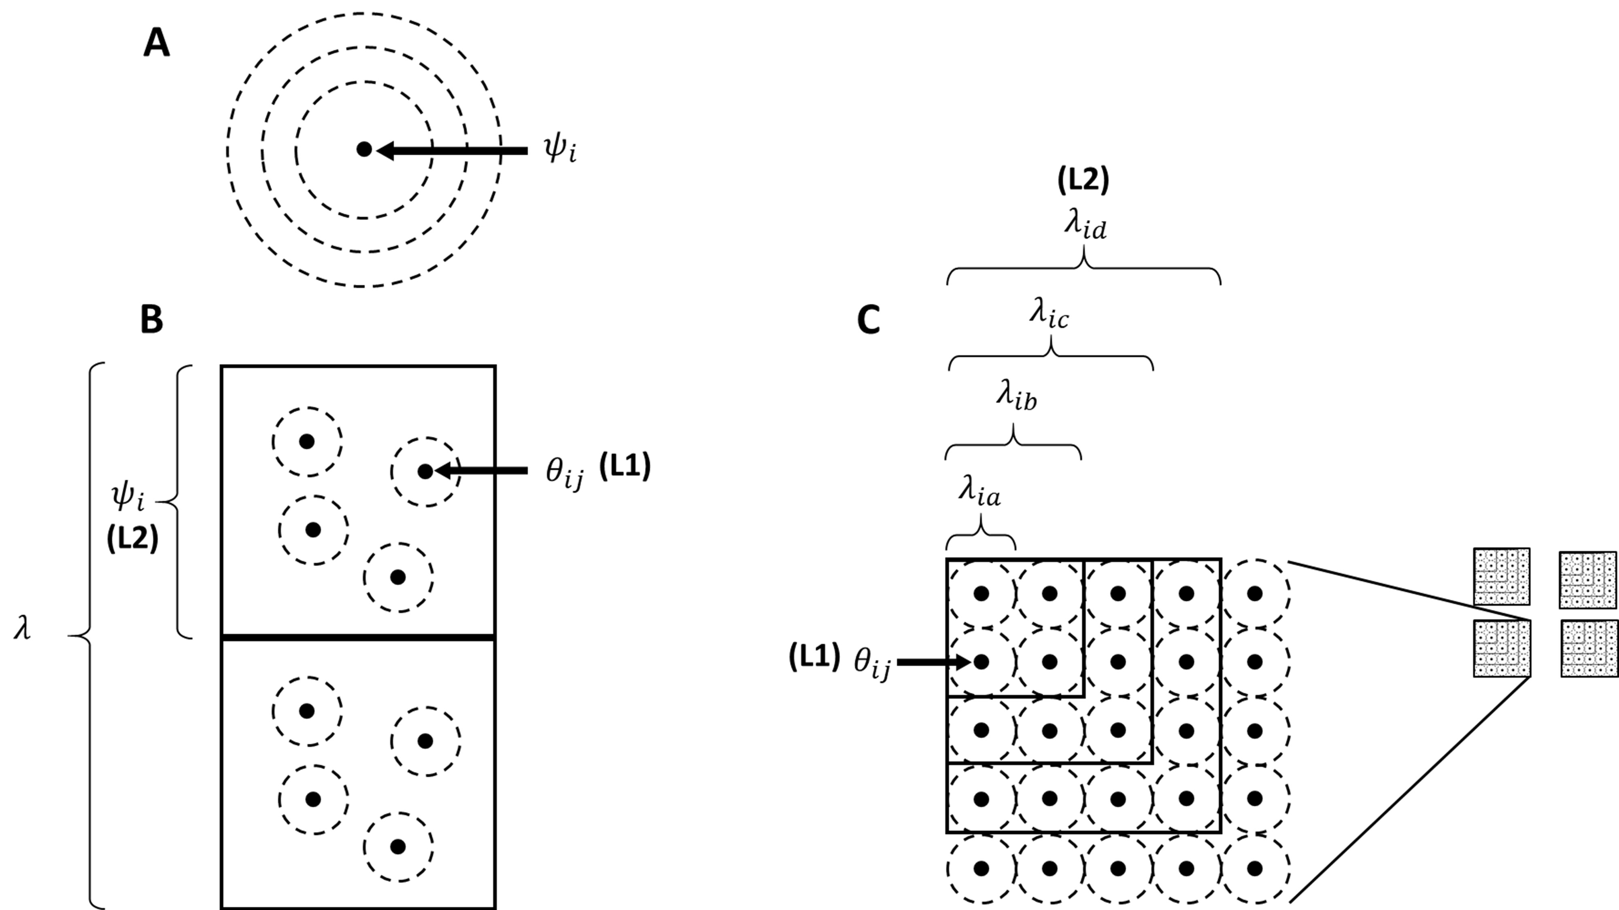

Figure 1. Three types of multiscale occupancy sampling designs, where $ψ$ refers to sample unit occupancy probability, $θ$ refers to subsample occupancy probability, and $λ$ refers to expected number of occupied sites or proportion of area occupied, and bold captions in parentheses refer to the organizational level of the study design: A) multiple radii around a sampling point, where inference is being made at the point (grain) and study area (extent) scales; B) multi-level hierarchical where points are subsamples within blocks (L1), blocks are samples within the study area extent (L1), and subsample grain and sample block extent remain constant; and C) multi-level, multi-scale hierarchical designs where subsample grain (L1) remains constant, and sample block extent (L2) changes.

Here, we employ a multi-level, multi-scale sampling design and modeling framework to quantify cumulative effects of human footprint on boreal songbird populations at different spatial scales in the western boreal region of Canada. Our objectives were to compare bird species responses to footprint among scales, and examine evidence for domains of scale in bird response to energy sector footprint. We considered three response types: A) a simple, direct effect of loss or alteration of native vegetation, regardless of footprint type (total area of habitat disturbed); B) independent direct effects among footprint types (additive effects); and C) interactive effects of different footprint types. We hypothesized that, if there are domains of scale in songbird responses to human footprint, we would see consistent scale-dependent patterns in responses among species. Although our application is specific to birds in the western boreal forest region of Canada, our unique sampling design and modeling framework is applicable to other regions and taxa.

Methods

Study Area

Our study area was the boreal forest region of northern Alberta, Canada, with most sampling locations occurring in the Mid-boreal Uplands ecoregion within the Athabasca Oil Sands region, and a small subset in the Boreal Transition, Western Alberta Upland, and Western Boreal ecoregions (Fig. 1, Ecological Stratification Working Group 1995). Throughout the region, dominant upland trees include trembling aspen (*Populus tremuloides*), balsam poplar (*Populus balsamifera*), white spruce (*Picea glauca*), and jack pine (*Pinus banksiana*). Black spruce (*Picea mariana*) and tamarack (*Larix lariciana*) occur in wet lowlands along with bogs, fens, and marshlands. The most common types of human footprint within our sampling units are associated with forest harvest. Energy sector activities in the study area frequently create disturbances such as seismic lines, pipelines, well-pads, industrial plants, power transmission lines and roads.

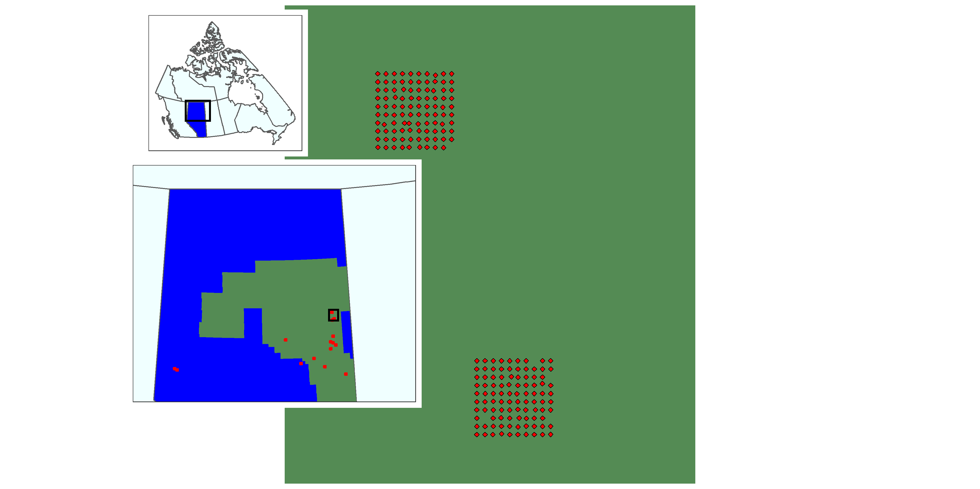

Figure 2. Study area showing the location of Oil Sands Region (green) in Alberta (blue),and the locations and arrengement of big grid sampling points (red).

Sampling design and data collection

We utilized data on bird species occurrence, habitat, and human footprint derived from a large-scale, grid-based sampling design (hereafter “big grids”). Each big grid consisted of a 10x10 grid of points spaced 600m apart, designed to assess ecological impacts of Steam Assisted Gravity Drainage (SAGD) facilities in Alberta’s Oil Sands region. Each SAGD site (hereafter “high footprint”) contains a central processing facility where extracted bitumen is pumped through pipelines from injection and extraction wells. The SAGD lease area around the facility (typically 50–100km2) contains unimproved roads, seismic lines, and exploration wells, and disturbance levels are higher than the surrounding landscape. Based on vegetation conditions at high footprint sites, we chose two additional grids: intermediate disturbance, and low disturbance. Intermediate disturbance grids were in areas where considerable energy exploration had taken place but no SAGD extraction had occurred. Low footprint grids were placed in areas of the study region where parks prevented bitumen development or a low probability of future energy development was expected. Our goal was to get a similar number of grids in each footprint category in landscapes dominated by upland vs lowland forest.

To collect data on bird species occurrence, autonomous recording units (ARU) were placed at each grid point (SM2, SM3, SM4+ by Wildlife Acoustics Ltd.). All sampling from a given grid was done in the same year, in 2014–2019. Each point was sampled for $≥$ four days. Technicians listened to recordings from each point, and noted all individually distinguishable birds and the time at which the individual was first heard. Recordings were filtered to remove those with excessive noise, and by selecting only those occurring between May 19 and July 11, and between 04:00 and 10:00 hours, as these are the main periods of breeding and singing activity for birds in northern Alberta (Charchuk and Bayne 2018). Most transcribed recordings were recorded near dawn (04:00–06:00). Although we tried to select four surveys from different days, if poor weather conditions limited choice, we selected additional times from the same day. Our final dataset consisted of detection/non-detection data for all bird species heard within the first three minutes of a recording, at all points where $≥$ two recordings were available from the same year.

We summarized vegetation and human footprint at each point using data from the Alberta Biodiversity Monitoring Institute (ABMI; <https://abmi.ca/home.html>). ABMI uses data derived from the Alberta Vegetation Inventory, and year-specific anthropogenic disturbances derived from a combination of inventory data and SPOT 6 satellite imagery interpretation, along with non-forest vegetation data to create wall-to-wall vegetation and human footprint maps for the province. Our data consisted of area covered by each of seven upland and lowland forest types, six non-forested wetland types, four non-forested upland types, and twenty-seven human footprint types (Appendix A; Tables A1 and A2) within a 150m circular buffer surrounding each point and a 36ha (600m x 600m) cell centered on each point. Forest types were further separated into ten age classes (0–9, 10–19, 20–39, 40–59, 60–79, 80–99, 100–119, 120–139, 140–159, and 160+ years old). Upland forest stands (Deciduous, Mixedwood, Pine, and White Spruce) harvested within the past 59 years were designated as distinct from unharvested stands, and were separated into age classes of 0–9, 10–19, 20–39, and 40–59. (Appendix A; Table A1). We aggregated vegetation data into proportion of area covered by each of 6 forest types, non-forested uplands, and non-forested wetlands (Appendix A; Table A1). We aggregated human footprint into proportion of area covered by four classes: seismic lines; wide linear disturbances (e.g., roads, power lines, pipelines); well sites; and industrial [Appendix A; Table A2, *sensu* Mahon et al. (2019)]. We summarized human footprint at larger spatial extents with a moving window over the grids at sizes of 2x2, 3x3, 4x4, and 5x5 grid cells, where each grid cell contained a single sampling point. To generate equal sample sizes among scales, we randomly selected 300 samples at each extent, including the 1x1 extent. For our purposes, point-level refers to a grid point where birds were sampled, and the 150m radius around the point from which habitat variables were derived, and block-level refers to points (and cells) aggregated within the different window sizes, where there are five block sizes (1x1–5x5), and a 1x1 block is a 36ha cell containing a single grid point.

Multi-level hierarchical occupancy model

We modeled the relationship between bird species occupancy and human footprint using a hierarchically structured occupancy model. This model explicitly separated the proportion of area occupied at the block-level as a function of human footprint, from point-level occupancy probability within the block as a function of local habitat conditions. Because sample unit size has a direct effect on occupancy probability, making it impossible to compare effects across scales, we developed a model that conditioned sub-sample occupancy on block-level occupancy rate: the probability that a given point within the block is occupied as a function of block-level variables. At the first level of the model, we calculated proportion of area occupied $δ$ in block *i* as the probability that the species occurred at any point sampled within the block, such that $logit\left(ψ_{i}\right)=∑β_{block}X_{i},$ and $δ_{i}=1-{\left(1-ψ_{i}\right)}^{n_{scale}},$ where $ψ_{i}$ is the block-level occupancy probability, $β_{block}X_{i}$ is the vector of block-level coefficients and human footprint covariates *X* in block *i*, respectively (including the intercept),and $n_{scale}$ is the number of sample points in each block at a given scale. Thus, the occupancy rate $δ_{i}$ is derived from block-level occupancy probability, and is the variable upon which point-level occupancy probability is conditioned, such that for each point *j* in block *i*, $z_{block_{ij}}∼Bernoulli\left(δ_{i}\right)$, where $z_{block_{ij}}$ is the point-level occupancy indicator (0 or 1) as a random realization of block-level occupancy rate.

At the point level, we modeled occupancy probability as a function of dominant habitat and mean area-weighted forest age within 150m of the point, independent of block-level human footprint, such that

$$logit\left(θ_{ij}\right)=∑β_{point}X_{ij},$$

where $θ_{ij}$ is the point-level occupancy probability, and $β_{point}X_{ij}$ is the vector of point-level coefficients $β_{point}$ and habitat covariates *X* at point *j* in block *i*. Thus, $z_{point_{ij}}∼Bernoulli\left(θ_{ij}z_{block_{ij}}\right)$. To reduce the influence of points in a mixture of habitats, we weighted observations according to the proportion of area covered by the dominant habitat type, where weight = 1 for proportions ≥ 0.75, linearly decreasing between 0.75 and 0.25, and 0 for <0.25 proportions (Sólymos et al. 2020).

We accounted for detection probability in our data using temporal subsamples at each point, such that the probability of detection *p* at point *ij* during subsample *k* was

$$logit\left(p_{ijk}\right)=\sum_{k=1}^{K}{β_{point}X_{ijk}},$$

where $β_{point}$ is the vector of coefficients on detection probability, and $X_{ijk}$ is the vector of detectability covariates during survey *ijk*. We modeled detectability for all species as a function of Julian day and its quadratic, and time since sunrise.

We fit three models at each scale: one using additive effects of all human footprint types, one containing interactive effects between all pairwise human footprint variables, and one using total human footprint as the only predictor. We fit each model at each scale using Bayesian Lasso (*sensu* Gerber et al. 2015; Stevens and Conway 2019) optimized for posterior predictive accuracy. Bayesian Lasso is a statistical regularization technique that identifies the prior distribution that results in optimal posterior predictive scores (Hooten and Hobbs 2015). We implemented the Lasso procedure by using a Laplace prior (Gerber et al. 2015) on all non-intercept variables in the block-level portion of the model, specifying fifty candidate values of prior variance ranging from 0.1 (wide, uninformative priors) to 5 (essentially forcing all coefficients to near zero) on the log scale (Stevens and Conway 2019). We used Watanabe-Akaike Information Criterion (WAIC, Watanabe 2010) as our estimate of posterior predictive accuracy to determine optimal prior variance for each version of the model. The advantage of Bayesian Lasso is that it does not require prior variable elimination (as in discrete model selection procedures), enabling us to compare the same models across scales while eliminating uninformative variables (Hooten and Hobbs 2015). See Appendix B for model code and details of Bayesian Lasso implementation.

Comparison among scales

To understand how human footprint effects on occupancy rates differ among species and scales, we compared parameter estimates for individual human footprint types (additive effects model), interactive effects, and total human footprint among species and across scales. Based on Bayesian Lasso results, we considered there to be strong evidence that a variable had no effect if the 20% Bayesian Credible Interval (CRI) contained 0, weak evidence for an effect (i.e. high uncertainty) if the 95% CRI contained 0 but the 20% CRI did not, and strong evidence for an effect if the 95% CRI did not contain 0. To determine which model type (additive, interactive, or total) was best at each scale (i.e. highest posterior predictive accuracy), we compared models using pseudo Bayesian Model Averaging weights (pBMA, Höge et al. 2020).

To meet our second objective, we investigated evidence for domains of scale in two ways. As there is yet no formal, quantitative method to assess scale domains (Wheatley 2010), we first visually compared plots of scale-specific parameter estimates and model comparisons to look for consistent patterns among plots. Second, we compared parameter estimates for all independent parameters (additive and total models) and species among scales using the nonparametric Kruskal-Wallace test to look for evidence of overall differences among scales, and applied the pairwise Wilcoxon Rank Sum test with the Benjamini-Hochberg correction for multiple comparisons to test for pairwise differences in group means (*sensu* Wheatley 2010).

We fit models for 16 species of songbirds, choosing 2–4 representative species of 5 different habitat associations: species associated with upland coniferous forests, deciduous forests, open lands, or black spruce; and habitat generalists. We fit models with the JAGS (Plummer 2003) and R (R Core Development Team 2017) programs using the jagsUI R package (Kellner 2015), with three chains of 50,000 iterations each, a burn-in of 40,000, and a thinning rate of 2. All non-footprint parameters were given uninformative priors, where $β_{i}∼Normal\left(μ=0,τ=0.1\right)$. We used the loo package in R (Vehtari et al. 2020) to calculate WAIC scores and pBMA weights, and applied Bayesian bootstrap to the pBMA calculation.

Results

There were 15 big grids, with bird and habitat data from 1,467 individual points. ARU failure was the reason we lacked data at 33 locations. The moving windows yielded 1,215, 960, 735, and 540 blocks available for sampling in the 2x2, 3x3, 4x4, and 5x5 window sizes, respectively. The probability of a sample containing human footprint was high, being 0.95 at the 1x1 scale and 1 for all other scales (Table 1). The most widely distributed footprint type was seismic lines, occurring in 98% of samples at the 2x2 scale and all samples at larger scales, while industry was the least widely distributed HF type (Table 1).

Median proportion of area in different HF types, when present in a sample, was consistent across scales for seismic, wide linear, and wells, but decreased with increasing scale for industrial disturbance (Fig. 2). For seismic, wide linear and total HF, interquartile range and range of outliers decreased as scale increased, while for wells and industrial disturbance, interquartile range increased with increasing scale (Fig. 2).

Table 1: Probability of a sample containing each type of human footprint, and median and interquartile ranges of area (ha) within sample units, across spatial scales. Each scale represents a square grid of 36ha cells. The column ‘Any human footprint’ refers to the probability that ≥ 1 of the 4 human footprint types occurs in the cell.

|  | HF type | | | | |
| --- | --- | --- | --- | --- | --- |
| Scale | Seismic | Wide linear | Wells | Industry | Any human footprint |
| 1x1 | 0.858 | 0.658 | 0.545 | 0.241 | 0.948 |
| (36ha) | 0.42 (0.134, 0.972) | 0.229 (0, 2.11) | 0.278 (0, 1.142) | 0 (0, 0) | 2.044 (0.634, 5.012) |
| 2x2 | 0.98 | 0.875 | 0.717 | 0.405 | 0.998 |
| (144ha) | 0.906 (0.436, 1.825) | 1.494 (0.182, 4.154) | 0.83 (0, 2.372) | 0 (0, 0.958) | 4.898 (1.567, 10.242) |
| 3x3 | 0.999 | 0.948 | 0.797 | 0.541 | 1 |
| (324ha) | 1.451 (0.804, 2.827) | 3.264 (0.564, 6.353) | 1.451 (0.267, 4.169) | 0.116 (0, 2.231) | 8.648 (2.549, 16.423) |
| 4x4 | 1 | 0.978 | 0.849 | 0.641 | 1 |
| (576ha) | 2.024 (1.22, 3.605) | 4.724 (1.198, 8.193) | 2.065 (0.327, 5.865) | 0.4 (0, 4.533) | 11.451 (3.995, 26.369) |
| 5x5 | 1 | 0.993 | 0.885 | 0.696 | 1 |
| (900ha) | 2.593 (1.545, 4.539) | 6.013 (2.008, 10.274) | 2.609 (0.325, 8.795) | 0.617 (0, 5.855) | 14.829 (5.85, 35.196) |

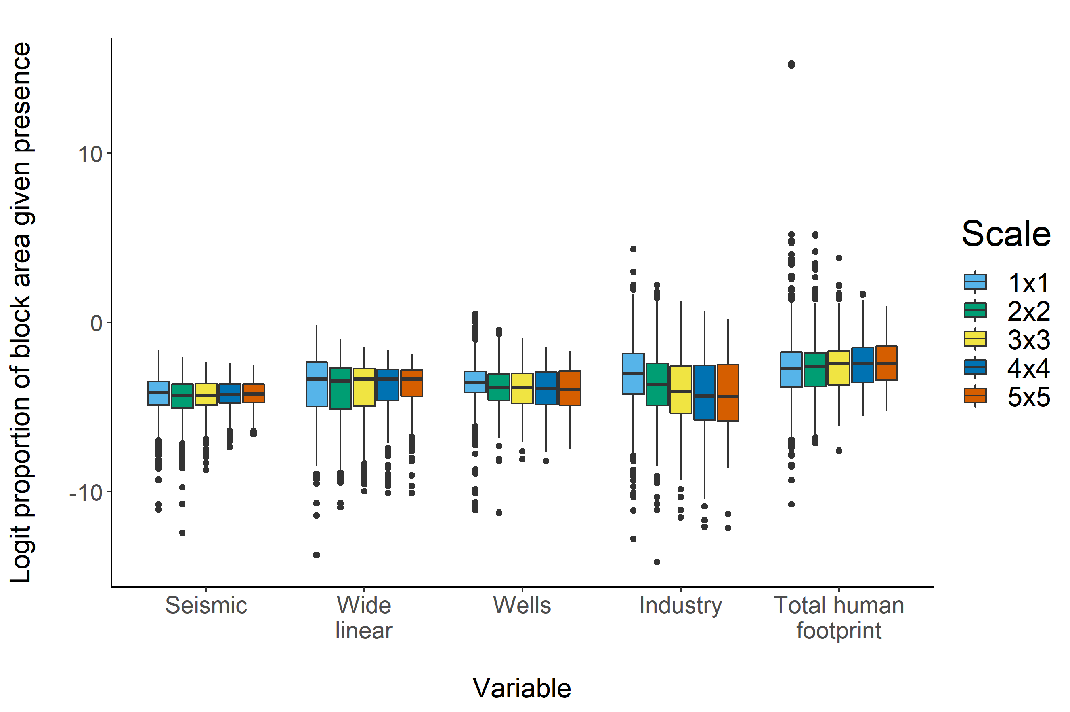

Figure 3. Logit proportion of area covered by individual human footprint types, conditional on the presence of that human footprint type, and total human footprint conditional on the presence of any human footprint, at five spatial scales in the boreal forest region of Alberta, Canada. Scales represent square grids of points, where points are 600m apart.

There was a mix of positive and negative responses across species and scales to total footprint and individual footprint types (Fig. 3). The strongest negative effects of total footprint occurred at the 1x1 scale, while the strongest positive effects were at the 4x4 and 5x5 scales (Fig. 3C). In our additive effects models, seismic lines had the weakest effects, while industry had the strongest (Fig. 3A). All model types (total, additive, and interactive) showed the weakest effects at 2x2 and 3x3 scales (Figs. 3, A–C). Industrial development had the strongest overall effect on species occupancy rates, especially at the 1x1 and 5x5 scales (Fig. 3C).

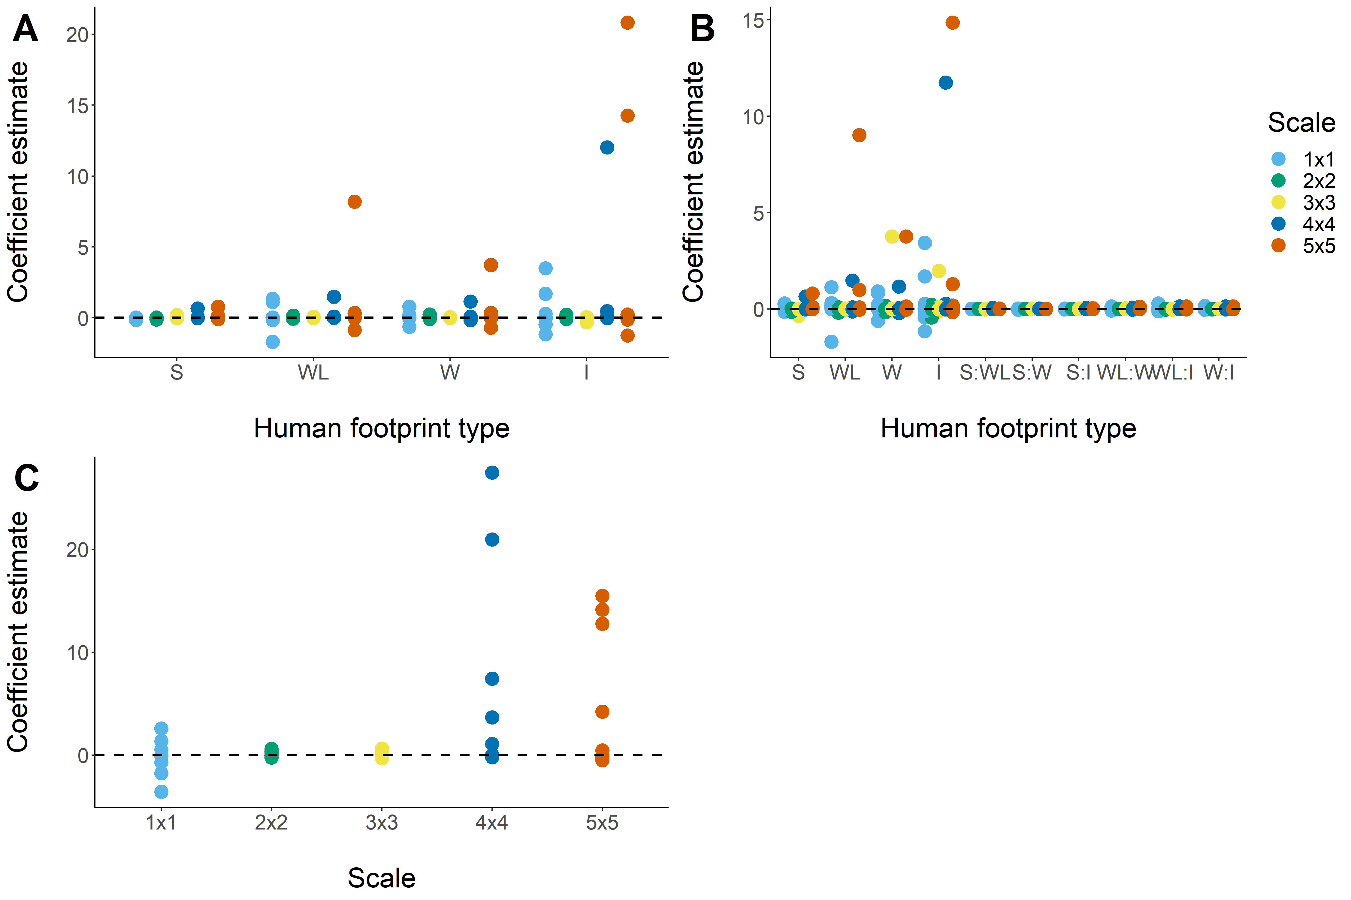

Figure 4. Coefficient estimates for effect of human footprint variables on occupancy rates among sixteen bird species at five spatial scales in the Boreal forest region of Alberta, Canada. Scales represent square grids of points, where points are 600m apart. Plots represent: (A) independent effects of individual disturbance types; (B) interactive effects of individual disturbance types; (C) total human footprint. S = seismic lines; WL - wide linear; W = well pads; I = industrial development.

Model comparison across species and scales showed even representation among model types at small scales (1x1 and 2x2), and total human footprint models becoming dominant at the largest scales (4x4 and 5x5) (Fig. 5). There was a strong negative relationship between spatial scale and model selection uncertainty, with best models for 12 of 16 species having < 50% of model weight at the 1x1 scale, and 15 of 16 having > 90% of model weight at the 5x5 scale (Table 3). We found few strong relationships between footprint variables and occupancy rates at any scale. The most consistent variable was total footprint at the two largest scales. We found one case where the effect of a variable changed between scales (Swainson’s Thrush, Table 3).

We found evidence for domains of scale in our visual inspections of plots and non-parametric tests of parameter estimates among scales. Visual inspection showed clear, consistent patterns among plots in distributions of parameter estimates among species and across scales. Specifically, we saw the strongest relationships at the 4x4 and 5x5 scales, marginally strong relationships at the 1x1 scale, and all relationships near zero at the 2x2 and 3x3 scales, across all model types (Fig. 3, A–D). Our non-parametric tests found evidence for statistically significant differences among scales in parameter estimates (Kruskal-Wallace: $χ^{2}=22.2,df=4,p<0.001$). The Wilcoxon test showed mean parameter estimates were not different among scales 1x1–3x3, and among scales 4x4–5x5 but that these two groups were significantly different from each other ($p<0.05$). Pairing these two sets of results suggests domains of scale at 1x1 and 4x4–5x5, with 2x2–3x3 acting as a transition zone.

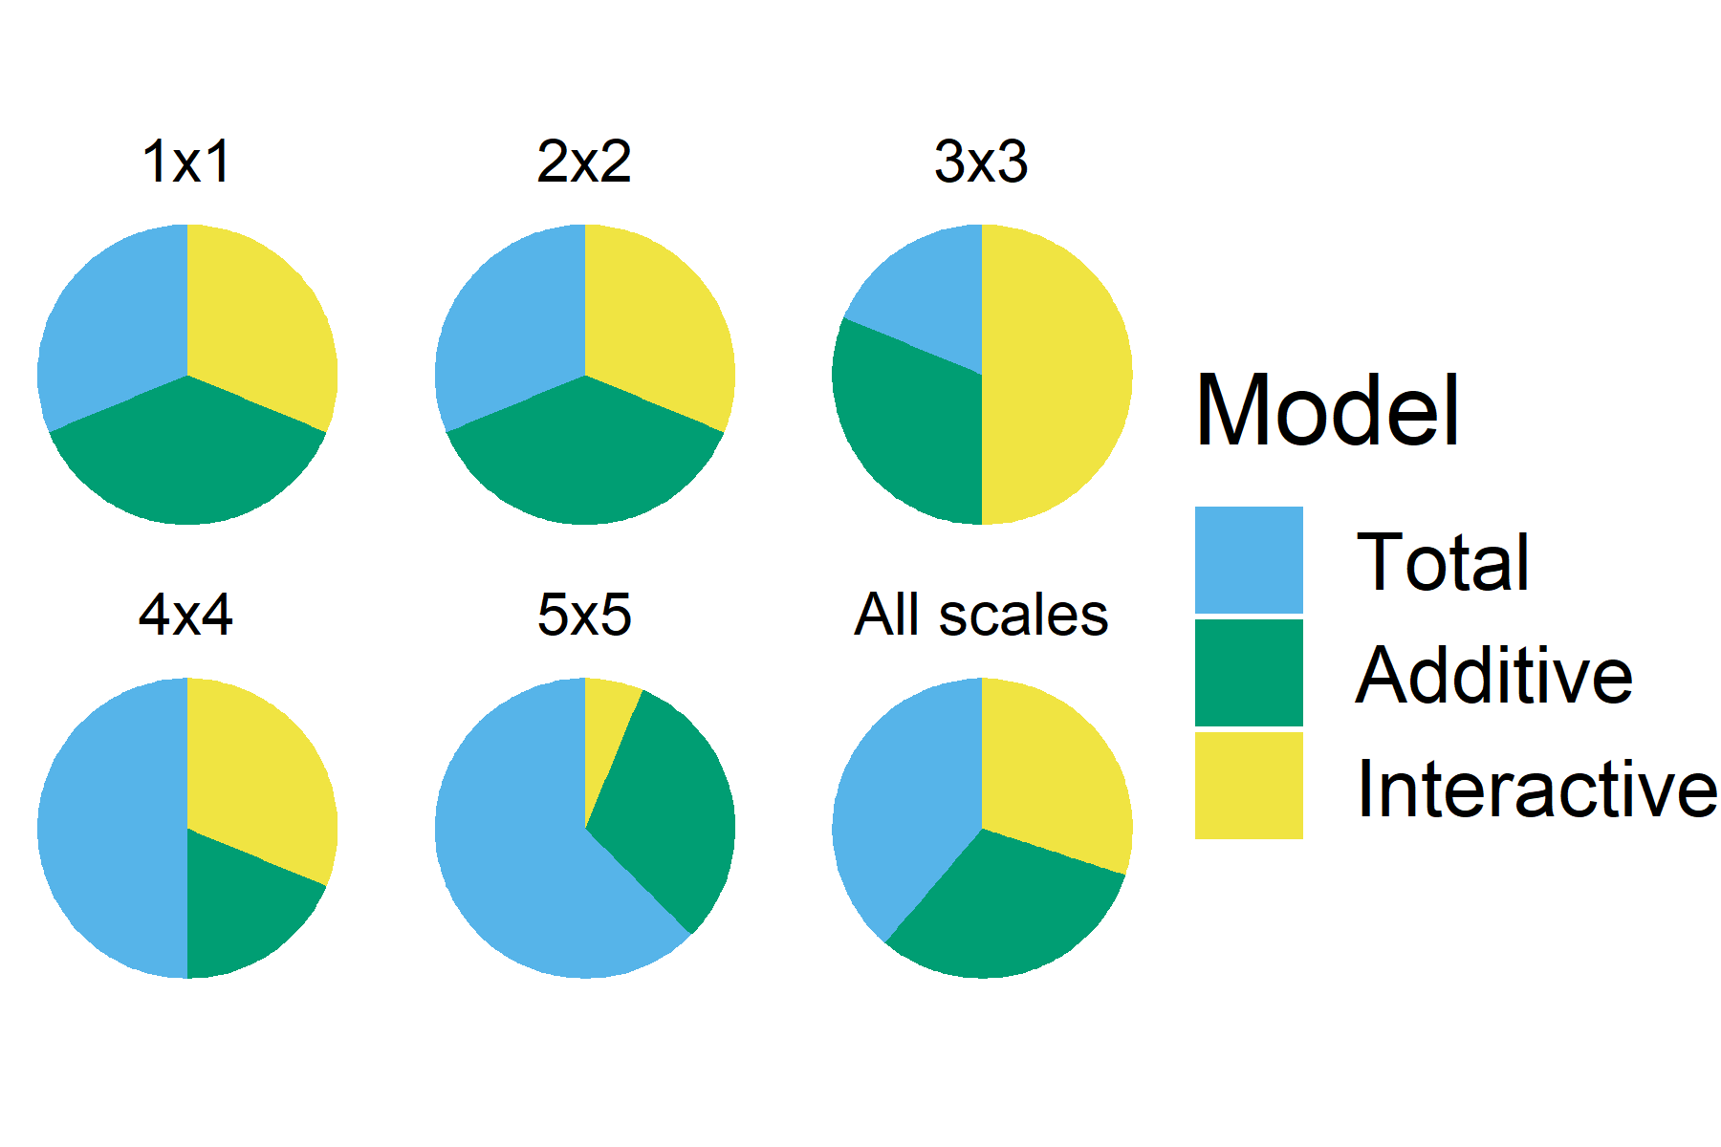

Figure 5. Proportion of species for which each model type received the highest model weight among twelve bird species at five spatial scales. Models estimated the cumulative effect of anthropogenic disturbance (human footprint) on occupancy rate. Total = all footprint types combined; Additive = independent effects of footprint types; Interactive = all pairwise interactions of footprint types. Human footprint types were: seismic lines; wide linear disturbances (e.g., roads, powerlines); well pads; and industrial development. Model weights were calculated as pseudo Bayesian Model Averaging weights.

Table 2: Scale-dependent best models based on pseudo Bayesian Model Averaging weights (in parentheses), and strongest explanatory variables (below), for sixteen passerine species, sorted by habitat association. Under ‘Habitat’: CO = upland conifer; DE = deciduous; GE = generalist; OP = open lands; BS = black spruce. For explanatory variables: S = seismic lines; WL = wide linear; W = wells; I = industrial; and T = total. A ‘+’ or ‘–’ following the variable indicates weak support (single) or strong support (double) for a positive or negative relationship, respectively. No variables associated with a model indicates none of the variables had a 20% Bayesian Credible Interval (CI) that did not include 0. Strong support indicates the 95% CI for that variable did not include 0.

|  | | Scale | | | | |
| --- | --- | --- | --- | --- | --- | --- |
| Species | Habitat | 1x1 | 2x2 | 3x3 | 4x4 | 5x5 |
| Swainson's Thrush | CO | Total (0.7) | Additive (0.95) | Interactive (0.96) | Interactive (0.99) | Total (1) |
|  |  | T(-) |  |  |  | T(+) |
| Tennessee Warbler | CO | Additive (0.35) | Additive (0.7) | Total (1) | Interactive (0.96) | Interactive (0.93) |
|  |  |  |  | T(+) |  | I(+) |
| Blue-headed Vireo | CO | Total (0.39) | Additive (0.84) | Interactive (1) | Total (1) | Additive (1) |
|  |  | T(-) |  |  |  |  |
| Ovenbird | DE | Total (0.39) | Total (0.87) | Interactive (0.7) | Interactive (1) | Total (1) |
|  |  |  | T(+) |  |  | T(+) |
| Mourning Warbler | DE | Interactive (0.36) | Additive (0.73) | Total (0.71) | Total (1) | Total (1) |
|  |  |  | W(+), I(+) |  | T(+) | T(++) |
| Rose-breasted Grosbeak | DE | Interactive (0.36) | Additive (0.4) | Interactive (0.97) | Total (0.54) | Total (1) |
|  |  |  |  |  | T(-) | T(-) |
| Connecticut Warbler | DE | Total (0.88) | Interactive (0.68) | Additive (1) | Total (1) | Additive (0.45) |
|  |  | T(--) | WL(-) |  |  |  |
| Yellow-rumped Warbler | GE | Interactive (0.35) | Total (0.37) | Total (0.85) | Total (0.78) | Additive (0.92) |
|  |  |  |  |  |  |  |
| Magnolia Warbler | GE | Additive (0.35) | Interactive (0.52) | Interactive (0.57) | Additive (1) | Total (1) |
|  |  |  | WL(-), I(+) | W(+), I(+) | W(+), I(+) | T(++) |
| Lincoln's Sparrow | OP | Additive (0.53) | Interactive (1) | Interactive (1) | Total (1) | Total (1) |
|  |  | WL(+), I(+) |  |  |  | T(+) |
| Alder Flycatcher | OP | Total (0.66) | Total (0.59) | Interactive (1) | Interactive (1) | Total (1) |
|  |  | T(++) |  |  | I(+) | T(+) |
| Clay-colored Sparrow | OP | Additive (0.5) | Total (0.81) | Additive (1) | Interactive (0.52) | Additive (1) |
|  |  | WL(+), W(+), I(++) |  |  | I(+) | I(+) |
| Chipping Sparrow | SB | Interactive (0.36) | Total (0.53) | Additive (0.64) | Total (1) | Total (1) |
|  |  |  | T(+) |  | T(++) | T(++) |
| Dark-eyed Junco | SB | Interactive (0.37) | Interactive (0.48) | Additive (0.9) | Additive (0.98) | Total (0.99) |
|  |  |  |  |  |  |  |
| Ruby-crowned Kinglet | SB | Additive (0.45) | Additive (0.53) | Interactive (1) | Total (1) | Additive (0.98) |
|  |  |  |  |  | T(++) |  |
| Palm Warbler | SB | Additive (0.36) | Interactive (0.51) | Additive (1) | Additive (1) | Total (1) |
|  |  |  |  |  |  | T(-) |

Discussion

Our analysis showed that although energy sector human footprint affects occupancy probability of some bird species, these effects are not constant across scales The overall pattern across species and scales provides evidence for domains of scale in the response of territorial passerines to energy sector footprint. Our study is one of the first to examine scale continua for establishing domains of scale in the relationship between species distributions and environmental conditions. The novel sampling design and modeling framework employed here represent a major advance in incorporating scale dependencies in modelling species responses to disturbance. Our results provide a rigorous quantitative evaluation of the complex interactions among habitat selection, landscape disturbance, and spatial scale of ecological processes in determining effects of multiple stressors on boreal birds. Given the dominant role of observational scale in results of ecological investigations, our work provides an important new framework for linking local and landscape scale processes to cumulative effects of anthropogenic disturbance on wildlife populations.

Our study is the first to find evidence for multiple scale domains representing individual- and population-level processes, as well as a potential transition zone between the domains (Fig. 4). The evidence for scale domains revealed by our analysis are congruent with the links to processes proposed by Bestelmeyer et al. (2003). More specifically, apparent scale domains at the 1x1 and 4x4–5x5 scales appear to correspond to the habitat selection and landscape distribution domains, respectively (*sensu* Bestelmeyer et al. 2003). The existence of such domains in the process of habitat selection and species distributions, and potential reasons for the pattern, have been hypothesized for quite some time (Wiens 1989; Holling 1992; Bestelmeyer et al. 2003). Fisher et al. (2011) found evidence for allometric scaling in the spatial scales that best describe habitat selection in small mammals, concluding that these optimal scales represented scale domains for the process of habitat selection. Because of our unique study design and modeling framework, we were able to investigate scale domains for local and landscape scale processes simultaneously.

Other studies in this region have reported large effects of human footprint on breeding bird densities (Bayne et al. 2016; Mahon et al. 2019) and relative abundance of mammals (Toews et al. 2018; Fisher and Burton 2018). These studies provide strong evidence for local effects of human footprint in the immediate area of disturbance. Of these, Mahon et al. (2019) was the first to examine interacting effects of multiple stressors at larger spatial scales, and was most comparable to our 3x3 scale of analysis. We found more limited evidence for human footprint effects on birds than either Mahon et al. (2019) or Bayne et al. (2016), and the differences can largely be explained by study design. One important difference between analyses is that Mahon et al. (2019) did not separate local habitat effects from landscape-scale human footprint, but rather averaged both over the entire sampling unit. A potential effect of this design may have been to dilute the effect of point-scale local habitat and so attribute a greater portion of variability to human footprint. Our analysis, by contrast, estimated point-level habitat effects identical to Sólymos et al. (2020), assuming habitat was the primary driver of point-level occupancy, and could be modified by landscape-scale human footprint. Although we did not explicitly include human footprint at the point level, the down-weighting of dominant habitat for total area covered somewhat accounted for the possibility of nearby human footprint affecting occupancy. Another major difference is that Mahon et al. (2019) included forest harvest units as part of human footprint because both energy sector and forestry sector disturbances occurred in a non-uniform distribution created by different temporal and spatial patterns (e.g. the timing, type, intensity, and location) of development within a large, multi-sector landscape. This likely increased the potential to find both individual effects and interactions. Our analysis, on the other hand, only examined energy sector footprint and assumed forestry and natural disturbance had the same effect on occupancy through forest age. While we acknowledge this assumption is not necessarily true in many cases, the fact that we were not concerned with forestry effects makes it consistent with our objectives, and we do not feel it affected our conclusions about energy sector effects on birds. Bayne et al (2016) used disturbance type as a categorical variable at spatial scales smaller than, or roughly equivalent to, our local habitat variables (0–50m, 0–100m, 0–unlimited).

A major implication of our results is they primarily reflect the loss or alteration of local habitat rather than an effect of footprint *per se*. In the analyses of Mahon et al. (2019), the fact that habitat and HF were both measured as proportion of land cover throughout the sample unit means that as footprint increased, proportion of area measured as any habitat type decreased within the sample unit, automatically causing it to outweigh habitat in terms of influence on sample unit bird density. Because we used dominant point-level habitat weighted for proportion of area covered, the habitat effect in our models was not conditional on footprint, except that footprint within 150m would reduce the weight of habitat at that point. Therefore, effects of footprint were mainly being reflected in the change in local habitat conditions around the point, regardless of the type of disturbance. This fact may account for the high uncertainty in model selection results at smaller scales. This interpretation is consistent with hierarchy theory in landscape ecology, which dictates that landscape scale patterns are the cumulative result of many smaller scale processes (e.g., individual habitat selection), although they might be constrained by larger scale processes such as dispersal (Holling 1992; King 1997). The interpretation is also consistent with the results of Bayne et al. (2016), which showed strong local effects on many bird species.

Most of the strong bird-footprint relationships we observed were positive, and reflect local colonization by generalist or non-forest species, consistent with Bayne et al. (2016). These species are not strongly associated with natural disturbance processes like fire, consistent with studies showing energy sector development is driving recent shifts in anthropogenic disturbance patterns away from patterns produced by natural disturbance (Pickell et al. 2015). It is notable that our analysis did not find many negative relationships between footprint and occupancy rates, particularly for species known to be sensitive to disturbance. A potential explanation for this is non-linearity in the occupancy-abundance relationship (Freckleton et al. 2005). There is generally a reliably positive relationship between occupancy and abundance (Zuckerberg et al. 2009). However, this relationship may become unstable due to Allee effects, dispersal probabilities, or spatio-temporal sampling scale (Freckleton et al. 2005; Steenweg et al. 2018). Birds are highly mobile and tend to colonize new areas easily, and species with larger populations tend to be buffered against local extinctions (Freckleton et al. 2005). In an occupancy analysis like ours, this would make it more likely to detect positive than negative relationships. Energy sector development in this study may not be sufficient to cause local extinction, but may reduce abundance of some species (Bayne et al. 2016).

Our modeling framework is unique relative to previously published hierarchical occupancy models (e.g., Nichols et al. 2008; Hines et al. 2010; Mordecai et al. 2011; Crosby and Porter 2018). In contrast to previous models, where sub-sample occupancy is conditional on sample unit occupancy probability. we condition point-level occupancy on the probability that any given point within the block is occupied. The effect of this difference is that the model is estimating human footprint effects on occupancy rate (as opposed to probability), thereby making it independent of scale, which allows us to make direct comparisons across scales. In contrast, estimating occupancy probability at the sample unit level means probability automatically increases with sample unit extent, so that estimates are not comparable across scales. This framework also allowed us to to make inferences about cumulative effects of human footprint independent of local habitat effects. Doing so creates a more realistic estimate of how local vegetation affects subsample occupancy probability, thereby explicitly separating it from effects of variables of interest measured at larger spatial scales.

Conclusions and recommendations

We found evidence that effects of anthropogenic disturbance on bird populations are manifested primarily at the point scale as a result of the habitat selection process, but that landscape scale distributional effects become apparent at larger spatial extents. This indicates that limiting cumulative area of disturbance within a given management unit is the most likely path towards conserving ecologically appropriate bird communities in this region. Our results strongly suggest that when developing models of cumulative effects, it is necessary to view the landscape at multiple spatial scales in order to incorporate different processes operating to determine species’ distributions. For management purposes, planning and regulation should be done over a range of organizational levels, representing hierarchically nested spatial scales, to reflect the scale domains of different ecological processes appropriate to the organism of interest. Such hierarchically structured planning is necessary if biodiversity is to be maintained on landscapes that are heavily altered by industrial development.

Author contributions

ADC, LL, and EMB designed the research; EMB and LL collected, cleaned, and filtered data; ADC and PS analyzed data; ADC, EMB, and LL led the writing of the manuscripts, assisted by PS, CLM, JDT, TD, and SS; all authors contributed critically to the manuscript and gave final approval for publication.

Competing interests

None of the authors have any competing interests concerning this work.

Data availability

Avian data is publicly available on the WildTrax website: <https://www.wildtrax.ca/home/>. Habitat and human footprint data is proprietary data owned by Alberta Biodiversity Monitoring Institute: <https://abmi.ca/home.html>

References

Bayne EM, Leston L, Mahon CL, et al (2016) Boreal bird abundance estimates within different energy sector disturbances vary with point count radius. The Condor 118:376–390. <https://doi.org/10.1650/CONDOR-15-126.1>

Bestelmeyer BT, Miller JR, Wiens JA (2003) Applying species diversity theory to land management. Ecological Applications 13:1750–1761. <https://doi.org/10.1890/02-5089>

Charchuk C, Bayne EM (2018) Avian community response to understory protection harvesting in the boreal forest of Alberta, Canada. Forest Ecology and Management 407:9–15. <https://doi.org/10.1016/j.foreco.2017.10.033>

Crosby AD, Porter WF (2018) A spatially explicit, multi-scale occupancy model for large-scale population monitoring. The Journal of Wildlife Management 82:1300–1310. <https://doi.org/10.1002/jwmg.21466>

Ecological Stratification Working Group (1995) [A National Ecological Framework for Canada](https://doi.org/Cat.%20No.%20A42-65/1996E;%20ISBN%200-662-24107-X)

Fisher JT, Anholt B, Volpe JP (2011) Body mass explains characteristic scales of habitat selection in terrestrial mammals. Ecology and Evolution 1:517–528. <https://doi.org/10.1002/ece3.45>

Fisher JT, Burton AC (2018) Wildlife winners and losers in an oil sands landscape. Frontiers in Ecology and the Environment 16:323–328. <https://doi.org/10.1002/fee.1807>

Freckleton RP, Gill JA, Noble D, Watkinson AR (2005) Large-scale population dynamics, abundance-occupancy relationships and the scaling from local to regional population size. Journal of Animal Ecology 74:353–364. <https://doi.org/10.1111/j.1365-2656.2005.00931.x>

Gerber BD, Kendall WL, Hooten MB, et al (2015) Optimal population prediction of sandhill crane recruitment based on climate-mediated habitat limitations. Journal of Animal Ecology 84:1299–1310. <https://doi.org/10.1111/1365-2656.12370>

Hines JE, Nichols JD, Royle JA, et al (2010) Tigers on trails: occupancy modeling for cluster sampling. Ecological Applications 20:1456–1466. <https://doi.org/10.1890/09-0321.1>

Höge M, Guthke A, Nowak W (2020) Bayesian model weighting: The many faces of model averaging. Water (Switzerland) 12: <https://doi.org/10.3390/w12020309>

Holling CS (1992) Cross-Scale Morphology, Geometry, and Dynamics of Ecosystems. Ecological Monographs 62:447–502. <https://doi.org/10.2307/2937313>

Hooten MB, Hobbs NT (2015) A guide to Bayesian model selection for ecologists. Ecological Monographs 85:3–28. <https://doi.org/10.1890/14-0661.1>

Kellner KF (2015) [jagsUI: a wrapper around rjags to streamline JAGS analyses](https://cran.r-project.org/web/packages/jagsUI/index.html)

King AW (1997) [Hierarchy Theory: A Guide to System Structure for Wildlife Biologists](https://doi.org/10.1007/978-1-4612-1918-7_7). In: Bissonette JA (ed) Wildlife and landscape ecology. Springer New York, New York, NY, pp 185–212

Mahon CL, Holloway GL, Bayne EM, Toms JD (2019) Additive and interactive cumulative effects on boreal landbirds: winners and losers in a multi‐stressor landscape. Ecological Applications 29:1–18. <https://doi.org/10.1002/eap.1895>

Mahon CL, Pelech S (2021) Guidance for analytical methods to cumulative effects assessment for terrestrial species. Environmental Reviews 29:201–224. <https://doi.org/10.1139/er-2020-0037>

McGarigal K, Wan HY, Zeller KA, et al (2016) Multi-scale habitat selection modeling: a review and outlook. Landscape Ecology 31:1161–1175. <https://doi.org/10.1007/s10980-016-0374-x>

Mordecai RS, Mattsson BJ, Tzilkowski CJ, Cooper RJ (2011) Addressing challenges when studying mobile or episodic species: hierarchical Bayes estimation of occupancy and use. Journal of Applied Ecology 48:56–66. <https://doi.org/10.1111/j.1365-2664.2010.01921.x>

Nichols JD, Bailey LL, O’Connell Jr. AF, et al (2008) Multi-scale occupancy estimation and modelling using multiple detection methods. Journal of Applied Ecology 45:1321–1329. <https://doi.org/10.1111/j.1365-2664.2008.01509.x>

Pickell PD, Andison DW, Coops NC, et al (2015) The spatial patterns of anthropogenic disturbance in the western Canadian boreal forest following oil and gas development. Canadian Journal of Forest Research 45:732–743. <https://doi.org/10.1139/cjfr-2014-0546>

Plummer M (2003) [JAGS: A program for analysis of Bayesian graphical models using Gibbs sampling](http://www.ci.tuwien.ac.at/Conferences/DSC-2003/). DSC 2003 Working Papers

R Core Development Team (2017) [R: A Language and Environment for Statistical Computing](https://www.r-project.org/). R Foundation for Statistical Computing, Vienna, Austria

Sólymos P, Toms JD, Matsuoka SM, et al (2020) Lessons learned from comparing spatially explicit models and the Partners in Flight approach to estimate population sizes of boreal birds in Alberta, Canada. The Condor 122:1–22. <https://doi.org/10.1093/condor/duaa007>

Steenweg R, Hebblewhite M, Whittington J, et al (2018) Sampling scales define occupancy and underlying occupancy-abundance relationships in animals. Ecology 99:172–183. <https://doi.org/10.1002/ecy.2054>

Stevens BS, Conway CJ (2019) Predicting species distributions: unifying model selection and scale optimization for multi‐scale occupancy models. Ecosphere 10:e02748. <https://doi.org/10.1002/ecs2.2748>

Toews M, Juanes F, Burton AC (2018) Mammal responses to the human footprint vary across species and stressors. Journal of Environmental Management 217:690–699. <https://doi.org/10.1016/j.jenvman.2018.04.009>

Turner MG, Dale VH, Gardner RH (1989) Predicting across scales: Theory development and testing. Landscape Ecology 3:245–252. <https://doi.org/10.1007/BF00131542>

Vehtari A, Gabry J, Magnusson N, et al (2020) [loo: Efficient leave-one-out cross-validation and WAIC for Bayesian models](https://mc-stan.org/loo/)

Venier LA, Thompson ID, Fleming R, et al (2014) Effects of natural resource development on the terrestrial biodiversity of Canadian boreal forests. Environmental Reviews 22:457–490. <https://doi.org/10.1139/er-2013-0075>

Venier LA, Walton R, Brandt JP (2021) Scientific considerations and challenges for addressing cumulative effects in forest landscapes in Canada. Environmental Reviews 29:1–22. <https://doi.org/10.1139/er-2019-0072>

Watanabe S (2010) [Asymptotic Equivalence of Bayes Cross Validation and Widely Applicable Information Criterion in Singular Learning Theory](http://arxiv.org/abs/1004.2316). Journal of Machine Learning Research 11:3571–3594

Watson JEM, Evans T, Venter O, et al (2018) The exceptional value of intact forest ecosystems. Nature Ecology & Evolution 2:599–610. <https://doi.org/10.1038/s41559-018-0490-x>

Wheatley M (2010) Domains of scale in forest-landscape metrics: Implications for species-habitat modeling. Acta Oecologica 36:259–267. <https://doi.org/10.1016/j.actao.2009.12.003>

Wiens JA (1989) Spatial Scaling in Ecology. Functional Ecology 3:385. <https://doi.org/10.2307/2389612>

Zuckerberg B, Porter WF, Corwin K (2009) The consistency and stability of abundance-occupancy relationships in large-scale population dynamics. Journal of Animal Ecology 78:172–181. <https://doi.org/10.1111/j.1365-2656.2008.01463.x>