

**GOVERNMENT of SIERRA LEONE**

**Chief Minister, Office of the President**

**State House**

**GENERAL ASSESSMENT OF YOUYI BUILDING COMPLEX**

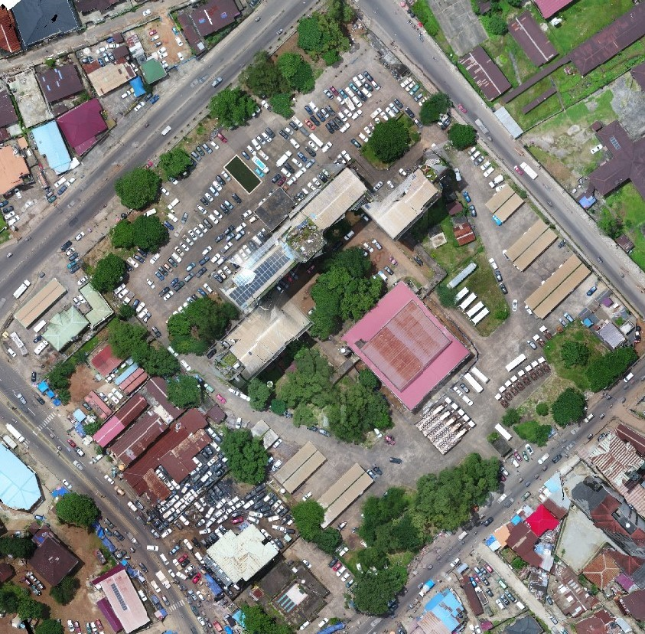

**AUGUST, 2023**

**PRESENTED BY: ING MONICA SELLU KAMARA**

**DIRECTOR, INFRASTRUCTURE**

**General Background**

The Chief Minister upon taking office, informed the Team about the proposal to clean/rehabilitate the Youyi Building. One of the outcomes of the Chief Minister’s statement was to carry out a general assessment of the entire Youyi Building and present holistic picture of the facility.

Assessment of existing structure/facility is an important process set in place before any repair or rehabilitation works can be carry out.

Following the general condition assessment of the Youyi Building facility, inside and outside, below are key findings of the facility:

**General Objectives of the Assessments**

To carry out comprehensive cleaning of the facilities and do complete overhauling of some components, if need be.

**General Conditions Outside:**

* The general area around the facility is not quite kept. There is a dump site located around the west wing of the building, where trashes are always kept, awaiting pickup by a dump vehicle. These trashes remain in this location for days before they are remove.
* The state of the fountain, located at the front of the building looks ok but needs minor repairs. The fountain is not always in operation due to power availability

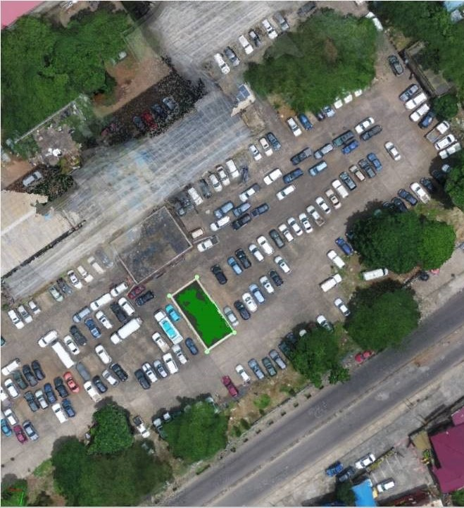 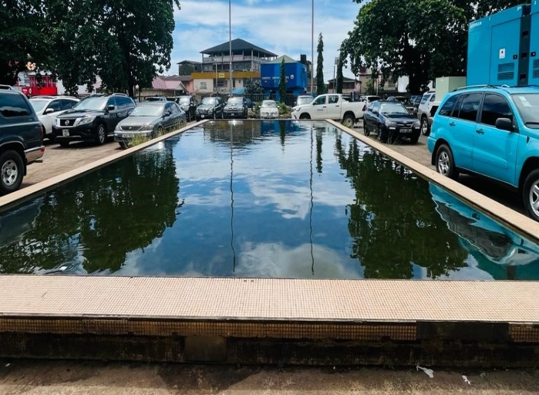***Photos showing fountain***

* There are parking lots located in different areas around the building (front, east and west wings and back). These parking lots have no markings or designation: meaning anyone can pack anywhere.
* There is a parking bay at the back of the building where the mobile clinic buses are packed. This parking lot is also in need of cleaning
* The Miatta conference center at the back of the building is still under renovation and is not open to the public for any activities. The rehabilitation process is very slow.
* Presence of gardens were observed around the facility (Front, east and west wings and back). All of the gardens are not quite kept.
* The trees around the facility are not well trimmed.

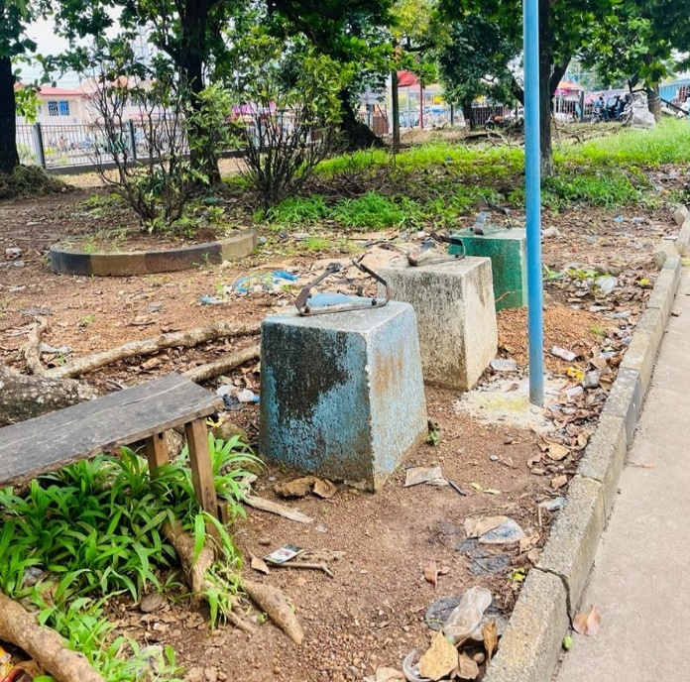 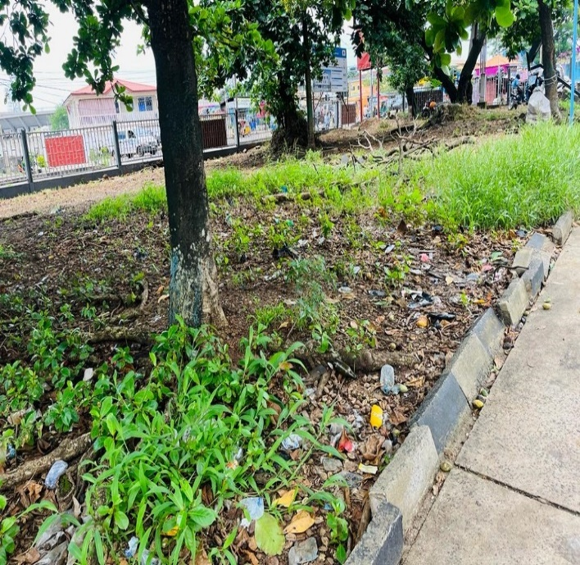

***Photos showing present status of the garden at the front of the building***

* There is a pumping unit around the facility that is use to pump water supply to the fountain and also inside the building. The pumping room is in good condition but needs painting
* There are different generator rooms available to supply power to different sections of the facility.
* Around the west wing of the building is a parking lot that is now used by car dealers for their day to day operations

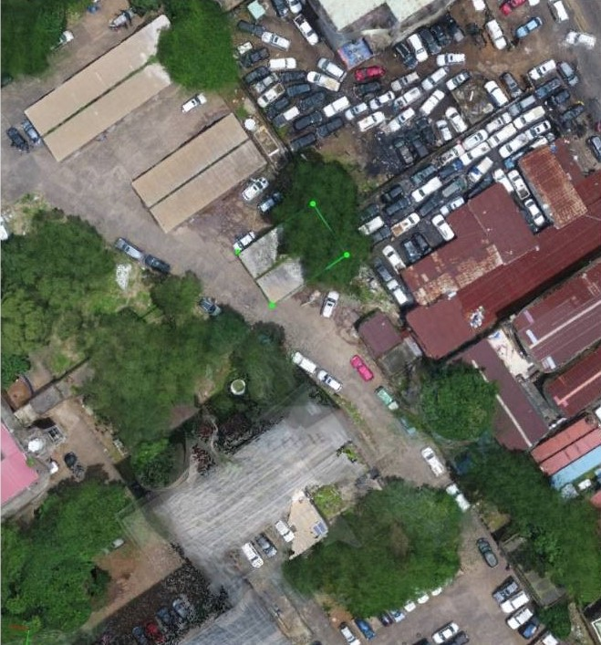

***Photo parking lot occupy by car dealers***

* There is a section at the back of the building available for EPA parking. Several scraps vehicles belonging to EPA and also the Government are packed around the facility, occupying more space.
* Several machineries have been brought in by Ministry of Agriculture and are packed at the back of the Miatta Conference Hall

**General Condition Inside the Building:**

* The general inside of the building is not quite pleasant
* Most floors have their own different tiling pattern which is not quite aesthetic

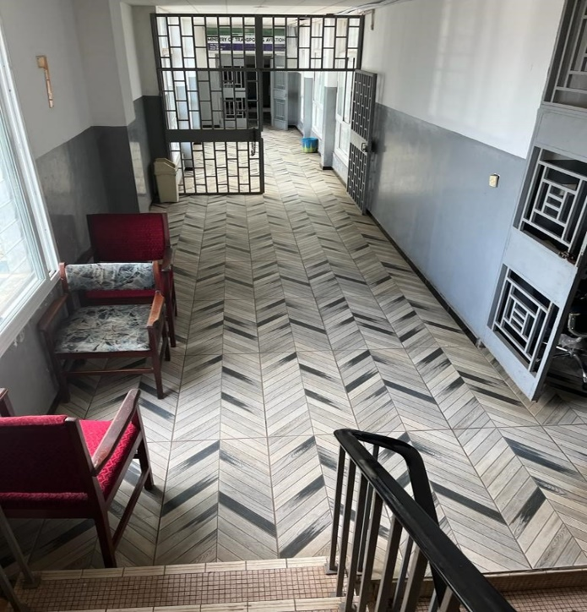 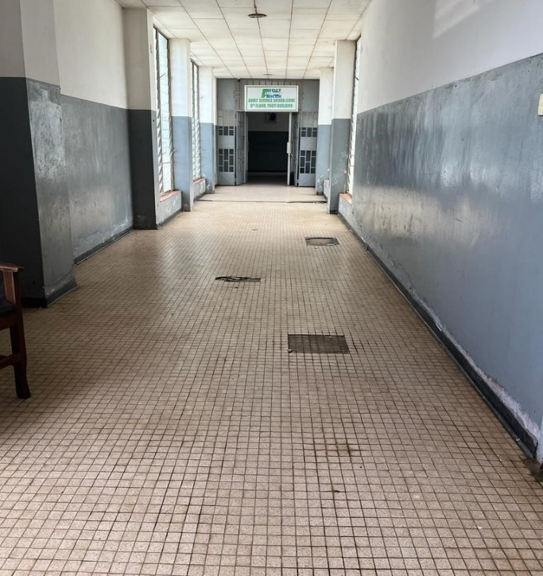

***Photos showing tiling in different floors***

* Different plumbing and maintenance pattern is employ in the different Ministries/Agencies
* All the rest rooms inside the building are not quite kept
* Most of the tiles along the staircases are damaged and needs repairs

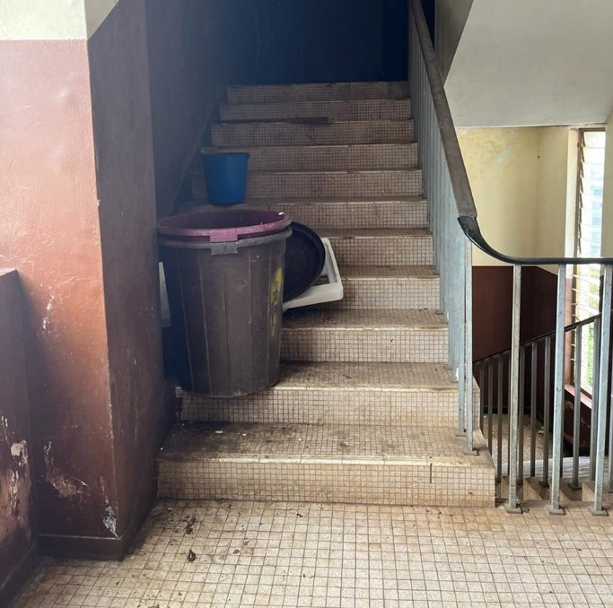 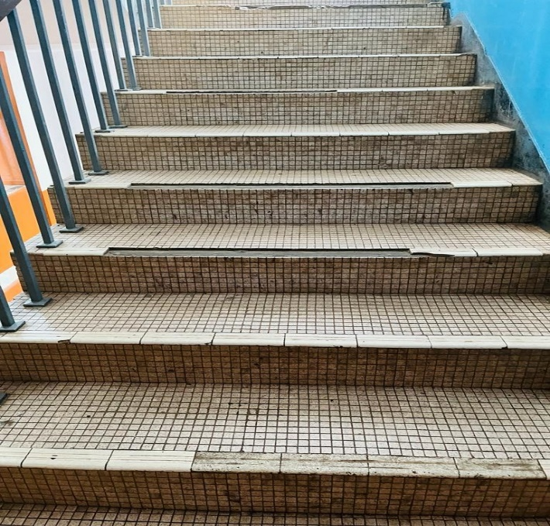

***Photos showing status of the tiles along the staircase***

* There are a total of seven lifts in the building (Three in the central, two on the east wing and two on the west wing). All these seven lifts are currently out of operation due to mechanical failure.

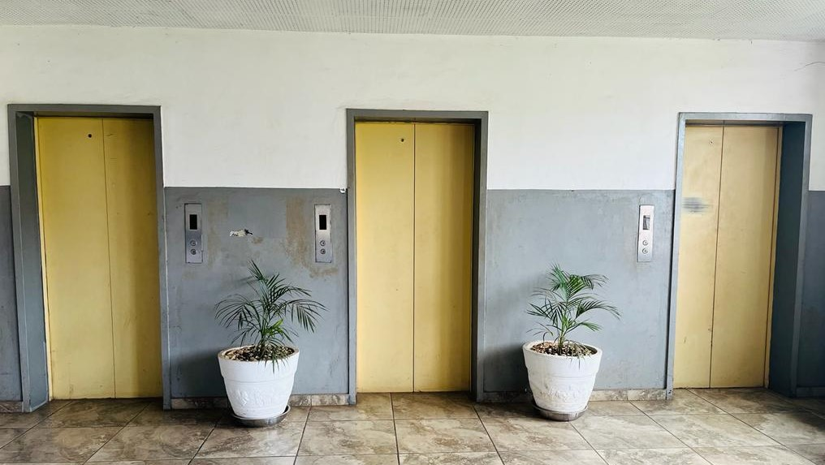 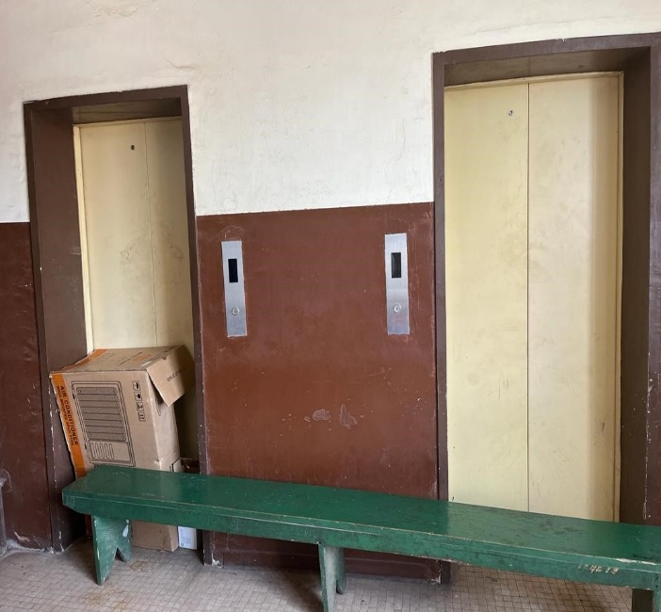

***Photos showing lifts in the building***

The Building is made of a basement floor and nine (9) other floors. Different Ministries and Agencies are occupying this floors.

Kindly see below composition of Ministries/Agencies in each floor and a contact of their PS/Focal person:

**Recommendations**

* Engage various sectorial heads and agencies (Agriculture, Environment, SLRA, SLRTA, MWPA, EPA, Military, Police, Padi etc) so that they can contribute towards the cleaning exercise, thereby reducing cost on Government. All the various Permanent Secretaries/focal persons can be contacted to engage their staff for this exercise.
* Employ the services of the youth with little stipend to do the general cleaning exercise and supervision from staff in the different sectors
* Engage the lift mechanic on the maintenance aspect of all the seven lifts
* Contract a dedicated cleaning company that will be responsible for cleaning the entire facility.
* Employ the services of a dedicated plumbing unit to take care of the entire plumbing system of the facility on a contractual basis

|  |  |  |  |  |  |
| --- | --- | --- | --- | --- | --- |
| **FLOORS** |  | **MINISTRIES/AGENCIES** |  | **PS/Contact** | **Contact** |
|  | **EAST WING** | **CENTRAL** | **WEST WING** |  |  |
| Basement | Canteen | Ministry of Health | Ministry of Agriculture | Mr AL Sorie | 079146533 |
| 1st | Ministry of Agriculture | Ministry of Agriculture | Ministry of Agriculture | Mr AL Sorie | 079146533 |
| 2nd | Ministry of Agriculture | Ministry of Agriculture | Ministry of Agriculture | Mr AL Sorie | 079146533 |
| 3rd | Ministry of Lands & Environment | Ministry of Lands & Environment | Ministry of Lands & Environment | Mr Abdul R.M Fofanah | 076466440 |
| 4th | Ministry of Health & Sanitation | Ministry of Health & Sanitation | Ministry of Health & Sanitation | Mr PI Cole |  |
| 5th | Ministry of Health & Sanitation | Ministry of Mines | Ministry of Mines | Mr Kinnie Lamin (PS Mines | 076308806 |
| 6th | Ministry of Local Government & Rural Development | Both | Ministry of Trade | Mr Thomas B. Lansanah (PS MoLRG)  Mr David W.S Banya (PS Trade) | 076661997  07622488 |
| 7th | Ministry of Transport & Aviation | Both | Ministry of Fisheries & Mineral Resources | Mr Alhasan Kondeh (PS MoTA)  Mrs Elizabeth H. Ellie (PS Fisheries) | 000  079673828 |
| 8th | Ministry of Information & Civic Education | Both | Ministry of Communication, Technology & Innovation | Mr Tamba E. Juanah | 079544738 |
| 9th | Audit Service S/L | Ministry of Public Administration & Political Affairs  Decentralization Secretariat (Dec/Sec) | National Commission for Democracy (NCD) | Mr Jabbie (Audit S/L)  Haja Rugiatu Kamara (Ps P Affairs)  Mr Joseph Johnson (Dec/Sec)  Mr Albert Kanu (NCD) | 076604999  076695244  079673709  076311783 |

**Areas of the Facilities**

See below areas of different components/units in the Youyi Building:

|  |  |  |
| --- | --- | --- |
| **NO#** | **UNIT** | **PROJECTED AREA(M2)** |
| 1 | Fountain | 126.71 |
| 2 | Garden Area | 7223.2 |
| 3 | Miatta Conference Hall | 1626.23 |
| 4 | Parting Lot | 7532.73 |
| 5 | Mobil Bus Park | 1611.99 |
| 6 | Main Structure (All wings) | 2373.42 |
| 7 | Total free space | 5689.97 |
| 8 | Total Land Area | 32,218.00 |

**PHOTOS**

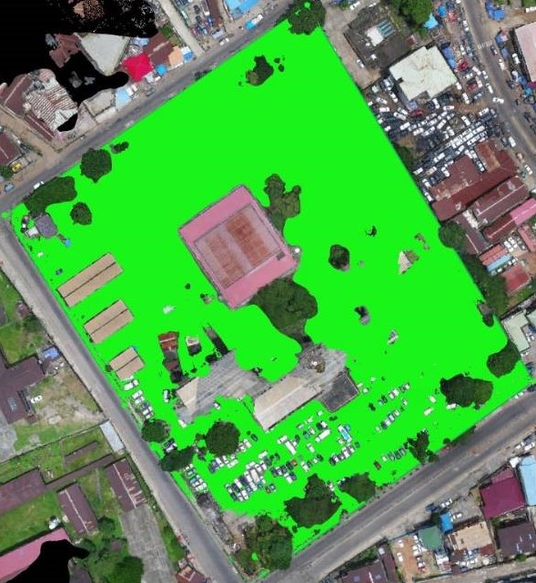 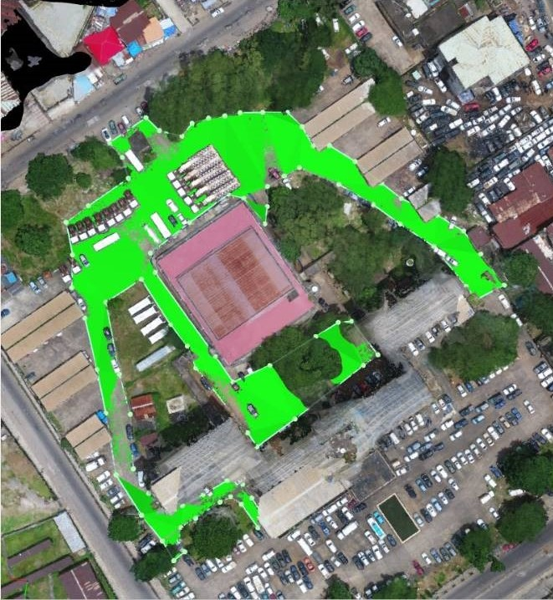

***Photos showing total land area Photos showing compound free space***

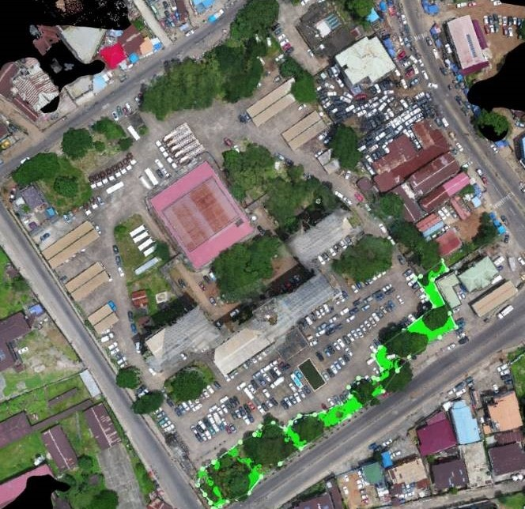 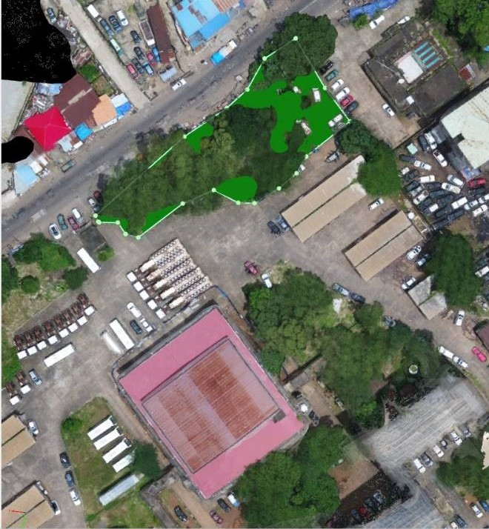

***Photos showing different garden areas of the facility***

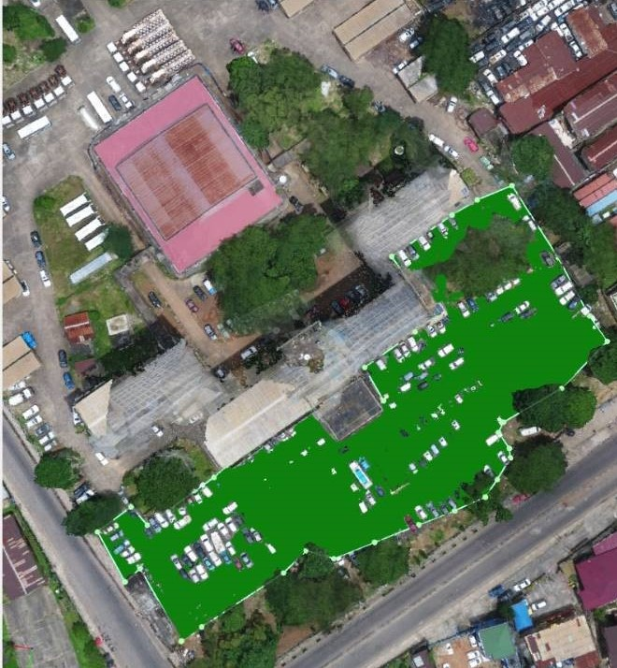 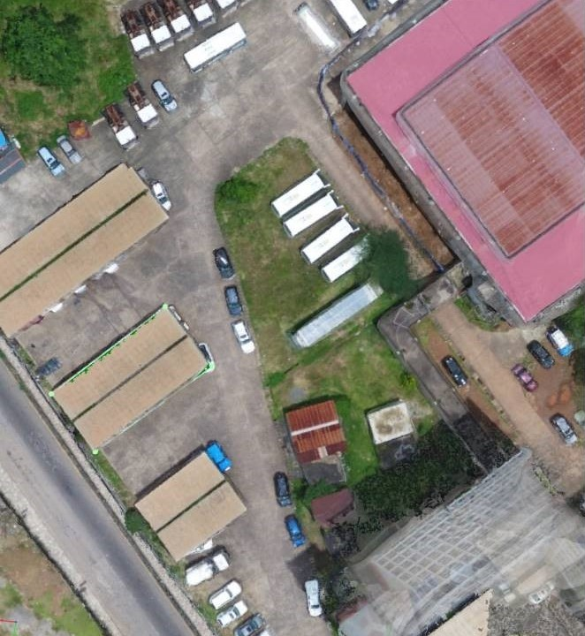

***Photos showing different parking lots of the facility***

 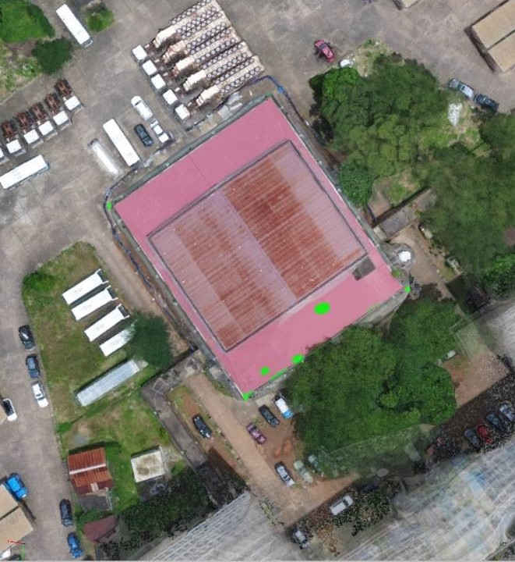

***Photos showing parking lot used by car dealers Miatta Conference Hall***