

**MIDDLE EAST TECHNICAL UNIVERSITY**

EE564

DESIGN OF ELECTRICAL MACHINES

Project-1 Inductance and Transformer Modeling

Olcay BAY

1673672

29.03.2018

# Inductor DESIGN

## In this study, inductor wrapped around a toroidal core will be analyzed. Designed inductor is aimed to be used in an application where inductor current is composed of a large DC component and a small AC component at 40 kHz. For this application, inductor is expected to have an inductance value more than 500μH when carrying the maximum current of 40A. In order to evaluate the low cost powder core materials in such an application, Kool Mμ MAX has been selected as the core material. And after investigating available products and using stored energy (LI2 Product) 0079337A7 from Magnetics has been selected as the inductor core for this study.

## PROPERTIES OF THE SELECTED CORE

Physical properties of the selected core has been given in Figure 1.1 and material properties are given in [1] and [2] in detail.

## 

Figure 1.1 Properties of 0079337A7

B-H characteristics of the selected core material is given in Figure 1.2 and a linearized version is given in Figure 1.3. Since powder core materials show "soft saturation" characteristics it is not an easy process to select a saturation region. Because of that an operating point (H= 300A.T/cm) where B-H curve slope considerably reduced and winding factor stays below 0.5 has been selected for the specified inductor current rating.

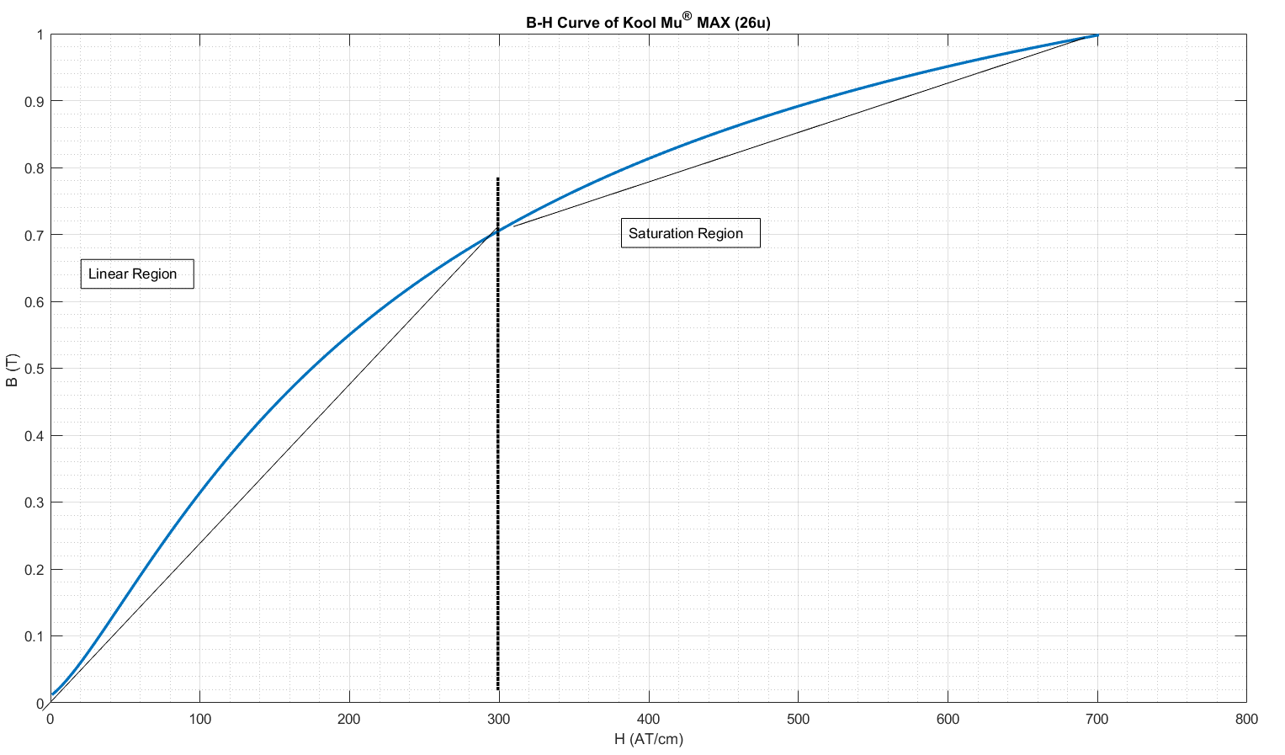

Figure 1.2 B-H Curve of the selected core material (Kool mu MAX 26u)

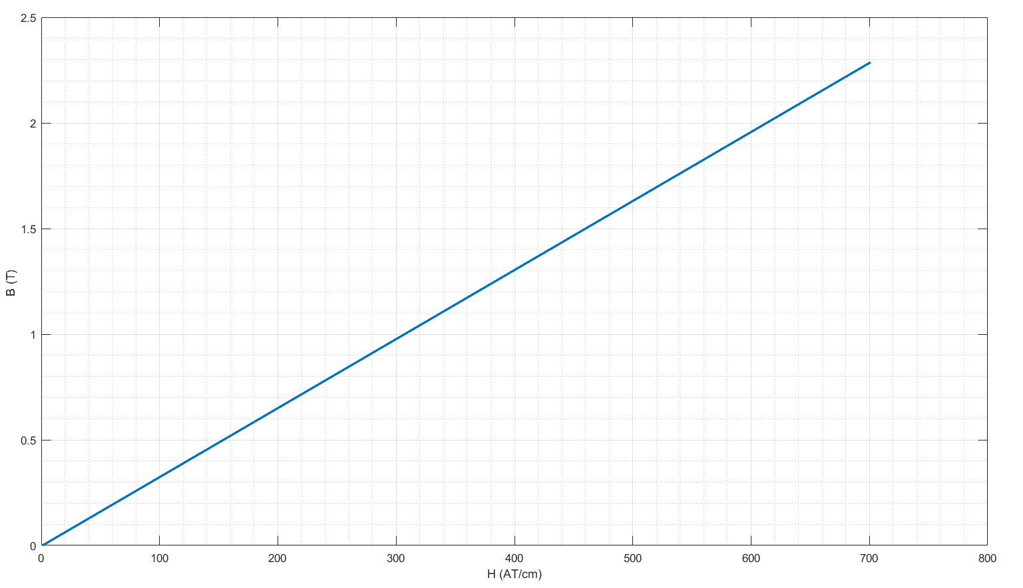

Figure 1.3 Linearized B-H Curve for the selected core material (Kool mu MAX 26u)

Figure 0.1,

# Analytıc CALCULATIONS

Figure 3.1 finite

# FEA of toroıd ınductance

## 

Figure 4.1 FEA model of the designed inductor in FEMM

# REFERENCES

## [1] [0079337A7](https://www.mag-inc.com/Media/Magnetics/Datasheets/0079337A7.pdf) datasheet.

## [2] [2017-Magnetics-Powder-Core-Catalog](https://www.mag-inc.com/Media/Magnetics/File-Library/Product%20Literature/Powder%20Core%20Literature/2017-Magnetics-Powder-Core-Catalog.pdf).