

**MIDDLE EAST TECHNICAL UNIVERSITY**

EE564

DESIGN OF ELECTRICAL MACHINES

Project-1 Inductance and Transformer Modeling

Olcay BAY

1673672

28.03.2018

# Inductor DESIGN

## In this study, inductor wrapped around a toroidal core will be analyzed. Designed inductor is aimed to be used in an application where inductor current is composed of a large DC component and a small AC component at 40 kHz. For this application, inductor is expected to have an inductance value more than 500μH when carrying the maximum current of 40A. In order to evaluate the low cost powder core materials in such an application, Kool Mμ MAX has been selected as the core material. And after investigating available products and using stored energy (LI2 Product) 0079337A7 from Magnetics has been selected as the inductor core for this study.

## PROPERTIES OF THE SELECTED CORE

Physical properties of the selected core has been given in Figure 1.1 and material properties are given in [1] and [2] in detail.

## 

Figure . Properties of 0079337A7

B-H characteristics of the selected core material is given in Figure 1.2 and a linearized version is given in Figure 1.3. Since powder core materials show "soft saturation" characteristics it is not an easy process to select a saturation region. Because of that an operating point (H= 300A.T/cm) where B-H curve slope considerably reduced and winding factor stays below 0.5 has been selected for the specified inductor current rating. Resulting turn count is then found to be 240.

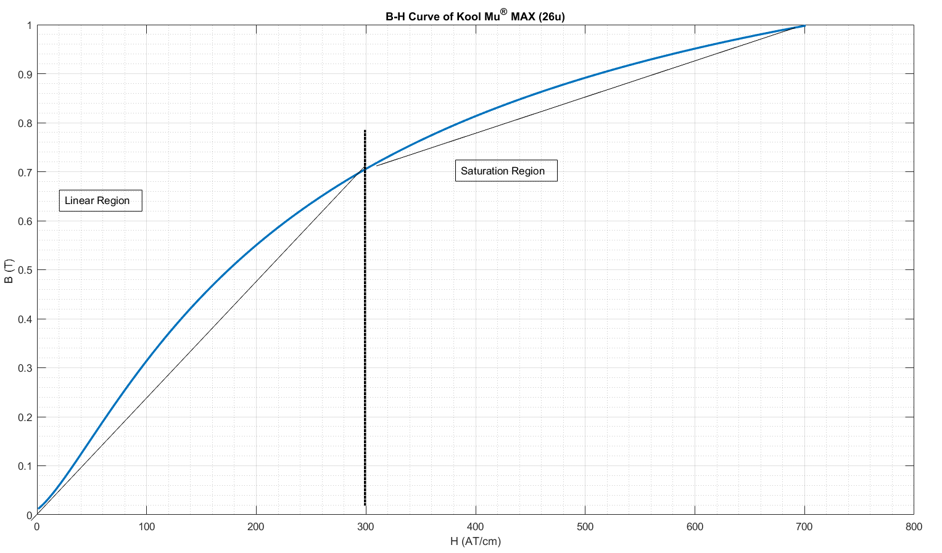

Figure . B-H Curve of the selected toroid core (Kool mu MAX 26u)

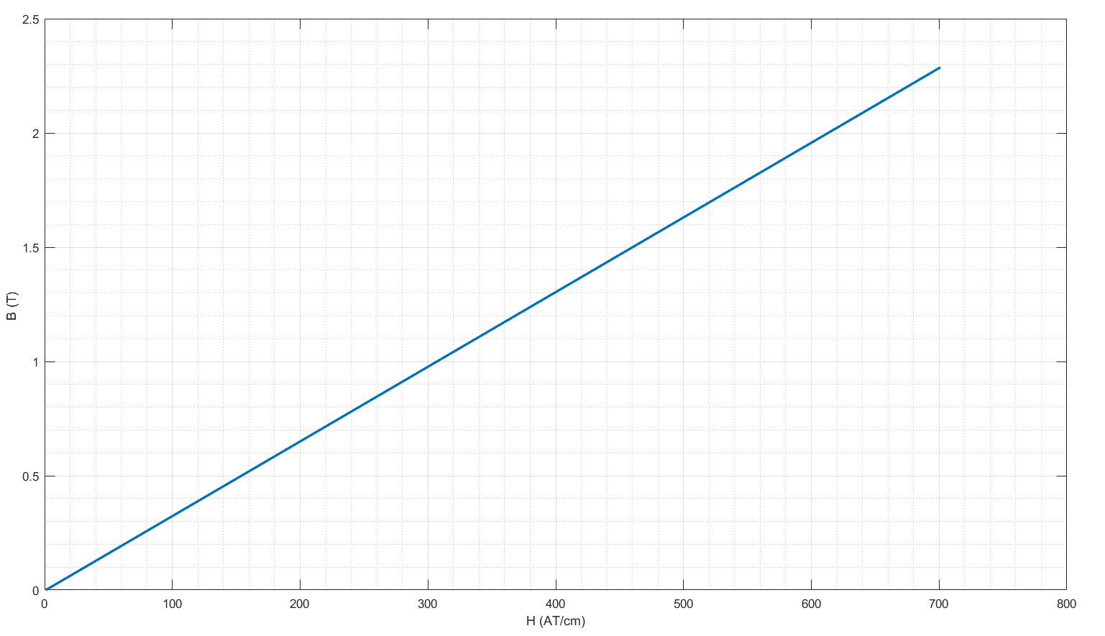

Figure . Linearized B-H Curve for the selected core material (Kool mu MAX 26u)

## Part A Analytical Calculations

## Inductance calculation with homogeneous flux distribution and linear B-H characteristics

## , and

## then:

Where (Figure 1.1) is equal to core area, N=240 is the number of turns, is the relative permeability of the core which is taken as 26 for this calculation, I is the DC current which is equal to 40A and is the mean flux path length.

Then inductance is found to be 3.9 mH

## Inductance calculation with non-homogeneous flux distribution and linear B-H characteristics

## where

Where is the height of the core and is again 26

is then found to be 4 mH using Matlab

## Inductance Calculation with homogeneous flux distribution, non-linear B-H characteristics and DC current is increased by 50%

From Figure ., B=0.85 T and L=2.3 mH

* **Inductance calculation with non-homogeneous flux distribution, non-linear BH characteristics and DC current is increased by 50%**

## where

Using B-H relation fitting formula given in [2], L found to be 2.9 mH

* **Inductance calculation of gapped toroid with homogeneous flux distribution, linear BH characteristics**

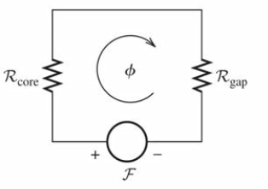

Where

and

L=3.4 mH

* **Inductance calculation of gapped toroid with homogeneous flux distribution, linear BH characteristics and considering fringing flux**

This time air gap area will be taken larger fringing area would be proportional to the gap length therefore gap dimensions can be enlarged by the gap length, i.e.

L=3.5mH

## Part B Finite Element Analysis (FEA) of Toroid Inductor

Constructed model of the designed inductor is given in Figure 1.5. In this model, the copper coil is represented by 24 homogeneously distributed copper regions and each of them represents 10 series wounded windings. An air region is placed inside and outside of the toroid.

## 

Figure . FEA model of the designed inductor in FEMM

### Flux distribution with linear core characteristics

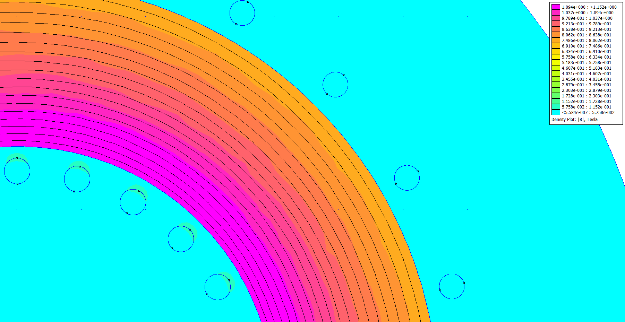

Figure . Flux distribution with linear core characteristics

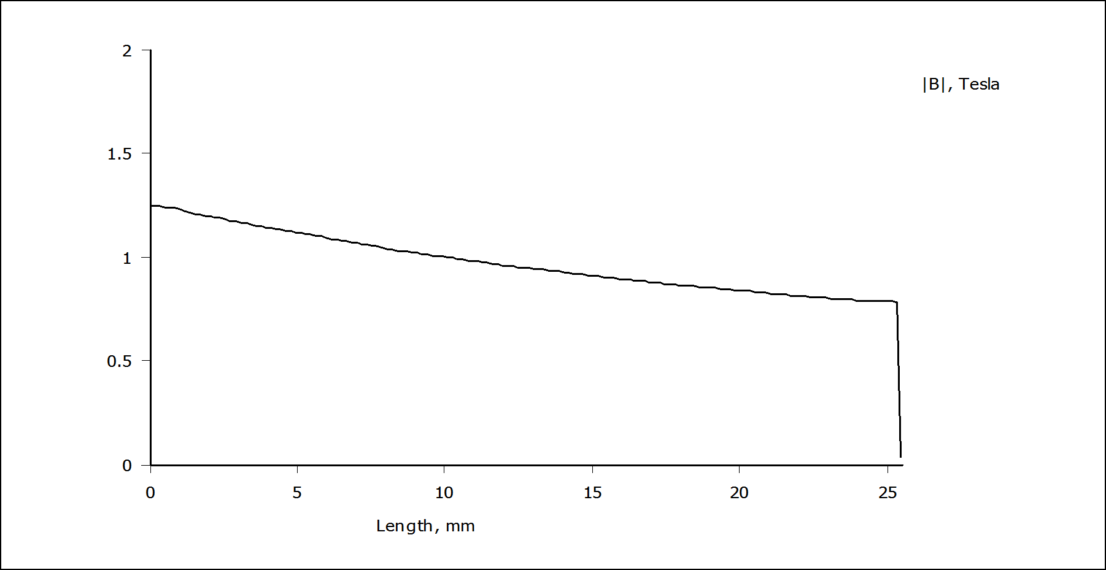

Figure . Variation of flux density from inner wall to outer wall

**Inductance Calculation Method 1**

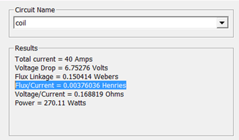Flux linkage and total inductance of the coil is

calculated automatically by the software and

reported as shown in the figure at the right side

**Inductance Calculation Method 2**

Alternatively, total inductance can be calculated using the stored energies in the air and core regions

as follows:

Magnetic energy stored in the air:

then:

Magnetic energy stored in the core:

then:

For linear core properties, it has seen that both method gives similar results.

### Flux distribution with nonlinear core characteristics

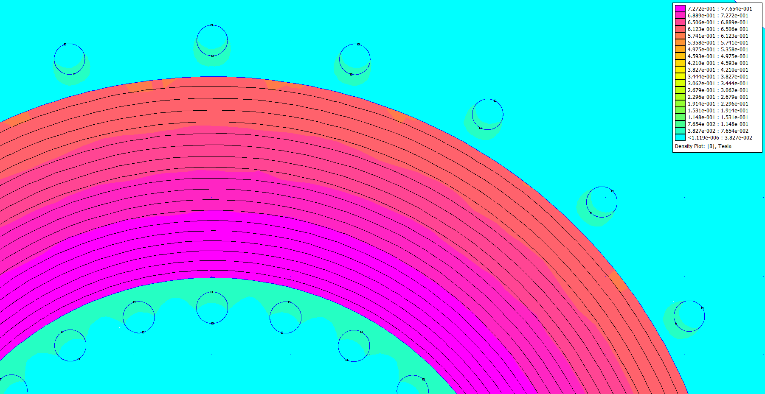

Figure . Flux distribution with linear core characteristics

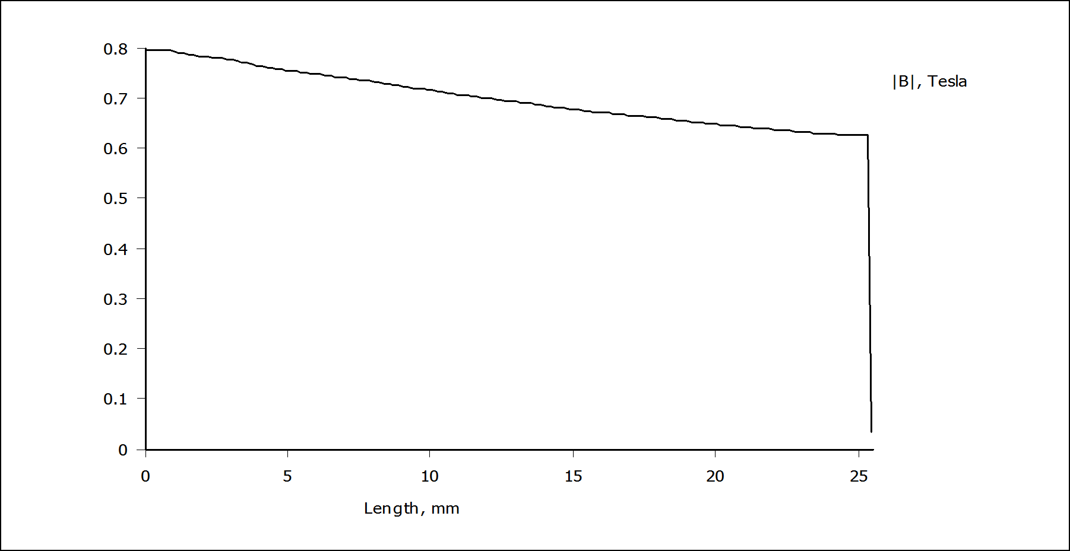

Figure . Variation of flux density from inner wall to outer wall

**Inductance Calculation Method 1**

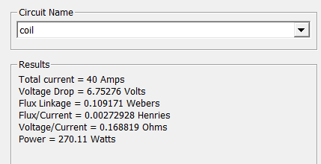Flux linkage and total inductance of the coil is

calculated automatically by the software and

reported as shown in the figure at the right side

**Inductance Calculation Method 2**

Alternatively, inductance can be calculated using the stored energies in the air and core regions

as follows:

Magnetic energy stored in the air:

then:

Magnetic energy stored in the core:

then:

However, in this case there is a significant difference between obtained inductance values with these two methods. In [3], it has been reported that it is usually better to use method1 since FEMM calculates the flux linkage using a method that accounts for this additional energy (energy is stored outside the modeled problem domain i.e boundaries), whereas integrating B×H over all elements does not.

### Flux distribution of the gapped toroid

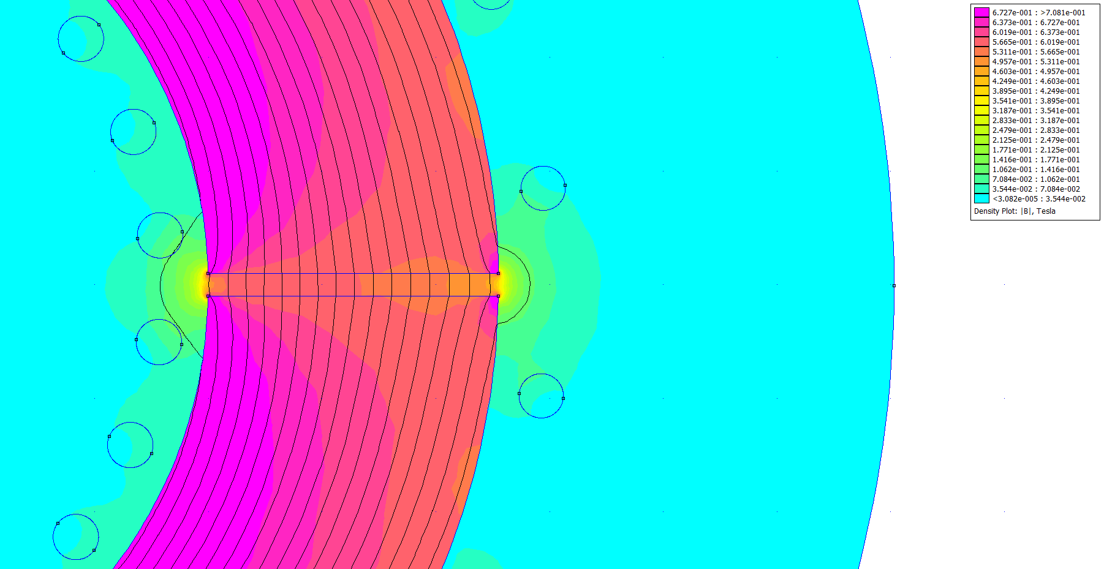

Figure . Flux distribution of the gapped toroid inductor

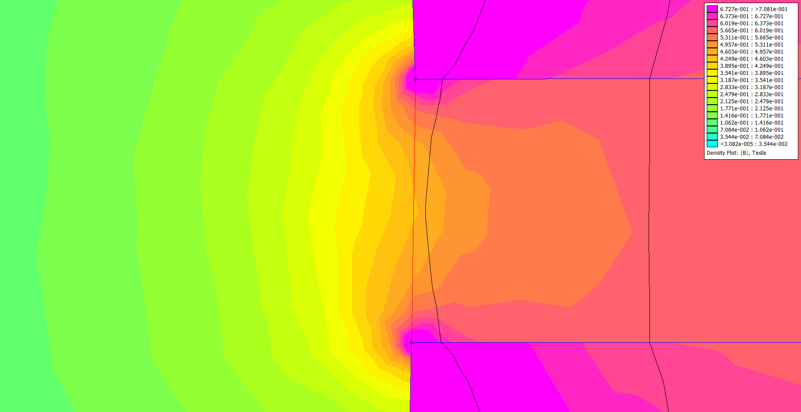

Figure . Flux distribution of the gapped toroid inductor (zoomed)

As it has shown in Figure 1.10 and in Figure 1.11, flux distribution not only at the outside of the core but also at the inside of the core is seriously affected with the placement of the air gap. It has seen that, at the vicinity of the air gap, magnetic flux inside the core loose its uniformity and it is concentrated at the edges of the gap. Air gap flux has also a non-uniform distribution and flows outside of the gap area and it has seen that effective air gap area enlarged by the length of air gap at both sides. However, flux density in this enlarged section is almost half of that in the inside of the gap.

Another important point which should be noted is the high concentration of the magnetic flux which is normal to the core surface at the edges of gap. As Figure 1.12 illustrates, a high magnetic flux density, perpendicular to the core, is observed at the edges of the core. This is an aspect of the gapped inductor design and it should be considered when placing conductors in order to prevent high Eddy current losses.

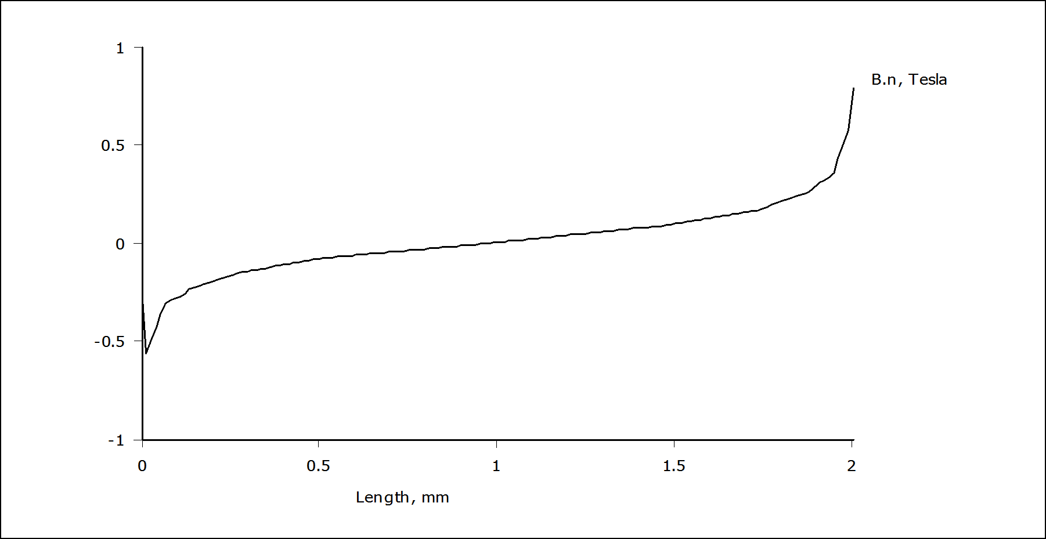

Figure . Flux distribution which is perpendicular to core through the air gap

**Inductance Calculation**

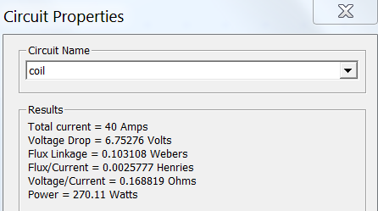**Method 1**

Flux linkage and total inductance of the coil is

calculated automatically by the software and

reported as shown in the figure at the right side

**Method 2**

Alternatively, inductance can be calculated using the stored energies in the air and core regions

as follows:

Magnetic energy stored in the air:

then:

Magnetic energy stored in the core:

then:

However, in this case there is a significant difference between obtained inductance values with these two methods. In [3], it has been reported that it is usually better to use method1 since FEMM calculates the flux linkage using a method that accounts for this additional energy (energy is stored outside the modeled problem domain i.e boundaries), whereas integrating B×H over all elements does not.

### Part C- Discussion

|  |  |  |
| --- | --- | --- |
|  | L (Analytic Calculation) | L (Simulation) |
| Linear Core Model | 4 mH | 3.75 mH |
| Non-linear Core Model | 2.9 mH | 2.72 mH |
| Gapped Linear | 3.5 mH |  |
| Gapped non-linear |  | 2.229 mH |

Although, FEA tool calculates the leakage flux in addition to the core flux, it has seen that analytic calculations result in slightly higher inductance values. Which is an unexpected situation and probably caused by a modeling mistake.

In 2D analysis the we can only analyze core flux distribution and leakage flux distribution in two dimension and assume same for all depths. This may not cause a large discrepancy for the core flux calculation. However, leakage flux would be concentrated in a toroid space rather than a cylindrical. Additionally, calculation of the fringing flux will also give better results with 3D simulation.

# TRANSFORMER DESIGN

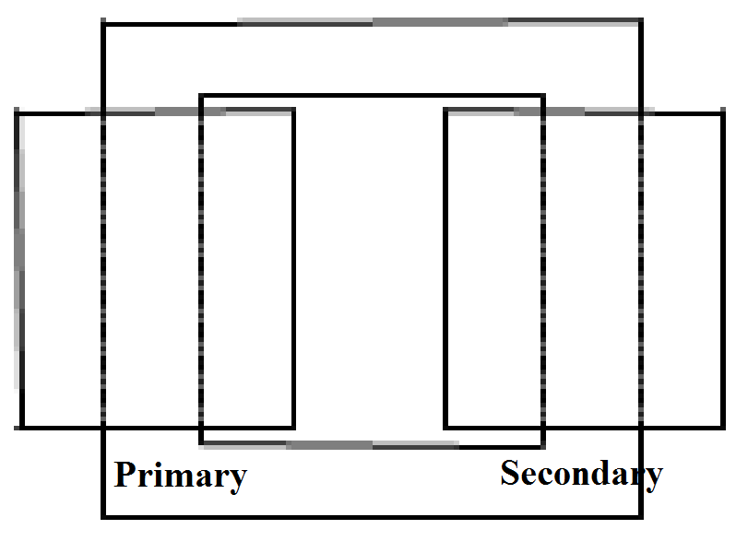

**Specifications**

* 500 kVA, Single Phase
* 34.5kV/25 kV
* 50 Hz
* Ambient Temp: -30C-50C
* Core Material Grain oriented

Steel.

Figure 2..Core type single phase transformer

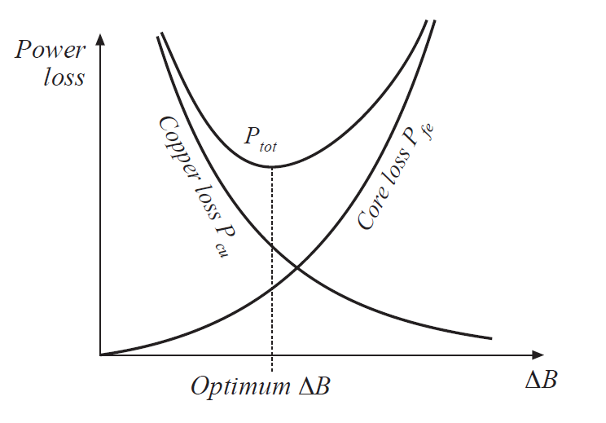

Figure . Optimum operating point of a transformer

Optimum operating point of a transformer

can be calculated analytically as shown in

Figure .. However, in this study an optimum

operating point will be obtained by numerical

iterations in the accompanying excel file.

# REFERENCES

## [1] [0079337A7](https://www.mag-inc.com/Media/Magnetics/Datasheets/0079337A7.pdf) datasheet.

## [2] [2017-Magnetics-Powder-Core-Catalog](https://www.mag-inc.com/Media/Magnetics/File-Library/Product%20Literature/Powder%20Core%20Literature/2017-Magnetics-Powder-Core-Catalog.pdf).

## [3] Finite Element MethodMagneticsInductanceExample, online: <http://www.femm.info/wiki/inductanceexample>

[4] M4 Grain Oriented Steel price, online: <https://www.alibaba.com/product-detail/Silicon-Steel-Prices-M4-M5-for_60295733102.html?spm=a2700.7724857.main07.24.7dfd177bcoSDFd&s=p>.

[5] JFE Grain Oriented Steel Cathalog , online: <http://www.jfesteel.co.jp/en/products/electrical/catalog/f1e-001.pdf>