

**MIDDLE EAST TECHNICAL UNIVERSITY**

EE564

DESIGN OF ELECTRICAL MACHINES

Project-1 Inductance and Transformer Modeling

Olcay BAY

1673672

29.03.2018

# Inductor DESIGN

## In this study, inductor wrapped around a toroidal core will be analyzed. Designed inductor is aimed to be used in an application where inductor current is composed of a large DC component and a small AC component at 40 kHz. For this application, inductor is expected to have an inductance value more than 500μH when carrying the maximum current of 40A. In order to evaluate the low cost powder core materials in such an application, Kool Mμ MAX has been selected as the core material. And after investigating available products and using stored energy (LI2 Product) 0079337A7 from Magnetics has been selected as the inductor core for this study.

## PROPERTIES OF THE SELECTED CORE

Physical properties of the selected core has been given in Figure 1.1 and material properties are given in [1] and [2] in detail.

## 

Figure 1.1 Properties of 0079337A7

B-H characteristics of the selected core material is given in Figure 1.2 and a linearized version is given in Figure 1.3. Since powder core materials show "soft saturation" characteristics it is not an easy process to select a saturation region. Because of that an operating point (H= 300A.T/cm) where B-H curve slope considerably reduced and winding factor stays below 0.5 has been selected for the specified inductor current rating. Resulting turn count is then found to be 240.

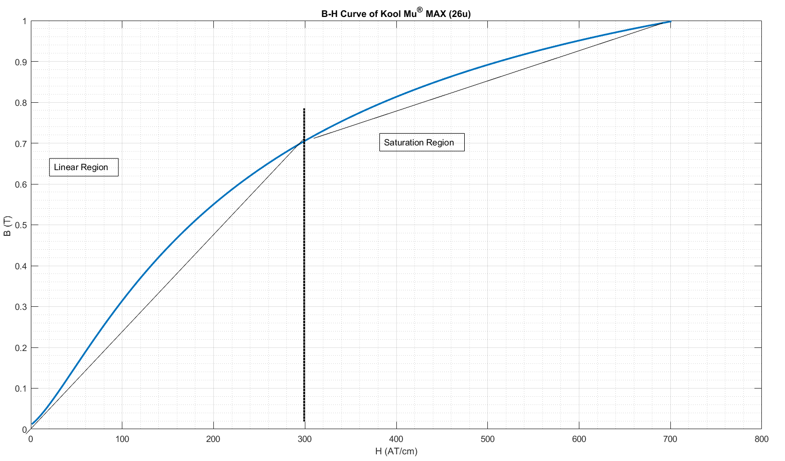

Figure 1.2 B-H Curve of the selected toroid core (Kool mu MAX 26u)

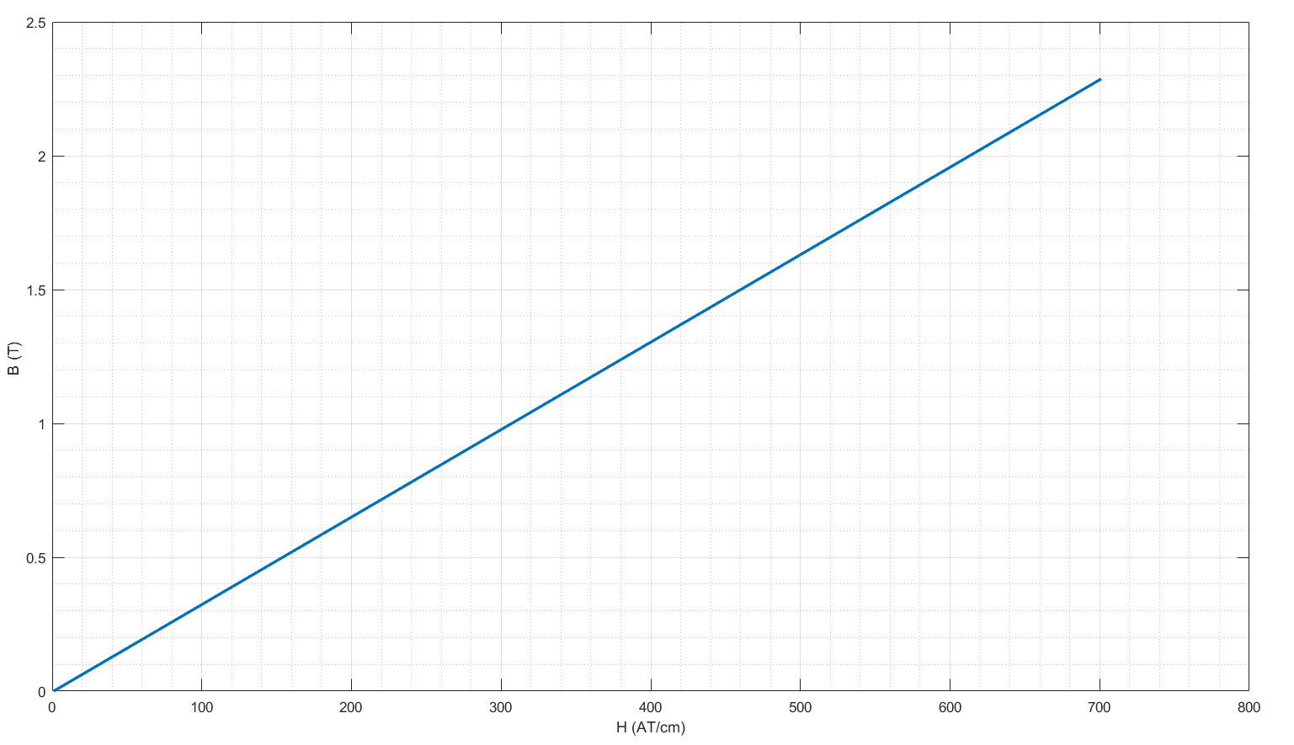

Figure 1.3 Linearized B-H Curve for the selected core material (Kool mu MAX 26u)

## Analytical Calculations

## Finite Element Analysis (FEA) of Toroid Inductor

Constructed model of the designed inductor is given in Figure 1.4. In this model, the copper coil is represented by 24 homogeneously distributed copper regions and each of them represents 10 series wounded windings. An air region is placed inside and outside of the toroid.

## 

Figure 1.4 FEA model of the designed inductor in FEMM

### Flux distribution with linear core characteristics

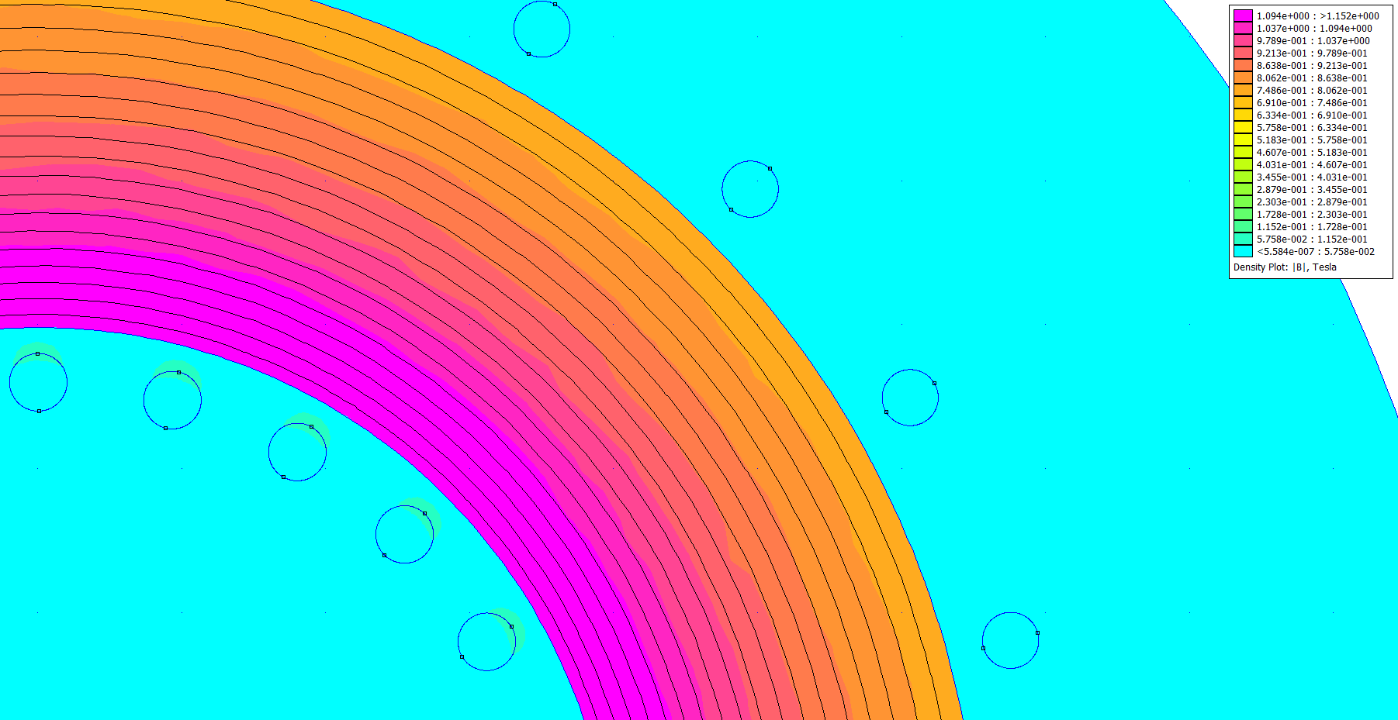

Figure 1.5 Flux distribution with linear core characteristics

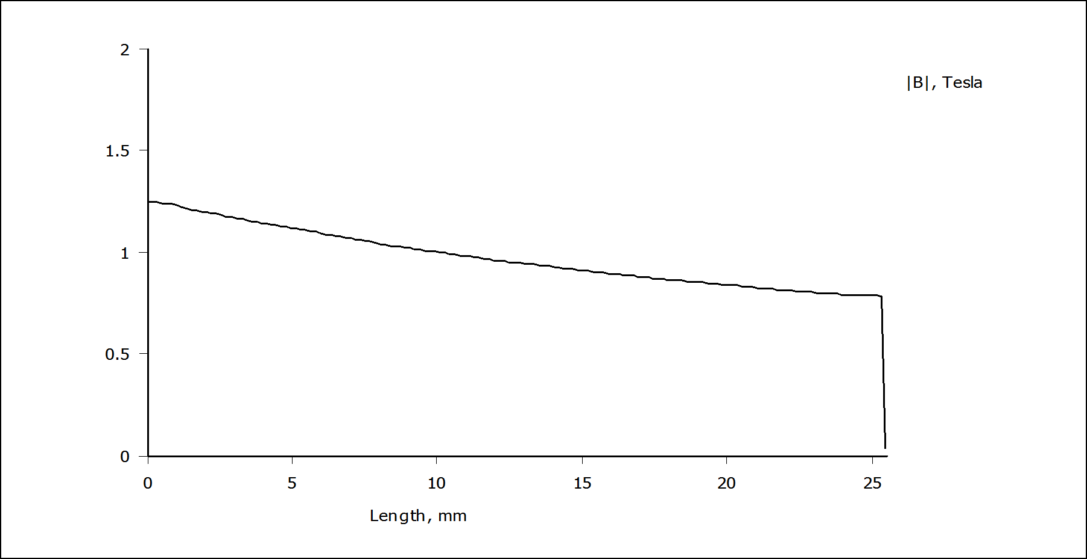

Figure 1.6 Variation of flux density from inner wall to outer wall

**Method 1**

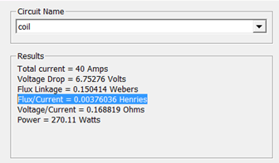Flux linkage and total inductance of the coil is

calculated automatically by the software and

reported as shown in the figure at the right side

**Method 2**

Alternatively, total inductance can be calculated using the stored energies in the air and core regions

as follows:

Magnetic energy stored in the air: $W_{air}=0.03789 Joules$

then:

$$L_{lk}=\frac{2*W_{air}}{I^{2}} = 47 uH$$

Magnetic energy stored in the core: $W_{core}=2.9631 Joules$

then:

$$L_{core}=\frac{2*W_{core}}{I^{2}} = 3.703 mH$$

$$L_{total}= L_{core}+L_{lk}=3.75 mH$$

For linear core properties, it has seen that both method gives similar results.

### Flux distribution with nonlinear core characteristics

Some comment

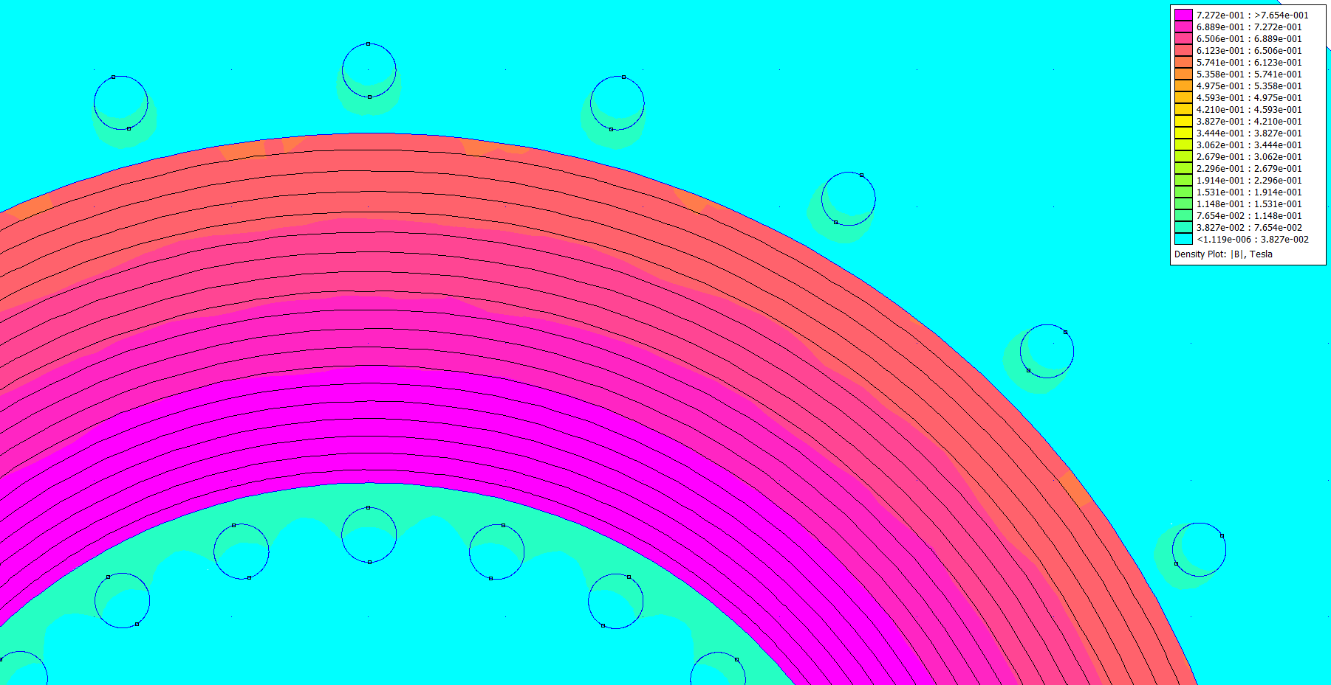

Figure 1.7 Flux distribution with linear core characteristics

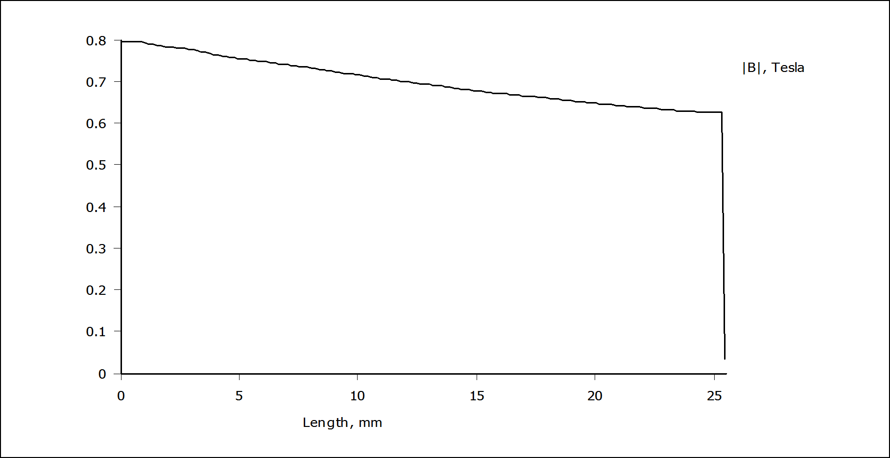

Figure 1.8 Variation of flux density from inner wall to outer wall

**Method 1**

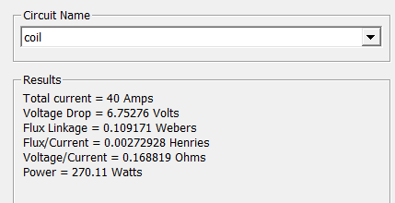Flux linkage and total inductance of the coil is

calculated automatically by the software and

reported as shown in the figure at the right side

**Method 2**

Alternatively, inductance can be calculated using the stored energies in the air and core regions

as follows:

Magnetic energy stored in the air:

then:

Magnetic energy stored in the core:

then:

However, in this case there is a significant difference between obtained inductance values with these two methods. In [3], it has been reported that it is usually better to use method1 since FEMM calculates the flux linkage using a method that accounts for this additional energy (energy is stored outside the modeled problem domain i.e boundaries), whereas integrating B×H over all elements does not.

### Flux distribution of the gapped toroid

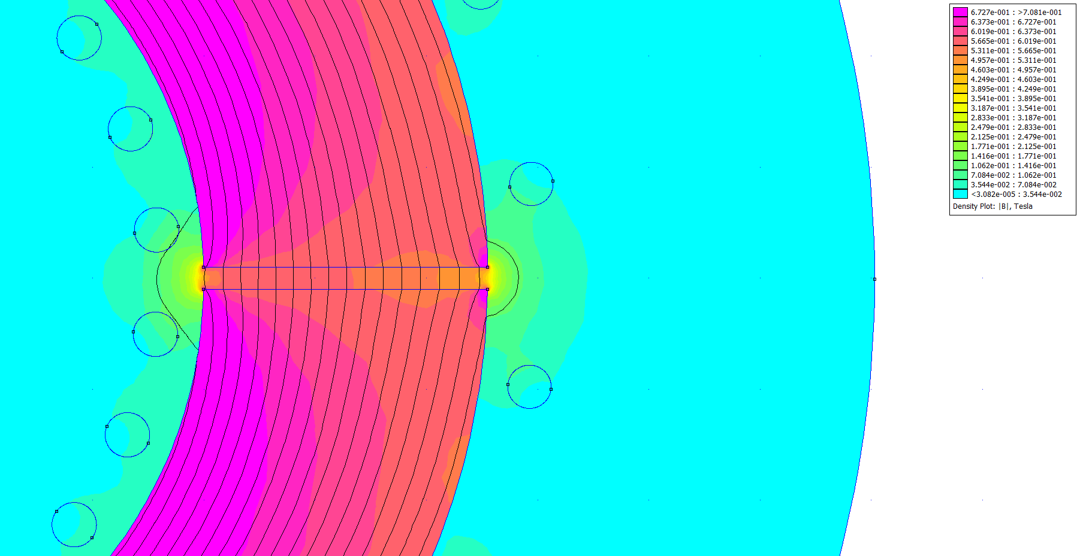

Figure 1.9 Flux distribution of the gapped toroid inductor

**Effect of the air gap**

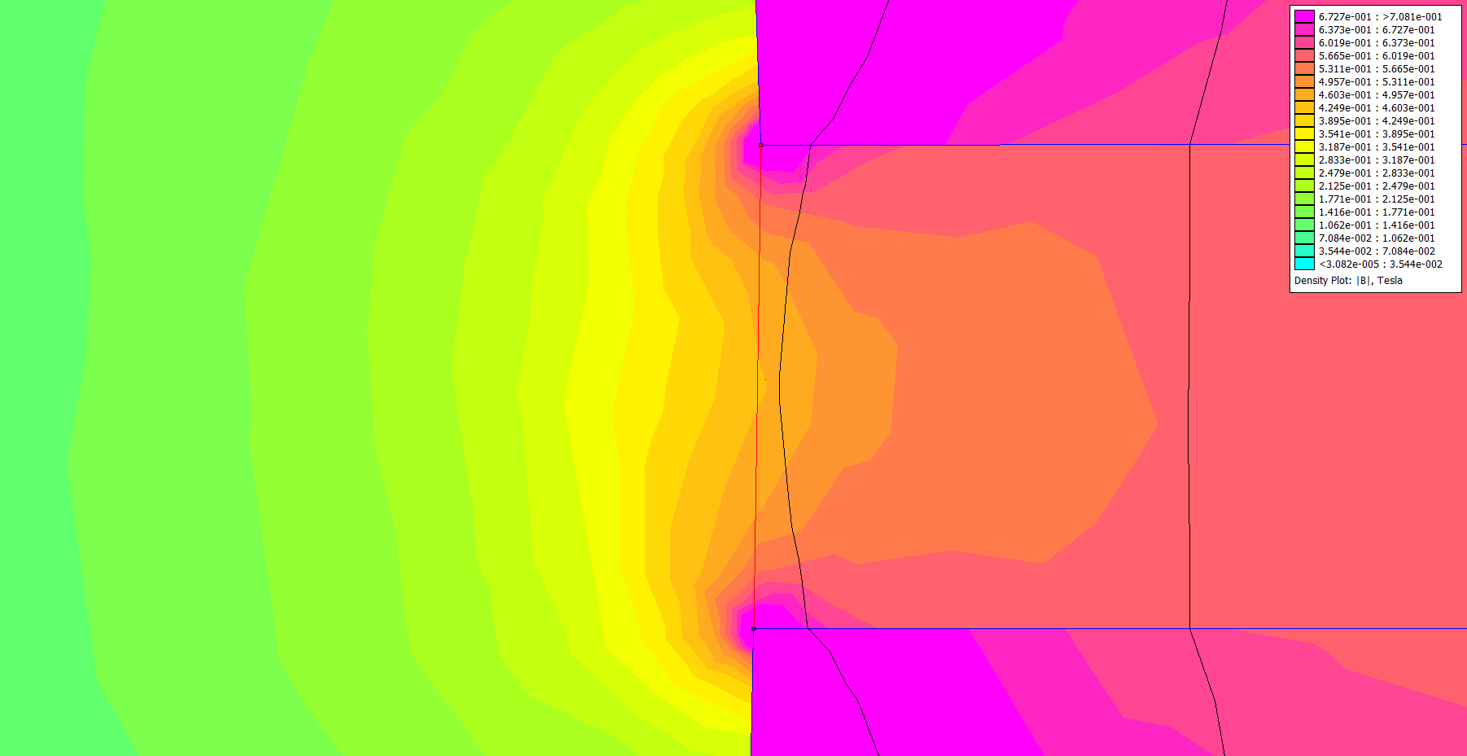

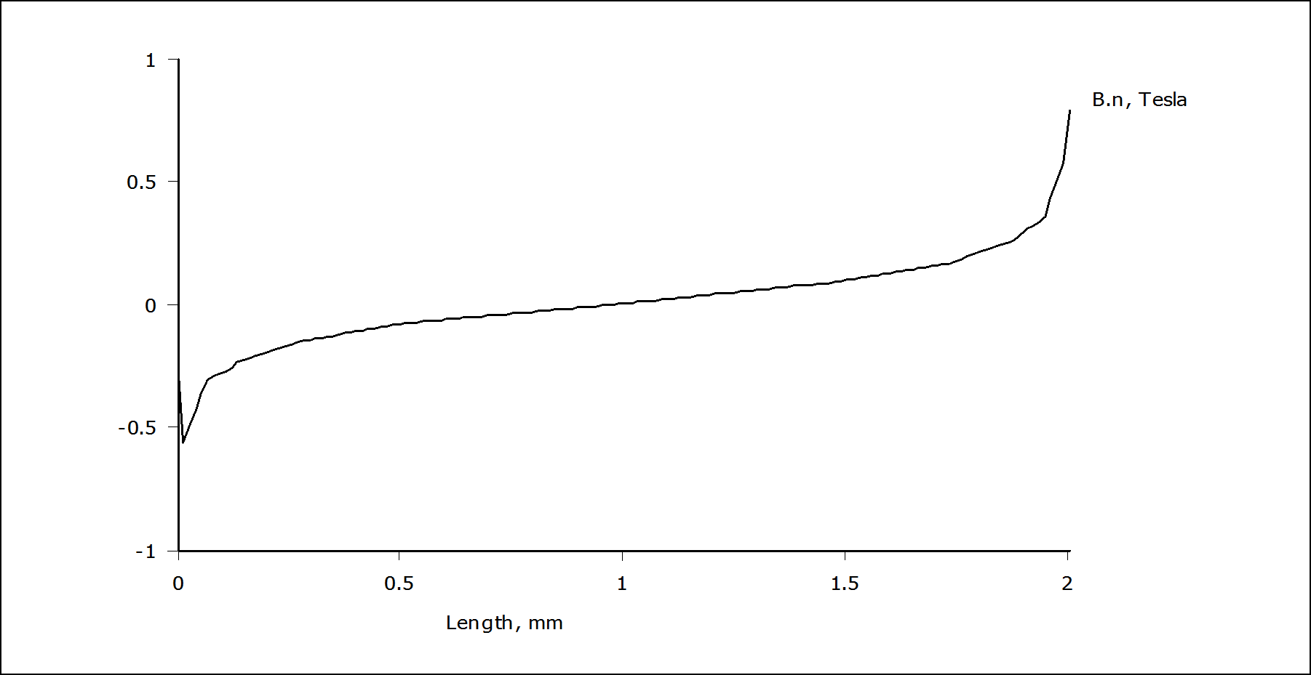

**Inductance Calculation**

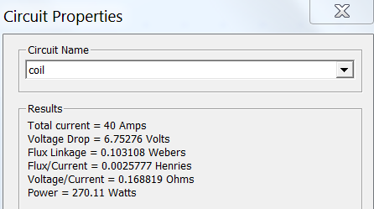**Method 1**

Flux linkage and total inductance of the coil is

calculated automatically by the software and

reported as shown in the figure at the right side

**Method 2**

Alternatively, inductance can be calculated using the stored energies in the air and core regions

as follows:

Magnetic energy stored in the air:

then:

Magnetic energy stored in the core:

then:

However, in this case there is a significant difference between obtained inductance values with these two methods. In [3], it has been reported that it is usually better to use method1 since FEMM calculates the flux linkage using a method that accounts for this additional energy (energy is stored outside the modeled problem domain i.e boundaries), whereas integrating B×H over all elements does not.

Spreaded around the air gap.

In two the we can only analyze flux distribution inside the core and the air volume with an height of core height however as the winding has an hollow shape leakage flux would be shaped accordingly.

Diameter of the copper regions and distance between the core and the copper regions are selected close to a real implementation in order to obtain a more reasonable leakage flux. However, as 240 turns of copper would require multiple layers

# REFERENCES

## [1] [0079337A7](https://www.mag-inc.com/Media/Magnetics/Datasheets/0079337A7.pdf) datasheet.

## [2] [2017-Magnetics-Powder-Core-Catalog](https://www.mag-inc.com/Media/Magnetics/File-Library/Product%20Literature/Powder%20Core%20Literature/2017-Magnetics-Powder-Core-Catalog.pdf).

## [3] Finite Element MethodMagneticsInductanceExample, online: <http://www.femm.info/wiki/inductanceexample>