

**MIDDLE EAST TECHNICAL UNIVERSITY**

EE564

DESIGN OF ELECTRICAL MACHINES

Project-2 Motor Winding Design & Analysis

Olcay BAY

1673672

23.04.2018

# WINDING DESIGN

In this study, design and analysis of stator winding for a 50 Hz, three-phase, squirrel cage, four-pole induction motor built with IEC 63/6-8.55 laminations from Kienle Spiess. Thickness of the laminations is selected to be 0.5 mm and dimensions of the core material are given in Figure 1.1.

## 

(a)

## 

(b) (c)

Figure 1.1 (a) properties of the selected lamination and dimension legend for (b) stator, (c) rotor

As it is given in Figure 1.1, stator core of this motor have 36 slots Qs and integral slot, double layer stator winding will be constructed.

number of slots per pole and phase *q* = *Q/*2*pm=3*

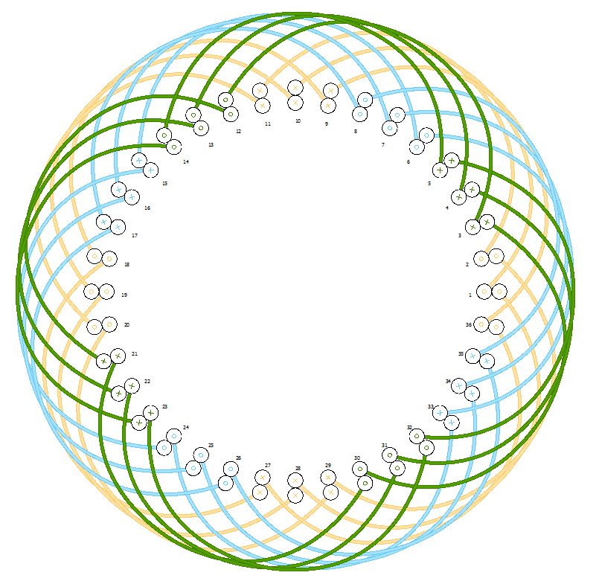

Figure 1.2 Winding diagram of full-pitched 4-pole stator

# REFERENCES

## [1] [0079337A7](https://www.mag-inc.com/Media/Magnetics/Datasheets/0079337A7.pdf) datasheet.

## [2] Pyrhonen, J., Jokinen, T., & Hrabovcova, V. (2013). Design of rotating electrical machines. John Wiley & Sons.

## [3]