BAYONET PRESTASHOP MODULE



**User’s Manual**

The Bayonet module for PrestaShop is the solution for your shop to opportunely detect fraud. This module bundles the Bayonet tools in an easy-to-install and easy-to-configure package.

Throughout this manual, you will be guided on how to install, configure and manage Bayonet’s module. Each section contains various subsections that are subtasks of the whole task, these are composed by the steps you need to follow in order to complete that specific subtask, also illustrated with images making easier to understand what you need to do.

It is necessary that you already have your API keys, otherwise, you will not be able to use this module.

**BAYONET’S MODULE INSTALLATION**

The next steps will guide you through Bayonet’s module installation.

Things you need for this task:

* Your PrestaShop store credentials
* Bayonet’s module zip file

1. Log into the back office of your store.

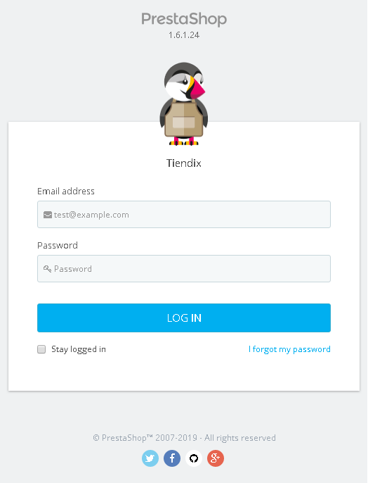

1. Navigate to the modules section using the dashboard’s sidebar, hovering over “Modules and Services” and then selecting “Modules and Services”.

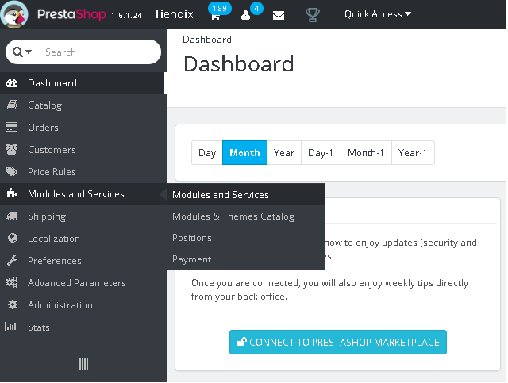

1. Press the “Add a new module” button, located at the upper right of the “List of modules” page, a panel will be shown in the page which will allow you to upload the module.

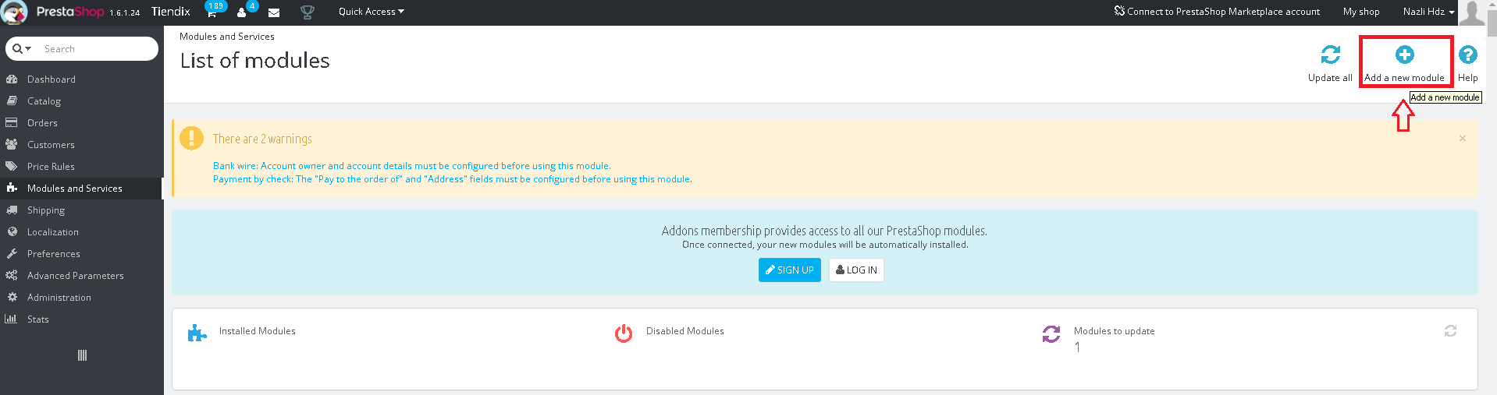

1. Press the “Choose a file” button to open the dialog box and then select the compressed file to upload, in this case, “bayonet.zip”.

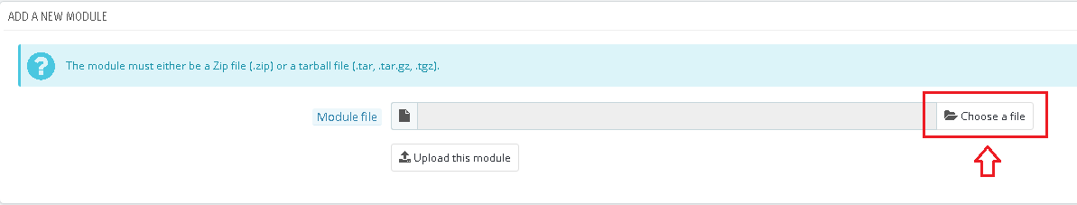

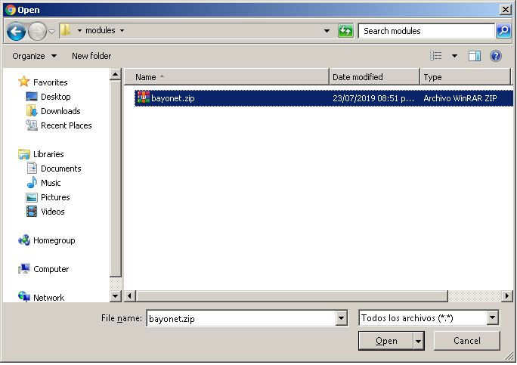

1. Press the button “Upload this module” to upload Bayonet’s module. A confirmation message will be shown after the module is uploaded and the option to install it will become available.

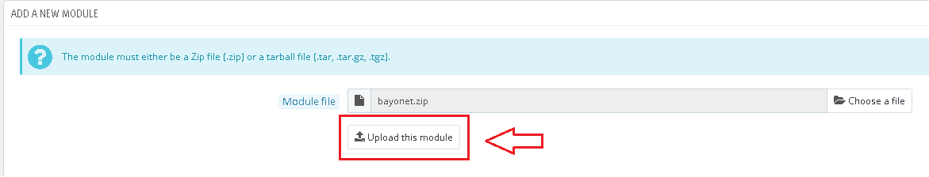



1. Press the “Install” button. A dialog box will appear showing the module’s information and will ask to confirm the installation, press “Proceed with the installation” to confirm.

After the installation is completed, PrestaShop will display the configuration page of the module.



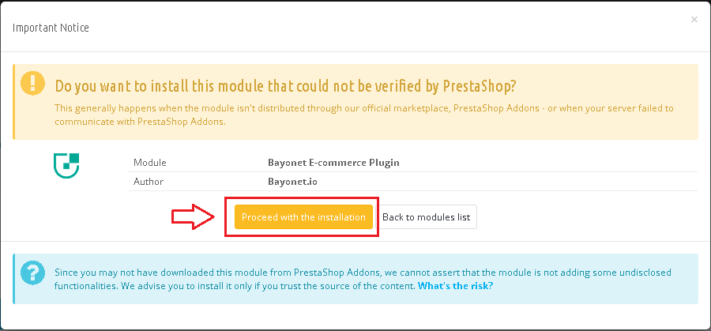

**BAYONET’S MODULE CONFIGURATION**

Here you will see how to configure the module and what is each configuration for. This task is required to make this module work properly.

Things you need for this task:

* Bayonet’s API keys
* Device Fingerprinting API keys

In the next image, you can see how the configuration page looks.

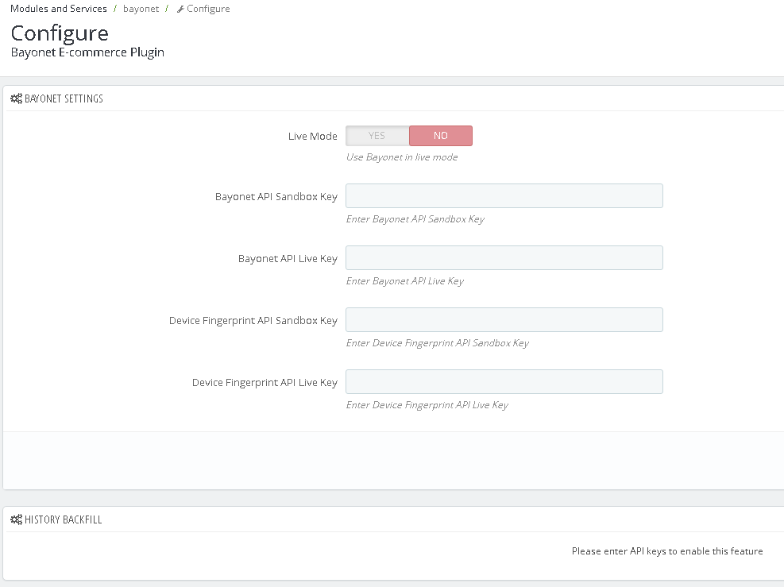

**Live Mode**: this option will set Bayonet’s API mode.

Selecting “No” will analyze every order in sandbox (test) mode, otherwise, the orders will be analyzed in live (production) mode.

**Bayonet API Sandbox Key**: this key is needed to use Bayonet’s module in sandbox mode.

**Bayonet API Live Key**: this key is needed to use Bayonet’s module in live mode.

**Device Fingerprint API Sandbox Key**: this key is needed to use the Device Fingerprint API in sandbox mode.

**Device Fingerprint API Live Key**: this key is needed to use the Device Fingerprint API in live mode.

**History Backfill**

This section is where you will execute the process to analyze your existing orders with Bayonet, this will help the module to have a better understanding of your store and your customers. At first, this section will appear disabled, you will need to add your API keys and save them in order to make this section available. Once you successfully save your API keys, this is how the backfill section will look.

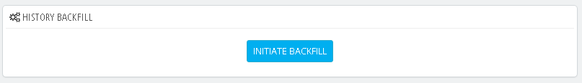

IMPORTANT

The module will show an error if you try to save with empty/incorrect fields, please fill every one with the correct information in order to avoid any errors. Each of these errors will give you a different message depending on which field is trying to save something incorrect.

**BAYONET’S MODULE MANAGEMENT**

**History Backfill**

Once the module has been successfully installed and configured, the first step to take afterwards is to run the backfill process, this is very important to help the module know more about your store and your customers.

To do this, press the “INITIATE BACKFILL” in the module’s configuration page.

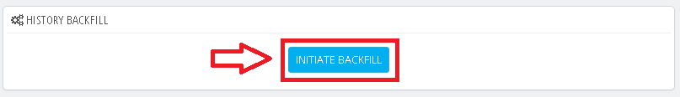

This will initiate the backfill process and a progress bar will appear showing the current completion percentage.

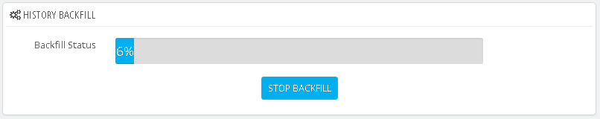

After the backfill process has been initiated, you can either wait for it to finish, or stop its execution pressing the “STOP BACKFILL” button below the progress bar.

*\*Note: if you close the page without stopping the process, it will keep running in the background.*

Completing the backfill process will mean Bayonet’s module is ready to analyze each one of your new orders. The analysis process will be performed automatically by the module every time a new order is placed.

**Bayonet information panel in Order Details**

The analysis will evaluate the information regarding that specific order and client, and it will give a decision which can be one of the following three; accept, review and decline.

After an order has been analyzed by Bayonet, you can check its result in the details of the order in the back office.

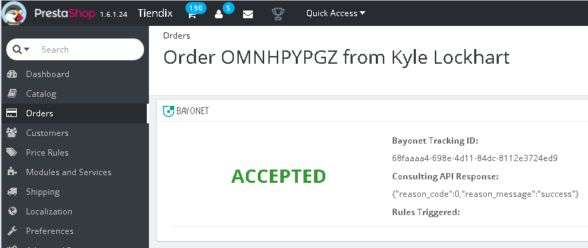

This panel includes:

* **Decision**: this will tell you how you should act over that specific order.
  + ACCEPTED: the order did not trigger any rules to consider it as a potential fraud, you should not take any actions on this order.
  + REVIEW: the order is not as safe to give the decision to accept it, but is not as risky to decline it right away. In this case, you should decide whether you cancel the order or take no actions on it.
  + DECLINED: the order has a high risk of being a fraudulent transaction. You should cancel the order as soon as possible.
* **Bayonet Tracking ID**: a unique identifier generated by Bayonet for this transaction in the analysis process.
* **Consulting API Response**: includes the reason code and reason message, these values will indicate if the analysis was successful or not.
* **Rules Triggered**: this will show the triggered rules to get the decision. It is possible to not trigger any rules.

The panel will show a warning message if the order was not processed by Bayonet or if it was part of the backfill process.

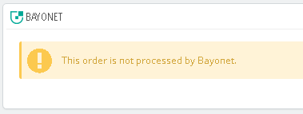

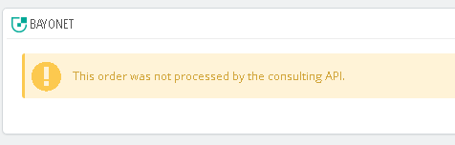

**Bayonet Tab in Back Office**

The module’s installation adds a new tab in the back office, this is located at the bottom of the sidebar, with the legend “Bayonet E-commerce Plugin”. Selecting this tab, will show its content, which is a table with all orders of your store that have been processed by Bayonet.

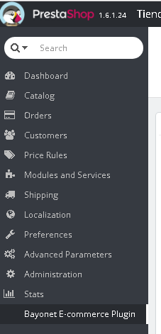

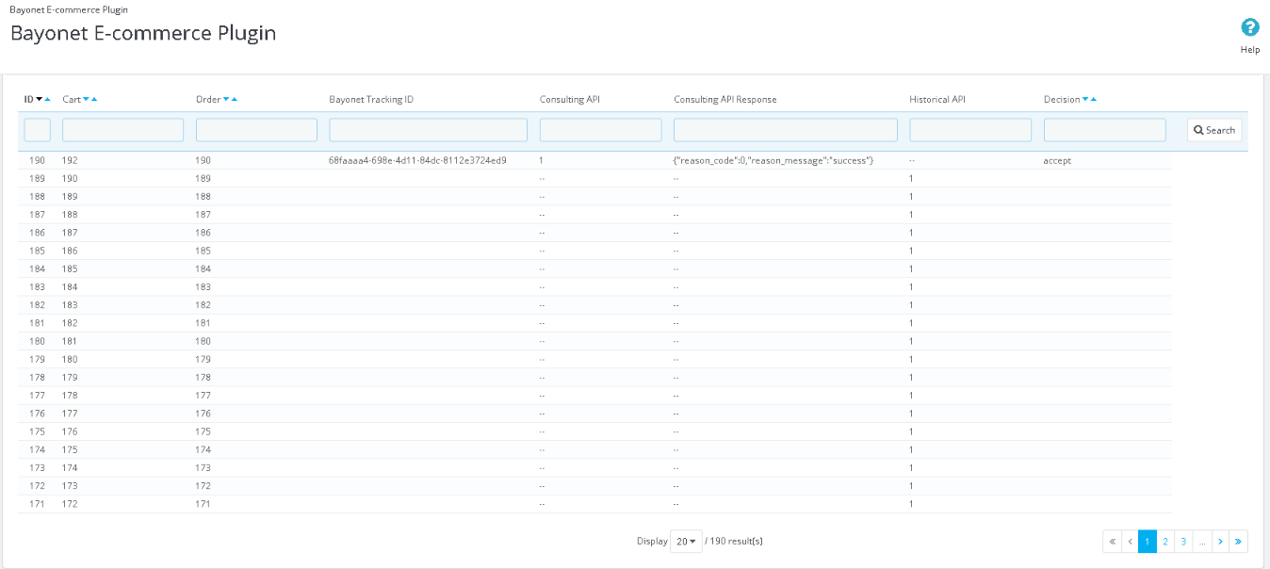

Breaking down its content, at the top you have the column names.



The columns of this table are:

* **ID**: the unique identifier for the Bayonet table in PrestaShop’s database (not confuse with the Bayonet Tracking ID).
* **Cart**: the cart ID of that specific order.
* **Order**: the ID of the order.
* **Bayonet Tracking ID**: the unique identifier generated by Bayonet for this order in the analysis process.
* **Consulting API**: indicates if the analysis for that order was successful or not. This is useful to know if an order was processed using the consulting or the history backfill process.
  + Empty: not processed by consulting API
  + 0: unsuccessful
  + 1: successful
* **Consulting API Response**: the response retrieved after attempting to perform the analysis, this will indicate if any errors were present at the analysis process. This will include a numeric code and a corresponding message based on that code.
* **Historical API**: indicates if the backfill process for that order was successful or not.
  + Empty: not processed by history backfill
  + 0: unsuccessful
  + 1: successful
* **Decision**: the decision given by the analysis process.
  + Accept
  + Review
  + Decline

Next, you have a filter area, where you can define a specific set of orders to display. For example, you can enter “1” in the *Consulting API* filter and “accept” in the *Decision* filter, pressing the button “Search” will display only the orders processed by the consulting API that have “accept” as decision. You can clear the filters by pressing the “Reset” button.

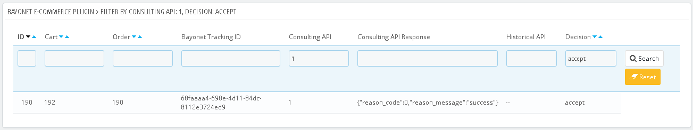

Besides filtering the data on the table, you can also order its rows by ID, Cart, Order or Decision. To do this, just click one of the two chevron arrows next to a column name, the downwards arrow will do a descending order, while the upwards arrow, will arrange the rows in an ascending order.

Finally, in the lower part of the table, you have a pagination feature, its behavior will be affected by the number of rows set to display per page. You can choose to display between 20, 50, 100, 300, 500 and 1000 rows per page, after modifying this value, the number of pages will change depending on how many entries are in your store’s Bayonet table.

