**FUNCTIONAL TESTING**

* specification of equivalence partitioning of input variables

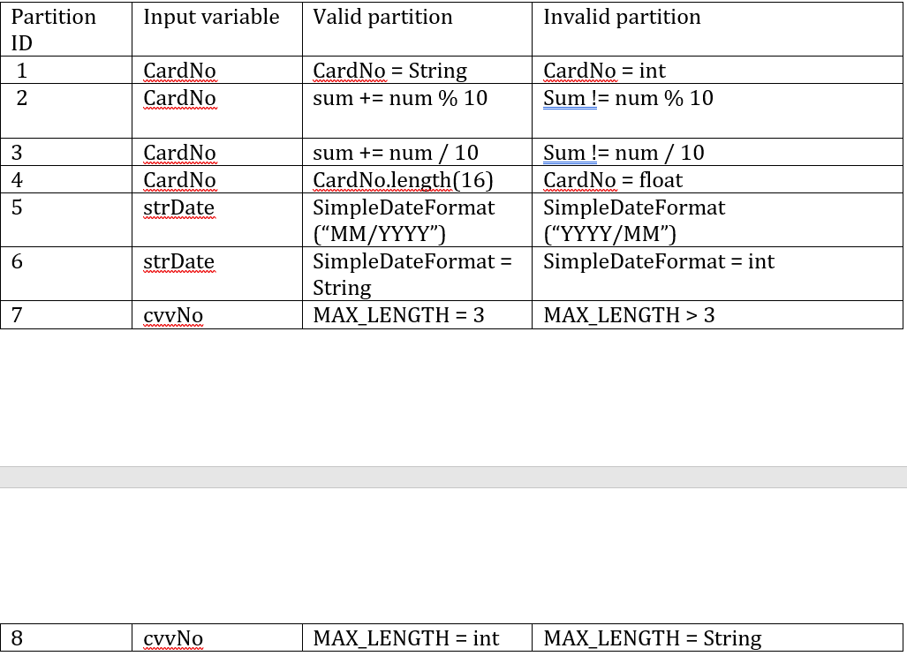

* 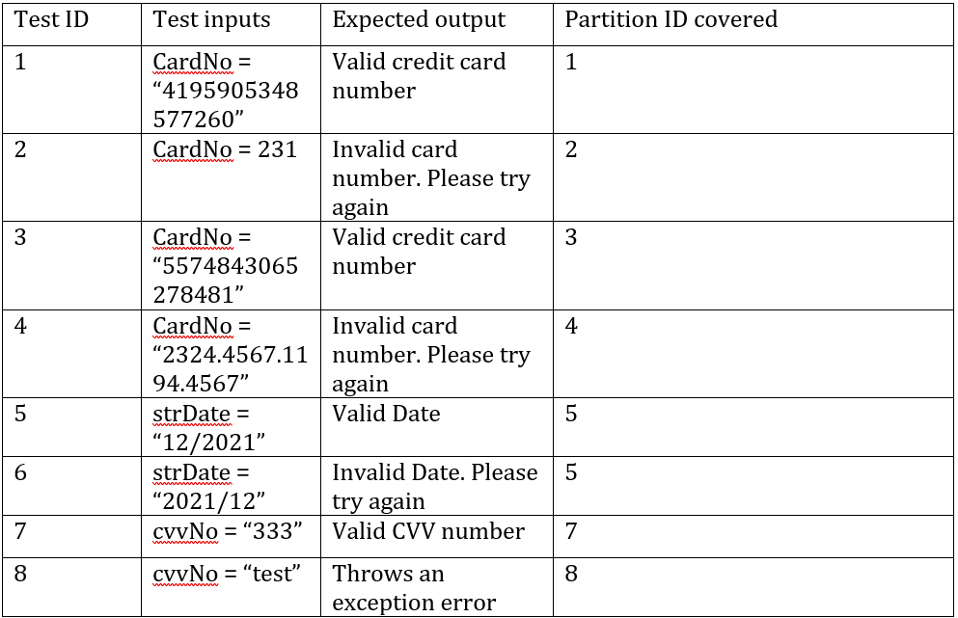test case specifications for each partition
* Unit implementation of the test cases

