**STRUCTURAL TESTING**

* 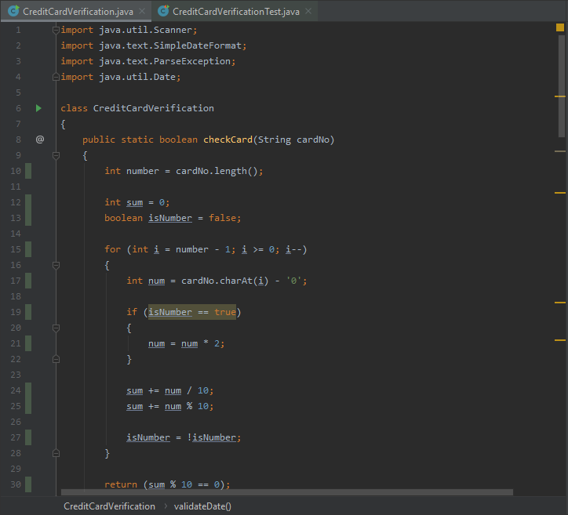initial screenshot of the statement adequacy

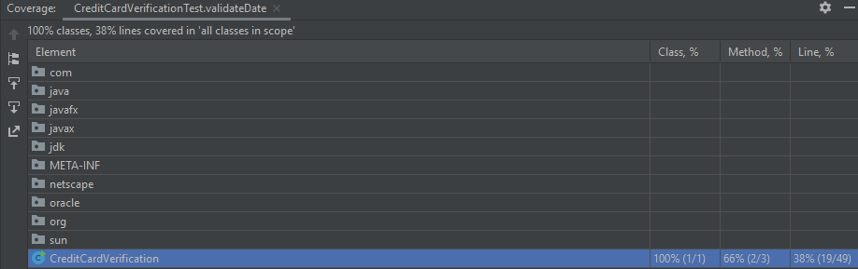

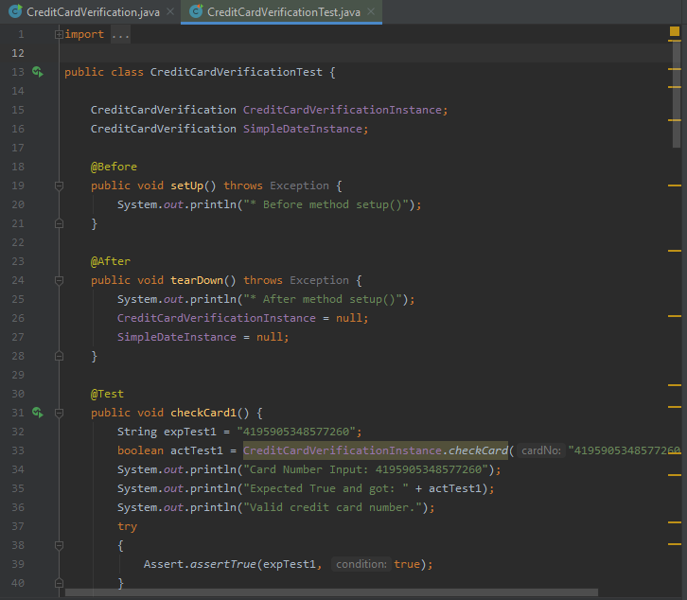

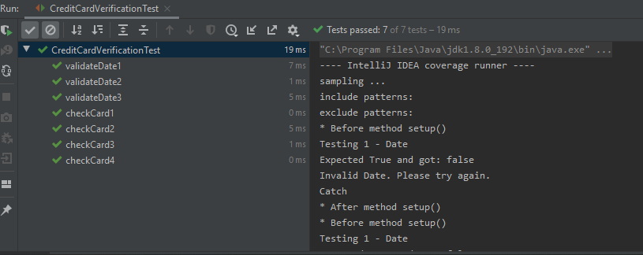

Could not achieve 100% coverage due to a method needing user input to the console!

