Name: Bayo Awoh
Course: IT 3883 Advance Application Development
Date: 05/28/2025

SPRINT 1

1. Requirements
For this specific problem were using user stories:
- User Stories:
As a user, I want to input a sentence that describes a collection of coins and their quantities so that I can receive the total value in dollars.
As a user, I expect the program to accept both singular and plural forms of coin names (e.g., penny and pennies, nickel and nickels).
As a user, I expect the program to correctly calculate the value based on the quantities and coin types, then return the total amount in dollars rounded to two decimal places.
As a user, I want the program to handle input that lists multiple types of coins in a single sentence (separated by “and”).

2. Design
This is a pseudocode for the program.
START
DEFINE a dictionary for coin values (e.g., penny = 0.01, nickel = 0.05)
RECEIVE the input sentence
REMOVE the word "and" from the input
SPLIT the sentence into words
INITIALIZE total to 0
FOR each pair of (quantity, coin):
CONVERT quantity to integer
NORMALIZE coin name to singular form (e.g., pennies -> penny)
LOOK UP the coin's value from the dictionary
ADD (quantity * coin value) to total
ROUND total to two decimal places
DISPLAY total
END

3. Implementation
Next, we write the Python code that follows the pseudocode.
# mapping of coin to dollar
coin_values = {
"penny": 0.01,
"nickel": 0.05,
"dime": 0.10,
"quarter": 0.25
}

def normalize_coin_name(name):
if name.endswith("ies"):
return name[:-3] + "y" # "pennies" -> "penny"
elif name.endswith("s"):
return name[:-1] # "nickels" -> "nickel"
return name

def parse_input(sentence):
sentence = sentence.replace(" and", "") # Remove "and" from sentence
words = sentence.split() # Split sentence into words
total = 0.0

# Loop through words in pairs (quantity, coin)
for i in range(0, len(words), 2):
try:
quantity = int(words[i]) # Convert quantity to integer
coin = normalize_coin_name(words[i + 1]) # Normalize coin name
if coin in coin_values:
total += quantity * coin_values[coin] # Add value to total
else:
print(f"Warning: Unknown coin type '{coin}'")
except ValueError:
print(f"Error: Invalid quantity '{words[i]}'. Must be a number.")
return None

return round(total, 2)

if __name__ == "__main__":
input_sentence = input("Enter a coin sentence: ")
dollar_amount = parse_input(input_sentence)
if dollar_amount is not None:
print(f"${dollar_amount:.2f}")

4. Testing
We now test our program with several test cases to make sure it works as expected.
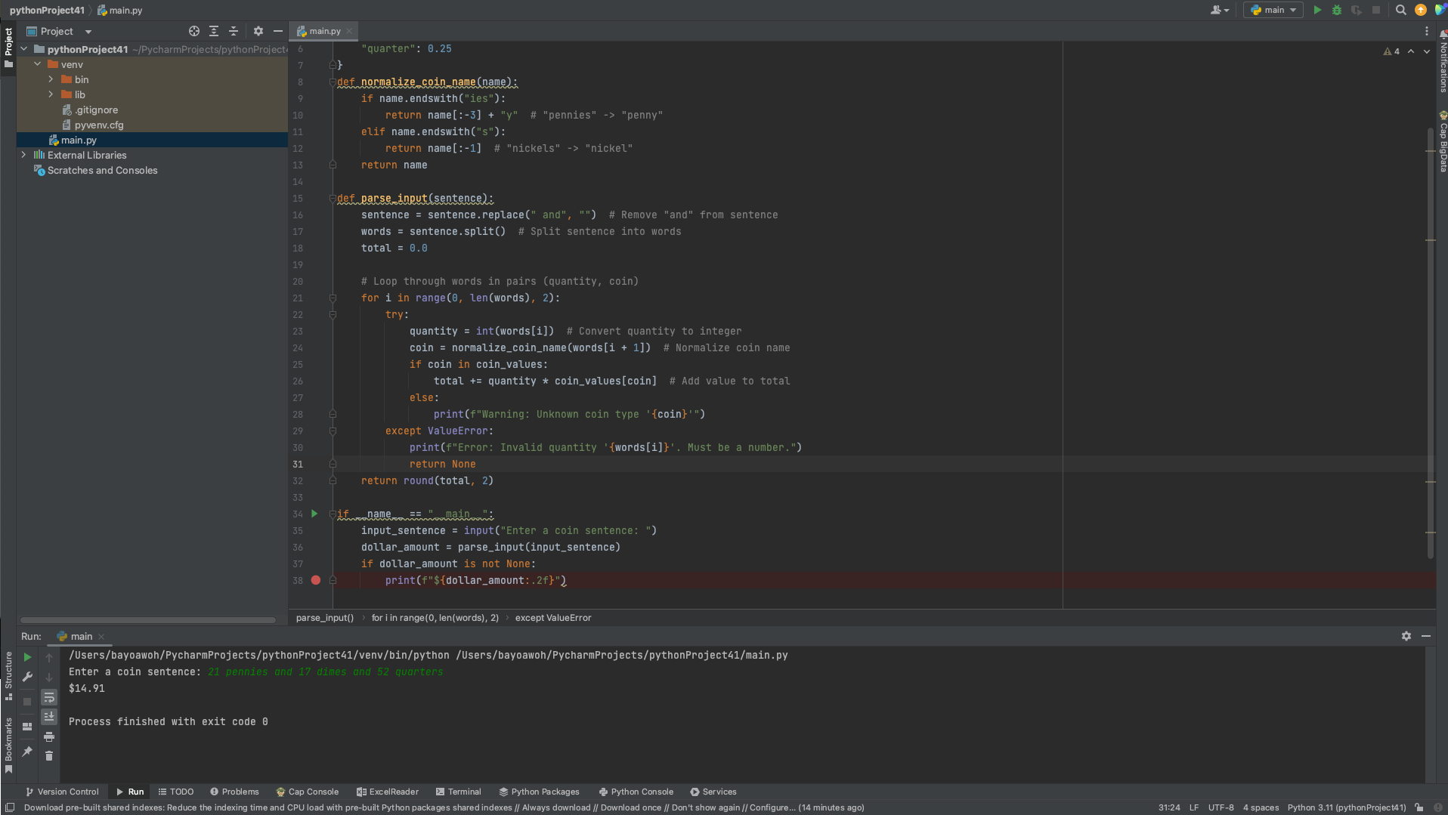
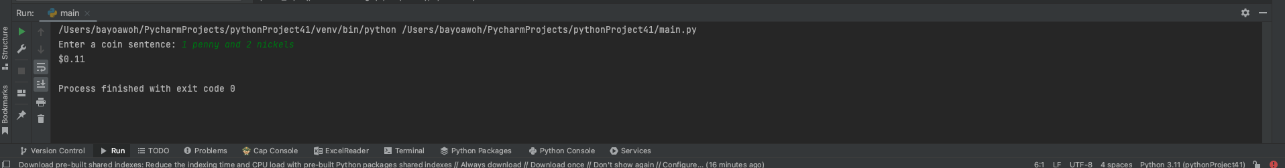
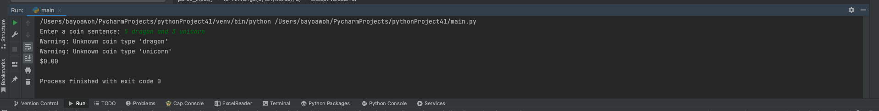

SPRINT 2

1. Updated/Corrected Requirements
After testing the sprint one, this updated was made to correct and refine the requirements:
Input should be a sentence containing pairs of quantity and coin names.
Program should handle both singular and plural forms.
If an invalid coin type is provided, it should display a warning message and continue.
If there’s an incomplete pair or invalid number, an error should be displayed.
Output should be a dollar value rounded to 2 decimal places.

2. Updated /Corrected Design
Updated pseudocode:
START
DEFINE coin-to-value mapping
RECEIVE input from the user
REMOVE "and" from sentence
SPLIT sentence into words
IF total number of words is not even, print error and return
INITIALIZE total to 0
FOR each pair (quantity, coin):
TRY to convert quantity to int
NORMALIZE coin name to singular form
IF coin not in dictionary, print warning
ADD quantity * coin value to total
ROUND total to two decimal places
DISPLAY total
END

3. Corrected Implementation
The code now includes error handling for missing or invalid pairs:
# Mapping the singular coin names to their dollar values
coin_values = {
"penny": 0.01,
"nickel": 0.05,
"dime": 0.10,
"quarter": 0.25
}

def normalize_coin_name(name):
if name.endswith("ies"):
return name[:-3] + "y" # e.g., "pennies" -> "penny"
elif name.endswith("s"):
return name[:-1] # e.g., "nickels" -> "nickel"
return name # already singular

def parse_input(sentence):
# Clean and split the input
sentence = sentence.replace(" and", "") # Remove 'and'
words = sentence.split() # Split into words

# Validating input
if len(words) % 2 != 0:
print("Error: Incomplete input. Each quantity must have a coin name.")
return None

total = 0.0

# Processing each pair (quantity, coin)
for i in range(0, len(words), 2):
quantity_str = words[i]
coin_name = words[i + 1]

try:
quantity = int(quantity_str)
except ValueError:
print(f"Error: '{quantity_str}' is not a valid number.")
return None

normalized_coin = normalize_coin_name(coin_name)

if normalized_coin not in coin_values:
print(f"Warning: '{normalized_coin}' is not a recognized coin type. Skipping.")
continue

coin_value = coin_values[normalized_coin]
total += quantity * coin_value

# Round and return total
return round(total, 2)

if __name__ == "__main__":
input_sentence = input("Enter a coin sentence: ")
dollar_amount = parse_input(input_sentence)
if dollar_amount is not None:
print(f"${dollar_amount:.2f}")

4. Testing (Sprint 2)
Re-test the program with edge cases (e.g., missing quantity, invalid coin type).
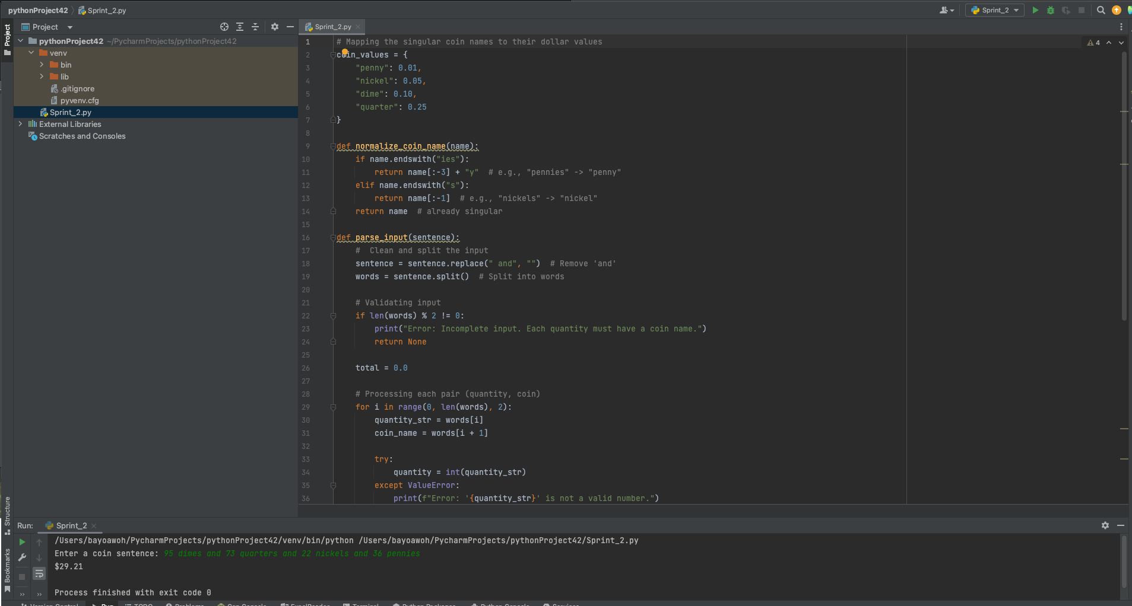
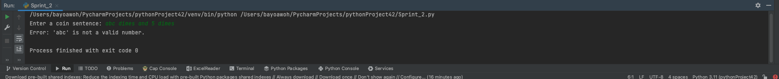

Summary
Input is now fully validated.
Handles singular and plural coin forms.
Skips unrecognized coin names with a warning.
Handles missing quantities and invalid inputs.
Output is properly rounded to two decimal places.

