M. Bayu Bazra 2024250042

**Link API :** https://github.com/bayubazra/UTS-IF3B-2024250042-API

**Pengujian Postman**

**Get** 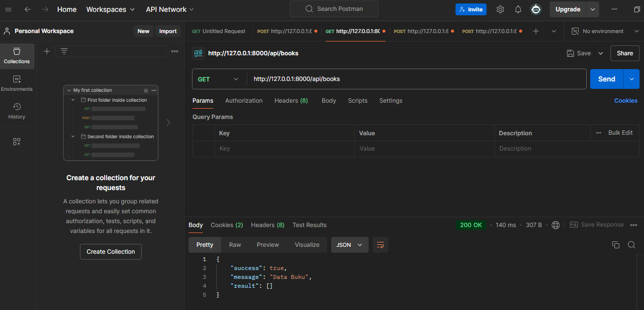

**Post**

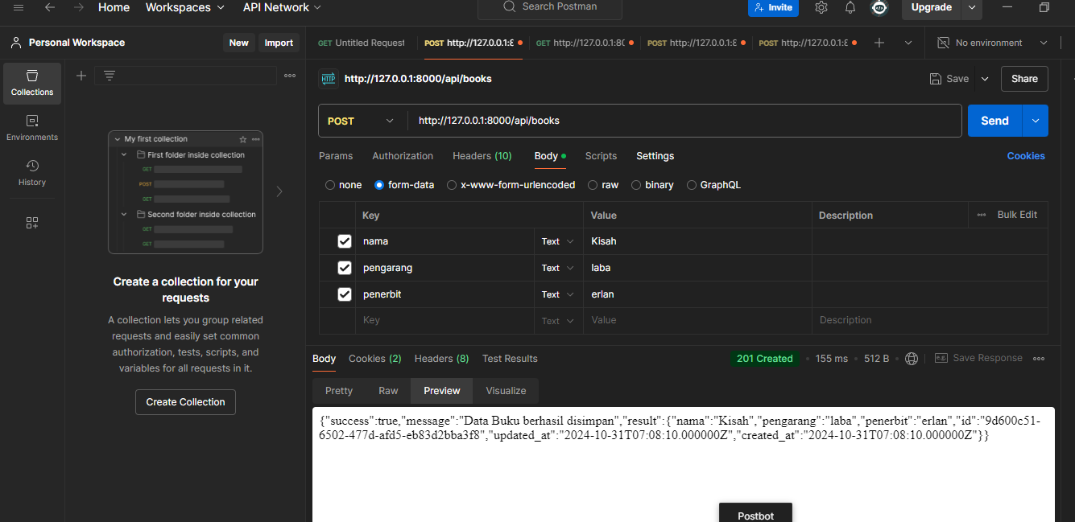

**phpMyAdmin**

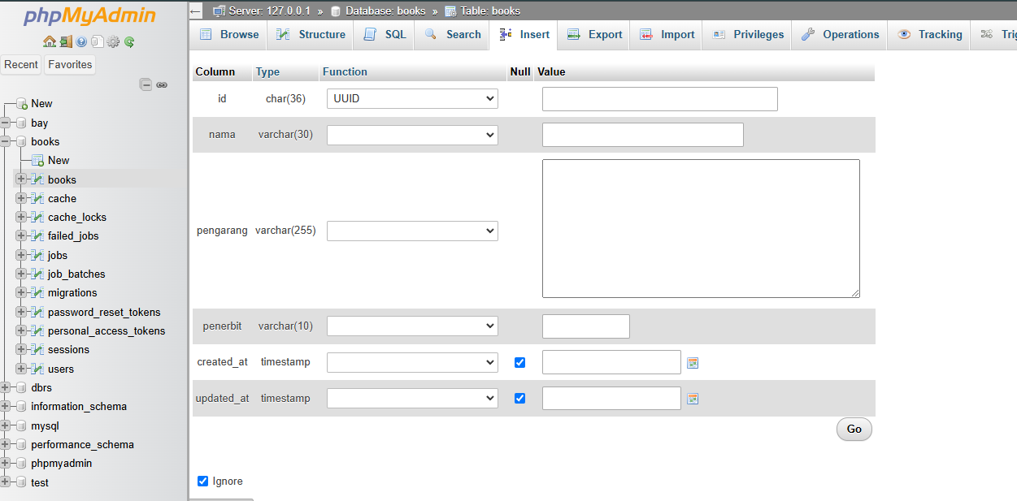

**Clever Cloud**

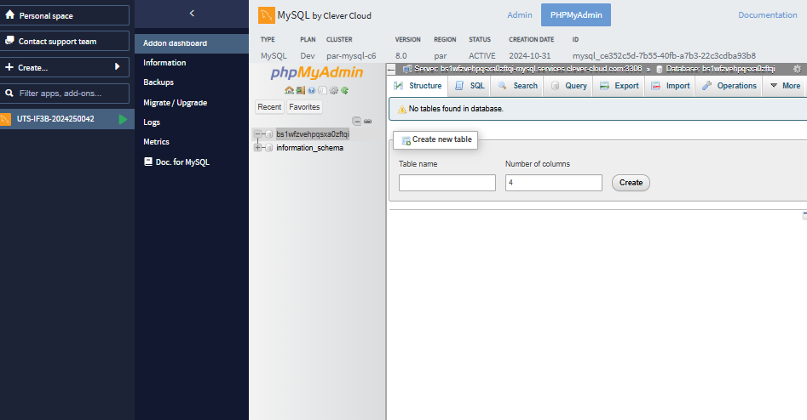

**Vercel**