Portfolio Website

Preparations and Submission Details
- The deadline will be on Thursday in 2nd week at 23.59 (WIB)
- Link to submit the assignment here (will be opened on Wednesday week 2)

Introduction

In this ten-day short course, you’ll learn all about becoming a software engineer, including the career path possibilities. We’ll also give you the opportunity to practice the main responsibilities of a software engineer as well!
Before you start...
- Make sure you have downloaded Visual Studio Code, Git and have access to Google Chrome
Mini Project Instructions
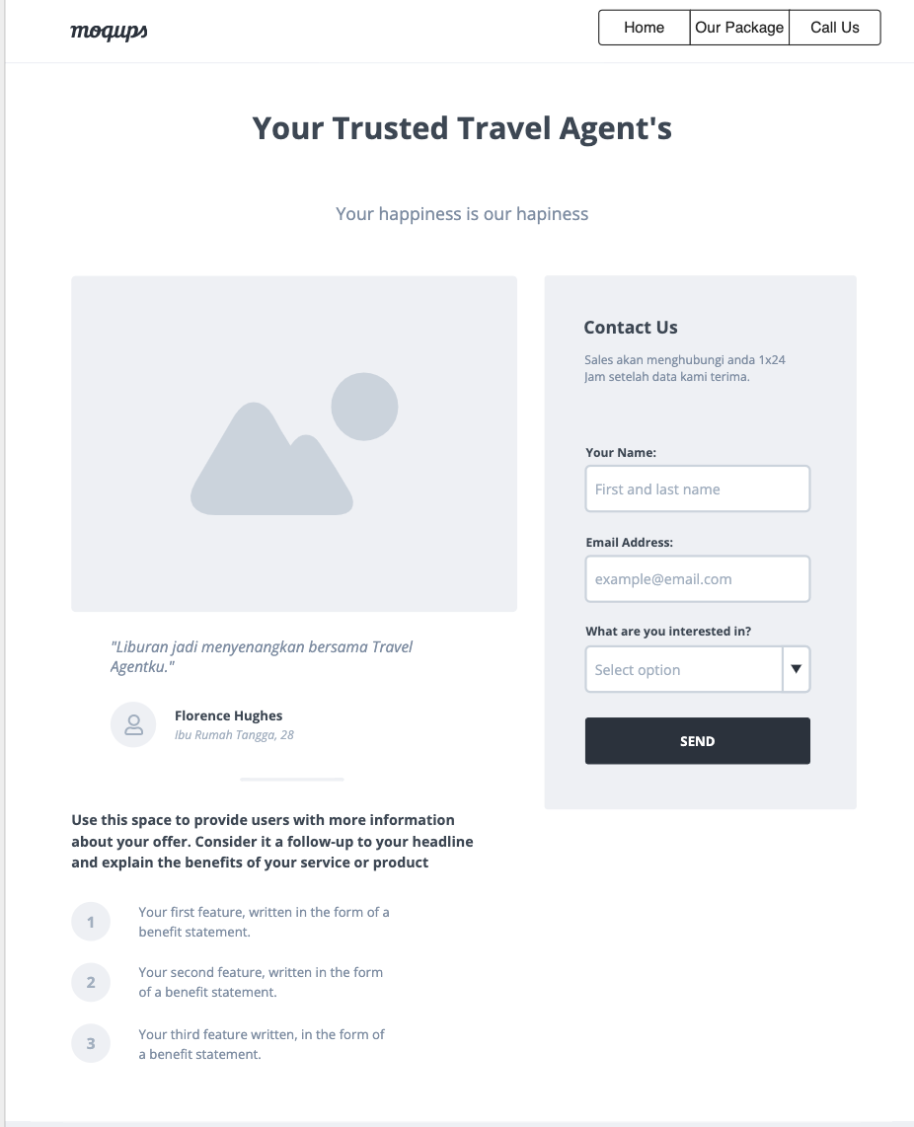
As a Software Engineer, you are asked to create a website for travel agents. You must create banner, information about traveling packages on the home page. Get your client personal information and inquiries (Name, Email, Travel Destination) by using JavaScript validation. Create a website using the mockup design below (completed mockup on this link mockup)

Workflow:
Workflow:
- Slicing according to the mockup above
- Navigation in One Page
- Home = Banner Section (Top of Pages Content)
- Our Package Section (Middle of Pages Content)
- Call Action Section (Bottom of Pages Content)
- Banner use auto slide using JavaScript
- Form Contact Us implements JavaScript Validation.
- Implement Responsive Design on each page (on Desktop and Mobile)
- Put css file inside of the css/ folder
- Please only put only 1 css for the entirety of the project
- Put javascript files inside the js/ folder
- Please put only 1 javascript file for the entirety of the project
- After finish your website, upload Source Code in GitHub Classroom and publish the website in Github Pages
- Submit URL repository and published website through dedicated Typeform submission that will be opened on Wednesday week 2

Mandatory pages (required) :
- index.html (Home Page)
- style.css (Home Page CSS)

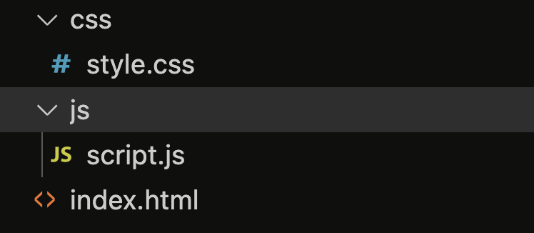
Expected file structure:

