**TUGAS PERSONAL 1**

**Minggu ke 2, Sesi ke 3**

Nama : **Bayu Permana Putra**

NIM : **2440116675**

Mata Kuliah : **Matematika Diskrit**

1. A. Logika Ekivalen

|  |  |  |  |  |
| --- | --- | --- | --- | --- |
| *p* | *q* | *r* | *p→(q→r)* | *(p^q) →r* |
| T | T | F | T→F = F | T→F = F |
| T | F | F | T→T = T | F→F = T |
| F | T | T | F→T = T | F→T = T |
| F | F | T | F→T = T | F→T = T |

B. Validitas Argumen

Dengan table kebenaran

|  |  |  |  |  |  |  |
| --- | --- | --- | --- | --- | --- | --- |
| *p* | *q* | *r* | *p v q* | *p ->r* | *~r* | *(p v q ) ^ ( p -> r) ^ ~r -> q* |
| T | T | T | T | T | F | T ^ T ^ F -> T = **T** |
| T | T | F | T | F | T | T ^ F ^ T -> T = **T** |
| T | F | T | T | T | F | T ^ T ^ F -> F = **T** |
| T | F | F | T | F | T | T ^ F ^ T -> F = **T** |
| F | T | T | T | T | F | T ^ T ^ F -> T = **T** |
| F | T | F | T | T | T | T ^ T ^ T -> T = **T** |
| F | F | T | F | T | F | F ^ T ^ F -> F = **T** |
| F | F | F | F | T | T | F ^ T ^ T -> F = **T** |

Dengan Aturan Inferensi

*p v q*

*p* → *r*

*~r*

∴ r

1. A. Output Sirkuit Kombinatorik

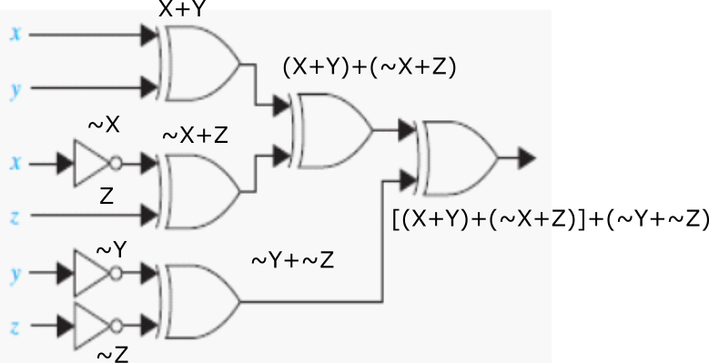

B. Ekspresi Boolean dari F(x, y, z), kemudian ekspresi Boolean dengan K-Map

*F(x, y, z) = xyz + xy’z’ + x’yz’ + x’y’z*

|  |  |  |  |  |
| --- | --- | --- | --- | --- |
|  | *yz* | *yz’* | *y’z’* | *y’z* |
| *x* | *1* |  | *1* |  |
| *x’* |  | *1* |  | *1* |