Nama : Bayu Utomo
NIM : G.231.20.0036
Makul : Rekayasa Web

Request POST localhost:8000/api/login
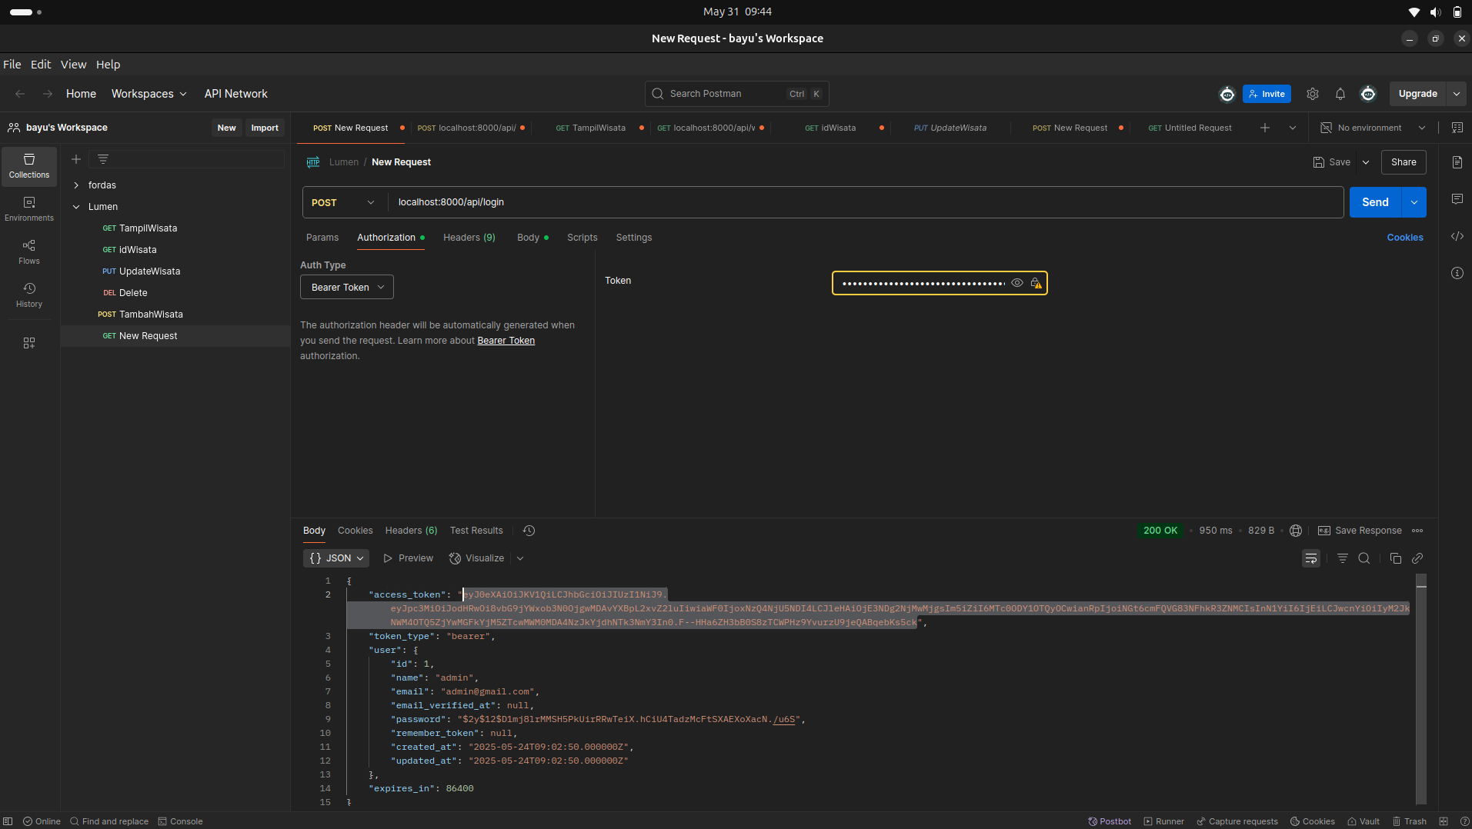
Request POST localhost:8000/api/user-profile
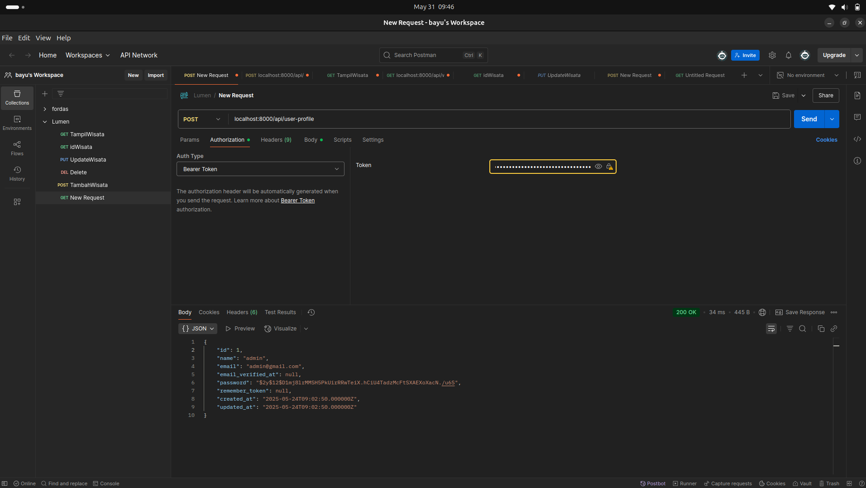

Request POST localhost:8000/api/refresh
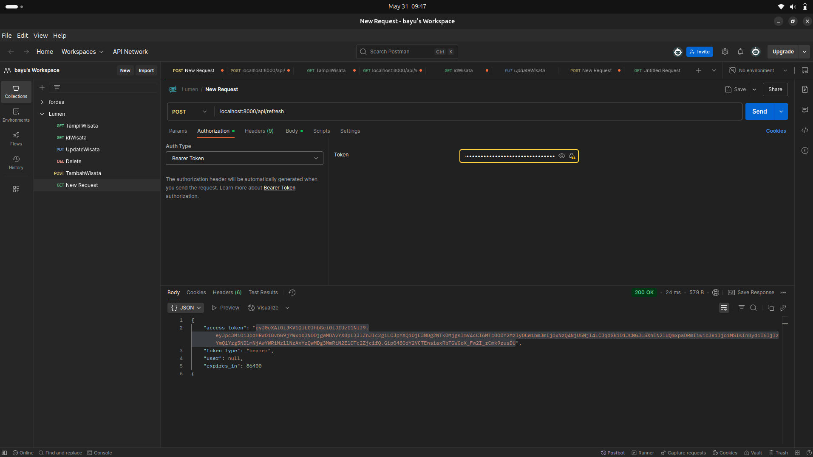
Request GET localhost:8000/api/wisata
no Auth
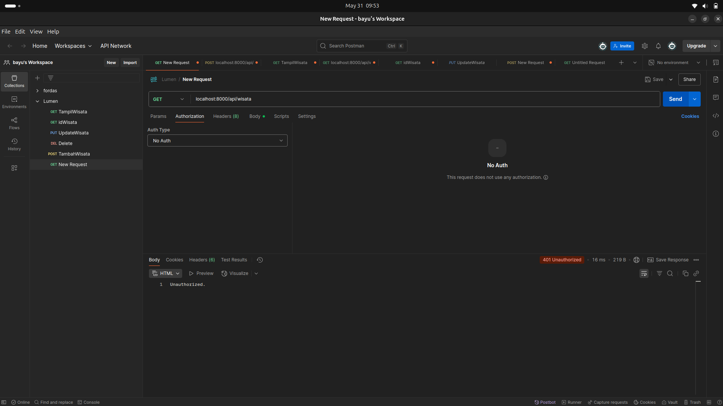

Request GET localhost:8000/api/wisata
barer token
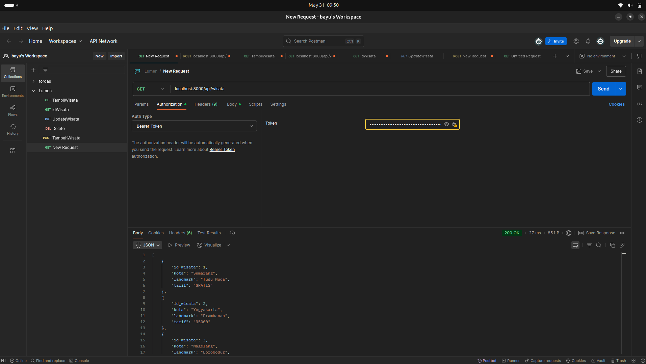

Request POST localhost:8000/api/logout

