**HTML & CSS FINAL EXAM**

Create simple website that consist of six pages: Login, Register, Welcome, Profile, Hobby, and Contact Page.

**RULES:**

* Use DocType HTML5
* Use **external** stylesheet
* **Tableless** Layout, use float for layouting (do not use css flexbox)
* CSS usage utilize: element, ID, class, attribute, and pseudo-class **selector**
* No client side script (eg: Javascript)
* No server side script (eg: php)
* No 3rd party CSS framework (eg: bootstrap)
* Responsive design is a plus

**General rule for page layout**

Consist of three sections: **Header**, **Content**, and **Footer** (except Login and Register page)

**What are the contents of each section?**

* **Header**: FREE (it could be logo/image, text, etc). But it must have Navigation bar.
  + **Navigation:** Home, Profile, Hobby, Contact.
* **Content**: must follow instruction per page below.
* **Footer**: copyright, your name.

**Position of elements** inside **header & footer** section is **FREE**.

E.g. Navigation bar could be on top/bottom/right/left/center inside Header section.

E.g. Copyright could be on top/bottom/right/left/center inside Footer section.

**About the scoring**

* Follow rules & instructions
* Valid & semantically correct HTML Docs
* Creativity

**Zip your work and upload to e-learning using this format:**

**Filename: Final_HTMLCSS_<yourname>.zip**

**E.g.: Final_HTMLCSS_WellyaSeptin.zip**

*Be creative & unique (Discussion is allowed but Never copy your friend's work).*

*.*

1. Login Page (**index.html**)

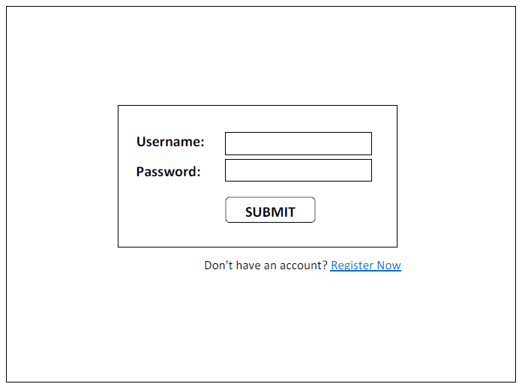

**Instruction:**

* No Header & Footer.
* Contain Login Form with fields:
  + Username (Textbox)
  + Password (Textbox with type=password)
  + Submit Button (Button)
  + When clicking "Submit" button, it goes to Home page - **home.html**.
* Contain a link to Register page - **register.html**.
* Position of Form, Label, Field, Button, and Link are FREE.

2. Register Page (**register.html**)

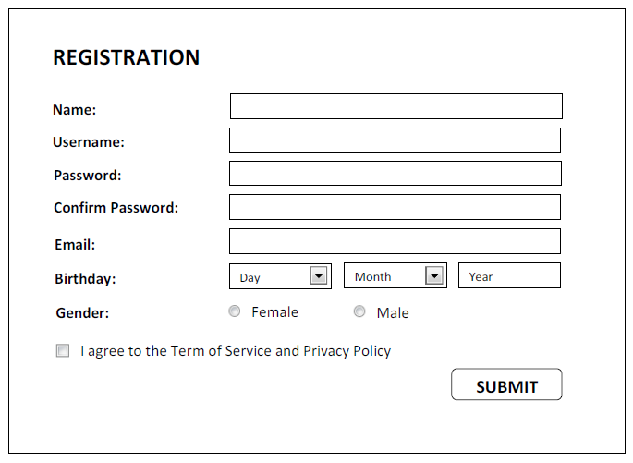

**Instruction:**

* No Header & Footer.
* Contain Register Form with fields:
  + Name (Textbox)
  + Username (Textbox)
  + Password (Textbox with type=password)
  + Confirm Password (Textbox with type=password)
  + Email (Textbox)
  + Birthday (Day Dropdown, Month Dropdown, Year Textbox )
  + Gender (Radio Button with 2 options: Female & Male)
  + Agreement to Term (Checkbox)
  + Submit Button (Button)
  + When clicking "Submit" button, it goes to Login page - **index.html**.
* Position of Form, Label, Field, and Button are FREE.

3. Home Page (**home.html**)

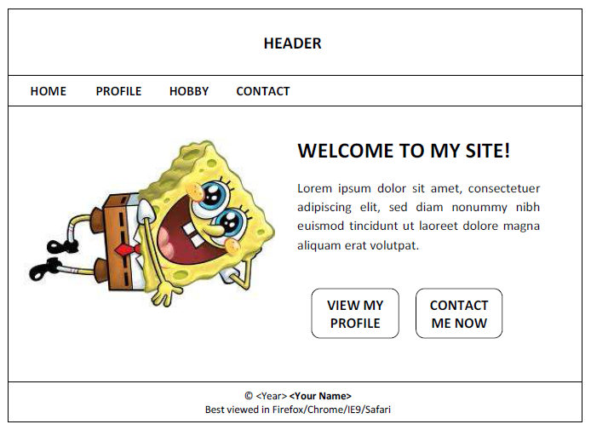

**Instruction:**

* Content is **One Column** layout.
* Contain:
  + Image on left
  + Text & two Links/Buttons on right
* One link goes to Profile page (**profile.html**) and other goes to Contact page (**contact.html**).

4. Profile Page (**profile.html**)

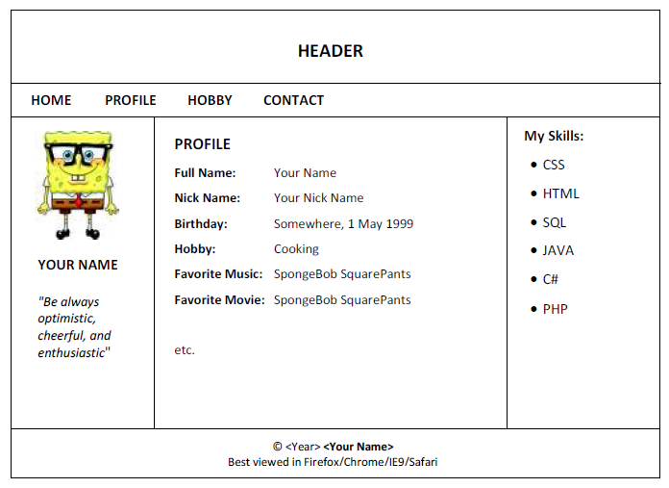

**Instruction:**

* Content is divided into **Three Columns** layout.
* **Left Column** contains your photo, your nickname, and your favorite quote. Position of them is FREE.
* **Middle Column** contains your profile. It may in list style (**minimum 10 lists**) or essay style (**minimum 50**
* **words**).
* **Right Column** contains your skills. It must be in list. You may add your IT related work/experience here.

5. Hobby Page (**hobby.html**)

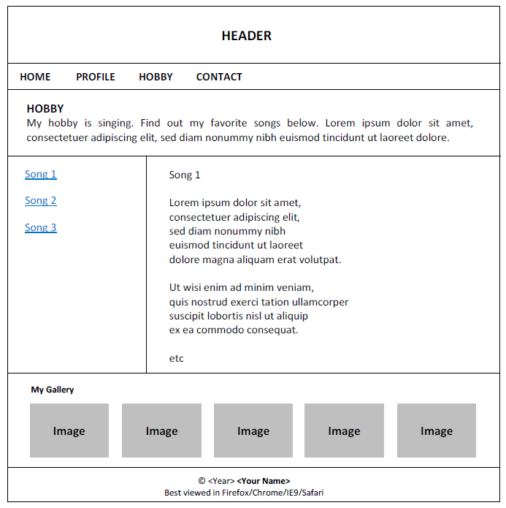

**Instruction:**

* Content is divided into **Three Rows** layout (Content Top, Content Middle, Content Bottom)
* Content Top is **One Column** layout. It contains brief explanation about your hobby.
* Content Middle is **Two Columns** Layout. It contains your collection in your hobby (**minimum 3 items**).

E.g. Hobby: Singing. Collection: Favorite Songs.

E.g. Hobby: Cooking. Collection: Favorite Recipes.

E.g. Hobby: Playing Basketball. Collection: Favorite Player's Profiles.

**Left Column**: List of collection items as link (with anchor). When it is clicked, it jumps to its description.

**Right Column**: Description of collection items.

Extra point: If you can add "Go to Top" link with position FIXED. When we scroll far down from the top, we

can click it for jumping back to the top.

* Content Bottom is **One Column** layout. It contains your favorite images (**minimum 5 images**).

6. Contact Page (**contact.html**)

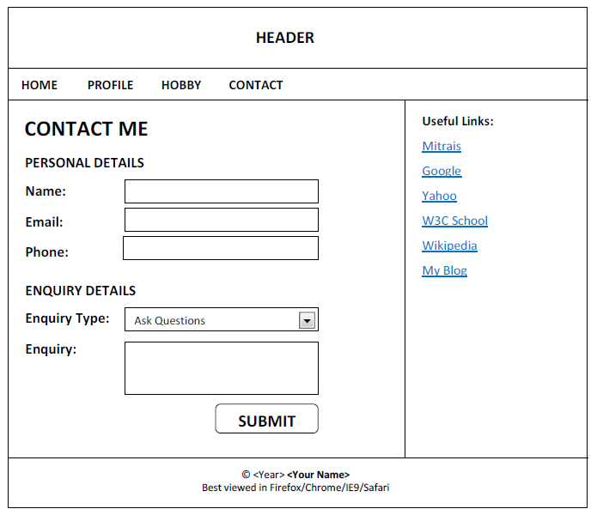

**Instruction:**

* Content is divided into **Two Columns** layout**.**
* **Left Column** contains Contact Form with fields:
  + Personal Details Fieldset:
    - Name (Textbox)
    - Email (Textbox)
    - Phone (Textbox)
  + Enquiry Details Fieldset:
    - Enquiry Type (Dropdown). The options are: Ask Questions, Feedback, and Request.
    - Enquiry (Textarea)
  + Submit Button
  + When clicking "Submit" button, it goes to Home page - **home.html**.
* **Right Column** contains list of Useful Links (**minimum 6 links**).