File System Hierarchy:
(HTB Academy,opensource.com, )
- The Linux operating system is structured in a tree-like hierarchy and is documented in the Filesystem Hierarchy Standard (FHS).
- The entire Linux directory structure starting at the top (/) root directory. A specific type of data storage format, such as EXT3, EXT4, BTRFS, XFS, and so on. Linux supports almost 100 types of filesystems, including some very old ones as well as some of the newest. Each of these filesystem types uses its own metadata structures to define how the data is stored and accessed.56
- All filesystems need to provide a namespace—that is, a naming and organizational methodology. This defines how a file can be named, specifically the length of a filename and the subset of characters that can be used for filenames out of the total set of characters available. It also defines the logical structure of the data on a disk, such as the use of directories for organizing files instead of just lumping them all together in a single, huge conglomeration of files.
- Once the namespace has been defined, a metadata structure is necessary to provide the logical foundation for that namespace. This includes the data structures required to support a hierarchical directory structure; structures to determine which blocks of space on the disk are used and which are available; structures that allow for maintaining the names of the files and directories; information about the files such as their size and times they were created, modified or last accessed; and the location or locations of the data belonging to the file on the disk. Other metadata is used to store high-level information about the subdivisions of the disk, such as logical volumes and partitions. This higher-level metadata and the structures it represents contain the information describing the filesystem stored on the drive or partition, but is separate from and independent of the filesystem metadata.
- Filesystems also require an Application Programming Interface (API) that provides access to system function calls which manipulate filesystem objects like files and directories. APIs provide for tasks such as creating, moving, and deleting files. It also provides algorithms that determine things like where a file is placed on a filesystem. Such algorithms may account for objectives such as speed or minimizing disk fragmentation.
- Modern filesystems also provide a security model, which is a scheme for defining access rights to files and directories. The Linux filesystem security model helps to ensure that users only have access to their own files and not those of others or the operating system itself.
- The final building block is the software required to implement all of these functions. Linux uses a two-part software implementation as a way to improve both system and programmer efficiency.
- The first part of this two-part implementation is the Linux virtual filesystem. This virtual filesystem provides a single set of commands for the kernel, and developers, to access all types of filesystems. The virtual filesystem software calls the specific device driver required to interface to the various types of filesystems. The filesystem-specific device drivers are the second part of the implementation. The device driver interprets the standard set of filesystem commands to ones specific to the type of filesystem on the partition or logical volume.
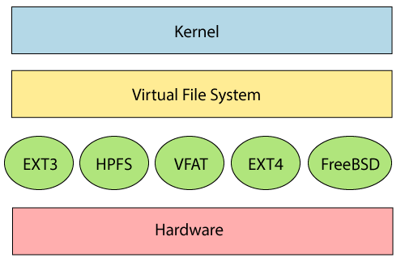
- Above, figure describes, The Linux two-part filesystem software implementation.
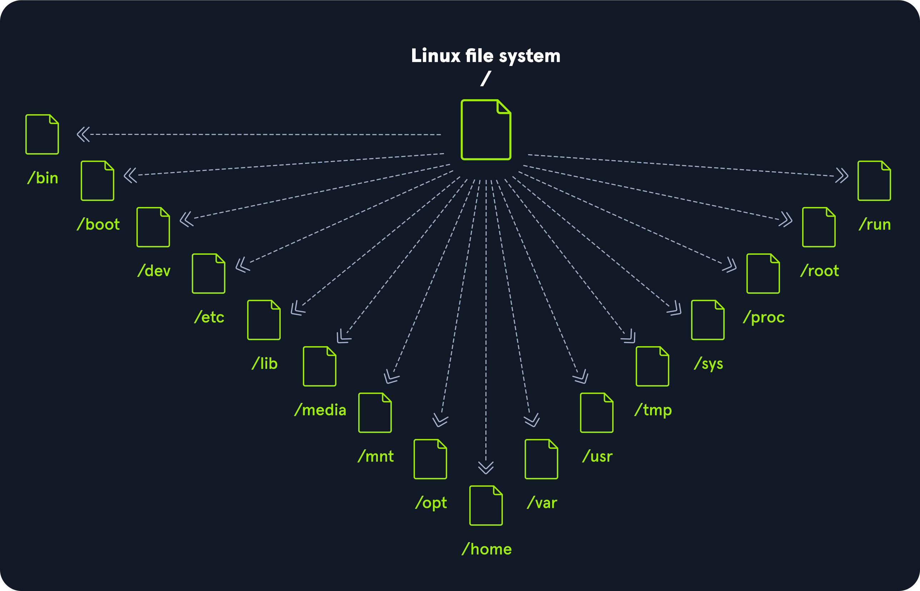
- Linux is structured with the above standard top-level directories.
- ‘/’ directory: The top-level directory is the root filesystem and contains all of the files required to boot the operating system before other filesystems are mounted as well as the files required to boThe entire Linux directory structure starting at the top (/) root directory.ot the other filesystems. After boot, all of the other filesystems are mounted at standard mount points as subdirectories of the root.
- ‘/bin’ directory: Contains essential command binaries.
- ‘/boot’ directory: Consists of the static bootloader, kernel executable, and files required to boot the Linux OS.
- ‘/dev’ directory: Contains device files to facilitate access to every hardware device attached to the system.These are not device drivers, rather they are files that represent each device on the computer and facilitate access to those devices.
- ‘/etc’ directory: Local system configuration files. Configuration files for installed applications may be saved here as well.
- ‘/home’ directory: Home directory storage for user files.Each user on the system has a subdirectory here for storage.
- ‘/lib’ directory: Contains shared library files that are required to boot the system.
- ‘/media’ directory: External removable media devices such as USB drives are mounted here.
- ‘/mnt’ directory: A temporary mountpoint for regular filesystems (as in not removable media) that can be used while the administrator is repairing or working on a filesystem.
- ‘/opt’ directory: Optional files such as vendor supplied, third-party application programs should be located here.
- ‘/root’ directory: It’s the home directory of the root user. Note, this isn’t the “/” - root filesystem.
- ‘/sbin’ directory: This directory contains executables used for system administration (binary system files).
- ‘/tmp’ directory: The operating system and many programs use this directory to store temporary files. This directory is generally cleared upon system boot and may be deleted at other times without any warning.
- ‘/usr’ directory: These are sharable, read-only files, including executable binaries & libraries, man files, and other types of documentation.
- ‘/var’ directory: Variable data files are stored here. This can include things like log files, MySQL, and other database files, web server data files, email inboxes, web application related files, cron files, and more.
- ‘/boot’, ‘/bin’, ‘/etc’, ‘/dev’, ‘/lib’, ‘/root’, ‘/sbin’ are considered an integral part of the root filesystem. That is, they cannot be created as a separate filesystem and mounted at startup time. This is because they (specifically, their contents) must be present at boot time in order for the system to boot properly.
- The ‘/media’ and ‘/mnt’ directories are part of the root filesystem, but they should never contain any data. Rather, they are simply temporary mount points.
- The remaining directories, do not need to be present during the boot sequence, but will be mounted later, during the startup sequence that prepares the host to perform useful work.

