PROJECT REPORT
On

AVOIDING INTRUDER AND SECURE DATA COMMUNICATION USING SDR

Submitted for partial fulfilment for the award of the degree

BACHELOR OF TECHNOLOGY
in
ELECTRONICS AND COMMUNICATION ENGINEERING
By
B.S.V.D.Prakash (1041240190)
V.Sai Santhosh (1041240143)
B.Vishnu Reddy (1041240129)

Under the guidance of
Ms. Yuvarajeshwari
(Assistant Professor, Department of Electronics and Communication Engineering)


DEPARTMENT OF ELECTRONICS & COMMUNICATION ENGINEERING
FACULTY OF ENGINEERING AND TECHNOLOGY
SRM UNIVERSITY,VADAPALANI- 600 026
MAY 2016
BONAFIDE CERTIFICATE

Certified that this project report titled “AVOIDING INTRUDER AND SECURE DATA COMMUNICATION USING SDR” is the Bonafide work of Mr. B.S.V.D.PRAKASH (Reg. No. 1041240190), Mr.B.VISHNU VARDHAN REDDY(Reg. No. 1041240129) and Mr.V.SAI SANTHOSH (Reg. No. 1041240143) who carried out the project work under my supervision as a batch. Certified further, that to the best of my knowledge the work reported herein does not form any other project report on the basis of which a degree or award was conferred on an earlier occasion for this or any other candidate.

Project guide Head of the Department
Ms. Yuvarajeshwari Dr. C. Gomathy
Asst. Prof.(O.G) H.O.D
Department of ECE, Department Of ECE,
SRM University SRM University

Date:

Submitted for University Examination held in May 2016 at SRM UNIVERSITY,
Vadapalani, Chennai-600 026.

Date: Internal Examiner External Examiner

ACKNOWLEDGEMENT

It has been an enjoyable journey over our cherished years at the SRMUniversity. This work would not have been completed without motivation and help from our
SRM UNIVERSITY MANAGEMENT.

We would like to express our sincere gratitude to Director of Engineering and Technology Dr.C.Muthamizhchelvan and Head of the Department, Electronics and Communication Engineering Dr.C.GOMATHY, for her support and constant encouragement throughout the project.

We are also grateful to the faculty members Ms. Vidyalakshmi, Ms. P. Radhika and
Ms. Kolangiammalfor reviewing our project and providing valuable feedbacks and suggestions amidst their busy schedule. We would like to have a special mention of our classteacher Ms.J.Radhika for her guidance.This work would not have been possible without motivation and help from our guide Ms. Sabitha Gauni, Asst. Professor(O.G).

We could not have finished this work without support from our family. They are dearest in heart and great source of motivation. Our hearty appreciation and thanks to our friends whose support and encouragement made all this possible.

SYNOPSIS

In today's world, radios exist in a multitude of items such as cell phones, computers, car door openers, vehicles, and televisions. The exponential growth in the ways and means by which people need to communicate - data communications, voice communications, video communications, broadcast messaging, command and control communications, emergency response communications etc. Modifying radio devices easily and cost effectively has become business critical. Software defined radio technology brings the flexibility, cost efficiency and power to drive communications forward, with wide-reaching benefits realized by service providers and product developers through to end users. A radio is any kind of device that wireless transmits or receives signals in the radio frequency part of the electromagnetic spectrum to facilitate the transfer of information. Traditional hardware based radio devices limit cross-functionality and can only be modified through physical intervention. This results in higher production costs and minimal flexibility in supporting multiple waveform standards. By contrast, software defined radio technology provides an efficient and comparatively inexpensive solution to this problem, allowing multimode, multi-band and/or multi-functional wireless devices that can be enhanced using software upgrades.

.

LIST OF FIGURES
FIGURE NO. FIGURE NAME PAGE NO.
1.1 Arichtecture of SDR 2
1.2 Transceiver Block Diagram of user 1 3
1.3 Transceiver Block Diagram of user 2 4
1.4 Intruder Section 4
3.1 Atmel 89s52 7
3.2 Pin Diagram 9
3.3 Block Diagram 10
3.4 Internal Diagram 18
3.5 Special Function Registers 19
3.6 I/o ports 21
3.7 Crystal Oscillator 21
3.8 Timer/Counter 23
3.9 Power Supply Graph 24
3.10 Serial Communication 24
3.11 Rf Receiver 31

LIST OF TABLES

TABLE NO. TABLE NAME PAGE NO.

3.1 Port 1 Discription 11
3.2 Port 3 Discription 12
3.3 Difference Between First Method
And Second Method 42

TABLE OF CONTENTS
ACKNOWLDGEMENT iii
SYNOPSIS iv
LIST OF FIGURES v
LIST OF TABLES vi

CHAPTER NO. CHAPTER NAME PAGE NO.

1. INTRODUCTION 1
1.1 SOFTWARE DEFINED RADIO 2
1.2 BLOCK DIAGRAM 3
2. LITERATURE SURVEY 5
3. HARDWARE COMPONENT DESIGN 7
3.1 MICROCONTROLLER 7
3.1.1 FEATURES 7
3.1.2 DISCRIPTION 8
3.1.3 PIN CONFIGURATION 9
3.1.4 BLOCK DIAGRAM 10
3.1.5 PIN DISCRIPTION 11
3.1.6 USES 16
3.1.7 WORKING 17
3.1.7 APPLICATIONS 26

3.2 RF TRANSMITTER 30

3.3 RF RECEIVER 31
3.3.1 SIGNAL/NOISE RATIO 32
3.3.2 INTEGRATION 36
3.3.3 PRECISION OF THE CLOCKS 39
3.3.4 BANDWIDTH 40
3.3.5 ACCUMULATOR ATTENUATION 41
3.3.6 SUPER HETRODYNE RECEIVER 44
3.3.7 WAYS TO ENHANCE COMMUNICATION 46
3.3.8 SPECTRUM EFFICEINCY 48

4. SOFTWARE ANALYSIS 49
4.1 INTRODUCTION 49
4.2 KEIL COMPILER 49
4.3 COMPILING WITH Cx51 50
4.4 8051 DERIVATIVE 51
4.5 ATMEL 89X8252 VARIANTS 52
4.6 VISUAL BASIC 52
4.7 SUMMARY 54

5. CONCLUSION 55
6. REFERENCES 56

ABSTRACT

In today's world, radios exist in a multitude of items such as cell phones, computers, car door openers, vehicles, and televisions. The exponential growth in the ways and means by which people need to communicate - data communications, voice communications, video communications, broadcast messaging, command and control communications, emergency response communications etc. Modifying radio devices easily and cost effectively has become business critical. Software defined radio technology brings the flexibility, cost efficiency and power to drive communications forward, with wide-reaching benefits realized by service providers and product developers through to end users. A radio is any kind of device that wireless transmits or receives signals in the radio frequency part of the electromagnetic spectrum to facilitate the transfer of information. Traditional hardware based radio devices limit cross-functionality and can only be modified through physical intervention. This results in higher production costs and minimal flexibility in supporting multiple waveform standards. By contrast, software defined radio technology provides an efficient and comparatively inexpensive solution to this problem, allowing multimode, multi-band and/or multi-functional wireless devices that can be enhanced using software upgrades.
Proposed System is an Software defined radio which can tune to any frequency band. It can able to transmit and receive different modulations and different physical parameters across the large frequency spectrum by programmable hardware and software. An SDR performs significant amount of signal processing in a general purpose computer on a reconfigurable pulse of digital electronics on the combination of both. The platform to transmit and receive the OFDM radio signal with QPSK and BPSK modulation. Here we are changing the modulation block and parameters into software by using embedded Technology.

CHAPTER-1
INTRODUCTION

SDR was seen as a technology that could facilitate the inter working of all different radios and radio systems used within the forces. The aim was to eventually reduce the number of different radio systems used by the different military services. However, implementation of such software radio is not possible with current processor technology and it will even be unnecessary for many applications. In some cases the possibility to connect to only a small number of different air interfaces might suffice, while in other cases only higher layer functionality needs reconfiguration with the radio configuration remaining unaltered. Until processors reach sufficient capabilities and processing power to fully implement all functions within a radio in software, compromises and customised solutions for terminals able to connect via multiple modes will have to be made. In the military domain, the main aim of SDR Technology was to reduce the number of different radio systems and to increase inter working between the different systems. In contrast, in the commercial domain SDR Technology can help to increase service offerings through temporal allocation of extra frequency bands.
Much of the research focus into SDR technology has shifted towards finding attractive application areas. In the US and in Asia the SDR research focus remains on the development of powerful SDR platforms. This also includes reduction of power requirements and development of platforms capable of digitising and computing IF (and in future RF) signals. Efforts in Europe concentrate mainly on the development of hybrid radio architectures and on the mechanisms necessary to smoothly reconfigure radios. The idea of using SDR Technology as a facilitator for a ‘seamless experience’, based on services flexibility (i.e. service provision via different underlying technologies) is the driver for the European E2 R initiative. Cognitive radio and therein the dynamic and flexible allocation of radio resources is the other main application area currently researched.
Flexible combinations of software and hardware are typically needed to implement the transmission characteristic of a radio. Within the old regulatory scheme, the time to certify such a terminal would have been intolerably long. Introduction of the R&TTE directive, allowing manufacturers to self-certify radio wave emitting equipment eased the situation. However, with the potential to install an unlimited number of possible software configurations on one programmable SDR platform, the current ways of regulating and certifying equipment are not sufficient. Technical solutions are required to overcome this problem. These technical solutions have to include mechanisms to determine, dependent on the scenario, the combination configuration (i.e. HW/SW combination) that may be implemented on a configuration SDR platform.
  - SOFTWARE DEFINED RADIO
A number of definitions can be found to describe Software Defined Radio, also known as Software Radio or SDR. The SDR Forum, working in collaboration with the Institute of Electrical and Electronic Engineers (IEEE) P1900.1 group, has worked to establish a definition of SDR that provides consistency and a clear overview of the technology and its associated benefits.Simply put Software Defined Radio is defined as
"Radio in which some or all of the physical layer functions are software defined".
A radio is any kind of device that wirelessly transmits or receives signals in the radio frequency (RF) part of the electromagnetic spectrum to facilitate the transfer of information. In today's world, radios exist in a multitude of items such as cell phones, computers, car door openers,vehicles, and televisions.
Traditional hardware based radio devices limit cross-functionality and can only be modified through physical intervention. This results in higher production costs and minimal flexibility in supporting multiple waveform standards. By contrast, software defined radio technology provides an efficient and comparatively inexpensive solution to this problem, allowing multimode,multi-band and/or multi-functional wireless devices that can be enhanced using software upgrades.

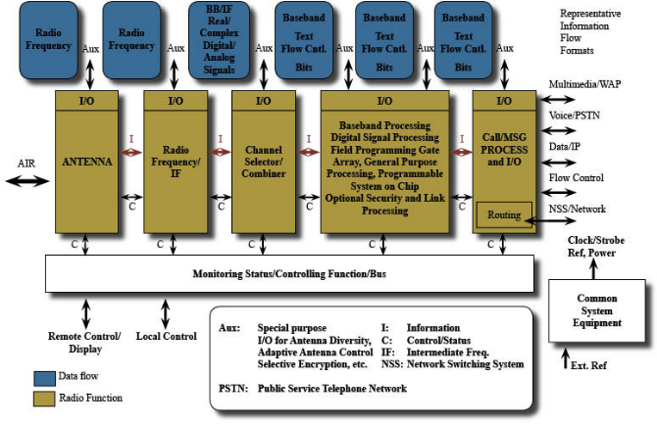

Figure.1.1: Architecture of sdr
SDR defines a collection of hardware and software technologies where some or all of the radio’s operating functions (also referred to as physical layer processing) are implemented through modifiable software or firmware operating on programmable processing technologies. These devices include field programmable gate arrays (FPGA), digital signal processors (DSP),general purpose processors (GPP), programmable System on Chip (SoC) or other application specific programmable processors. The use of these technologies allows new wireless features and capabilities to be added to existing radio systems without requiring new hardware.
  - BLOCK DIAGRAM
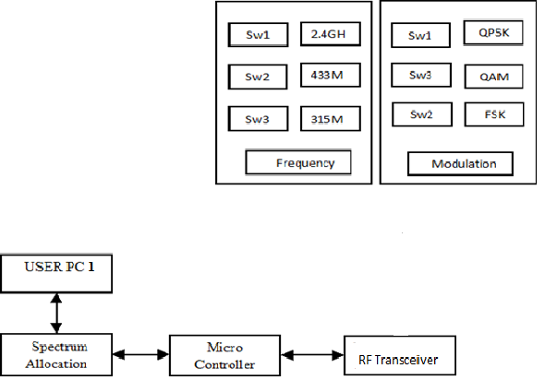
Figure.1.2: Tranceiver section user 1

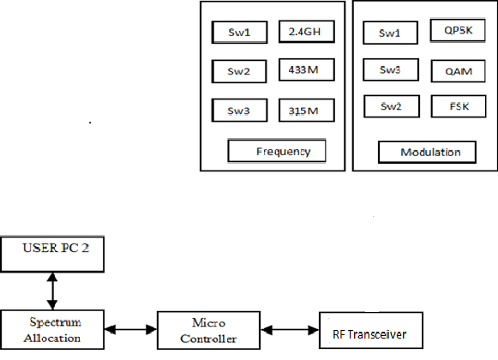
Figure.1.3: Transceiver section of user 2
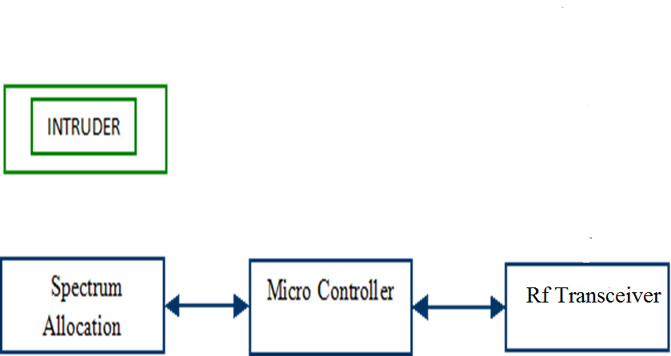
Figure.1.4: Intruder section

CHAPTER-2
LITERATURE SURVEY

1.Software-defined radio (SDR) is a self-contained, embedded software system with hardware components and real-time constraints. SDR is the basis for many of today's wireless communications systems. Because SDR combines basic digital signal processing, circuitry, and software elements, it is the perfect project for multi-disciplinary, undergraduate teams. This paper explains both the SDR system created by computer science and engineering undergraduates at Grove City College and how SDR projects can help undergraduates acquire the skills to succeed on multidisciplinary teams.

2.Combining MIMO with OFDM, it is possible to significantly reduce receiver complexity as OFDM greatly simplifies equalization at the receiver. MIMO-OFDM is currently being considered for a number of developing wireless standards; consequently, the study of MIMO-OFDM in realistic environments is of great importance. This paper describes an approach for prototyping a MIMO-OFDM systems using a flexible software defined radio (SDR) system architecture in conjunction with commercially available hardware. An emphasis on software permits a focus on algorithm and system design issues rather than implementation and hardware configuration. The penalty of this flexibility, however, is that the ease of use comes at the expense of overall throughput. To illustrate the benefits of the proposed architecture, applications to MIMO-OFDM system prototyping and preliminary MIMO channel measurements are presented. A detailed description of the hardware is provided along with downloadable software to reproduce the system.

3.Radio Frequency Identification (RFID) is currently the hottest technology in wireless applications area.Its unique advantages such as data transmission with extreme low power or even without power in tag can be the biggest beneficial for goods management. Software-Defined Radio(SDR) is a wireless communications system where all of the signal processing is implemented in software. By simply downloading a new program, a software radio is able to interoperate with different wireless protocols, incorporate new services, and upgrade to new standards. In this paper, we build an RFID application simulation environment over the SDR. We do the source to sink transmission simulation by using Quadrature Amplitude Modulation, Then, we compare the differences of BER versus SNR performances for input and output signals.

4.Telecommunications have been in constant evolution during past decades. Among the technological innovations, the use of digital technologies is very relevant. Digital communication systems have proven their efficiency and brought a new element in the chain of signal transmitting and receiving, the digital processor. This device offers to new radio equipments the flexibility of a programmable system. Nowadays, the behavior of a communication system can be modified by simply changing its software. This gave rising to a new radio model called Software Defined Radio (or Software-Defined Radio - SDR). In this new model, one moves to the software the task to set radio behavior, leaving to hardware only the implementation of RF front-end. Thus, the radio is no longer static, defined by their circuits and becomes a dynamic element, which may change their operating characteristics, such as bandwidth, modulation, coding rate, even modified during runtime according to software configuration. This article aims to present the use of GNU Radio software, an open-source solution for SDR specific applications, as a tool for development configurable digital radio.

CHAPTER-3
HARDWARE DESIGN DETAILS

3.1.MICROCONTROLLER

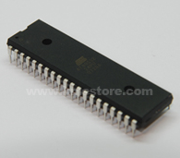

Figure 3.1 AT89s52 Microcontroller

The AT89S52 is a low-power, high-performance CMOS 8-bit microcontroller with 8K bytes of in-system programmable Flash memory. The device is manufactured using Atmel’s high-density nonvolatile memory technology and is compatible with the Indus-try-standard 80C51 instruction set and pin out.

3.1.1 Features:
- Compatible with MCS®-51 Products.
- 8K Bytes of In-System Programmable (ISP) Flash Memory – Endurance: 1000 Write/Erase Cycles.
- 4.0V to 5.5V Operating Range.
- Fully Static Operation: 0 Hz to 33 MHz.
- Three-level Program Memory Lock.
- 256 x 8-bit Internal RAM.
- 32 Programmable I/O Lines.
- Three 16-bit Timer/Counters.
- Eight Interrupt Sources.
- Full Duplex UART Serial Channel.
- Low-power Idle and Power-down Modes.
- Interrupt Recovery from Power-down Mode.
- Watchdog Timer.
- Dual Data Pointer.
- Power-off Flag.
- Fast Programming Time.
- Flexible ISP Programming (Byte and Page Mode).
- Green (Pb/Halide-free) Packaging Option.

3.1.2 Description:

The AT89S52 is a low-power, high-performance CMOS 8-bit microcontroller with 8K bytes of in-system programmable Flash memory.

The device is manufactured using Atmel’s high-density nonvolatile memory technology and is compatible with the Indus-try-standard 80C51 instruction set and pin out.

The on-chip Flash allows the program memory to be reprogrammed in-system or by a conventional nonvolatile memory pro-grammars. By combining a versatile 8-bit CPU with in-system programmable Flash on a monolithic chip, the Atmel AT89S52 is a powerful microcontroller which provides a highly-flexible and cost-effective solution to many embedded control applications.

The AT89S52 provides the following standard features: 8K bytes of Flash, 256 bytes of RAM, 32 I/O lines, Watchdog timer, two data pointers, three 16-bit timer/counters, a six-vector two-level interrupt architecture, a full duplex serial port, on-chip oscillator, and clock circuitry.

In addition, the AT89S52 is designed with static logic for operation down to zero frequency and supports two software selectable power saving modes. The Idle Mode stops the CPU while allowing the RAM, timer/counters, serial port, and interrupt system to continue functioning.

The Power-down mode saves the RAM con-tents but freezes the oscillator, disabling all other chip functions until the next interrupt or hardware reset.

3.1.3 Pin configuration:

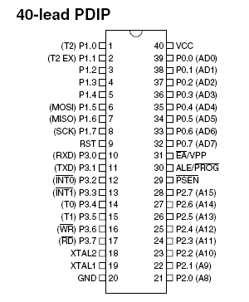

Figure 3.2-Pin diagram

3.1.4 Block Diagram 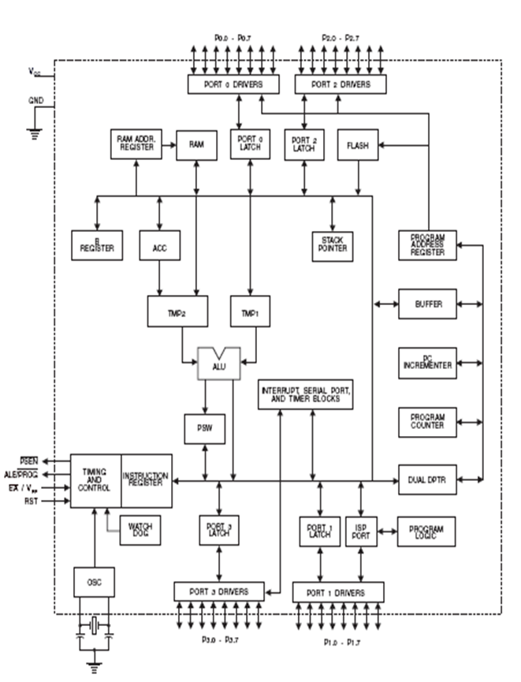

Figure 3.3-Block Diagram

3.1.5 Pin Description:

VCC:

Supply voltage.

GND:

Ground.

Port 0:

Port 0 is an 8-bit open drain bidirectional I/O port. As an output port, each pin can sink eight TTL inputs. When 1s are written to port 0 pins, the pins can be used as high-impedance inputs.

Port 0 can also be configured to be the multiplexed low-order address/data bus during accesses to external program and data memory. In this mode, P0 has internal pull-ups.

Port 0 also receives the code bytes during Flash programming and outputs the code bytes during program verification. External pull-ups are required during program verification.

Port 1:

Port 1 is an 8-bit bidirectional I/O port with internal pull-ups. The Port 1 output buffers can sink/source four TTL inputs. When 1s are written to Port 1 pins, they are pulled high by the inter-nal pull-ups and can be used as inputs.

As inputs, Port 1 pins that are externally being pulled low will source current (IIL) because of the internal pull-ups. In addition, P1.0 and P1.1 can be configured to be the timer/counter 2 external count input (P1.0/T2) and the timer/counter 2 trigger input (P1.1/T2EX), respectively, as shown in the following table.Port 1 also receives the low-order address bytes during Flash programming and verification.

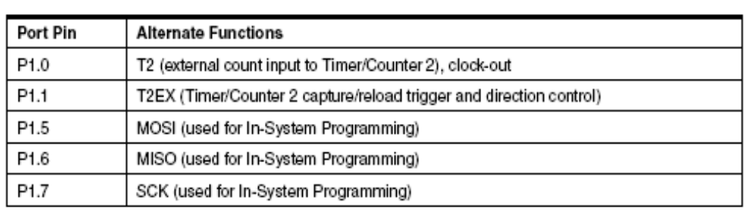

Table 3.1 Port 1 Discription

Port 2:

Port 2 is an 8-bit bidirectional I/O port with internal pull-ups. The Port 2 output buffers can sink/source four TTL inputs. When 1s are written to Port 2 pins, they are pulled high by the internal pull-ups and can be used as inputs.

As inputs, Port 2 pins that are externally being pulled low will source current (IIL) because of the internal pull-ups. Port 2 emits the high-order address byte during fetches from external program memory and during accesses to external data memory that uses 16-bit addresses (MOVX @ DPTR).

In this application, Port 2 uses strong internal pull-ups when emitting 1s. During accesses to external data memory that uses 8-bit addresses (MOVX @ RI), Port 2 emits the contents of the P2 Special Function Register. Port 2 also receives the high-order address bits and some control signals during Flash programming and verification.

Port Pin Alternate Functions P1.0 T2 (external count input to Timer/Counter 2), clock-out P1.1 T2EX (Timer/Counter 2 capture/reload trigger and direction control) P1.5 MOSI (used for In-System Programming) P1.6 MISO (used for In-System Programming) P1.7 SCK (used for In-System Programming)

Port 3

Port 3 is an 8-bit bidirectional I/O port with internal pull-ups. The Port 3 output buffers can sink/source four TTL inputs. When 1s are written to Port 3 pins, they are pulled high by the internal pull-ups and can be used as inputs.

As inputs, Port 3 pins that are externally being pulled low will source current (IIL) because of the pull-ups. Port 3 receives some control signals for Flash programming and verification. Port 3 also serves the functions of various special features of the AT89S52, as shown in the following table.

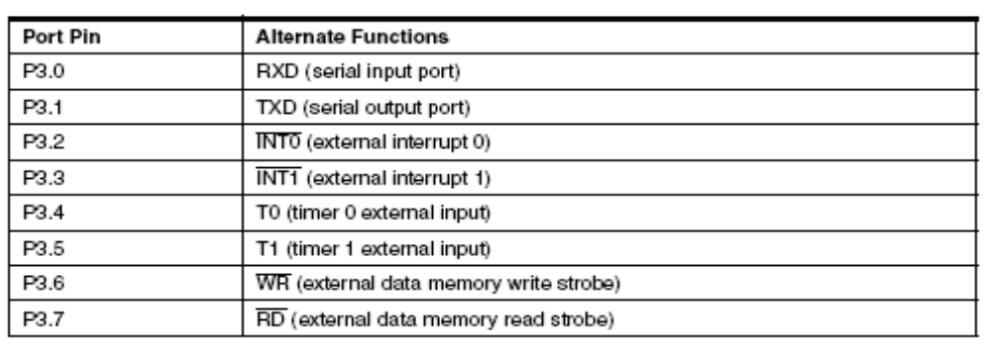

Table 3.2 Port 3 Discription

RST:

Reset input. A high on this pin for two machine cycles while the oscillator is running resets the device.

This pin drives high for 98 oscillator periods after the Watchdog times out. The DISRTO bit in SFR AUXR (address 8EH) can be used to disable this feature. In the default state of bit DISRTO, the RESET HIGH out feature is enabled.

ALE/PROG:

Address Latch Enable (ALE) is an output pulse for latching the low byte of the address during accesses to external memory. This pin is also the program pulse input (PROG) during Flash programming.

In normal operation, ALE is emitted at a constant rate of 1/6 the oscillator frequency and may be used for external timing or clocking purposes. Note, however, that one ALE pulse is skipped during each access to external data memory.

If desired, ALE operation can be disabled by setting bit 0 of SFR location 8EH. With the bit set, ALE is active only during a MOVX or MOVC instruction.Otherwise, the pin is weakly pulled high. Setting the ALE-disable bit has no effect if the microcontroller is in external execution mode.

PSEN:

Program Store Enable (PSEN) is the read strobe to external program memory.

When the AT89S52 is executing code from external program memory, PSEN is activated twice each machine cycle, except that two PSEN activations are skipped during each access to external data memory.

EA/VPP :

External Access Enable. EA must be strapped to GND in order to enable the device to fetch code from external program memory locations starting at 0000H up to FFFFH.

Note, however, that if lock bit 1 is programmed, EA will be internally latched on reset. EA should be strapped to VCC for internal program executions. This pin also receives the 12-volt programming enable voltage (VPP) during Flash programming.

XTAL1:

Input to the inverting oscillator amplifier and input to the internal clock operating circuit.

XTAL2:

Output from the inverting oscillator amplifier.

Memory Organization:

MCS-51 devices have a separate address space for Program and Data Memory. Up to 64K bytes each of external Program and Data Memory can be addressed.

Program Memory:

If the EA pin is connected to GND, all program fetches are directed to external memory. On the AT89S52, if EA is connected to VCC, program fetches to addresses 0000H through 1FFFH are directed to internal memory and fetches to addresses 2000H through FFFFH are to external memory.

Data Memory:

The AT89S52 implements 256 bytes of on-chip RAM. The upper 128 bytes occupy a parallel address space to the Special Function Registers.

This means that the upper 128 bytes have the same addresses as the SFR space but are physically separate from SFR space.

When an instruction accesses an internal location above address 7FH, the address mode used in the instruction specifies whether the CPU accesses the upper 128 bytes of RAM or the SFR space. Instructions which use direct addressing access the SFR space.

For example, the following direct addressing instruction accesses the SFR at location 0A0H (which is P2). MOV 0A0H, #data Instructions that use indirect addressing access the upper 128 bytes of RAM.

For example, the following indirect addressing instruction, where R0 contains 0A0H, accesses the data byte at address 0A0H, rather than P2 (whose address is 0A0H).

MOV @R0, #data Note that stack operations are examples of indirect addressing, so the upper 128 bytes of data RAM are available as stack space.

Watchdog Timer:

The WDT is intended as a recovery method in situations where the CPU may be subjected to software upsets. The WDT consists of a 14-bit counter and the Watchdog Timer Reset (WDTRST) SFR. The WDT is defaulted to disable from exiting reset.

To enable the WDT, a user must write 01EH and 0E1H in sequence to the WDTRST register (SFR location 0A6H).

When the WDT is enabled, it will increment every machine cycle while the oscillator is running. The WDT timeout period is dependent on the external clock frequency.

There is no way to disable the WDT except through reset (either hardware reset or WDT overflow reset). When WDT over-flows, it will drive an output RESET HIGH pulse at the RST pin.

Using the WDT:

To enable the WDT, a user must write 01EH and 0E1H in sequence to the WDTRST register (SFR location 0A6H). When the WDT is enabled, the user needs to service it by writing 01EH and 0E1H to WDTRST to avoid a WDT overflow. The 14-bit counter overflows when it reaches 16383 (3FFFH), and this will reset the device.

When the WDT is enabled, it will increment every machine cycle while the oscillator is running. This means the user must reset the WDT at least every 16383 machine cycles.To reset the WDT the user must write 01EH and 0E1H to WDTRST. WDTRST is a write-only register. The WDT counter cannot be read or written.When WDT overflows, it will generate an output RESET pulse at the RST pin. The RESET pulse duration is 98xTOSC, where TOSC = 1/FOSC.

To make the best use of the WDT, it should be serviced in those sections of code that will periodically be executed within the time required to prevent a WDT reset.

WDT during Power-down and Idle:

In Power-down mode the oscillator stops, which means the WDT also stops. While in Power-down mode, the user does not need to service the WDT.

There are two methods of exiting Power-down mode: by a hardware reset or via a level-activated external interrupt which is enabled prior to entering Power-down mode.

When Power-down is exited with hardware reset, servicing the WDT should occur as it normally does whenever the AT89S52 is reset. Exiting Power-down with an interrupt is significantly different. The interrupt is held low long enough for the oscillator to stabilize.

When the interrupt is brought high, the interrupt is serviced. To prevent the WDT from resetting the device while the interrupt pin is held low, the WDT is not started until the interrupt is pulled high. It is suggested that the WDT be reset during the interrupt service for the interrupt used to exit Power-down mode.

To ensure that the WDT does not overflow within a few states of exiting Power-down, it is best to reset the WDT just before entering Power-down mode. Before going into the IDLE mode, the WDIDLE bit in SFR AUXR is used to determine whether the WDT continues to count if enabled.

The WDT keeps counting during IDLE (WDIDLE bit = 0) as the default state. To prevent the WDT from resetting the AT89S52 while in IDLE mode, the user should always set up a timer that will periodically exit IDLE, service the WDT, and reenter IDLE mode.With WDIDLE bit enabled, the WDT will stop to count in IDLE mode and resumes the count upon exit from IDLE.

3.1.6 Uses of microcontroller:

Like all good things, this powerful component is basically very simple. It is made by mixing tested and high- quality "ingredients" (components) as per following receipt:
- The simplest computer processor is used as the "brain" of the future system.
- Depending on the taste of the manufacturer, a bit of memory, a few A/D converters, timers, input/output lines etc. are added.
- All that is placed in some of the standard packages.
- Simple software able to control it all and which everyone can easily learn about has been developed.
- On the basis of these rules, numerous types of microcontrollers were designed and they quickly became man's invisible companion.
- Their incredible simplicity and flexibility conquered us a long time ago and if you try to invent something about them, you should know that you are probably late, someone before you has either done it or at least has tried to do it.
- The following things have had a crucial influence on development and success of the microcontrollers:

Powerful and carefully chosen electronics embedded in the microcontrollers can independently or via input/output devices (switches, push buttons, sensors, LCD displays, relays etc.), control various processes and devices such as industrial automation, electric current, temperature, engine performance etc.

Very low prices enable them to be embedded in such devices in which, until recent time it was not worthwhile to embed anything. Thanks to that, the world is overwhelmed today with cheap automatic devices and various “smart” appliances.

Prior knowledge is hardly needed for programming. It is sufficient to have a PC (software in use is not demanding at all and is easy to learn) and a simple device (called the programmer) used for “loading” ready-to-use programs into the microcontroller.

So, if you are infected with a virus called electronics, there is nothing left for you to do but to learn how to use and control its power.

3.1.7 Working of microcontroller:

Even though there is a large number of different types of microcontrollers and even more programs created for their use only, all of them have many things in common.

Thus, if you learn to handle one of them you will be able to handle them all. A typical scenario on the basis of which it all functions is as follows:
- Power supply is turned off and everything is still…the program is loaded into the microcontroller, nothing indicates what is about to come…
- Power supply is turned on and everything starts to happen at high speed! The control logic unit keeps everything under control.

It disables all other circuits except quartz crystal to operate. While the preparations are in progress, the first milliseconds go by.

Power supply voltage reaches its maximum and oscillator frequency becomes stable. SFRs are being filled with bits reflecting the state of all circuits within the microcontroller.

All pins are configured as inputs. The overall electronic starts operation in rhythm with pulse sequence. From now on the time is measured in micro and nanoseconds.

Program Counter is set to zero. Instruction from that address is sent to instruction decoder which recognizes it, after which it is executed with immediate effect.

The value of the Program Counter is incremented by 1 and the whole process is repeated...several million times per second.

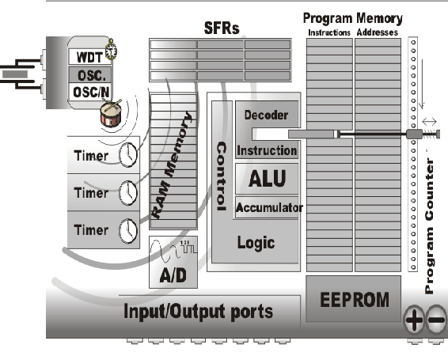

Figure 3.4-internal diagram

Inside a microcontroller:

As you can see, all the operations within the microcontroller are performed at high speed and quite simply, but the microcontroller itself would not be so useful if there are not special circuits which make it complete. In continuation, we are going to call your attention to them.

Read Only Memory (ROM):

Read Only Memory (ROM) is a type of memory used to permanently save the program being executed. The size of the program that can be written depends on the size of this memory.

ROM can be built in the microcontroller or added as an external chip, which depends on the type of the microcontroller. Both options have some disadvantages.

If ROM is added as an external chip, the microcontroller is cheaper and the program can be considerably longer. At the same time, a number of available pins are reduced as the microcontroller uses its own input/output ports for connection to the chip. The internal ROM is usually smaller and more expensive, but leaves more pins available for connecting to peripheral environment. The size of ROM ranges from 512B to 64KB.

Random Access Memory (RAM):

Random Access Memory (RAM) is a type of memory used for temporary storing data and intermediate results created and used during the operation of the microcontrollers.

The content of this memory is cleared once the power supply is off. For example, if the program performs an addition, it is necessary to have a register standing for what in everyday life is called the “sum”.

For that purpose, one of the registers in RAM is called the "sum" and used for storing results of addition. The size of RAM goes up to a few KBs.

Electrically Erasable Programmable ROM (EEPROM):

The EEPROM is a special type of memory not contained in all microcontrollers.

Its contents may be changed during program execution (similar to RAM ), but remains permanently saved even after the loss of power (similar to ROM). It is often used to store values, created and used during operation (such as calibration values, codes, values to count up to etc.), which must be saved after turning the power supply off.

A disadvantage of this memory is that the process of programming is relatively slow. It is measured in milliseconds.

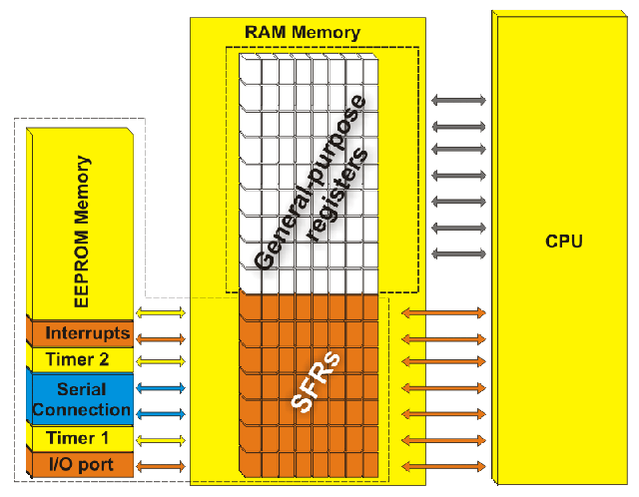

Figure 3.5-Special Function Register

Special Function Registers (SFR):

Special function registers are part of RAM memory. Their purpose is predefined by the manufacturer and cannot be changed therefore. Since their bits are physically connected to particular circuits within the microcontroller, such as A/D converter, serial communication module etc., any change of their state directly affects the operation of the microcontroller or some of the circuits.

For example, writing zero or one to the SFR controlling an input/output port causes the appropriate port pin to be configured as input or output. In other words, each bit of this register controls the function of one single pin.

Program Counter:

Program Counter is an engine running the program and points to the memory address containing the next instruction to execute. After each instruction execution, the value of the counter is incremented by 1. For this reason, the program executes only one instruction at a time just as it is written.

However…the value of the program counter can be changed at any moment, which causes a “jump” to a new memory location. This is how subroutines and branch instructions are executed.

After jumping, the counter resumes even and monotonous automatic counting +1, +1, +1…

Central Processor Unit (CPU):

As its name suggests, this is a unit which monitors and controls all processes within the microcontroller and the user cannot affect its work.

It consists of several smaller subunits, of which the most important are:

Instruction decoder is a part of the electronics which recognizes program instructions and runs other circuits on the basis of that. The abilities of this circuit are expressed in the "instruction set" which is different for each microcontroller family.

Arithmetical Logical Unit (ALU) performs all mathematical and logical operations upon data. Accumulator is an SFR closely related to the operation of ALU. It is a kind of working desk used for storing all data upon which some operations should be executed (addition, shift etc.).

It also stores the results ready for use in further processing. One of the SFRs, called the Status Register, is closely related to the accumulator, showing at any given time the "status" of a number stored in the accumulator (the number is greater or less than zero etc.). A bit is just a word invented to confuse novices at electronics. Joking aside, this word in practice indicates whether the voltage is present on a conductor or not. If it is present, the appropriate pin is set to logic one (1), i.e. the bit’s value is 1.

Otherwise, if the voltage is 0 V, the appropriate pin is cleared (0), i.e. the bit’s value is 0. It is more complicated in theory where a bit is referred to as a binary digit, but even in this case, its value can be either 0 or 1.

Input/output ports (I/O Ports):

In order to make the microcontroller useful, it is necessary to connect it to peripheral devices.

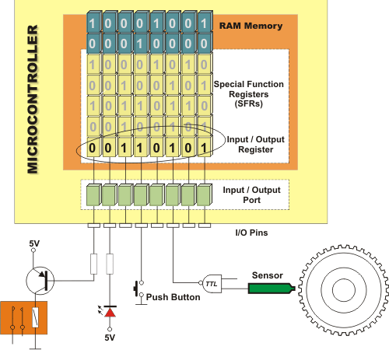

Figure 3.6-I/o Ports

Each microcontroller has one or more registers (called a port) connected to the microcontroller pins.

Why do we call them input/output ports? Because it is possible to change a pin function according to the user's needs. These registers are the only registers in the microcontroller the state of which can be checked by voltmeter.

Oscillator:

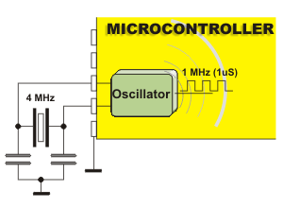

Figure 3.7-Crystal Oscillator

Even pulses generated by the oscillator enable harmonic and synchronous operation of all circuits within the microcontroller. It is usually configured as to use quartz-crystal or ceramics resonator for frequency stabilization.

It can also operate without elements for frequency stabilization (like RC oscillator). It is important to say that program instructions are not executed at the rate imposed by the oscillator itself, but several times slower.

It happens because each instruction is executed in several steps. For some microcontrollers, the same number of cycles is needed to execute any instruction, while it's different for other microcontrollers.

Accordingly, if the system uses quartz crystal with a frequency of 20MHz, the execution time of an instruction is not expected 50nS, but 200, 400 or even 800 nS, depending on the type of the microcontroller.

Timers/Counters:

Most programs use these miniature electronic "stopwatches" in their operation. These are commonly 8- or 16-bit SFRs the contents of which is automatically incremented by each coming pulse. Once the register is completely loaded, an interrupt is generated!

If these registers use an internal quartz oscillator as a clock source, then it is possible to measure the time between two events (if the register value is T1 at the moment measurement has started, and T2 at the moment it has finished, then the elapsed time is equal to the result of subtraction T2-T1 ).

If the registers use pulses coming from external source, then such a timer is turned into a counter.

This is only a simple explanation of the operation itself. It’s somehow more complicated in practice.

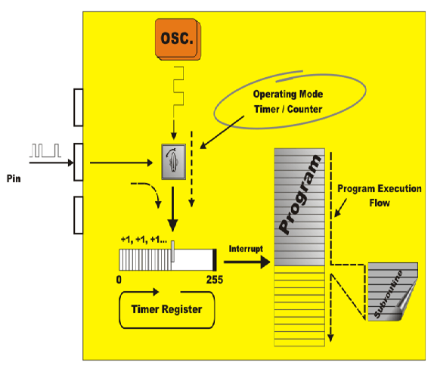 Figure 3.8-Timer/Counter

A register or a memory cell is an electronic circuit which can memorize the state of one byte. Besides 8 bits available to the user, each register has also a number of addressing bits. It is important to remember that:

All registers of ROM as well as those of RAM referred to as general-purpose registers are mutually equal and nameless. During programming, each of them can be assigned a name, which makes the whole operation much easier.

All SFRs are assigned names which are different for different types of the microcontrollers and each of them has a special function as their name suggests.

Power Supply Circuit:

There are two things worth attention concerning the microcontroller power supply circuit:

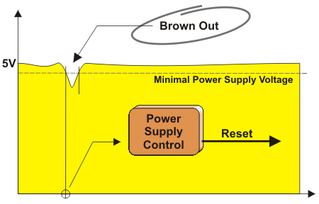

Figure 3.9-Power supply graph

Brown out is a potentially dangerous state which occurs at the moment the microcontroller is being turned off or when power supply voltage drops to the lowest level due to electric noise.

As the microcontroller consists of several circuits which have different operating voltage levels, this can cause its out of control performance. In order to prevent it, the microcontroller usually has a circuit for brown out reset built-in.

This circuit immediately resets the whole electronics when the voltage level drops below the lower limit.

Reset pin is usually referred to as Master Clear Reset (MCLR) and serves for external reset of the microcontroller by applying logic zero (0) or one (1) depending on the type of the microcontroller. In case the brown out is not built in the microcontroller, a simple external circuit for brown out reset can be connected to this pin.

Serial communication:

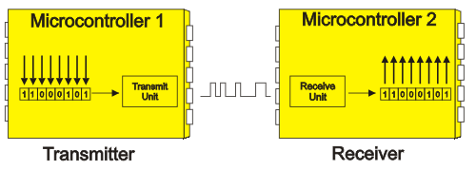

Figure 3.10- Serial Communication

Parallel connections between the microcontroller and peripherals established over I/O ports are the ideal solution for shorter distances up to several meters.However, in other cases, when it is necessary to establish communication between two devices on longer distances it is obviously not possible to use parallel connections.Then, serial communication is the best solution.

Today, most microcontrollers have several different systems for serial communication built in as a standard equipment. Which of them will be used depends on many factors of which the most important are:
- How many devices the microcontroller has to exchange data with?
- How fast the data exchange has to be?
- What is the distance between devices?
- Is it necessary to send and receive data simultaneously?

One of the most important things concerning serial communication is the Protocol which should be strictly observed. It is a set of rules which must be applied in order that devices can correctly interpret data they mutually exchange.

Fortunately, the microcontrollers automatically take care of this, so the work of the programmer/user is reduced to a simple write (data to be sent) and read (received data).
A byte consists of 8 bits grouped together. If a bit is a digit then it is logical that bytes are numbers. All mathematical operations can be performed upon them, just like upon common decimal numbers, which is carried out in the ALU.

It is important to remember that byte digits are not of equal significance. The largest value has the leftmost bit called the most significant bit (MSB). The rightmost bit has the least value and is therefore called the least significant bit (LSB).

Since 8 digits (zeros and ones) of one byte can be combined in 256 different ways, the largest decimal number which can be represented by one byte is 255 (one combination represents zero).

Program:

Unlike other integrated circuits which only need to be connected to other components and turn the power supply on, the microcontrollers need to be programmed first. This is a so called "bitter pill" and the main reason why hardware-oriented electronics engineers stay away from microcontrollers. It is a trap causing huge losses because the process of programming the microcontroller is basically very simple.

In order to write a program for the microcontroller, several "low-level" programming languages can be used such as Assembly, C and Basic (and their versions as well). Writing program procedure consists of simple writing instructions in the order in which they should be executed.

There are also many programs running in Windows environment used to facilitate the work providing additional visual tools.

This book describes the use of Assembly because it is the simplest language with the fastest execution allowing entire control on what is going on in the circuit.
Interrupt - electronics is usually more faster than physical processes it should keep under control. This is why the microcontroller spends most of its time waiting for something to happen or execute. In other words, when some event takes place, the microcontroller does something.

In order to prevent the microcontroller from spending most of its time endlessly checking for logic state on input pins and registers, an interrupt is generated. It is the signal which informs the central processor that something attention worthy has happened.

As its name suggests, it interrupts regular program execution. It can be generated by different sources so when it occurs, the microcontroller immediately stops operation and checks for the cause. If it is needed to perform some operations, a current state of the program counter is pushed onto the Stack and the appropriate program is executed. It's the so called interrupt routine.

Stack is a part of RAM used for storing the current state of the program counter (address) when an interrupt occurs. In this way, after a subroutine or an interrupt execution, the microcontroller knows from where to continue regular program execution.

This address is cleared after returning to the program because there is no need to save it any longer, and one location of the stack is automatically availale for further use. In addition, the stack can consist of several levels. This enables subroutines’ nesting, i.e. calling one subroutine from another.

3.1.8 Applications:

Automotive:
Automotive electronics are a demanding application, encompassing a wide range of products, from body electronics, engine components, and access systems to lighting and entertainment components.
They must support small designs and offer a high level of integration, to fit the limited space available in automotive environments. To meet the diverse needs of a variety of automotive applications, developers need solutions that offer:
- Compliance with strict automotive qualification demands, including industry standards and automotive-qualified fabs.
- Flexible interface options for a variety of HMI capabilities.
- Standards-based connectivity for intelligent networked solutions.
- Protection and compatibility for high-voltage products, including robust electromagnetic compatibility (EMC); electrostatic discharge (ESD) protection; and OEM approvals.
- Resistance to high temperatures for trouble-free operation in automotive environments.
- Maximum safety for automobile access.
- Low power consumption for maximum efficiency.
Building Automation:
Today's intelligent home and building automation solutions offer new levels of comfort, security, and efficiency. To develop the sophisticated solutions that meet the needs that consumers demand, designers need standards-based, flexible technology that can provide:
- Innovative touch control to enable a variety of home devices, including remote controls, control panels, or thermostats.
- Power efficiency to meet the needs of today's green applications.
- Compatibility with standards-based technology to bring innovative solutions to market, fast.
- Support for wireless networking to enable home connectivity.
- Robust security through hardware authentication and secure communication, which is essential for highly networked devices.

Home Appliances:
More than ever, consumers have high expectations for home appliances. They demand sophisticated, feature-rich products that are reliable and easy to use. To meet these needs, developers of white goods need technology that provides:
- Advanced motor control features for safe, quiet operation.
- Green, power-efficient technology, as well as energy measurement and control through connectivity with smart metering networks.
- Advanced human machine interface (HMI) support through touchscreen technology for a rich, easy user experience.
- Flexible, compatible connectivity to integrate devices with the outside world.
- Standards-based certification to enable reliable, high-quality solutions.

Home Entertainment:
Home entertainment systems continue to evolve in size and sophistication, delivering new levels of experiences and adventure to consumers.
Home Entertainment has expanded to become a veritable indoor electronic playground for children and adults alike, with systems incorporating large-screen displays, gaming consoles, audio equipment, and docking stations.
And often this entertainment empire is completely controlled and managed through a single remote control. Atmel solutions for home entertainment help you address your most pressing design challenges, including:

- Delivering innovative capabilities that entice consumers to upgrade and expand.
- Responding to consumer demand for energy-saving solutions.
- Integrating wireless and touchscreen technologies.
- Connecting and protecting more home entertainment products.
- Robust RF interference protection.

Industrial Automation:
As industrial environments become more advanced and connected, automation technology is developing at a rapid pace. To deliver the communication features and intelligence required at the plant floor and beyond, developers need solutions that can provide:
- High performance together with power efficiency.
- Rugged environmental design to resist water, dust, moisture, and extreme temperatures.
- Advanced, yet cost effective Human Machine Interface (HMI) features.
- Support for high-speed wired and wireless communication.
- Dedicated features for functional safety implementation.

Lighting:
Fluorescent and LED lights use 50 to 80 percent less energy than their incandescent counterparts. No wonder U.S. and European governments are pushing vendors for lighting solutions that rely on high frequency electronic ballasts. Successful ballast design depends on a few key tradeoffs:
- Balancing ease of use against design complexity and cost.
- Balancing voltage and current control against design complexity and board space.
- Balancing functionality against low power consumption.

Metering:
The market for energy, water, and gas metering systems is rapidly changing, driven by new environmental and conservation concerns and regulations. Traditional standalone meters are now being replaced by complex networked systems that utilize a variety of communication methods. To meet the needs of this evolving Smart Grid, metering developers need solutions that can provide:
- Intelligent support for application and communication stacks.
- Robust security functionality.
- Remote upgrades in the field.
- Support for communications protocols for home connectivity.

Mobile Electronics:
Today's mobile products are changing the way people consume information, socialize, conduct business, and purchase products. Major technology revolutions have completely changed the landscape for mobile devices.
To meet the needs of increasingly mobile customers, designers require solutions that offer:
- Efficient power management to support portable devices on the move.
- Fast response time for nimble operation.
- Highly integrated design for small footprint and minimal BOM.
- Support for intuitive touch screen interfaces.
- Secure hardware authentication of accessories.

PC Peripherals:
Today's personal computers do so much more than compute. With the right peripheral, computers can entertain, educate, connect, monitor, and secure. Successful PC peripheral design depends on some key tradeoffs:
- Balancing high performance against design complexity and board space.
- Balancing ease of use against design complexity and cost.
- Balancing high functionality against low-power consumption.
OUTPUT CAPACITOR
- The 7805 voltage regulator requires an output capacitor to maintain stability and improve transient response.
- A capacitor on the output is less important but it is preferable to have one close to the output and ground pins as well. If you make the output capacitor too big, it has a detrimental effect on the regulators transient response.
INPUT CAPACITOR
Input capacitor of larger values will help to improve ripple rejection by passing the input to the regulator, further improving the integrity of the output voltage.

3.2 RF TRANSMITTER
In general, the function of a radio frequency (RF) transmitter is to modulate, up convert, and amplify signals for transmission into free space. An RF transmitter generally includes a modulator that modulates an input signal and a radio frequency power amplifier that is coupled to the modulator to amplify the modulated input signal. The radio frequency power amplifier is coupled to an antenna that transmits the amplified modulated input signal.
Power amplifiers are required in radio telecommunication systems to amplify signals before transmitting, because a radio signal attenuates on the radio path. For efficiency, the amplifier is often a non-linear amplifier operated near its peak capacity. To avoid distortion of the transmitted signals due to the non-linearity, the signals are pre-distorted by a predistorter before they are transmitted.
The predisposition is required to prevent transmitter from transmitting signals on channel bands other than the band assigned to the transmitter. Digital predistortion may be performed by multiplying the modulated signals prepared for transmission by a set of predistortion values. The predistortion values are chosen such that the product values entering the power amplifier will be distorted by the power amplifier to return to a substantially linear amplification of the modulated signals.
A direct conversion transmitter system to produce a transmission signal is generally comprised of a low oscillator (LO), a phase locked loop (PLL), a quadrature generator, a modulator, a power amplifier (PA), and one or more filters. The low oscillator, coupled to the PLL, produces a signal with a frequency that is substantially equal to the frequency of a desired RF transmission signal. The quadrature generator is coupled to the low oscillator and the modulator. The PA is coupled to the quadrature generator, and receives the transmission signal and amplifies it.
The amplified signal may go through a filter to reduce noise or spurious outputs outside of the transmission band. High quality RF transmitters typically include band pass filters, such as surface acoustic wave (SAW) filters provide excellent performance. A typical cell phone may employ a band pass filter following the power amplifier to reduce undesired noise present at the antenna in different portion of RF spectrum to meet various standards' regulations and specifications.
The optimal functioning of a transmitter in a telecommunications system depends upon the suitability of the bandwidth of the transmitted signal to its data rate and modulation type. Cellular phones are designed to operate within the environment of one of several mobile communications networks. Transmitters and receivers for communication systems generally are designed such that they are tuned to transmit and receive one of a multiplicity of signals having widely varying bandwidths and which may fall within a particular frequency range.

3.3 RF RECEIVER:
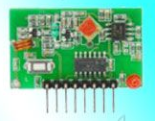

Figure 3.11-Rf Receiver
Radio frequency (RF) is a rate of oscillation in the range of about 3 kHz to 300 GHz, which corresponds to the frequency of radio waves, and the alternating currents which carry radio signals.
RF usually refers to electrical rather than mechanical oscillations, although mechanical RF systems do exist When you turn the emitter switch on, the lamp of the receiver begins to glow. When you turn the switch of the emitter off, the lamp of the receiver darkens and so on. If the receiver has been build a basic way, then the distance over which the communication works will be a few meters or a few tens of meters.If you put the receiver, say 50 meters away of the emitter, then there will be no more communication. When you turn the switch of the emitter on, the lamp of the receiver will not begin to glow. It will remain dark. But, if you build a long distance receiver, then the distance may be a lot more than 50 meters.Suppose you are in a noisy city. You put the emitter somewhere, then walk away. At a few tens of meters distance your ears no more hear the sound of the emitter.
But, after 1 kilometre walking away, the long distance receiver still manages to hear the sound of the emitter. Amazingly, the communication works: when the switch of the emitter is pushed to on; the lamp of the receiver begins to glow. And when the switch of the emitter is pulled to off, the lamp of the receiver darkens at 1 kilometre distance.
There is only one drawback: the communication is now rather slow. When the switch of the emitter is pulled to on, you have to wait 1 minute until the lamp of the receiver begins to glow. And when you push the switch of the emitter to off, you have to wait again 1 minute till the lamp of the receiver darkens.
It is thanks to this technology that communication with space probes going outside the solar system has been possible.
3.3.1.The signal/noise ratio :
Suppose we take a microphone and connect it to an oscilloscope tuned appropriately. (If you don't have an oscilloscope at hand, you may use a PC with a sound card and a sound recording program). The emitter is put a few centimeters away from the microphone. When the emitter is switched off, the oscilloscope will show a straight line, no signal:
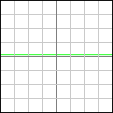
When the emitter is switched on, the oscilloscope will show a sine wave:
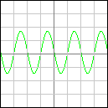
So, a deaf person will be able to tell whether the emitter is switched on or off. Just by looking at the screen of the oscilloscope. Suppose now we put the emitter two times further from the microphone. When the emitter is on, the signal shown by the oscilloscope will be two times weaker:
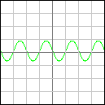
So, in order to still see the signal clearly, we will increase the amplification of the oscilloscope to make it show the sine wave again at a correct size:
No problem. The more we put the emitter further from the microphone, the more we ask the oscilloscope to amplify the signal. That way the signal remains clearly visible, whatever the distance.
Well, in fact this is not true. Once we have put the emitter, say 5 meters away from the microphone and the amplification has become relatively important, we see the noise appear. This is what the oscilloscope shows when the emitter is off:
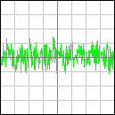
And this is what it shows when the emitter is on:
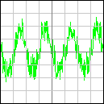
The emitter may be on or off, it makes no difference. The noise remains the same. When the emitter is on, the sine wave simply adds itself to the noise.
Noise is something you cannot avoid. Whatever you measure, if your amplification is enough, you always get a noise. In fact it was there since the beginning, but it was so weak that we didn't notice it. It became visible once we amplify enough.
Let's put the emitter again two times further. We have to increase two times the amplification. Now the noise has the same amplitude as the sine wave:
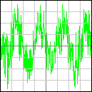
From now on, when we will put the emitter further, we will no more increase the amplification. Because the noise fills the screen of the oscilloscope. Any increase in amplification would be useless: it would simply make the noise go outside the boundaries of the screen of the oscilloscope.
This is what appears when we put the emitter 10 meters away:
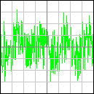
This is what appears when we put the emitter 20 meters away:
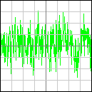
And this appears when we put the emitter 40 meters away:
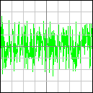
We are no more able to see the sine wave. (You may have the impression to see pieces of sine wave, but it is only an illusion.) The emitter may be on or off , the oscilloscope will show exactly the same thing: a noise. Thus, at a distance of 40 meters our system does not work any more.The key is the intensity of the signal versus the intensity of the noise. That's why we use the concept of signal/noise ratio. The signal/noise ratio is a number. You obtain this number by dividing the number of the measure of the intensity of the signal by the number of the measure of the intensity of the noise.

3.3.2.Integration
Let's use what we received when the signal/noise ratio was 1. We had 4 periods of sine wave.
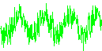
We cut these 4 periods away from each other:
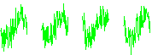
Then we put them one above the other and make the sum of them:


Finaly we divide by four the result of that sum (just to scale it):
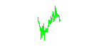
As you can see, the noise is now two times weaker.(Compare with any of the four periods we summed.) When you make the sum of four sine periods, the result is a sine period four times bigger.

That's because when you make the sum of n precise numbers, you get a result that is precisely n times bigger.

7 + 7 + 7 + 7 = 28
-5 + -5 + -5 + -5 = -20
When you make the sum of four noise "periods", the result is only two times bigger.

That's because the noise is sometimes positive, sometimes negative, at random. When you add random positive and negative numbers together, they "eat" each other up.
8 + 3 + -5 + -10 = -6
1 + -5 + 11 + -8 = -1
The sum of n sine periods of amplitude a is a sine period of amplitude n . a
The sum of n noise "periods" of amplitude a is a noise "period" of amplitude n . a.
Thus, when we made the sum of four periods, the sine wave grew four times, but the noise grew only two times. The signal/noise ratio was thus increased by two.
When we make the sum of n periods, the signal/noise ratio is increased by a factor n.
A sum of periods is a very important object. Because it tells us if the sine wave was there or if it was not there. That allows us for example to transmit morse code. Here are the results of 27 successives results of sums calculated by a receiver: Transcribed with more readability, a space for absent and an underscore for there, it gives us this:
It's the morse code for S.O.S. The same way, you can transmit modern digital code.
The space probe Galileo is curently in orbit around the planet Jupiter. The radio signal we received from the probe was cut into one billion periods each tenth of a second. All those periods are carefully summed to generate an information flow of ten bits per second.
That makes one text character per second. Character afther character, word afther word, sentence afther sentence, the probe transmited a description of what it saw or measured.
More refined systems do measure the intensity of the sine wave. Each time a sum is calculated, the size of the sine wave is measured and that measure is transmitted to whatever needs it. AM long wave and short wave receivers you can bye in any store work that way. By calculating several thousand sums per second and transmitting the result to a loudspeaker they make that loudspeaker reproduce a certain sound, voice or music.
3.3.3. The precision of the clocks :
When the sine wave is visible in the signal, it is not difficult to know where to cut the signal to get successive periods. A few periods may even be hidden by the noise, you still know where to cut just by looking at the position of the other periods near them. (That's what a PLL does.) There is only one solution: rely upon a clock.
If we know that one period takes a milionth of a second, we make a clock give a tick each milionth of a second. Each time we hear a tick, we cut a period out of the received signal, blindly. And when we have accumulated enough periods, the sum of them will tell us whether there was a sine wave hidden inside the noise or not.
But that clock must have a certain accuracy. Let's take for example the following signal:
If the clock runs perfectly, we will get the following sixteen neat pieces:
But if the clock runs 5% too fast, and the periods are thus cut each time 5% earlier, we get this:
Compare the first period and the tenth. They are each others' opposite. If you make the sum of them, you get zero as result. In fact, the sum of all the periods will give, perhaps not precisely zero, but in any case something very little. We will not see a beautiful sine period emerge. The more periods we want to cut and sum, the more accurate the clock will have to be.
If we want to sum hundred periods, we need a clock with a precision better than one hundredth. (This means that after a time of say 100 seconds it deviates of less than a second.)
Attention: we have spoken about the precision of the clock used by the receiver. The clock of the emitter must have the same precision. It wouldn't help that the receiver cuts accurately the signal in periods, if the signal send by the emitter is unreliable. Both clocks must be accurate.
3.3.4. Bandwidth
Imagine we have a receiver that makes sums of, say, 1000 periods. And the radio frequency he is made to hear is 10,000,000 Hz (10 MHz). That makes 10,000 sums calculated each second.
It will hear perfectly an emitter emitting at 10,000,000 Hz. Of course. It will also hear an emitter emitting at 10,002,000 Hz. Nearly perfectly. But il will not hear an emitter emitting at 10,500,000 Hz. For the obvious reason given in chapter 4. (Well in fact it may hear it if it emits a very powerful signal, but let's no think about that.) So, an emitter at 10,500,000 Hz will not disturb our receiver working at 10,000,000 Hz.
Thus we can use a second receiver, receiving at 10,500,000 Hz, to hear that emitter at 10,500,000 Hz. That receiver at 10,500,000 Hz will not be disturbed by the emitter at 10,000,000 Hz.That's wonderful. Each emitter receives the signal emitted by the emitter using the same frequency, but is not disturbed by the other emitter using another frequency.
If a receiver can be tuned it will be able to choose to which emitter it listens. It can be tuned to listen to the emitter emitting at 10,000,000 Hz or to listen to the emitter emitting at 10,500,000 Hz. Or any other frequency. It's just a matter of clock frequency.
We work at about 10 MHz and we do 10,000 sums per second. We have the ability to use several frequencies at the same time to allow different emitters and receivers to work at the same place without disturbing each other. But, if we use frequencies between 9 MHz and 11 MHz, how many different couples of receivers ans emitters will be able to work simultaneously?
The answer depends on several things. Commonly a difference in frequency of ten times the transmission rate is taken. We transmit 10,000 informations per second, so we will rely upon a difference of 100,000 Hz between each emitter-receiver couple. Thus: 9,000,000 Hz, 9,100,000 Hz, 9,200,000 Hz... up to 11,000,000 Hz, that makes 20 couples of emitter and receiver talking to each other at the same time without disturbing each other.10,000 is the bandwidth. It is the number of elementary informations elements that are transmitted each second. That is, the number of times per second you calculate the sum of the periods received.
The broader the bandwidth, the more elementary information you transmit each second. the less far that information is transmitted. Because you are using less periods to make one sum. the less emitters can work together inside a certain frequency window. the less accurate the clocks must be inside emitter and receiver. (It may seem a paradox, but VHF TV modulators are easier to manufacture than FM audio modulators.
A TV image needs 20 million elementary information to be transmitted (one image is made of 480,000 pixels (600 lines x 800 columns) and 25 images must be transmitted each second). An audio signal, on the contrary, only needs 40 thousand elementary informations to be transmitted each second.
An audio signal requires a lot less informations per second! Thus one puts a lot more audio channels on a given frequency window than TV channels, and therefore one needs far out more precise clocks for audio signals.)
This method that allows several emitters to emit at the same time, is called "frequency multiplexing". It is not the only one. Another is "time multiplexing": all emitters use the same frequency (or do not use any frequency at all) but emitting time is shared amongst them. Each his turn.
These two methods have their advantages and disadvantages, which one is choosed for a given application is a mather of engineering choice.
3.3.5.Accumulator Attenuation
The description that is given above of a receiver is good but a bit theoretical. In reality, common receivers work not exactly that way.
The method we described can be sumarized this way:
At the beginning of a series of periods, an accumulator is set to null. Then, each period received is added to the accumulator. Ones n periods have been received and added, the content of the accumulator is looked at. If it draws a sine period, we state the signal was on. If it draws pure noise, we state there was no signal. (Or we measure the size of the sine).The method that is most commonly used is this one:
The accumulator is never set to null. Each period received is added to it, then the content of the accumulator is shrinked a little bit (it is multiplicated by 0.999, say). The content of the accumulator is looked at continuously. If it draws a sine period, we state the signal is on. If it draws pure noise, or a too little sine period, we state there is no signal.(Or we measure the size of the sine.) This second method is less mathematicaly correct, but it is more physicaly realistic, smoother, and easier to use.
The first method has three practical drawbacks:
First method | Second method
It requires perfect memories, that are not disturbed afther n periods. That can only be done with digital memories or with delay lines. | It only requires simple components like a guitar string, a tuning fork or a condensator and a self.
When you look at how frequencies different from the perfect frequency are received, you get unregular results: a frequency slightly different will not be received at all, but another frequency further away from the perfect frequency will be heared a little bit. | You get a smooth behaviour: the further away from the perfect frequency, the less it is received.
You must know when a series of periods starts (for digital transmissions) and when it ends. This requires circuits or algorithms in order to allow the receiver to be phased with the emitter. | Because the accumulator is looked at continuously, you don't bother to be synchronised with the emitter.

Table 3.3 Difference Between first and second method
The first method was characterised by the number n of periods summed.Everythingdepends on the number n. You may wonder what characterises the second method. Answer: the number by which the content of the accumulator is multiplicated each time a period is added. That is 0.999 in our example above.Now let's look at some practical aspects of this second method:
Simple electronic receivers that use a rudimentary LC circuit as their heart work that way naturally. The LC circuit (one capacitor and one self latched together) works as a resonator: if it receives pure noise, it will just oscillate a little bit at low amplitude. But if the noise contains a signal that has the same frequency as the resonance frequency of the circuit then the circuit will begin resonating and will thus oscillate at higher and higher amplitude. Once the amplitude reaches a given threshold, that will trigger a transistor and "make a lamp glow". The LC circuit acts as a memory that sums the oscillations.
Mechanical receivers work the same way too. Early radio command devices used little tuning forks to determine if a given beep sound was being received: if the beep sound was there the appropriate tuning fork would begin vibrating so strongly it's end would touch an electric contact.
If you want to build some mechanical device to visualize what's happening, here are two suggestions. I tried out none of them so if you do please mail me your remarks and recomendations.
Use a guitar with metal strings (or wrap some thin electric wire a few turns around the middle of a string). Latch some needle very close to the middle of a string. Use some more electric wire, a battery and a lamp to build a complete electric loop between the string and the needle. When you push the string a little bit it touches the needle and the lamp begins to glow.
Then aim at the guitar any source of music that produces the same music note as the guitar string: another instrument or an electronic tunable sound generator. The string will begin resonating, will make wide movements and thus will touch the needle and thus the lamp will begin to glow... Should you aim at the guitar a signal with another frequency, or any noise, then nothing will happen. Should you aim a mixture of any noise and the right frequency, then the lamp will glow...
You may also put a needle and lamp on all guitar strings and determine what frequency will make each lamp glow.
That way you may choose which lamp will glow by emitting the right frequency. You may make several lamps glow at the same time by emitting at the same time the right frequency for each choosen lamp.
Build two the same pendulums (especially their rope's length must be exactly the same). Latch the end of the first pendulum to any heavy object and make it oscillate. Take the end of the second pendulum between your fingers. Look at the first pendulum and make your fingers go back and forth exactly at the same rate yet with a very little amplitude.
The movement of your fingers should be hardly noticeable. The pendulum between your fingers will begin oscillating and make wider and wider movements. The amplitude of it's movement will become very important, for sure a lot more important than the amplitude of your fingers' movements... Now do it again but change the first or the second pendulum's frequency by making its rope be longer or shorter. This time nothing happens when you move the second pendulum with your fingers. It moves a little bit together with your fingers but that's all.
You may also try to move the second pendulum with any random little movements, nothing neither will happen, unless those random movements contain a little bit of the movement of the first pendulum (with same rope length as the second)...
You may also latch both pendulums and link them with a thin elastic rope. If you make the first one oscillate, the elastic rope will transmit the oscillations to the second pendulum that will begin oscillating too and make wider and wider movements... provided both pendulums rope's lengths are the same. You may even use several "emitter" and "receiver" pendulums and latch them all together trough crossed thin elastic ropes. In order to make one given receiver pendulum oscillate you will have to launch an emitter pendulum with the same rope length (frequency). (The thin elastic ropes are not necessary if the object the pendulums are latched to is not too heavy and is allowed to make little movements.)
3.3.6. The super-heterodyne receiver
The super-hetrodyne receiver is the most widespread type of radio receiver.
It works on a mathematical trick: When you multiply a sine wave by a sine wave with a slightly different frequency, you get a result that is the sum of two other sine waves:
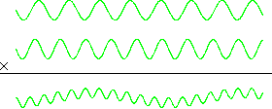
The two sine waves inside the result have frequencies that are higher and lower than the frequencies of the sine waves that have been multiplicated.
The lowest frequency is equal to the difference between the frequencies of the two initial sine waves. If the first frequency was of 1,000,000 Hz and the second was of 999,000 Hz then the sine wave will have a frequency of 1,000 Hz.
That sine wave with the lowest frequency is the one we are going to use. The sine wave with the highest frequency is filtered away.
What is that low frequency good for? A lot of things:
Suppose you receive a signal that is the sum of two frequencies. Say 10,000,000 Hz and 10,010,000 Hz. But you only want to measure the intensity of the 10,000,000 Hz signal.
The problem is these two frequencies are close to each other: there is only 0.1% difference between them. Therefore it is very difficult to filter away the 10,010,000 Hz and keep the 10,000,000 Hz. The solution is to multiply the received signal by a frequency of 9,999,000 Hz. The frequency at 10,000,000 Hz will yield a low frequency of 1,000 Hz, the frequency at 10,010,000 Hz will yield a low frequency of 11,000 Hz. Between these two low frequencies you now have a difference of 1,000%! It is very easy to filter the 11,000 Hz away and keep the 1,000 Hz, even with a rudimentary filter.
By measuring the intensity of that 1,000 Hz signal you get the intensity of the 10,000,000 Hz signal.
Good filtering and amplification systems are delicate to build. If besides they must be tunable for different frequencies, it becomes an impossible task. With the super-heterodyne system you get a simple solution: you build the filtering system for one frequency, say 100,000 Hz, and you multiply the received signal by a tunable frequency before sending it into that filter.
Want to receive a signal at 100,000,000 Hz? Multiply the signal from the antena by a sine wave at 99,900,000 Hz... Want to receive a signal at 98,000,000 Hz? Multiply the signal from the antena by a sine wave at 97,900,000 Hz... And so on. The filtering system will always have to deal with a signal at 100,000 Hz.
Suppose you want to use frequency modulation, FM. At first hand, you cannot use the sum of periods, like mentioned in chapter 3, to make the signal emerge out of the noise.
That looks impossible because the frequency must be stable. FM is, of course, not stable. The solution is the super-heterodyne system. If for example you want to receive a signal that varies between 100,100,000 Hz and 99,900,000 Hz, just multiply the antena signal by a stable sine wave at 99,800,000 Hz and you will get a low signal between 300,000 Hz and 100,000 Hz. Like pointed above, unwanted noise and signals will be easy to filter away, then the frequency of the low signal will be measurable by standard methods.
3.3.7.Common ways to enhance communications
Directivity of the emitter
A device is added to the emitter to make as much as possible of the signal go towards the receiver. So there is no waste in useless directions. That's what you do when you put your hands around your mouth when you whant to shout at somebody far away or in a noisy environment.
The device best known is the parabolic antenna, but there are a lot of other ways to achieve directivity. For example sets of common antennas connected together trough wires of acurately calculted length.
The bigger the antenna, the more directivity you will get.
The bigger the wavelength of the signal you transmit, the bigger the antenna you will need to achieve the same directivity.
Directivity of the receiver
A device is added to the receiver to make him listen as much as possible only to the signal coming from the direction of the emitter.
That's what you do when you put your hands back your ears to hear better a weak sound. The device best known is again the parabolic antenna, but there are a lot of other ways to achieve directivity.
Like using several antennas and adding their signals. The bigger the device, the more directivity you get.A parabolic antenna acts for radio waves just like a solar oven acts for the sunlight, concentrating what it receives on one given point.
The considerations about antenna size, directivity and wavelength are the same as for point 8.1 just above.
Reduction of the internal noise of the receiver
You can imagine for sure that making a receiver work in a noisy environment reduces its performances. But a receiver also produces it's own "internal noise": every electronic component inside a receiver produces a noise. That's why those components must be carefully choosed or manufactured to produce the less possible noise.
Metalfilm resistors are prefered over carbon resistors, FET transistors are prefered over bipolar transistors, and so on.
To decrease even more the remaining amount of noise, and it can physically not be done another way, the receiver must be cooled down. It can be plunged into liquid nitrogen or even liquid helium. This is true whatever the type of communication system you are using: radio waves, light, light trough fibre optics, sound, electric signals trough wires, even interstellar gravitational waves...
Inside a simple component like a resistor, the noise is simply due to the electrons moving around inside the resistor. The hotter the resistor, the faster the electrons move thus the more noise. The higher the impedance, the higher the noise tension (this is compensated by the fact the noise is limited by the higher impedance).
If you want to hear directly such a noise, just put your ear inside an empty glass. Or both ears (inside two separate glasses, not inside the same glass).
Increase of the emitted power
The louder you shout, the farther one may hear you...
Here is some data for amateur electronics. Let's talk about the basic straight antenna.
You may consider an antenna as behaving like a simple electric resistance connected to the ground (picture below). But it has two differences with a common electric resistance: When electricity is send trough it, the energy of the electric signal is not transformed into heat. Instead, it is transformed into radio waves that will travel away. Just like a loudspeaker produces sound waves.
The impedance of the antenna depends on it's length and on the frequency of the signal you send trough it. You may consider that a thick metalic antenna with a length of one half the wavelength (wavelength = 300,000,000 / frequency) has an impedance of 75.
Spectrum Efficiency
Research into dynamic spectrum allocation and management mechanisms in general has shown that any scheme that dynamically reacts to demand and availability of spectrum can achieve higher efficiency. The currently, most often deployed, long term allocations which have been defined to cover peak traffic demands remain underused most of the time. Ofcom have initiated first steps towards the liberalisation of spectrum by directing the handling and allocation of spectrum into a level where market forces can steer the actual allocation of spectrum. This process started with an initial statement on spectrum trading [44], continued with a first detailed consultation on spectrum liberalisation [45] and the publication of draft spectrum regulations [46] and finally the Publication of a proposed Spectrum Framework Review [47] and its implementation [48]. Eventually this should lead to a rather consumer oriented market where only the ‘goods used/occupied’ will be charged. The state of the art in SDR Technology and the, so far, analysed models and approaches towards SDR indicate that the technology will be sufficiently flexible to adapt to any wireless access scheme. This opens the possibility of choosing the most efficient configuration (or radio access technology) for the required application. Such flexibility will give both users and operators the choice to use the air interface standard that would be most suitable and most efficient (in terms of resource usage) to provide/use a service.

3.3.8 SDR TECHNOLOGY TO INCREASE SPECTRUM EFFICIENCY
SDR technology has been heralded as one of the facilitators of the ABC paradigm (‘Always Best Connected’ – [49]), enabling the seamless interoperation between different communication platforms, not only within one family (e.g. cellular) but also between different hierarchical levels of systems (satellite, broadcast, cellular, wireless local area and personal networks). SDR is expected to enable the inter-operability of wireless heterogeneous radio access networks. This in turn raises a new range of challenges in terms of spectrum and radio resource management.
As mentioned earlier, one of the core features offered by SDR technology is the possibility of implementing spectrum management in a more dynamic fashion. Use of SDR Technology for dynamic allocation of spectrum was initially proposed and investigated by the IST OverDRiVE project [24] and is currently being continued in the IST (FP6) Project on End-toEnd Reconfigurability (E2 R) [31]. Dynamic spectrum management requires a high degree of interoperability between the different access networks, but it might also require fundamental changes in the way spectrum is regulated and used by the operator. The spectrum liberalisation efforts (of Ofcom) are a significant step towards regulation, which will allow such flexible management and allocation. SDR Technology will facilitate the split of the classical combination between service/radio access technology/spectrum band. The examples in figures 3-2 to 3-4 illustrate the principle. Figure 3-2 displays the classical arrangement where a, lets say, GSM voice service is provided by a GSM system using a GSM band.

CHAPTER 4
SOFTWARE ANALYSIS

4.1 Introduction

The main purpose of using the microcontroller in our project is because high-performance CMOS 8-bit microcontroller with 8K bytes of in-system programmable Flash memory. By combining a versatile 8-bit CPU with in-system programmable Flash on a monolithic chip, the Atmel AT89S52 is a powerful microcontroller which provides a highly-flexible and cost-effective solution to many embedded control applications.

The programs of the microcontroller have been written in Embedded C language and were compiled using KEIL, a compiler used for microcontroller programming. The communication between PC and the microcontroller was established MAX 232 standard and those programs were also done in C language.The following programs are used at various stages for the mentioned functions.
Serial communication In this program, the various special function registers of the microcontroller are set such that they can send and receive data from the PC. This program uses the serial library to communicate with the ports.

4.2 KEIL compiler

The C programming language is a general-purpose, programming language that provides code efficiency, elements of structured programming, and a rich set of operators. C is not a big language and is not designed for any one particular area of application. Its generality combined with its absence of restrictions, makes C a convenient and effective programming solution for a wide variety of software tasks. Many applications can be solved more easily and efficiently with C than with other more specialized languages.

The Cx51 Optimizing C Compiler is a complete implementation of the American National Standards Institute (ANSI) standard for the C language.
Cx51 is not a universal C compiler adapted for the 8051 target. It is a ground-up implementation dedicated to generating extremely fast and compact code for the 8051 microprocessor. Cx51 provides you the flexibility of programming in C and the code efficiency and speed of assembly language.

Since Cx51 is a cross compiler, some aspects of the C programming language and standard libraries are altered or enhanced to address the peculiarities of an embedded target processor.

Support for all 8051 Variants

The 8051 Family is one of the fastest growing Microcontroller Architectures. More than 400 device variants from various silicon vendors are today available. New extended 8051 Devices, like the Philips 80C51MX architecture are dedicated for large application with several Mbytes code and data space. For optimum support of these different 8051 variants, Keil provides the several development tools that are listed in the table below. A new output file format (OMF2) allows direct support of up to 16MB code and data space. The CX51 compiler is a variant of the C51 compiler that is design for the new Philips 80C51MX architecture.

4.3 Compiling with Cx51
This explains how to use Cx51 to compile C source files and discusses the control directives you may specify. These directives allow you to perform several functions. For example:
- Direct Cx51 to generate a listing file
- Control the information included in the object file
- Specify code optimization and memory models

Running Cx51 from the Command Prompt

To invoke the C51 or CX51 compiler, enter C51 or CX51 at the command prompt. On this command line, you must include the name of the C source file to be compiled, as well as any other necessary control directives required to compile your source file.
The format for the Cx51 command line is shown below:

C51 source file _directives…_
CX51 source file _directives…_
or:
C51 @command file
CX51 @command file

where:
source file is the name of the source program you want to compile.
directives are the directives you want to use to control the function of the
compiler.
Command file is the name of a command input file that may contain sourcefile and directives. A command file is used, when the Cx51 invocation line gets complex and exceeds the limits of the Windows command prompt.

The following command line example invokes C51, specifies the source file
SAMPLE.C, and uses the controls DEBUG, CODE, and PREPRINT.
C51 SAMPLE.C DEBUG CODE PREPRINT

The Cx51 compiler displays the following information upon successful
invocation and compilation.

C51 COMPILER V6.10
C51 COMPILATION COMPLETE. 0 WARNING(S), 0 ERROR(S)

4.4 8051 Derivatives

A number of 8051 derivatives are available that provide enhanced Performance while remaining compatible with the 8051 core. These derivatives provide additional data pointers, very fast math operations, and reduced instruction sets.

The Cx51 compiler directly supports the enhanced features of the following 8051-based microcontrollers:
- Atmel 89x8252 and variants (2 data pointers).
- Dallas 80C320, 80C420, 80C520, 80C530, 80C550 an variants (2 data pointers).
- Infineon C517, C517A, C509, and variants (high-speed 32-bit and 16-bit binary arithmetic operations, 8 data pointers).
- Philips 8xC750, 8xC751, and 8xC752 (maximum code space of 2 KBytes, no LCALL or LJMP instructions, 64 bytes internal, no external data memory).
- Philips and Temic support on several device variants 2 data pointers.

The C51 compiler provides you with support for these CPUs through the use of special libraries, library routines, and the MODxxx command-line directives. These directives enable C51 to generate object code that takes advantage of the enhancements mentioned above.

4.5 Atmel 89x8252 and variants

The Atmel 89x8252 and variants provide 2 data pointers which can be used for memory access. Using multiple data pointers can improve the speed of library functions like memcpy, memmove, memcmp, strcpy, and strcmp.

The MODA2 control directive instructs the C51 compiler to generate code that uses both data pointers in your program.

The C51 compiler uses at least one data pointer in an interrupt function. If an interrupt function is compiled using the MODA2 directive, both data pointers are saved on the stack. This happens even if the interrupt function uses only one data pointer.

To conserve stack space, you may compile interrupt functions with the NOMODA2 directive. The C51 compiler does not use the second data pointer when this directive is used.

4.6 VISUAL BASIC

Visual Basic (VB) is an ideal programming language for developing sophisticated professional applications for Microsoft Windows. It makes use of Graphical User Interface for creating robust and powerful applications. The Graphical User Interface as the name suggests, uses illustrations for text, which enable users to interact with an application. This feature makes it easier to comprehend things in a quicker and easier way.
Coding in GUI environment is quite a transition to traditional, linear programming methods where the user is guided through a linear path of execution and is limited to small set of operations. In GUI environment, the number of options open to the user is much greater, allowing more freedom to the user and developer. Features such as easier comprehension, user-friendliness, faster application development and many other aspects such as introduction to ActiveX technology and Internet features make Visual Basic an interesting tool to work with.
Visual Basic (VB) was developed from the BASIC programming language. In the 1970s, Microsoft started developing ROM-based interpreted BASIC for the early microprocessor-based computers. In 1982, Microsoft QuickBasic revolutionized Basic and was legitimized as a serious development language for MS-DOS environment. Later on, Microsoft Corporation created the enhanced version of BASIC called Visual Basic for Windows.
Visual Basic (VB) is an event-driven programming language. This is called because programming is done in a graphical environment unlike the previous version BASIC where programming is done in a text only environment and executed sequentially in order to control the user interface. Visual Basic enables the user to design the user interface quickly by drawing and arranging the user elements. Due to this spent time is saved for the repetitive task.

IMPORTANT FEATURES OF VISUAL BASIC (VB)
- Full set of objects - you 'draw' the application
- Lots of icons and pictures for your use
- Response to mouse and keyboard actions
- Clipboard and printer access
- Full array of mathematical, string handling, and graphics functions
- Can handle fixed and dynamic variable and control arrays
- Sequential and random access file support
- Useful debugger and error-handling facilities
- Powerful database access tools
- ActiveX support
- Package & Deployment Wizard makes distributing your applications simple

VISUAL BASIC 6 VS PREVIOUS VERSIONS OF VISUAL BASIC
The original Visual Basic for DOS and Visual Basic For Windows were introduced in 1991.
Visual Basic 3.0 (a vast improvement over previous versions) was released in 1993.
Visual Basic 4.0 released in late 1995 (added 32 bit application support).
Visual Basic 5.0 released in late 1996. New environment, supported creation of ActiveX controls, deleted 16 bit application support.
Visual Basic 6.0 - released in mid 1998s - some identified new features of Visual Basic 6.0:
- Faster compiler
- New ActiveX data control object
- Allows database integration with wide variety of applications
- New data report designer
- New Package & Deployment Wizard
- Additional internet capabilities.
4.7 Summary
In this chapter the software analysis was done by giving the flowcharts and their corresponding algorithms.

CHAPTER 5
CONCLUSION
SDR Technology development is progressing and eventually the technology will be available to implement even the most demanding radio configurations in software. However, the pace at which this is going to happen will be highly dependent on external incentives such as a regulatory regime that allows the use of re-configurable radio technology.

SDR technology itself has evolved and, in the military domain, a range of products is already available. Progress in the military domain still precedes the developments in the commercial arena. However, even in the commercial domain, there is already some form of reconfiguration of most communications “blocks”, i.e. Base band, converters and RF blocks including improved antenna technologies and multiple access systems. The main limitations in the area of technology deployment relate to the testing and certification Procedures (an area that needs thorough addressing since the nature of Type Approval itself may change – SDR terminals for example may have the capability to upgrade themselves for operation on future systems for which they could not have been Type Approved, but would still need to be tested to ensure correct operation on this, new, system). Manufacturers are likely to have to re-submit such upgrade-able terminals, or regulation needs to be put in place that ensures upgrades for which Type Approval has not yet been obtained are barred from taking place.

6. REFERENCES

[1] Thales Group: Network Management Solutions http://www.thalesgroup.com/Portfolio/Defence/Network_ManagementSolutions/, 2013
[2] Elbit Systems: Radio Network Management System http://elbitsystems.com/Elbitmain/files/RNMS_2012.pdf, 2013
[3] Hanigk,Sebastian; Kretzschmar, Michael; Eyermann, Frank: Towards a
management system for SDR-based ad-hoc networks in military
environments; MILCIS, 2010
[4] Secure Communication Systems: SDS Secure DTD2000 Syste, KIK-20,
http://www.securecomm.com/sds2000.html, Santa Ana, CA, 2013
[5] Secunet: Sina-Boxhttp://www.secunet.com/en/topics-solutions/highsecuritysina/,2013
[6] Bundesamt für Sicherheit in der Informationstechnik: SINA system description;https://www.bsi.bund.de/DE/Themen/weitereThemen/ SINA/Systembeschreibung/systembeschreibung_node.html, 2013
[7] Genua: data diode. http://www.genua.eu/produkte/datendiode/
index.en.html, 2013
[8] Defense File: Eurofighter Typhoon gains next generation encryption
technology. http://www.defensefile.com/News_Detail_Eurofighter_
typhoon_gains_next_generation_encryption_technology_6267.asp, 2013
[9] Pfitzmann, Andreas.: Security in IT Networks: Multilateral Security in
Distributed and by Distributed Systems; TU Dresden, Page 458,
October, 2006
[10] Kerckhoffs, Auguste: La cryptographie militaire. In: Journal des
sciences militaires. Bd. 9, Page 5–38 (Jan. 1883), Page 161–191 (Feb.
1883).

