Collections:

Drawbacks in Arrays:
1. Fixed in size:
2. Homogeneous : array can hold only Homogeneous datatype elements.
3. Readymade methods are not there
An array is an indexed Collection of fixed number of Homogeneous data elements.The main advantage of arrays is
we can represent multiple valued by using single variable.so that readability of the code will be improved.
Collections are growable.
Collections can hold Homogeneous and heterogeneous data
Every Collection class is implemented based on some standard data structure.
Hence for every requirement ready made support is avaiilable.
Being a programmer we are responsible to use those methods and are not responsibe to implement those methods.

Differeneces between arrays and collections:
If we know the size in advance Array is recommendable. fixed in size ie., once we creates an array we cant increase or decrease the size based on our requirements.
memory wise collections are recomendable.
performance wise arrays are recommendable.
arrays contain only homogeneous.
Collections can hold only objects.
arrays holds both objects and primitive.
----------------------------------------------------222222222222222222222222-------------------------------------
Collection(I): If we want to represent a group of individual objectsas a single entity then we should go fot collection.
Collection interface defines the most common methods which are applicable for any collection object.
In general collection interface is considered as root interface of collection framework.
there is no concrete class which implements collection interface directly.
Difference between collection and collections:
Collectoins is an utility class present in java.util package to define several utility methods for collection objects.(like sorting, searching etc.,)

List: Duplicated are allowed
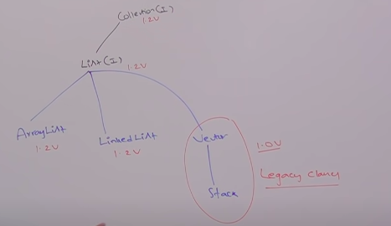

In 1.2 version vector and stack classes are re-engineered to implement list interface.

Set: Duplicates are not allowed.
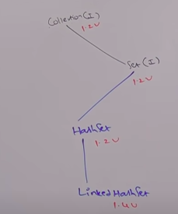

SortedSet(I):
it is the clild interface of set i we want to represent a group of individual objects as a single entity where duplicated are not allowed and all objects should be inserted according to some sortinng order. then we should go for sorted set

NavigableSet:
it is the child interface of sortedset iit contains several methods for navigation purposes.
TreeSet is the implementation for NavigableSet.

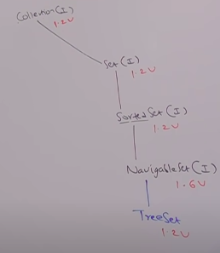

Queue(I):
it is the child interface of collection if we want to represent a group of individual objects prior to processing then we should go for queue.
usualy queue follows FIFO order but based on requirement we can implement our own priority order also.
ex: Before sending a mail all mail Ids we have to store in some data structure in which order we added mail Ids in the same order only mail should be delivered. For this requirement queue is best choice.


Map(I): When required key,value pair
Duplicate keys are not alllowed.But values can be duplicated

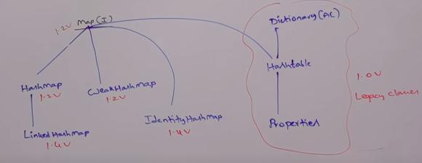

SortedMap:
It is the child interface of map. if we want to represent a group of key, value pairs according to some sorting order of keys then we should go for sortedmap.
In sortedmap the sorting should be based on key but not based on value.

NavigableMap:
It is the child interface of sorted map it defines several methods for navigation purposes.TreeMap is the child class of navigableMap.

The following are legacy characters present in collection framework
Enumeration
Dictionary
Vector
Stack
Hashtable
Properties

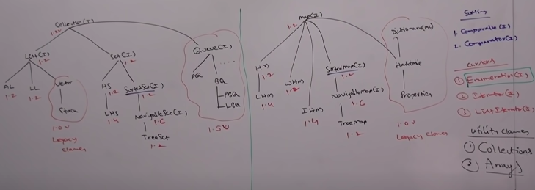

if wewant to represent a froup of individual objects as a single entity then we shold go for collection.
Collection interface defines the most common methods which are applicable for any collection object.

add(object o)
addAll(Colletion c)
remove(Object o)
removeAll(Collection c)
clear()
retainAll(Collection c)
contain(Object o)
containsAll(Collection c)
isEmpty()
size()
toArray()
iterator()

List:
List is the child interface of collection if we want to represent a group of individual objects adds a single entity where duplicates are allowed and insertion order must be preserved then we should o for list.
List interface defnes the following specific methods:

add(object o)
add(index i ,object o) ----> the existing element will be moved to next index.
addAll(index i,Collection c)
remove(index i)
set(object o) replaces existing element
indexOf(object) -->returns first index
lastIndexOf(object o)
listIterator()

1.resizable
2. dupicates are allowed
3.insertion order is preserved
4.Heterogeneous objects are allowed
5. null insertion is allowed
Constructor-1
ArrayList l = new ArrayList();
Constructor-2
ArrayList l = new ArrayList(10);

Default size is 10. when it exceeds then



Constructor-3
ArrayList l = new ArrayList(Collection c);

Usually we can use collections to hold and transfer objects from one location to another location (container) to provide support for this requirement every collection class by deafault implements serializable and clonable interfaces.
Every collection class by default implements Serializable and clonable

ArrayList and vector classes implements RandomAccess interface so that any random element we can access with the same speed.
RandomAccess Interface present in java.util package and it doesn contain any methods it is a marker interface .
Where required ability will be provided automatically by the JVM.
ArrayList is the best choice if our frequent operation is retrival operation.because arraylist implements RandomAccess Interface.
Arraylist is the worst choice is our frequent operation is insertion or deletion in the middle.

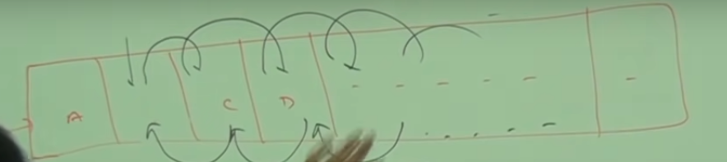

Differences between arraylist and vector
Vector is Synchronized.
vector is thread safe.
vector performance is less because threads are to be waited
vector is legacy.

How to get synchronied version of arraylist object.
By deafult arraylist is non synchronized but we can get synchronized version of arraylist object by using Collections.SynchronizedList(l) of Collections class.
ArrayList l = new ArrayList();
ArrayList l2 = Collections.SynchronizedList(l);
Similarly we can get synchronized version of set and map objects by using the following methods of Collections class.
Collections.SynchronizedSet(s);
Collections.SynchronizedMap(m);

LinkedList:
The underlying data structure is doubly linked list
Insertion order is preserved
duplicates are allowed.
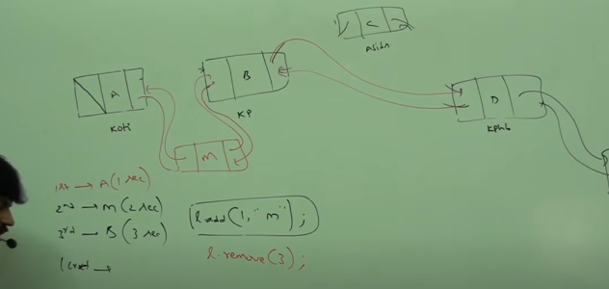

LinkedList is best choice if our frequent operation is insertion or deletion in middle.
LinkedList is worst choice if our frequent operation is retrieval operation.
Contructors:
LinkedList class specific methods :
Usually we can use linked list to develop stacks and queues. to provide support for these requirements linked list class defines the following specific methods
addFirst()
addLast()
getFirst()
getLast()
removeFirst()
removeLast()
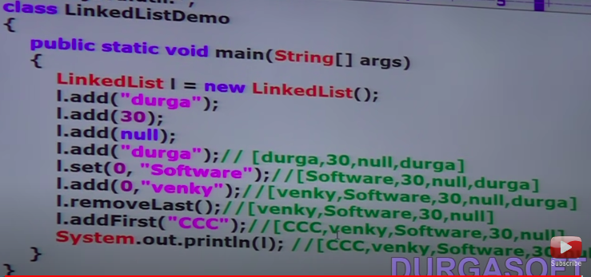
Differences between arraylist and linkedlist

Retrival is fast in arraylist
updation is fast in linked list
In linked list the elements wont be stored in consecutive memory locations and hence retrival operation will become complex.
Vector Constructors:
Vector v = new Vector();
Vector v = new Vector(int initialsize);
creates an empty vector object will specified initial capacity.
Vector size will be doubled when size exceeds.
Vector v = new Vector(int initialsize, int incrementalsize);
Vector contains legacy methods like:
addElementAt(int index)
removeAllElements()
elementAt(int index);
firstElement();
lastElement();
capacity();

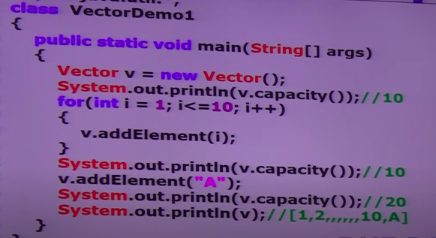

Stack:
it is the child class of vector. It is a specially designed for LIFO order.
push() ---->add
pop() ----> remove
peek() ---->retieve
empty() ---> similar to isEmpty()
search(object 0) ------->return offset -1 of false returns offset if true
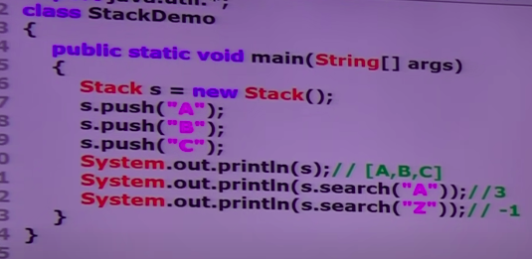

If we want to get Objects one by one from the collection then we should go for cursor.
There are 3 types of curors available in java.
Enumeration
Iterator
ListIterator.

Enumeration:
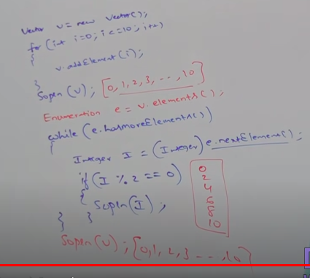

Limitations of Enumeration:
we can apply enumeration concept only for legacy classes.and it is not a universal cursor.
By using enumeration we can get only read operation and we can't perform remove operation.
to overcome above limitations we should go for iterator.

Iterator:
we can apply Iterator concept for any collection object and hence it is universal cursor.
By using iterator we an perform both read and remove operations.
We can create iterator object by using iterator() of collection interface.
Public Iterator iterator()
ex:
Iterator itr = c.iterator(); --->here c is any collection.
Methods:
- public boolean hasNext()
- public Object next()
- public void remove()
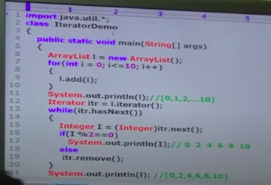

By using enumeration and iterator we can always move only towards forward direction and cannot move towards backward direction these are single direction cursors but not directional cursor.
By using iterator we can perform read and remove operations and we cannot perform replacement and addition of new objects.
To overcome above limitations we should go for ListIterator.
ListIterator:
By using ListIterator we can move either to the forward direction or to the backward direction and hence it is birectional cursor.
By using listIterator we can perform replacement and addition of new objects in addition to read and remove operations.
We can create ListIterator by using listIterator() of List Interface.
Public ListIteratot listIterator();
ex: ListIterator ltr = list.listIterator()
ListIterator is the child interface of Iterator and hence all methods present in iterator are by default available in listIterator.
ListIterator defines the following 9 methods:
-----------FORWARD-------------------
public boolean hasNext();
public Object next();
public int nextIndex();
-----------PREVIOUS----------------
public boolean hasPrevious();
publlic Object previous();
public int previousIndex();
---------- update ----
public void add();
public void remove(Object o);
public void set(Object o);

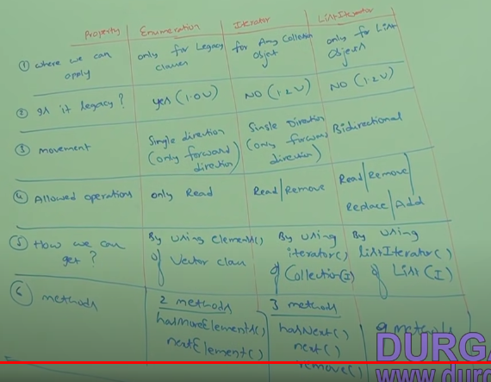
Set:
If we want to represent a group of objects as a single entity where duplicates are not allowed and insertion order not preserved.
Set interface doesnt contain any new methods and we have to use only collection interface 12 methods.
HashSet:
The undelying data structure is hashtable duplicate objects are not allowed insertion order is nor preserved and it is based on hashcode of objects.
Null insertion is possible (only once).
Heterogeneous objects are allowed.
Implements Serializable and Clonable but not RandomAccess.
Note: In hashset duplicates are not allowed if we are trying to insert duplicates then we wont get any compile time or runtime errors and add() returns false.
Ex: HashSet h = new HashSet();
h.add(“VASU”); --------->returns true;
h.add(“VASU”); --------->returns false;
Constructor-1
HashSet h = new HashSet();
creates an empty hashset with default size of 16 and default fill ratio is 0.75.
Constructor-2
HashSet h = new HashSet(10);
creates an empty hashset with specified size of 10 and default fill ratio is 0.75.
Constructor-3
HashSet h = new HashSet(size,fillratio);
HashSet h = new HashSet(10,0.9);
Constructor-4
HashSet h = new HashSet(Collection c);
This constructor meant for inter convertion between collection objects.

After filling how much ratio a new hashset object will be created, this ratio is called fill ratio or load factor.
Ex: if fillratio is 0.75 after filling 75% ratio a new hashset object will be created.
\

LinkedHashSet:
LinkedHashSet is exactly same as HashSet along with the constructors except the following differences.


LinkedHashSet is combination of LinkedList and HashTable.
In LinkedHashSet insertion order is preserved.
In general we can use linkedHashSet to develop cache based applications where duplicates are not allowed and insertion order preserved .

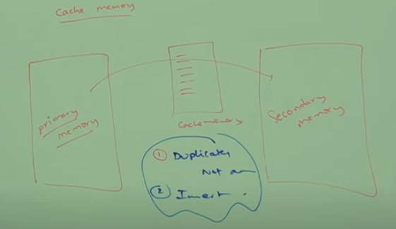
SortedSet:
Sortedset is the child interface of set.
If we want to represent a group of individual objects according to some sorting order without duplicates then we should go for sorted set.
SortedSet Interface defines the following specific methods.
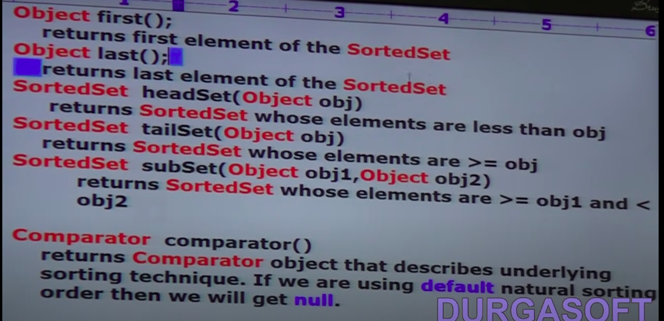
For integers the default sorting order is ascending order.
For strings the default sorting order is alphabetical order.
TreeSet:
The underlying data structure is balanced tree.
duplicate objects are not allowed.
insertion order not preserved.
heterogeneous objects are not allowed otherwise we will get runtime exception saying class cast exception.
Null insertion is possible(only once).
Implements Serializable and clonable but not RandomAccess.
All objects will be inserted based on some sorting order.
It may be default natural sorting order or customized sorting order.
Constructors:
- TreeSet t = new TreeSet(); -->creates an TreeSet Object where the elements will be inserted according to default natural sorting order .
- TreeSet t = new TreeSet(Comparator c); ---> creates an empty TreeSet Object where the elements will be inserted according to customized sorting order specified by comparator Object.
- TreeSet t = new TreeSet(Collection c);
- TreeSet t = new TreeSet(SortedSet s);

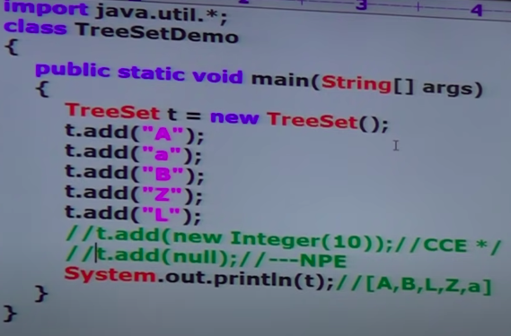
Null Acceptance:
For non empty TreeSet if we are trying to insert null then we will get NullPointerException.
For empty TreeSet as first element null is allowed.But after inserting that null if we are trying to insert any other then we will get RunTimeException saying NullPointerException.
Note: Until 1.6 version null is allowed as the first element to the empty TreeSet but from 1.7 onwards null is not allowed even as the first element.
ie., Null is not applicable for TreeSet from 1.7 onwards..

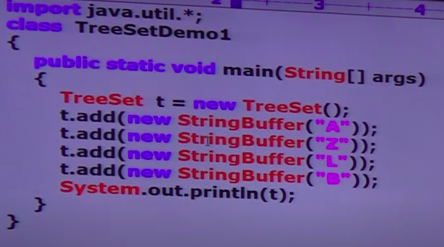
If we are depending on default sorting order compulsarily the objects should be homogeneous and comparable .otherwise we will get runtimeException saying classcast excpetion.
An object is said to be comparable if and only if corresponding class implements comparable interface.
String class and all wrapper classes already implements comparable interface.
But StringBuffer class does not implement Comparable interface.
Hence we got ClassCastException in the above example.
Comparable:
It is present in java.lang package and it contains only one method compareTo.
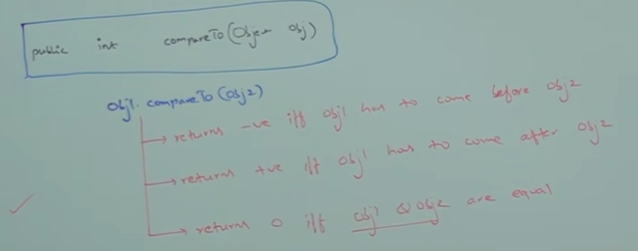
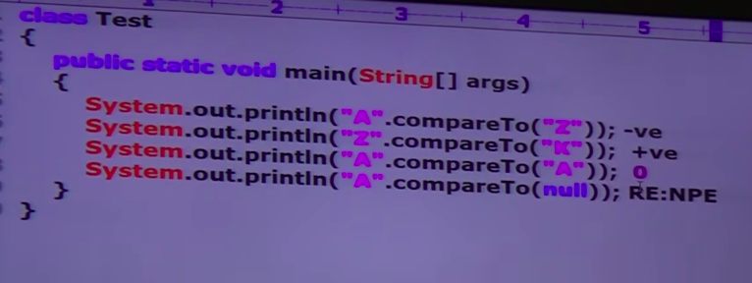
If we are depending on default natural sorting order then while adding the objects into the TreeSet JVM will call compareTo()

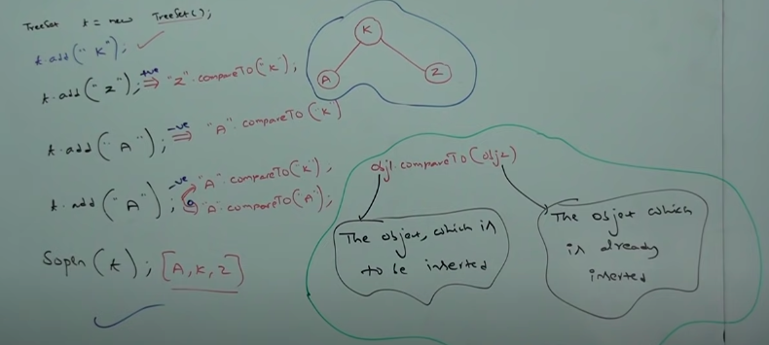
Note:
If we are not satisfied with default natural sorting order then we can go for custoomized sorting by using Comparator.
Comparable meant for default natural sorting order whereas Comparator meant for customized sorting order.
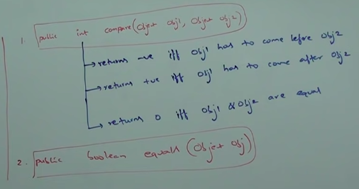

Whenever we are implementing comparator interface compulsary we shoud provide implementation only for compare method and we are not required to provide implementation for equals() because it is already available to our class from object class through inheritance.
Write a program to insert integer object into the tree set where the sorting order is desccending order.
+ve ====== after
-ve ====== before

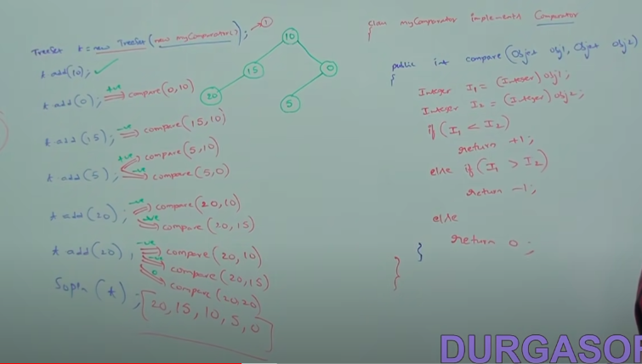
At line 1 if we are not passing comparator object then internally jvm will call compareTo() which is meant for default natural sorting order.
In this case output is 0,5,10,15,20
At line 1 if we are passing comparator object then JVM will call compare() which is meant for customized sorting in this case output is 20,15,10,5,0
various possible implementations of comparator:

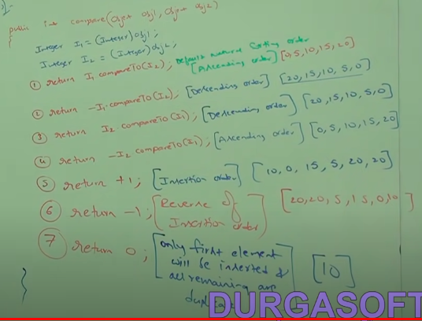
Write a program to insert String objects into the TreeSet where all elements should be inserted according to reverse of alphabetical order.
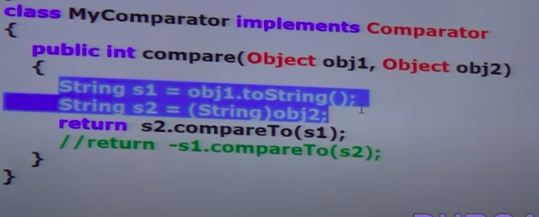
StringBuffer sorting:
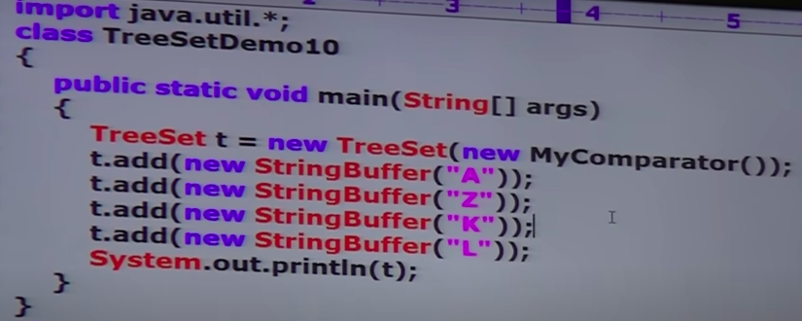

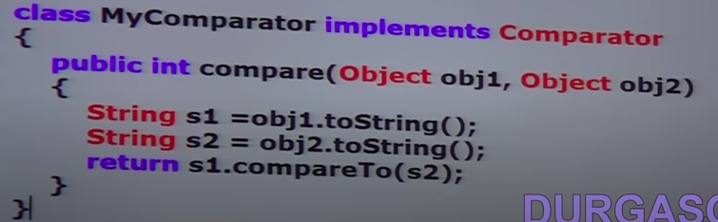
Comparator to arrange strings from short length to long length
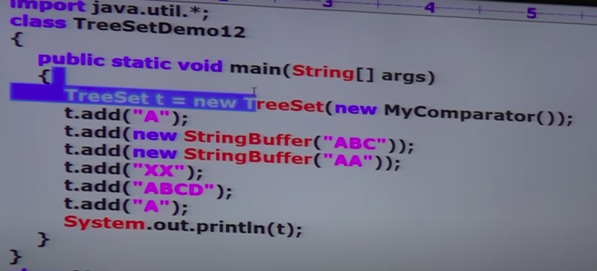
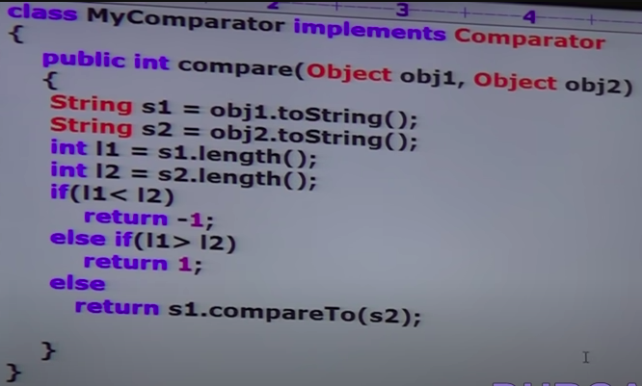
Comparable vs Comparator
For predefined comparable classes default natural sorting order already available.
If we are not satisfied with that default natural sorting order then we can define our own sorting order using Comparator.
For predefined non comparable classes like StringBuffer default natural sorting order not already available. We can define our own sorting Comparator.
For our own classes the person who is writing the class is responsible to define default natural sorting order by implementing comparable interface.
The person who is using our class is not satisfied with the default sorting order then he can define his own sorting by using comparator.
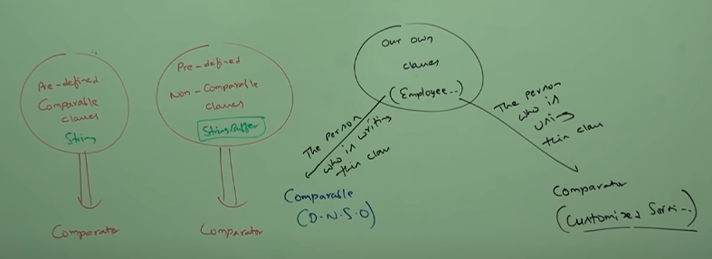
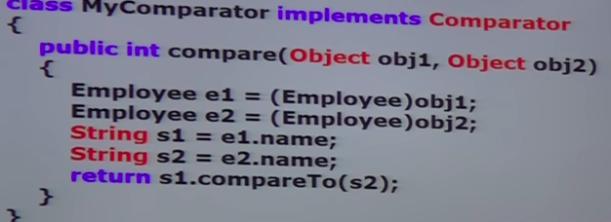
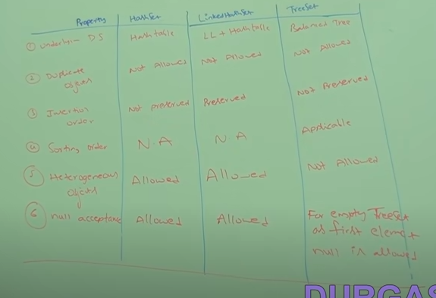

Map:
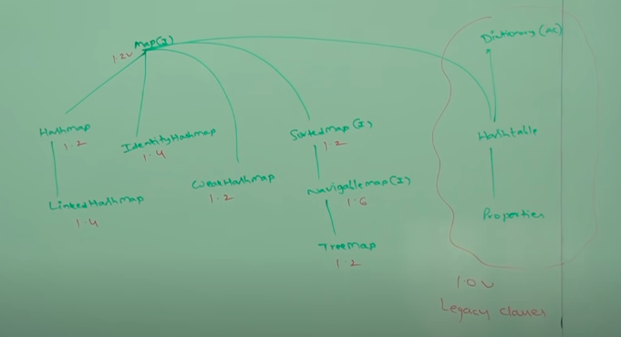
1. put():
Object put(Object key,Object value);
To add one key value pair to the map . Return type is null when new key and object for old key.
If the key is already present then old value will be replaced with new value and returns old value.
Ex:
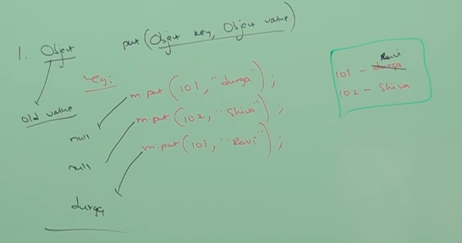
- void putAll(Map m)
- Object get(Object key)
- Object remove(Object key)
- boolean containsKey()
- boolean containsValue();
- boolean isEmpty()
- int size()
- void clear(); ---------------- collection views------>
- Set keySet();
- Collection values();
- Set entrySet();
Entry(I):
A map is a group of key value pairs and each key value pair is called an entry.
Hence map is considered as a collection of entry objects.
Without existing map object there is no chance of existing entry object.
Hence, entry interface is defined inside map interface.
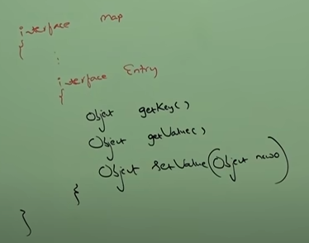

- the underlying data structure is hashtable.
- Insertion order is not preserved and it is based on hashcode of keys.
- Duplicate keys are not allowed but values can be duplicated.
- Heterogeneous objects are allowed for both key and value.
- Null is allowed for key.(only once)
- Null is allowed for values any number of times.
- Hashmap implements Serializable and Clonable interfaces but not random access.
- Hashmap is the best choice if our frequent operation is search operation.
Contructors:
- Hashmap h = new HashMap(); ------------------>16 , 0.75
- Hashmap h = new HashMap(int size);
- Hashmap h = new HashMap(int size,float fillratio);
- Hashmap h = new HashMap(Map m);
EntrySet Example :
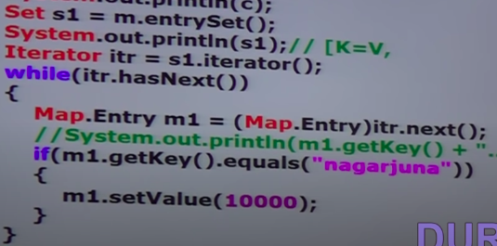
Difference between HashMap and HashTable:
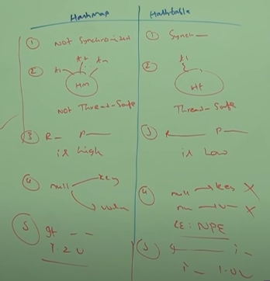

LinkedHashMap:
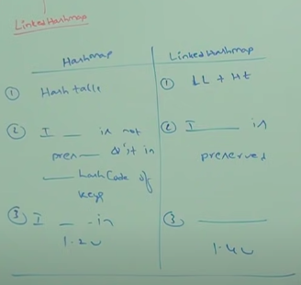

IdentityHashMap:
It is exactle same as HashMap(including methods and constructors) except the following difference.
In the case of normal HashMap JVM willl use .equals() to identify duplicate keys, which is meant for content comparision.
But in IdentityHashMap JVM uses ‘==’ operator to identify deplicate keys which is meant for reference comparision(address commparision).
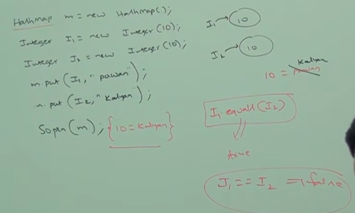

WeakHashMap:
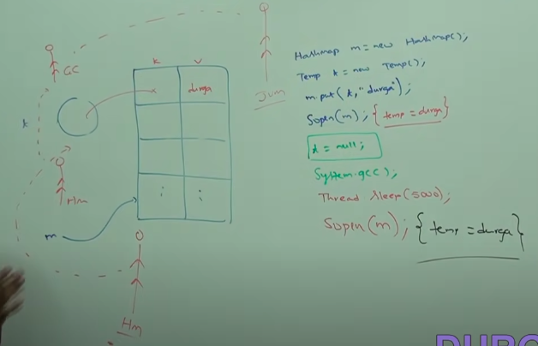
It is exactly same as hashmap except the following difference.In the case of hashMap object does not have any reference it is not elgible for GarbageCollector(GC) if it is assiciated with HashMap ie.,hashmap dominates garbage collector.
But in the case of WeakHashMap if object dosnt cotain any references it is eligible for GC eventhough object associated with WeakHashMap. ie., GarbageCollector dominated WeakHashMap.

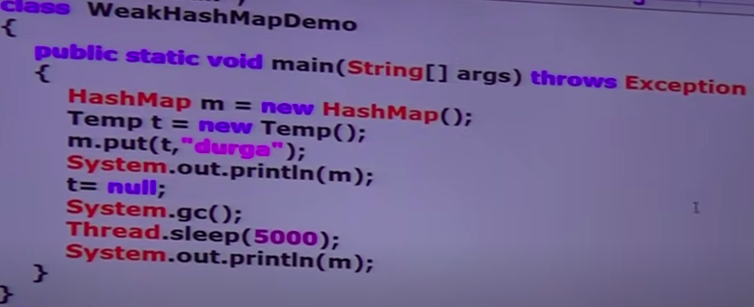
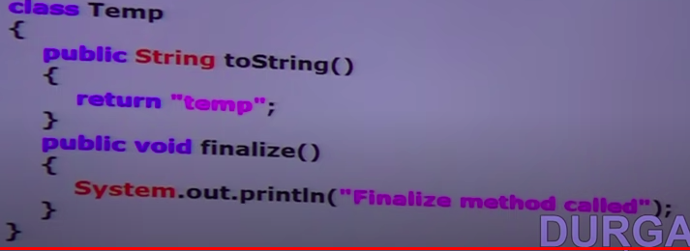
In the above example temp object not eligble for gc because it is associated with hashmap in this case output is {temp = durga} and {temp = durga}.
In the above program if we replace hashmap with WeakHashMap then temp object is eligible for gc in this case output is
{temp = durga}
Finalize method called
{}

SortedMap:
SortedMap is the child interface of map.
If we want to represent a group of key,value pairs according to some sorting order of keys then we should go for sorted map.
Sorting is based in the key but not based on value.
SortedMap defines the following the specific methods.
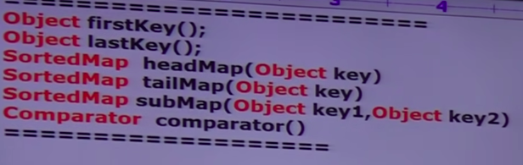
The underlying data structure is red black tree insertion order is not preserved and it is some sorting order of keys.
Duplicate keys are not allowed but values can be duplicated.
If we depending on default natural sorting order then keys shoud be homogeneous and comparable,otherwise we will get runtimeException saying classcastexception.
If we are defining our own soring by comparator then keys need not be homogeneous and comparable.
We can take heterogeneous non comparable objects also.
- For non empty treemap if we are trying to insert an entry with null key then we will get runtimeexception saying nullpointer exception
- For empty treemap as the first entry with null key is allowed. But after insering that entry if we are trying to insert any other entry then we will get runtimeexception saying nullpointerexception.
Note: The above null acceptance is applicable until 1.6v only from 1.7v onwards null is not allowed for key.but for values we can use null any number of times.
Contructors:
- TreeMap m = new TreeMap();
- TreeMap m = new TreeMap(Comparator c);
- TreeMap m = new TreeMap(Collection c);
- TreeMap m = new TreeMap(SortedMap c);
HashTable:
- The underllying data structure of hashmap is hashtable.
- Insertion order is not preserved and is based on hashcode of keys.
- Duplicate keys are not allowed and values can be duplicated.
- Heterogeneous objects are allowed for both keys and values.
- Null is not allowed for both key and value. Otherwise we will runtimexception saying nullpointerexxception.
- It implements serializable and clonable interfaces but not random access.
- Every method present in hashtable is synchronized and hence hashtable object is threadsafe.
- Hashtable is best choice if our frequent operation is search operation.
Contructors:
- HashTable h = new HashTable(); -->creates an empty hashtable object with default initial capacity 11 and default fill ratio 0.75.
- HashTable h = new HashTable(int initialCapacity);
- HashTable h = new HashTable(int initialCapacity, floar fillRatio);
- HashTable h = new HashTable(Map m);

HashTable:
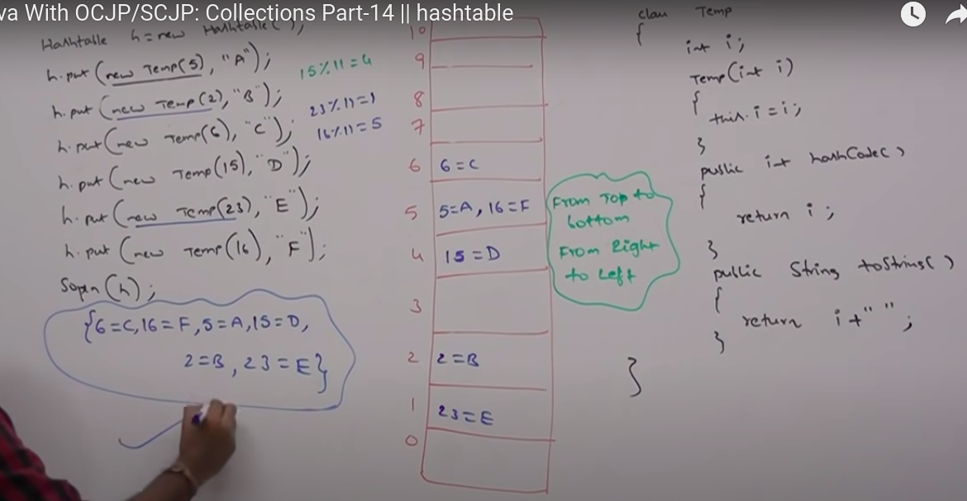
Properties:
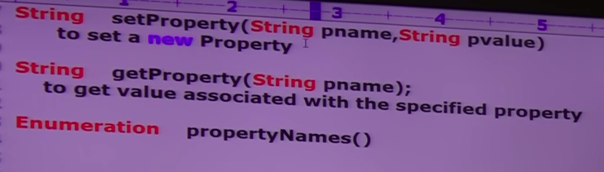
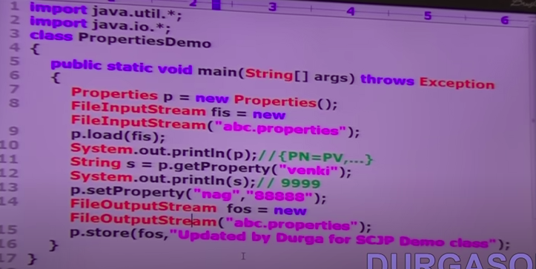
1.5v Enhancements in queue interface:
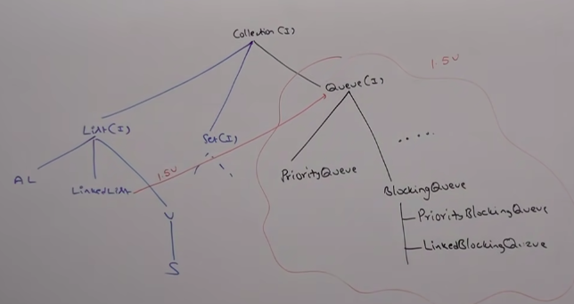
It is the child interface of Collection.
If we want to represent a group of individual objects according to prior to processing then we shoud go for queue.
For example before sending sms message all mobile numbers we have to store in some data structure. In which order we added mobile numbers in the same order only message should be delivered. For these FIFO requriement queue is best choice.
Usually queue follows FIFO order but based on our requirement we can implement our own priority order also(Priority Queue).
From 1.5v onwards LinkedList class also implements queue interface.
LinkedList based implementation of queue always follows FIFO order.
Queue interface specific methods :
- boolean offer(Object o) --->to add an object into th queue.
- Object peek() -----> to return head element in the queue.if queue is empty then this method returns null.
- Object element() -----> to return head element in the queue.if queue is empty then this method returns noSuchElementException.
- Object poll() ----> to remove and return head element in the queue.if queue is empty then this method returns null.
- Object remove() -----> to remove and return head element in the queue.if queue is empty then this method returns noSuchElementException.
If we want to represennt a group of individual objects prior to processing according to some priority then we should go for priority queue.
The priority can be either default natural sorting order or customized sortng order defined by comparator.
Insertion order is not preserved and it is based on some priority.
Duplicate objects are not allowed.
If we are depending on default natural sorting order compulsary the object should be homogenoenous and comparable. Otherwise we will get runtime exception saying classCastException.
If we are defining our own sorting order by comparator then objects need not be homogeneous and comparable.
Null is not alllowed even as the first element also.
Constructors :
- PriorityQueue p = new PriorityQueue(); ---->11
- PriorityQueue p = new PriorityQueue(int initialCapacity);
- PriorityQueue p = new PriorityQueue(int initialCapacity,Comparator c);
- PriorityQueue p = new PriorityQueue(SortedSet s);
- PriorityQueue p = new PriorityQueue(Collection c);
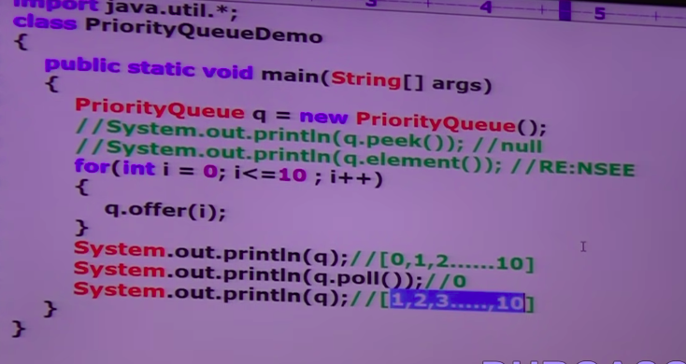
Some platforms wont provide proper support for thread priorities and priority queues.
1.6v enhancements in collection framework:
As the part of 1.6v the following 2 concepts introduced in 1.6v
NavigableSet(I), NavigableMap(I)
It is the child interface of sortedset and it defines several methods for purposes.
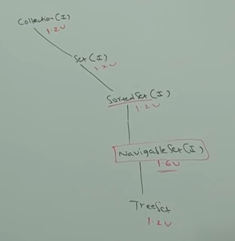

Navigable Interface Methods:
floor(e): returns highest element which is <=e
lower(e): returns highest element which is <e
ceiling(e): returns lower element which is >=e
higher(e): returns lower element which is >e
pollFirst(): remove and return first element.
PollLast(): remove and return last element.
DescendingOrder(): it returns NavigableSet in reverse order.
NavigableMap:
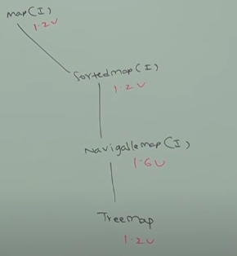

NavigableMap defines the following methods:
floorKey(e): returns highest element which is <=e
lowerKey(e): returns highest element which is <e
ceilingKey(e): returns lower element which is >=e
pollFirstEntry(): remove and return first element.
PollLastEntry(): remove and return last element.
DescendingOrderMap(): it returns NavigableSet in reverse order.

Collections class defines several utility methods for collection objects like sorting, searching, reversing etc.,
sorting elements of list
Collections class defines the following 2 sort methods:
- public static void sort(List l); -------------->to sort based on default natutal sorting order in this case list should compulsary contain hommogeneous and comparable objects. otherwise we will get runtimeexception saying ClassCastException. List should not contain null otherwise we will get NullPointerException.

- public static void sort(List l, Comparator c) ------------>To sort based on customized sorting order.
Collections class defines the following binary search methods.
- Public static int binarySearch(List l, Object target)
If the list is sorted according to default natural sorting order then we have to use this method.
- Public static int binarySearch(List l, Object target,Comparator c)
we have to use this method if the list is sorted according to customized sortinng order.
Conclusion:
The above search methods internally will use binary search algorithm. Successfull search return index. Unsucessfull search returns insertion point.
Insertion point is the location where we can place target element in the sorted list.
Before calling binary search method compulsary list should be sorted otherwise we will get unpredictable result.
If the list is sorted according to comparator then at the time of search operation also we have to pass same comparator object otherwise we will get unpredictable result.
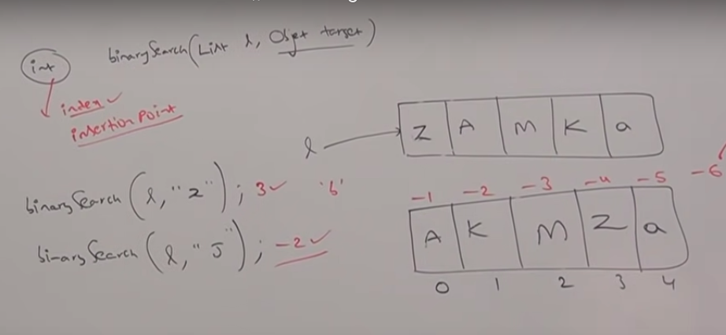

Collections class defines the following binary
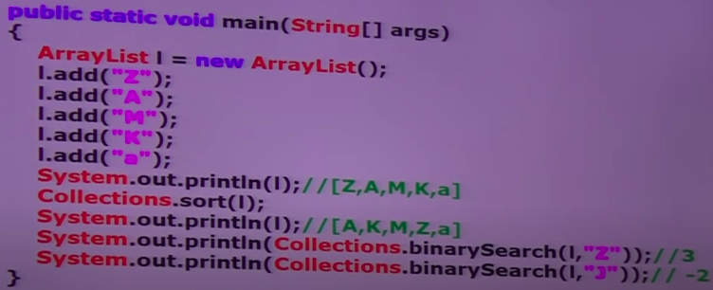

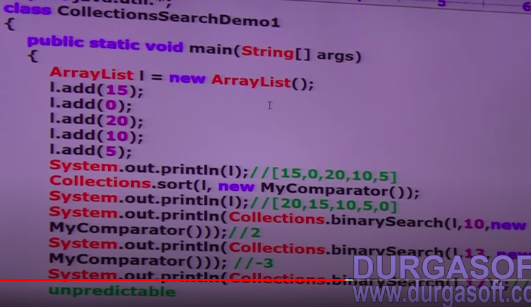
Note:
For the list of n elements in the case of binary search method succesfull search result range 0 to n-1.
Unsuccessfull search result range -(n+1) to -1
Total result range -(n+1) to n-1
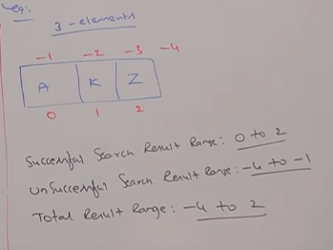

Collections reverse():
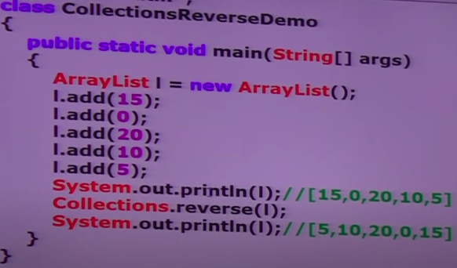

Collections reverseOrder():
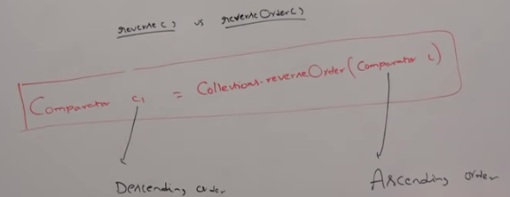
Arrays class is an utility class to define several utility methods for Arrays or Array Objects.
Arrays.sort():
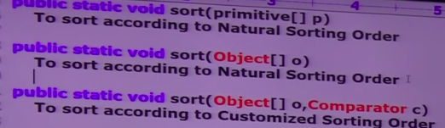
Arrays.binarySearch():
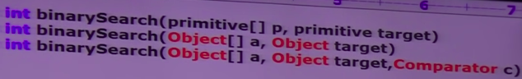

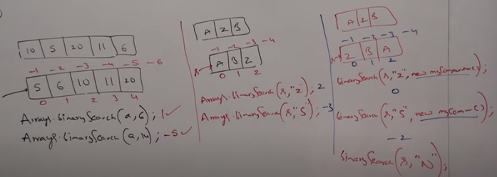
Arrays.asList():
List l = Arrays.asList(Array a);
By using the List reference we cannot perform any operation which effects size(). Otherwise we will get runtime exception saying UnsupportedOperationException.
By using the List reference we are not allowed to replace with heterogeneous objects. Otherwise we will get runtime exception saying ArrayStoreException.

