**Quick Start with the Bazaarvoice Android SDK**

1. You will need to have a developer API key. http://developer.bazaarvoice.com.

2. Download the SDK (two methods):

Check out the entire SDK git repository.

* There is no jar file included in the repo anymore. You can use our SDK in your project in one of two ways:

1. Import the SDK into Eclipse, compile it, and use the jar file generated in the bin folder.
2. Import the SDK into Eclipse, and added to your Android project as a Library. I will demonstrate this second option during this tutorial.

3. Open Eclipse and make a new Android Application Project, File > New > Android Application Project. call it “BVDisplayExample”.

a. Eclipse should take you through a Project set up wizard. For the “Configure Launcher Icon” portion of the Android project wizard, just click “Next”. Then choose “BlankActivity” and click “Next”.

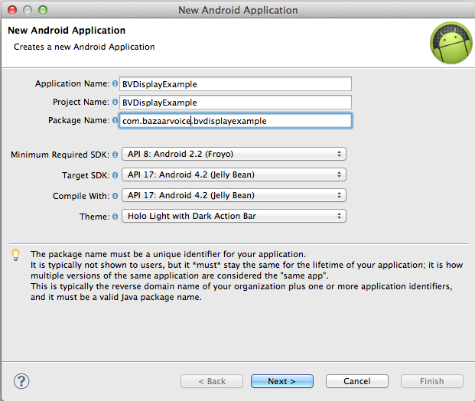

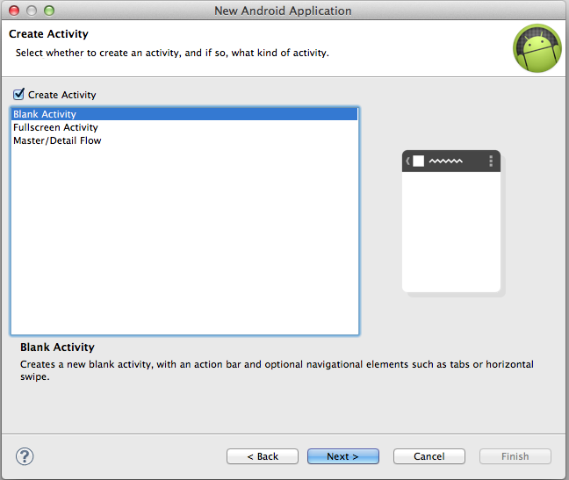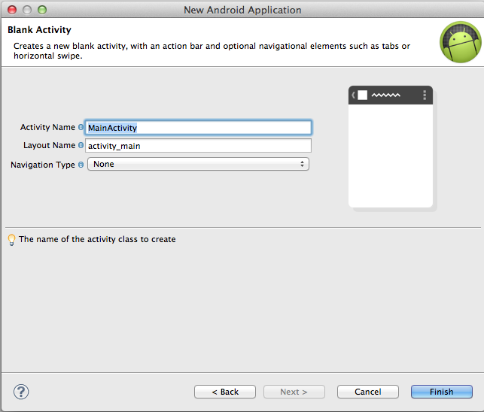

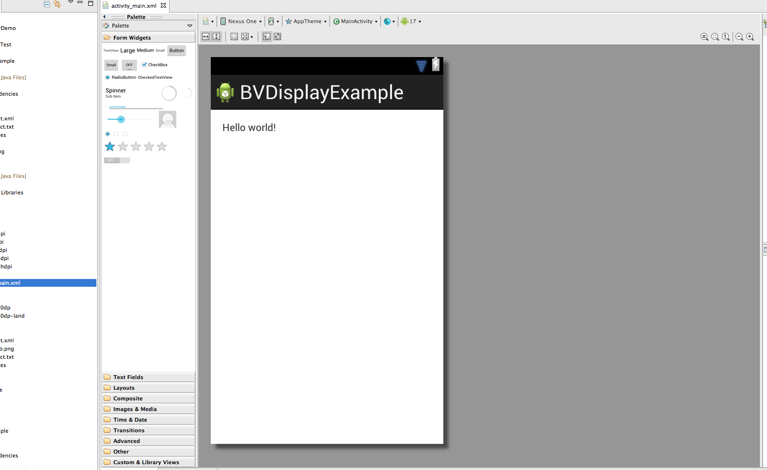

b. Now you have a MainActivity with a TextView in it. Under res/layout in the package explorer open activity_main.xml, and change the ID of the TextView to "mainText" by one of these methods:

1. Use the “Graphical Layout” tab, right click on the TextView and choose “Edit ID...”

2. Use the "activity_main.xml" tab, find the xml tag for the TextView and add the property android:id="@+id/ mainText" , the XML should look like this:

<RelativeLayout xmlns:android=*"http://schemas.android.com/apk/res/android"*

xmlns:tools=*"http://schemas.android.com/tools"*

android:layout_width=*"match_parent"*

android:layout_height=*"match_parent"*

android:paddingBottom=*"@dimen/activity_vertical_margin"*

android:paddingLeft=*"@dimen/activity_horizontal_margin"*

android:paddingRight=*"@dimen/activity_horizontal_margin"*

android:paddingTop=*"@dimen/activity_vertical_margin"*

tools:context=*".MainActivity"* >

<TextView

android:id=*"@+id/mainText"*

android:layout_width=*"wrap_content"*

android:layout_height=*"wrap_content"*

android:text=*"@string/hello_world"* />

</RelativeLayout>

c. Add a permission to use android.permission.INTERNET to the AndroidManifest.xml

file.

<uses-permission android:name=*"android.permission.INTERNET"*/>

4. If you have not yet done do, import the Bazaarvoice Android SDK project from the /Source/BVAndroidSDK directory into Eclipse.

Now add this project as a Library to your Android project by: right-click on your project > Select “Android” on the left hand side > in the “Library” box click “Add…” > if the Android SDK is in Eclipse, it should be amongst the options, select it and click “OK” > Click Apply > Click “OK”.

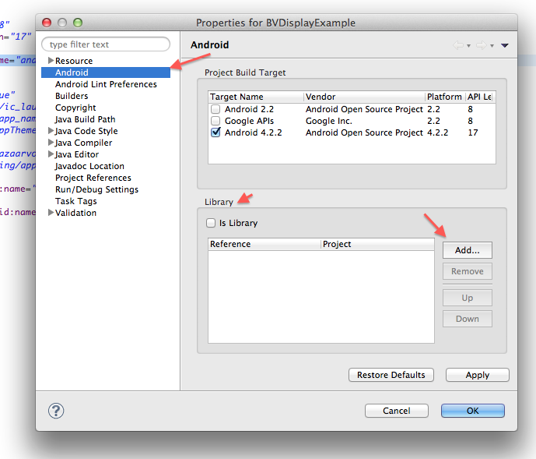

5. Now that we have the library set up, let’s make an example. Open up MainActivity.java.

6. In the onCreate() method, create a new BazaarRequest object:

**BazaarRequest request = new BazaarRequest(<your domain name>, <your API key>, <the API version you are using>);**

For example:

BazaarRequest request = **new** BazaarRequest("reviews.apitestcustomer.bazaarvoice.com/bvstaging", " kuy3zj9pr3n7i0wxajrzj04xo", ApiVersion.*FIVE_FOUR*);

**Note: The API version should be specified like “ApiVersion.FIVE_FOUR”. You should use the latest one.**

7. While still inside the onCreate() method, add some parameters to your request. I will not filter the parameter and our request will return all the products under the pass key you use.:

DisplayParams params = **new** DisplayParams();

**Note: This assumes you are using the apitestcustomer API.**

8. Next, set the MainActivity to implement the OnBazaarResponse interface:

**public** **class** MainActivity **extends** Activity **implements** OnBazaarResponse {

9. The last bit of code in our onCreate() method is to tie it together and send of the request:

request.sendDisplayRequest(RequestType.*PRODUCTS*, params, **this**);

10. Add a variable to your MainActivity for the mainText

TextView mainText;

Then assign it inside your onCreate() method:

TextView mainText;

@Override

**protected** **void** onCreate(Bundle savedInstanceState) {

**super**.onCreate(savedInstanceState);

setContentView(R.layout.*activity_main*);

mainText = (TextView) findViewById(R.id.*mainText*);

BazaarRequest request = **new** BazaarRequest("reviews.apitestcustomer.bazaarvoice.com/bvstaging", " kuy3zj9pr3n7i0wxajrzj04xo", ApiVersion.*FIVE_FOUR*);

DisplayParams params = **new** DisplayParams();

request.sendDisplayRequest(RequestType.*PRODUCTS*, params, **this**);

}

11. Next, we add define a callback inside our MainActivity class to handle the response:

@Override

**public** **void** onResponse(JSONObject json) {

**final** JSONObject myJson = json;

**this**.runOnUiThread(**new** Runnable() {

@Override

**public** **void** run() {

**try** {

**if** (myJson.getBoolean("HasErrors")) {

mainText.setText("JSON response has errors");

} **else** {

mainText.setText(myJson.toString());

}

} **catch** (JSONException exception) {

Log.*e*("BVDisplayExample", "Error = " + exception.getMessage() + "\n");

exception.printStackTrace();

}

}

});

}

@Override

**public** **void** onException(String message, Throwable exception) {

Log.*e*("BVDisplayExample", "Error = " + message + "\n");

exception.printStackTrace();

}

Note: If you get formatting errors from copying and pasting, simply press Ctrl+Shift+F to format the file you are viewing.

Also: If you are getting errors on @Override at this point, make sure your compiler is set to Java 1.6 not 1.5. Click on the project in the Package Explorer, then go to Preferences ­> Java Compiler ­> Compiler Compliance Level to check.

Your whole MainActivity class should now look like this (note, your package will be whatever you choose during the project setup):

**package** com.bazaarvoice.bvdisplayexample;

**import** org.json.JSONException;

**import** org.json.JSONObject;

**import** android.app.Activity;

**import** android.os.Bundle;

**import** android.util.Log;

**import** android.widget.TextView;

**import** com.bazaarvoice.BazaarRequest;

**import** com.bazaarvoice.DisplayParams;

**import** com.bazaarvoice.OnBazaarResponse;

**import** com.bazaarvoice.types.ApiVersion;

**import** com.bazaarvoice.types.Equality;

**import** com.bazaarvoice.types.RequestType;

**public** **class** MainActivity **extends** Activity **implements** OnBazaarResponse {

TextView mainText;

@Override

**protected** **void** onCreate(Bundle savedInstanceState) {

**super**.onCreate(savedInstanceState);

setContentView(R.layout.*activity_main*);

mainText = (TextView) findViewById(R.id.*mainText*);

BazaarRequest request = **new** BazaarRequest("reviews.apitestcustomer.bazaarvoice.com/bvstaging", " kuy3zj9pr3n7i0wxajrzj04xo", ApiVersion.*FIVE_FOUR*);

DisplayParams params = **new** DisplayParams();

request.sendDisplayRequest(RequestType.*PRODUCTS*, params, **this**);

}

@Override

**public** **void** onResponse(JSONObject json) {

**final** JSONObject myJson = json;

**this**.runOnUiThread(**new** Runnable() {

@Override

**public** **void** run() {

**try** {

**if** (myJson.getBoolean("HasErrors")) {

mainText.setText("JSON response has errors");

} **else** {

mainText.setText(myJson.toString());

}

} **catch** (JSONException exception) {

Log.*e*("BVDisplayExample", "Error = " + exception.getMessage() + "\n");

exception.printStackTrace();

}

}

});

}

@Override

**public** **void** onException(String message, Throwable exception) {

Log.*e*("BVDisplayExample", "Error = " + message + "\n");

exception.printStackTrace();

}

}

Congratulations, you’ve made your first app with the Bazaarvoice SDK. Go ahead and run it and see the result. It should look like this:

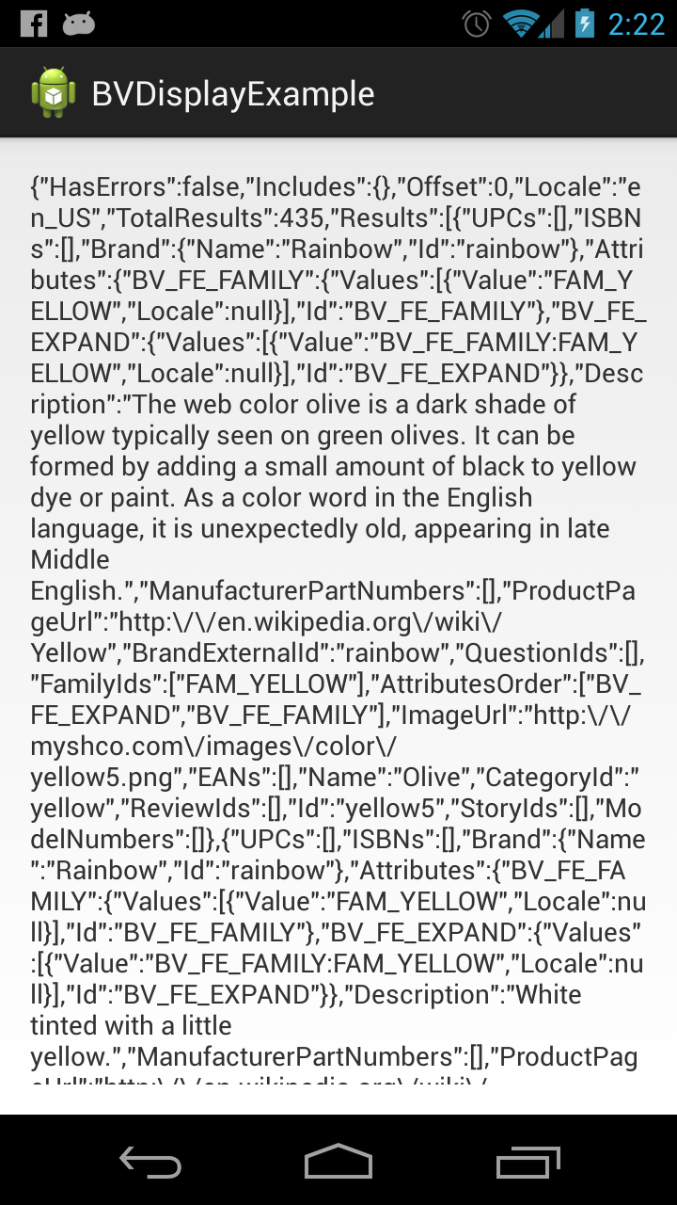

If things aren’t working correctly, check the LogCat to see if any errors were displayed. To enable LogCat, go to Window >

Show View > Other... and choose LogCat from the list. If you are still unsure of what is going wrong, find the request string in LogCat and copy and paste it into a browser to check that you get a valid response.

13. For further examples, check out the /Sample Apps folder in the git repository.