1. <https://www.thinqchess.com/tournaments>

Kavitha: share.google/AeKt……  
  
2. Favicon isnt getting picked up properly on certain pages 

3. Previous tournament link. We need the queen to be displayed when the website links are shared or saved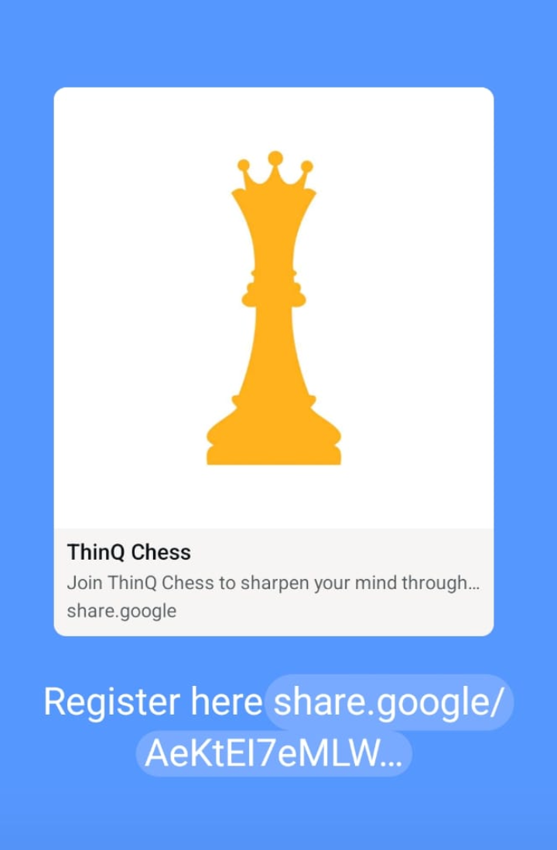  
3. ⁠Edit and update Tournament information: Delete a category; Add a new category - does not reflect on website; Basically Tournament edit does not work properly

4. When Razorpay transaction fails - the message comes up invalid PIN. But that is not coming up anymore. Failure scenarios to be checked

5. Google reviews are not reflecting correctly

JP8: <https://www.google.com/search?q=ThinQ+Chess+-+JP+Nagar+8th+Phase&stick=H4sIAAAAAAAA_-NgU1I1qDBOSkw1S0pLMjdINkyzSEuyMqiwNDZINUyyTEwzSLJMSU1KWcSqEJKRmReo4JyRWlysoKvgFaDgl5ieWKRgUZKhEJCRWJwKAMRvTpFMAAAA&hl=en-GB&mat=CZx9Ewb1ziUmElYBYJahafFY3cpZYesydDvqy_QQLdgaRBBCmvgQE0NpISg136dyqyRB-h7XvjMPPN69a-rxUGLDsfEfFMKN3GNRmbn1Ka6P2G0QFYS2yj60MDVDms22-Q&authuser=0>

AKS: <https://www.google.com/search?q=ThinQ+Chess+-+Akshayanagar&stick=H4sIAAAAAAAA_-NgU1I1qDAxM0tKNjOzSElNNjVOtjS0MqiwTDEwSTU0TzGxME1LSjIxXMQqFZKRmReo4JyRWlysoKvgmF2ckViZmJeYnlgEAGMIe0JGAAAA&hl=en-GB&mat=CcXFRAHa9BkvElcBYJahaZDwLbrFecayjnUX4lUPSpK5eTzndlwF20WIp_sTDlwOQxR2X50lT9syzDNRlLZ_-eHWAcqt_K0Nxj9wEN36C4CYXKfl_Nt1xlybZA3_JPZ5RAw&authuser=0>

6. Akshayanagar location pin to be setup correctly in Admin console

7. excel download of tournament registration - data not showing correctly (phone number, category)

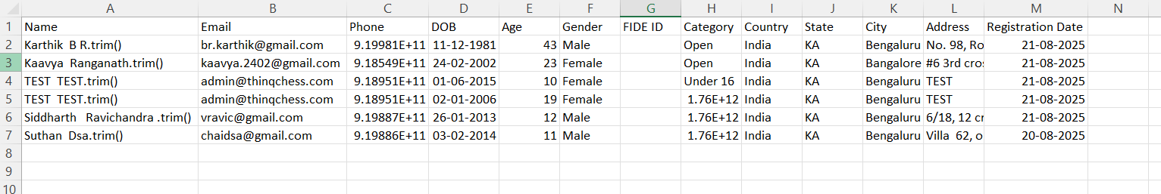

8. The admin console is flickering after logout. shared the video in the whatsapp group

9. For the [lms.thinqchess.com](http://lmw.thinqchess.com) url, the favicon and name do not match. Is this coming from the website or the lms?-

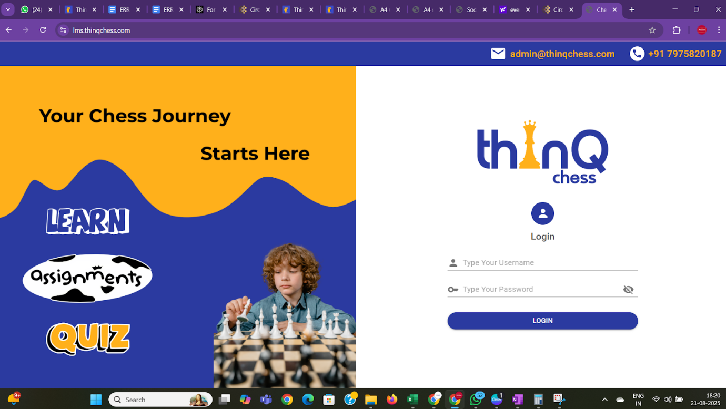

10. After every website update for bug fixes, the settings information is lost. It is difficult to remember to setup Razorpay live settings/placeid or google review codes’

11. Why does the admin id and password have to be displayed on the settings page?

12. Razorpay keys in the admin console - are they working fine? Is this configurable?: HAS BEEN MADE PERMANENT

13. Tournament enhancement: Need KSCA id to be made mandatory if event has KSCA event code: CAN BE ADDED IN NEW SCOPE OF WORK

14. We received a tournament payment from drishtee2009@outlook.com but this registration is not available in the registration list. this was done 6 mins back. There is a lag of 10+ mins from when the payment is received to when the registration is reflected in the admin console

15. The registration information does not show the category of registration

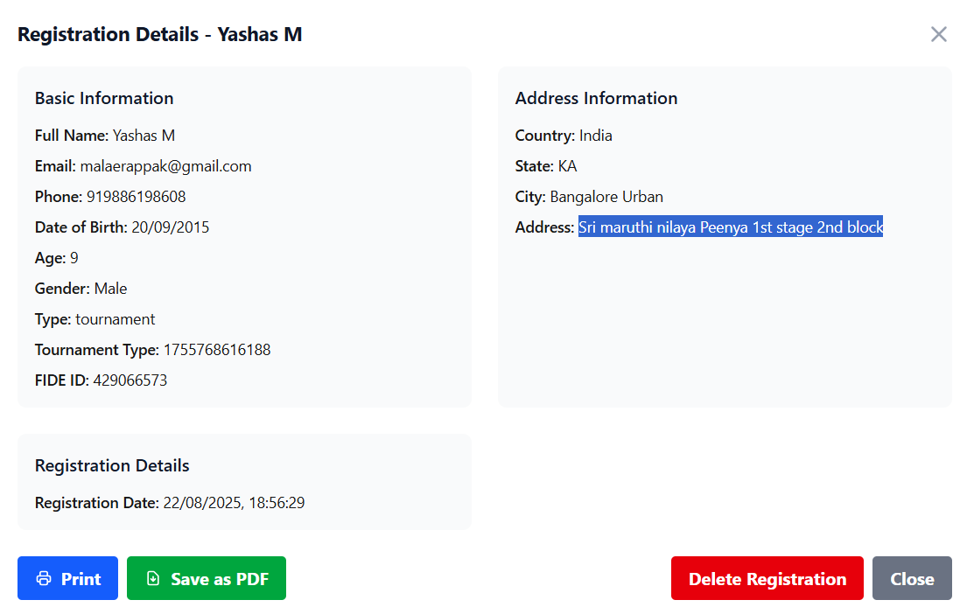

16. dISCOUNT - Should be able to give fixed discount of Rs 100, etc.

17. Usage for discount code is not showing correctly



18. Need to discuss pon Gallery Managemnt

What sort of images and videos can be uploaded; where will it reflect; does it slow down the website loading?ic

19.