PRODUCT CONCEPT • BUSINESS REQUIREMENTS • FIGMA-STYLE UX

SchoolConnect Lite
A simple, beautiful single mobile app for school communication, homework, results and parent absence acknowledgement.
PRODUCT THESIS
Keep the first release intentionally narrow: teachers publish the information parents need every day; parents see it in one child-centric timeline and can acknowledge attendance alerts without using separate apps.

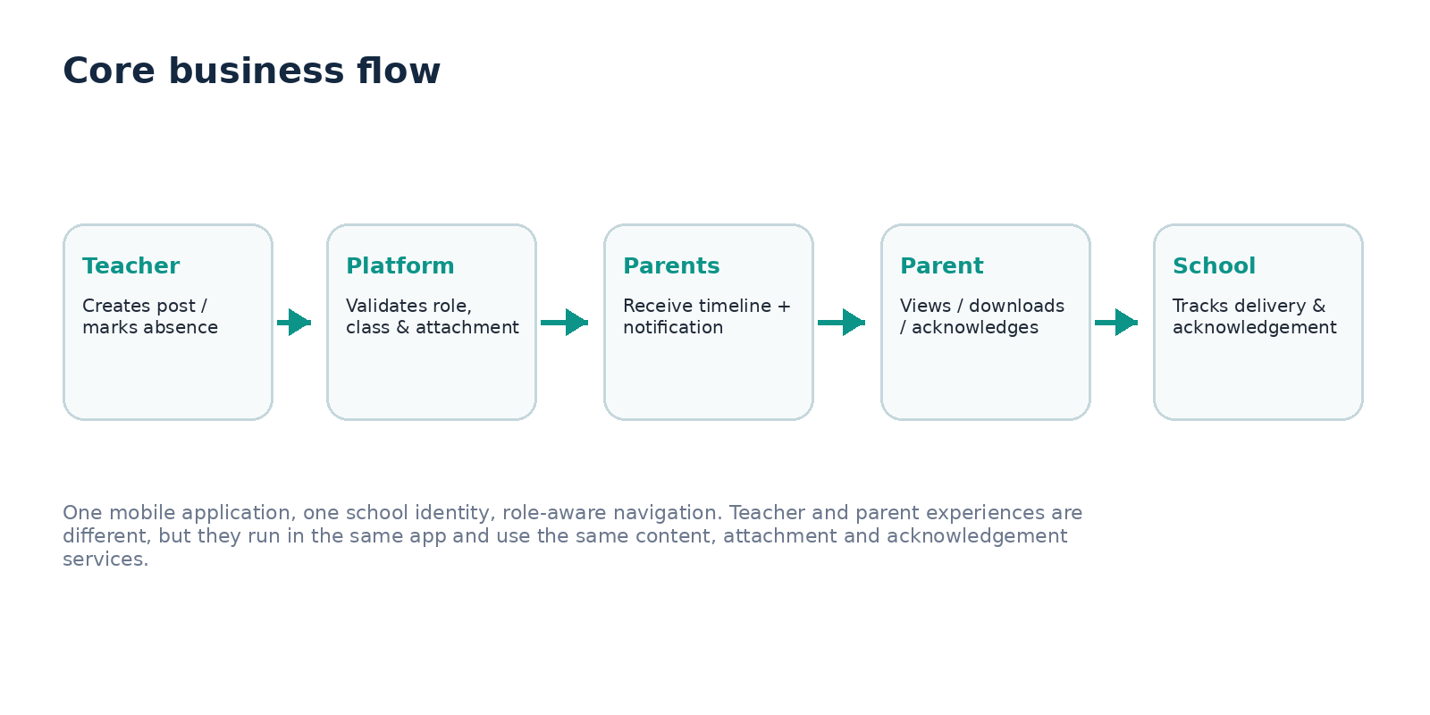
Product shape | Single mobile app | Primary users | Teacher + Parent
Pilot focus | Homework • Results • Announcements • Absence | Design status | Business & UX baseline

01 • EXECUTIVE SUMMARY

One app. Two role experiences. Four daily jobs.
SchoolConnect Lite is deliberately smaller than a full school ERP. It solves the high-frequency communication loop between teachers and parents using one role-aware mobile application. Teachers publish homework, result attachments and announcements; parents view these items for their linked children and acknowledge absence alerts.
Daily job | Teacher experience | Parent experience | Business outcome
Homework | Create, attach file/photo, select class, publish | See due date, instructions, attachment, view status | Less confusion and fewer WhatsApp follow-ups
Results | Publish controlled result attachment to class/child audience | Open result securely for linked child | Faster, auditable result delivery
Announcements | Publish school/class notice with optional attachment | See announcement in timeline and notifications | One official source for school updates
Absence | Mark/confirm absence through attendance workflow | Receive alert, acknowledge, optionally add reason/leave note | Closed-loop attendance follow-up

Why a single app matters
The same install supports both roles. After sign-in, the navigation, actions and permissions change based on role. A teacher never sees parent-only child views; a parent never receives teacher publishing controls.

Success criteria for the pilot
- 90%+ of published homework and announcements delivered to intended parents.
- 80%+ parent view rate within 24 hours for urgent announcements.
- Absence acknowledgements visible to the school with timestamp and optional reason.
- No cross-class or cross-child content exposure.
- Teacher can publish a normal post in under 60 seconds.

02 • SCOPE & PRODUCT BOUNDARY

Simple by design, extensible by architecture
In MVP | Not in MVP
Role-aware login: Teacher / Parent | Fees and online payments
Teacher class/subject assignments | Transport tracking
Homework post + attachments | Student chat/social feed
Result attachment publishing | AI tutor or generative student assistant
School/class announcements | Complex examinations/mark entry engine
Parent child switcher | Full school ERP replacement
Attendance alert + acknowledgement | HR, library, inventory
Push/in-app notifications | Open parent-to-parent messaging
View/delivery/acknowledgement status | Unrestricted file sharing

Business rules
- A single account may have one or more roles, but the UI exposes only actions allowed for the active role.
- A parent can see only children explicitly linked to that guardian account.
- A teacher can publish only to classes/subjects assigned by the school.
- Result attachments are private content; URLs must not be public or guessable.
- Every post has created-by, audience, created-at, publish status, and attachment metadata.
- Absence acknowledgement does not overwrite the official attendance record. It records parent response alongside it.
- Deleted or corrected official content should retain an audit trail.

03 • USERS, PERSONAS & JOBS-TO-BE-DONE

Design around two people, not ten modules
Persona | Typical situation | Needs | Pain today
Teacher – Ms. Priya | Moves between classes; publishes from phone after class | Fast compose flow, reusable audience, camera/PDF attach, clear publish confirmation | Repeated WhatsApp messages, unclear who received content
Parent – Mr. Ahmed | Checks updates after work; has multiple children | One timeline, child switcher, strong unread indicators, simple acknowledgement | Updates spread across groups, missed messages, no official history
School coordinator – optional support role | Configures classes, teacher assignments and guardian links | Simple setup/admin web later; not required as a daily app persona | Manual onboarding and permission errors

Jobs-to-be-done
- “When class ends, I want to publish homework with the right attachment in under a minute.”
- “When results are ready, I want only the intended parents to access them.”
- “When the school has an announcement, I want to know parents actually received/viewed it.”
- “When my child is marked absent, I want to confirm I saw it and optionally tell the school why.”
- “When I have two children, I want to switch children without logging out.”

04 • DETAILED BUSINESS SCENARIOS

End-to-end scenarios and acceptance behavior

SC-01 — Teacher posts homework
Precondition | User flow | System behavior | Acceptance
Teacher is signed in; assigned to Grade 5A Mathematics. | Select Create → Homework; select class/subject; enter title, instructions, due date; attach PDF/photo; preview audience; publish. | System stores post + attachment, sends push/in-app notification, records delivery/view status. | Parents of Grade 5A see the homework under the correct child; no other class can access it.

SC-02 — Teacher publishes result attachment
Precondition | User flow | System behavior | Acceptance
Teacher has permission for Grade 5A result publishing. | Select Results; choose class/exam/subject; attach PDF/image; confirm privacy check; publish. | Private attachment is stored securely and linked to the audience; parents are notified. | Only guardians of eligible students can open the result; access is logged.

SC-03 — Teacher posts announcement
Precondition | User flow | System behavior | Acceptance
Teacher has announcement permission. | Choose audience (class/grade/whole school); add title/message; optional attachment; publish now or save draft. | Announcement enters parent timeline and notification inbox. | Parent sees source, published time, audience context and attachment.

SC-04 — Parent acknowledges absence
Precondition | User flow | System behavior | Acceptance
Student is marked absent; parent is linked to child. | Parent taps alert → Acknowledge; optionally enters reason or chooses Leave Note; confirms. | Acknowledgement is timestamped with parent identity and becomes visible to authorized school staff. | Official attendance stays “Absent”; a separate parent response state becomes “Acknowledged”.

SC-05 — Parent has two children
Precondition | User flow | System behavior | Acceptance
Guardian is linked to two students in different grades. | Use child switcher from home; timeline refreshes to selected child. | Queries and notifications are child-scoped; unread counts remain attributable. | No content from Child A appears under Child B.

SC-06 — Teacher posts wrong homework
Precondition | User flow | System behavior | Acceptance
Published post is incorrect. | Teacher opens own post → Edit/Correct; changes attachment/instructions; confirms update. | System versions the change and notifies parents if material. | Parents see “Updated” label; previous version retained for audit/support.

SC-07 — Attachment upload fails
Precondition | User flow | System behavior | Acceptance
Network drops during upload. | App shows upload state and retry; draft remains local/server-side as applicable. | Post cannot publish until required attachment is safely stored. | No broken attachment is sent to parents.

SC-08 — Parent does not acknowledge absence
Precondition | User flow | System behavior | Acceptance
Alert is delivered but parent takes no action. | No parent action. | System keeps status as Pending; school can filter unacknowledged absences. | No false acknowledgement is inferred from notification delivery or opening the app.

05 • MOBILE INFORMATION ARCHITECTURE

Same shell, role-aware navigation
Navigation area | Teacher | Parent
Home | Quick actions, recent posts, class summary | Child timeline, urgent actions, recent updates
Posts | Homework, Results, Announcements; create + manage | Homework, Results, Announcements; read-only
Attendance | Class attendance view; absent follow-up status | Child attendance alerts; acknowledge/leave note
Notifications | Delivery/publishing events | All child/school updates
Profile | School, role, notification preferences | Guardian profile, linked children, notification preferences

Design convention
Do not ask the user to choose “Teacher App” or “Parent App.” Authentication resolves the role. If a person has both roles, provide a controlled role switch inside Profile.

Content model
Entity | Key fields | Notes
Post | id, type, title, body, school_id, audience, author, status, created_at, published_at | type = HOMEWORK / RESULT / ANNOUNCEMENT
Attachment | id, post_id, file_name, mime_type, size, storage_key, checksum | Private object storage; signed access
Audience | school, grade, class, subject, selected students | Resolved at publish time and authorization time
View receipt | post_id, guardian_id, student_id, first_viewed_at, last_viewed_at | Useful for school visibility; not same as acknowledgement
Attendance event | student_id, date, status, teacher, source, version | Official transactional record
Absence acknowledgement | attendance_event_id, guardian_id, status, reason, timestamp | Separate record; does not mutate attendance

06 • FIGMA-STYLE MOBILE DESIGN DIRECTION

Clean, calm, action-first mobile UI
The following screens are high-fidelity business wireframes intended as a Figma handoff baseline. They define information hierarchy, actions, states and component behavior; final brand colors, typography and icons can be mapped to the school brand system.
Design token | Recommendation
Frame | 390 × 844 px logical mobile frame; Android/iOS responsive
Grid | 8 pt spacing system; 16–20 px page gutters
Primary color | Deep navy for headers + trust; teal for primary actions
Cards | 16–18 px radius; subtle neutral border; minimal shadow
Typography | Readable sans serif; 24–28 px page titles; 16–18 px body
Accessibility | Minimum 44 px tap targets; strong contrast; semantic status text, not color alone
Attachments | Show file type, file size, open/download action and error state
Status | Draft, Uploading, Published, Updated, Viewed, Acknowledged, Pending

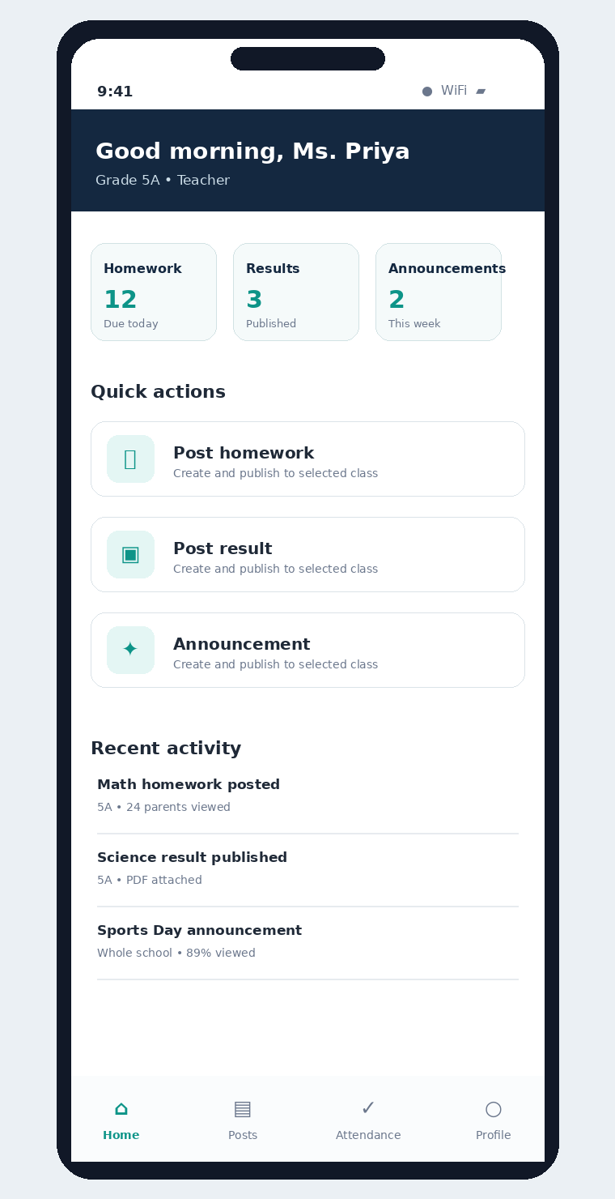  F01 • Teacher home | 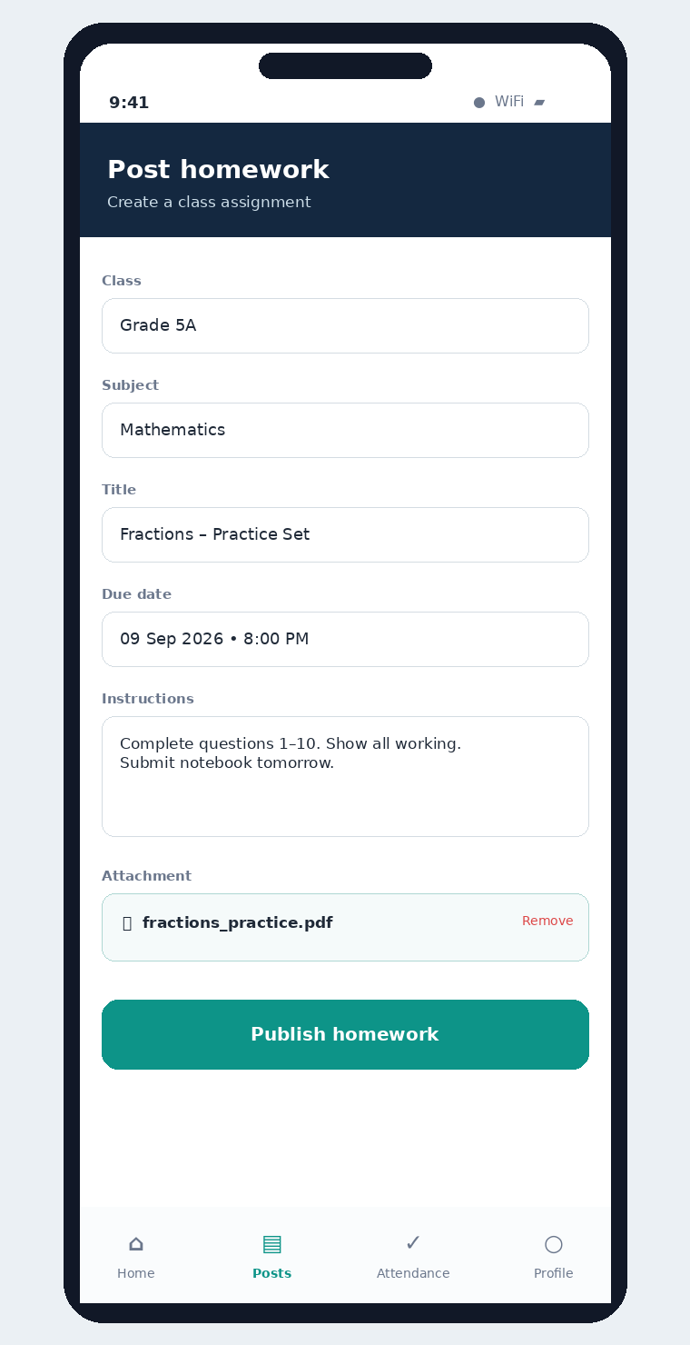  F02 • Post homework

06 • FIGMA-STYLE MOBILE DESIGN DIRECTION

Teacher publishing flows
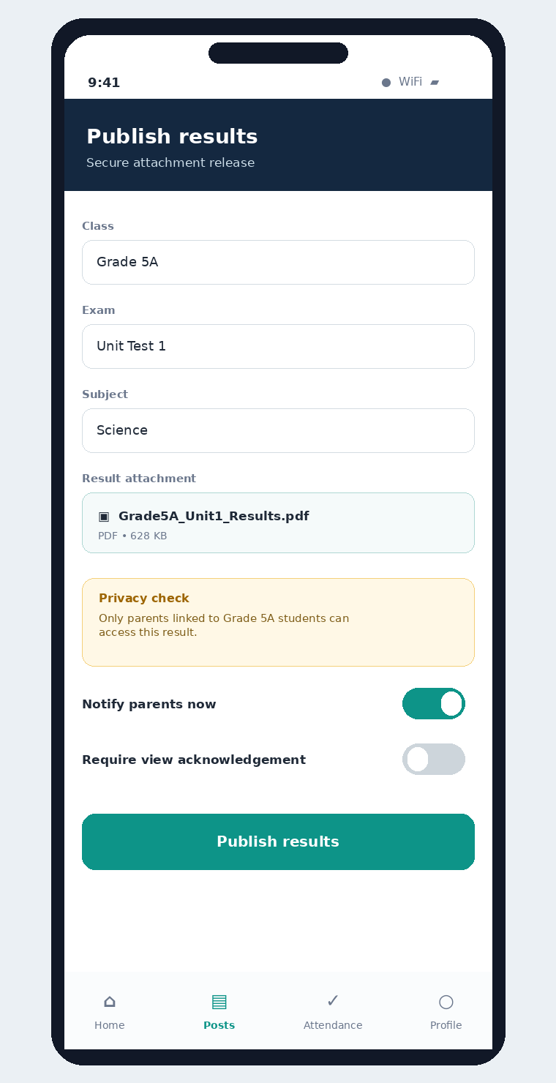  F03 • Publish result | 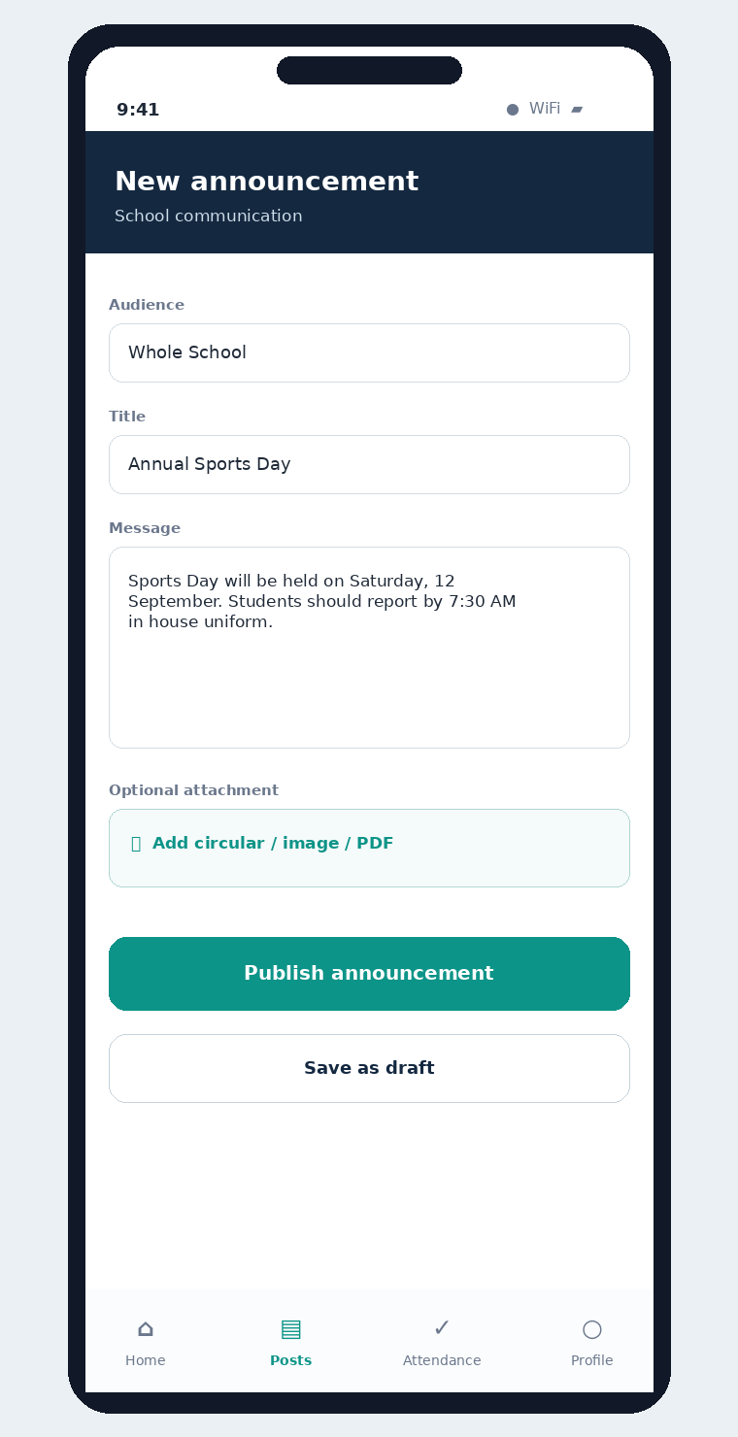  F04 • New announcement

06 • FIGMA-STYLE MOBILE DESIGN DIRECTION

Parent timeline and attendance action
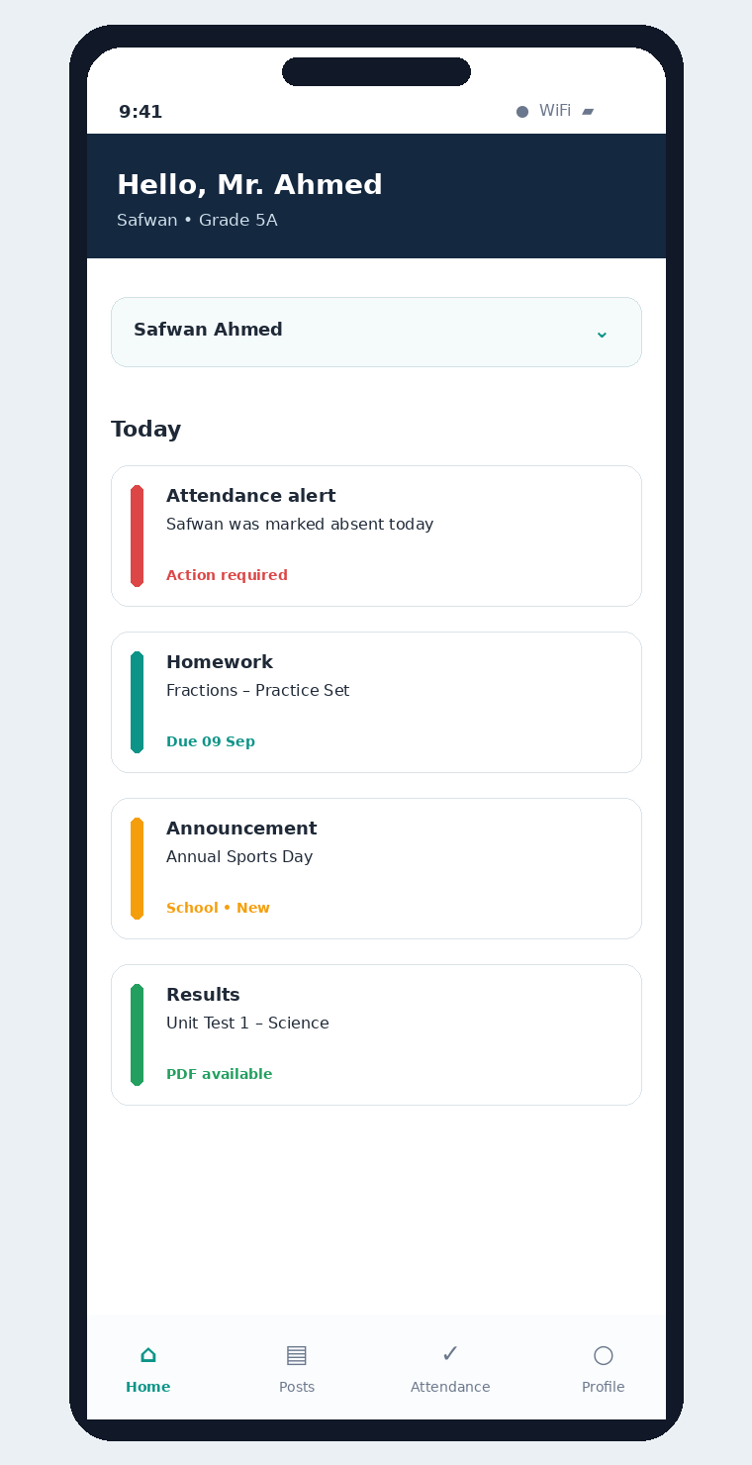  F05 • Parent home / child timeline | 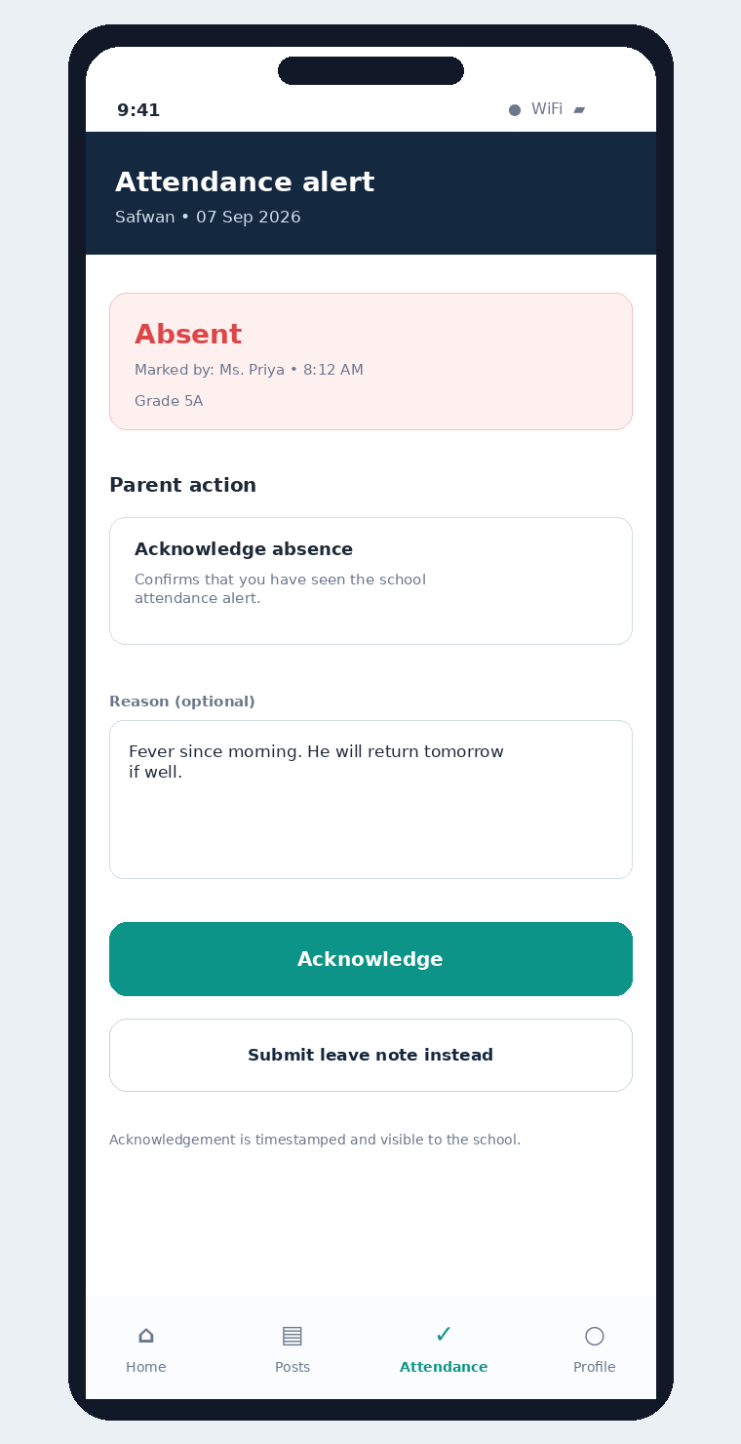  F06 • Absence acknowledgement

06 • FIGMA-STYLE MOBILE DESIGN DIRECTION

Content detail and notifications
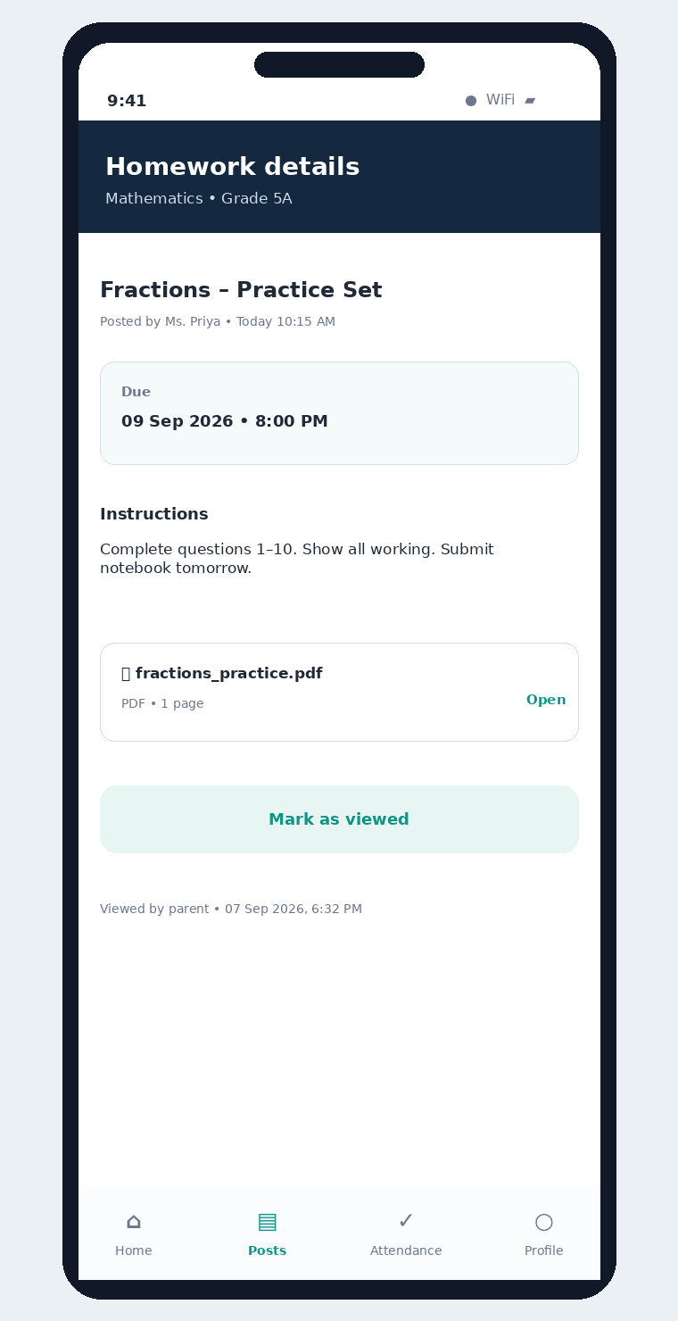  F07 • Content detail | 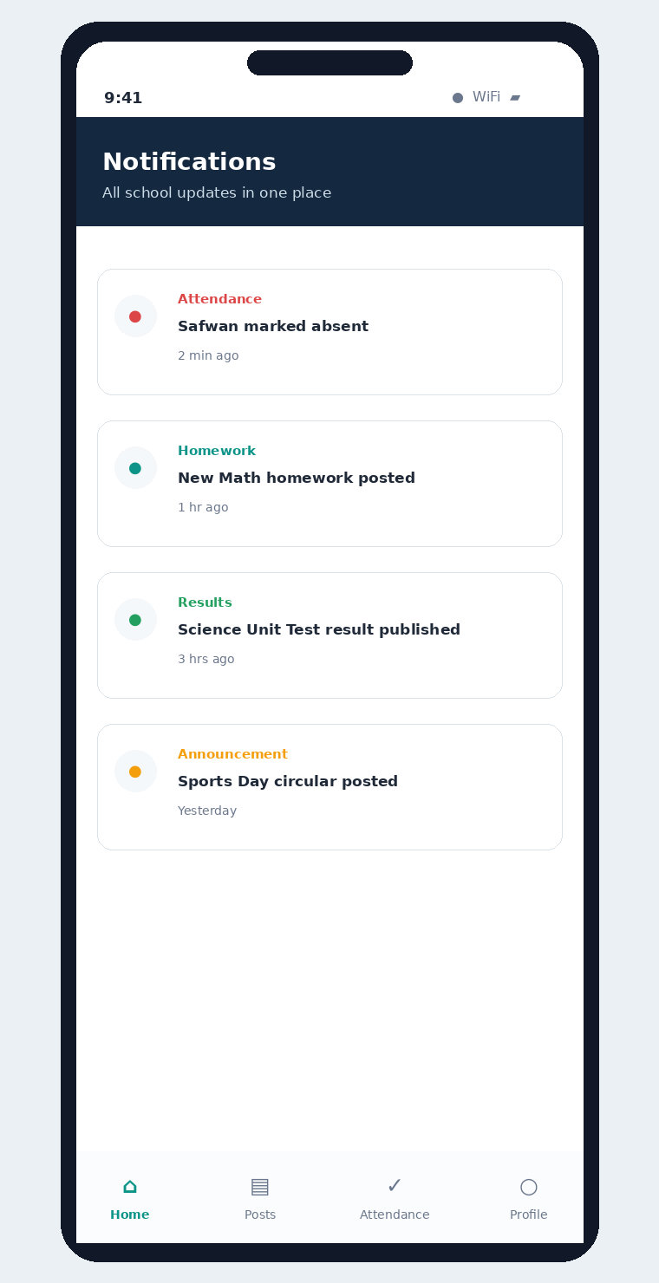  F08 • Notification center

07 • SCREEN-BY-SCREEN UX SPECIFICATION

Figma handoff requirements
Screen | Primary components | Key states / interactions
F01 Teacher Home | Greeting, class context, summary cards, quick actions, recent activity, bottom nav | Loading; no assigned class; draft count; successful publish
F02 Post Homework | Class, subject, title, due date, instructions, attachment uploader, publish CTA | Draft; uploading; upload failed; validation error; published
F03 Publish Result | Class/exam/subject, private file, privacy notice, notification toggle, publish CTA | File scan pending; publish blocked; published; corrected
F04 Announcement | Audience picker, title, message, optional attachment, publish/save draft | Class/grade/school audience; urgent flag optional
F05 Parent Home | Child switcher, Today timeline, action required card, unread badges | Single child; multiple children; no updates; offline cached view
F06 Absence Ack | Attendance facts, acknowledge action, optional reason, leave-note route | Pending; acknowledged; leave requested; already acknowledged
F07 Content Detail | Title, author/time, due date, body, attachment, view status | Attachment unavailable; updated content; viewed
F08 Notifications | Typed notification rows, timestamps, read/unread state | Deep link to exact child + content item

08 • WORKFLOWS & STATE MODELS

Explicit states prevent confusion

Post lifecycle
State | Meaning | Allowed next state
Draft | Teacher has saved but not published | Uploading / Published / Deleted
Uploading | Required attachment is being stored | Draft / Ready / Failed
Ready | Validation and upload complete | Published
Published | Visible to resolved audience | Updated / Archived
Updated | Material change after publish | Updated / Archived
Archived | Hidden from normal feed but retained for history | —

08 • WORKFLOWS & STATE MODELS

Absence acknowledgement lifecycle
Attendance | Parent response | Meaning
Absent | Pending | Alert exists; no guardian acknowledgement
Absent | Acknowledged | Guardian confirmed alert seen
Absent | Leave note submitted | Guardian sent reason/request; school may review
Corrected to Present | Historical acknowledgement retained | Attendance correction never deletes response history

Implementation note
An acknowledgement is append-only evidence of parent response. If attendance is corrected later, the original absence event and the parent response remain traceable for support and audit.

09 • NOTIFICATIONS & COMMUNICATION POLICY

Useful without becoming noisy
Event | In-app | Push | Suggested urgency
New homework | Yes | Yes | Normal
Homework updated materially | Yes | Yes | Normal
Result published | Yes | Yes | High privacy
Announcement – normal | Yes | Yes | Normal
Announcement – urgent | Yes | Yes | Urgent
Student marked absent | Yes | Yes | Action required
Acknowledgement accepted | Yes | Optional confirmation | Normal

- Notification opens the exact child and exact content item.
- Do not put result details or sensitive marks in push-notification text; use a generic “Result published” message.
- Keep delivery status separate from view status and acknowledgement status.
- Support school quiet hours for non-urgent posts in later iterations.

10 • SECURITY, PRIVACY & AUDIT

The product is simple; permissions cannot be simple-minded
Control | Requirement
Guardian-child access | Parent requests are authorized using explicit guardian ↔ student relationship, not only class membership.
Teacher scope | Teacher publishing is restricted to assigned school/classes/subjects and permission level.
Tenant isolation | Every content and attendance request carries school context; cross-school access is denied by default.
Attachments | Store privately; malware/file validation; size/type limits; time-limited signed download/open URLs.
Results | Never expose a public attachment URL; log access; minimize sensitive details in notifications.
Authentication | Short-lived access tokens, refresh/session controls, device logout, optional staff MFA.
Audit | Capture publish/edit/archive, attendance corrections, acknowledgement, attachment access, permission changes.
Data retention | Define retention separately for posts, attachments, attendance, audit events and notifications.

Important product distinction
“Viewed” means the parent opened the item. “Acknowledged” is an explicit parent action. The system must never automatically convert a view into an acknowledgement.

11 • NON-FUNCTIONAL REQUIREMENTS

Pilot-ready quality expectations
Area | Target / requirement
Performance | Home timeline p95 < 2 sec on ordinary 4G; normal publish action confirmation < 2 sec excluding large upload.
Availability | Target 99.9% monthly for core authenticated APIs, excluding third-party push provider outages.
Offline behavior | Parents can see recent cached content; teacher drafts must not be lost if connection drops during compose.
File upload | Resume/retry where practical; clear progress; publish blocked on failed required upload.
Scalability | Stateless API tier; attachment/object storage independent; notification worker can scale separately.
Observability | Track publish failures, push failures, attachment errors, auth denials, acknowledgement completion rate.
Accessibility | Dynamic text support where feasible, meaningful labels, large tap targets, adequate contrast.
Localization | Design should allow English + regional languages without breaking layout; RTL support can be planned if required.

12 • HIGH-LEVEL API & INTEGRATION VIEW

Enough structure for estimation and engineering handoff
Capability | Illustrative API | Notes
Login / session | POST /auth/login • POST /auth/refresh | Role and school context returned after auth
Teacher assignments | GET /me/teaching-scope | Classes/subjects teacher may publish to
Posts | POST /posts • GET /timeline • GET /posts/{id} | Type-driven payload and authorization
Attachments | POST /attachments/presign • POST /attachments/complete | Private object storage pattern
Views | POST /posts/{id}/view | Idempotent first-view capture
Attendance | GET /students/{id}/attendance • POST /attendance/events | Official events versioned/audited
Acknowledgement | POST /attendance/{eventId}/acknowledgements | Separate parent-response record
Notifications | GET /notifications • POST /notifications/{id}/read | Deep-link metadata included

13 • DELIVERY PLAN & ESTIMATION BASELINE

A focused 10–12 week MVP is realistic for a small product team
Phase | Weeks | Scope | Exit evidence
Discovery + UX | 1–2 | Final workflows, Figma component system, permissions, data model, API contract | Clickable prototype signed off; edge cases agreed
Foundation | 3–4 | Auth, role scope, school/class/child relationships, navigation shell, notifications foundation | Teacher/parent login and correct scoped home
Publishing | 5–7 | Homework, results, announcements, attachments, timeline | Teacher publishes all 3 post types; parent views securely
Attendance loop | 8–9 | Absent alert, acknowledgement, reason/leave note, school status view | End-to-end acknowledgement visible and audited
Hardening + Pilot | 10–12 | QA, security, analytics, retry/error states, store builds, pilot support | Pilot-ready build with acceptance checklist

Suggested MVP team
- 1 Product/Business Analyst (part-time after discovery)
- 1 UX/UI designer (heavy in weeks 1–3, then support)
- 1–2 mobile engineers (Flutter or React Native)
- 1 backend engineer
- 1 QA engineer (ramping from week 5)
- DevOps/cloud support part-time

14 • MVP ACCEPTANCE CHECKLIST

What must be true before the first school pilot
☐ 01 Teacher can create homework with title, instructions, due date and attachment.
☐ 02 Teacher can publish a result attachment only to authorized audience.
☐ 03 Teacher can publish class/grade/school announcement with optional attachment.
☐ 04 Parent timeline shows only linked child content and supports multiple-child switching.
☐ 05 Parent receives an absence alert and can explicitly acknowledge it.
☐ 06 Parent can enter an optional reason or submit a leave note path.
☐ 07 School can distinguish Delivered vs Viewed vs Acknowledged.
☐ 08 Attachment errors never result in a published broken file link.
☐ 09 Cross-class, cross-child and cross-school negative authorization tests pass.
☐ 10 Material edits show an Updated state and are audit-traceable.
☐ 11 Push deep links open the correct child/content item.
☐ 12 Basic analytics report publish counts, view rates, failure rate and acknowledgement rate.

APPENDIX • ALIGNMENT WITH THE ATTACHED SCHOOL PLATFORM HLD

Narrow product, compatible foundation
This concept intentionally extracts only the communication, academic-content and attendance-follow-up slice from the larger AI School Platform high-level design supplied with this request. The proposed app remains compatible with that foundation rather than recreating the full ERP scope.
HLD principle used | How it appears here
Role, school and child scope before access | Single role-aware app; teacher assignment scope; explicit guardian-child permissions
Operational records remain authoritative | Attendance stays official transactional data; parent acknowledgement is separate
Object storage for attachments | Homework/result/announcement files are private, versioned attachments
Academic module includes homework and report workflows | MVP narrows this to homework posts and result attachments
Communication module owns notices and delivery status | Announcements + notification status are first-class
Auditable corrections and state transitions | Post updates and attendance acknowledgements keep history
Scale workers separately | Push notifications and attachment processing can scale independently

Recommended next artifact
Create a clickable Figma prototype from screens F01–F08, then produce a component inventory (buttons, cards, fields, child switcher, status chips, attachment tile, confirmation sheet) and developer-ready redlines.

