Mathbook · Chapter 2 · Lesson 2-2 Parent Learn
2-2 Round Multi-Digit Numbers
Learning goal: I can round a number to the nearest 10 or nearest 100 using a number line or place value.
Textbook: pages 37–42. Includes the Math Probe on rounding (pp. 41–42).
Words to Know
round | Find a ten or hundred that is close to a number. We round to tell “about how many.”
nearest ten | The ten that is closest: 127 rounded to the nearest ten is 130.
nearest hundred | The hundred that is closest: 127 rounded to the nearest hundred is 100.
halfway point | The number exactly in the middle of two tens or hundreds: 125 is halfway between 120 and 130.
round up / round down | Move to the greater ten or hundred (up) or the lesser one (down).
How to Teach It
- Name the two tens (or hundreds) the number is between. 364 is between 360 and 370, and between 300 and 400.
- Number line: label the two ends and the halfway point. Place the number. It rounds to the end it is closer to.
- Place value: underline the place you are rounding to. Look at the digit just to its right. If it is 5 or more, round up. If it is less than 5, round down. The digits after the rounding place become 0.
- A number exactly on the halfway point (like 125 or 650) rounds up.
- In word problems, round each number to find “about how many” before deciding.
Tip: Ask, “Which two tens is it between? Which one is it closer to?” The number line explains why the 5-or-more rule works.
Worked Examples
Example 1: Number line, nearest 10  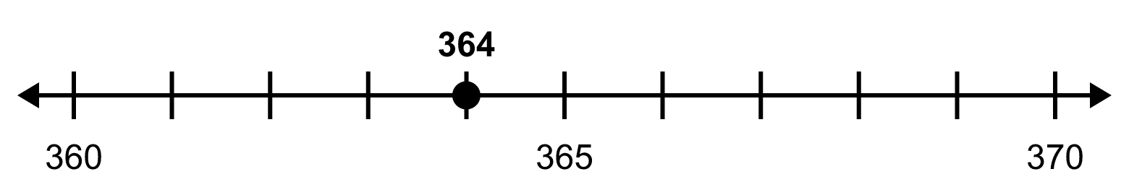  364 is between 360 and 370. The halfway point is 365.  364 is to the left of halfway, so it rounds to 360. |  | Example 2: Number line, nearest 100  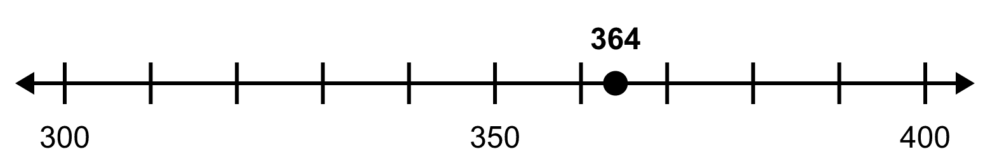  364 is between 300 and 400. The halfway point is 350.  364 is to the right of halfway, so it rounds to 400.
Example 3: Use place value  Round 583 to the nearest 10. Look at the ones digit: 3 is less than 5, so round down → 580.  Round 583 to the nearest 100. Look at the tens digit: 8 is 5 or more, so round up → 600. |  | Example 4: Which numbers round to it?  Which numbers round to 450 (nearest 10)?  Every number from 445 to 454. 445 is the halfway point, so it rounds up to 450. 455 rounds up to 460.
Skills Checklist Check off each skill your child can do without help.
☐ Find the two tens or hundreds a number is between.  ☐ Round to the nearest 10 using a number line.  ☐ Round to the nearest 100 using a number line. | ☐ Round using the “5 or more, round up” rule.  ☐ Find all the numbers that round to a given number.  ☐ Use rounding to answer “about how many” questions.

Mathbook · Chapter 2 · Lesson 2-2 Together and On My Own
2-2 Round Multi-Digit Numbers
Name Date
Together Work with your grown-up. Talk about each step.
A. | Round 46 to the nearest 10. Fill in the boxes on the number line. Mark 46.  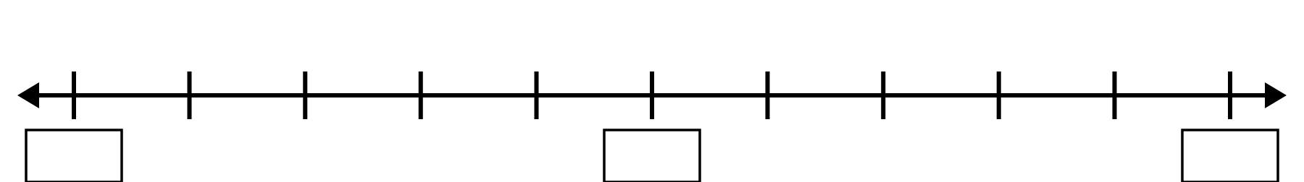  46 rounded to the nearest 10 is:
B. | Round 752 to the nearest 100. Underline the hundreds digit. Look at the digit to its right.  752 rounded to the nearest 100 is:
C. | Mia rounds 345 to 350. Leo rounds 345 to 300. Why are their rounded numbers different?
On My Own Try these by yourself. Show your work.
1. | Use a number line. Round 83 to the nearest 10.  83 rounded to the nearest 10 is:
2. | Use a number line. Round 517 to the nearest 100.  517 rounded to the nearest 100 is:
3. | Round 65 to the nearest 10. | 4. | Round 384 to the nearest 10.
5. | Round 249 to the nearest 100. | 6. | Round 951 to the nearest 100.
7. | Round to the nearest 10. Circle all the numbers that round to 470. Explain your choices.  468 474 465 476 374 475 471
8. | Round to the nearest 100. Circle all the numbers that round to 600.  553 649 650 602 548 695
9. | Ben says that 735 rounded to the nearest 10 is 730. Do you agree? Explain.
10. | A pet store has 34 goldfish, 18 turtles, 26 hamsters, 41 birds, and 22 rabbits. Which animals does the store have about 20 of?
11. | Lily has $60. She wants a book for $24, a game for $18, and a puzzle for $13. Round each price to the nearest 10. About how much will she spend? Does she have enough money?

Mathbook · Chapter 2 · Lesson 2-2 Parent Answer Key
2-2 Round Multi-Digit Numbers
Together
A | Boxes: 40, 45, 50. 46 is to the right of 45, closer to 50. Answer: 50
B | 752: the tens digit is 5, so round up. Answer: 800
C | Mia rounded to the nearest 10 (345 is halfway between 340 and 350, so it rounds up to 350). Leo rounded to the nearest 100 (345 is less than 350, so it rounds down to 300).  Accept any answer that says they rounded to different places.
On My Own
1 | Boxes: 80, 85, 90. 83 is left of 85. Answer: 80
2 | Boxes: 500, 550, 600. 517 is left of 550. Answer: 500
3 | 70  Ones digit is 5, so round up.
4 | 380  Ones digit 4 is less than 5.
5 | 200  Tens digit 4 is less than 5. A common mistake is rounding 249 → 250 → 300.
6 | 1,000  951 is between 900 and 1,000; the tens digit 5 means round up.
7 | Circle 468, 474, 465, 471.  Numbers from 465 to 474 round to 470. 475 and 476 round to 480. 374 rounds to 370, not 470 (look at every digit, not just the last ones). Accept a number line or place-value explanation.
8 | Circle 553, 649, 602.  Numbers from 550 to 649 round to 600. 650 and 695 round to 700; 548 rounds to 500.
9 | No. The ones digit is 5, so 735 rounds up to 740.  735 is exactly halfway between 730 and 740, and halfway numbers round up.
10 | Turtles and rabbits. 18 → 20 and 22 → 20.  Goldfish → 30, hamsters → 30, birds → 40.
11 | $24 → $20, $18 → $20, $13 → $10. About $50. Yes, she has enough because $50 is less than $60.  Two prices were rounded down, so it is smart to check the exact total: $55, which is still less than $60. Accept a check with exact numbers too.

