Mathbook · Chapter 2 · Lesson 2-1 Parent Learn
2-1 Represent 4-Digit Numbers
Learning goal: I can show a 4-digit number with base-ten blocks and a place-value chart, and write it in standard form, expanded form, and word form.
Textbook: pages 33–36. The book models 2,138 with base-ten blocks, a place-value chart, and three written forms.
Words to Know
digit | One of the symbols 0, 1, 2, 3, 4, 5, 6, 7, 8, 9 that we use to write numbers.
place value | The value a digit has because of its place. In 2,138 the 2 means 2 thousands, or 2,000.
base-ten blocks | A cube is 1,000. A flat is 100. A rod is 10. A unit is 1.
standard form | The usual way to write a number with digits: 2,138.
expanded form | The number written as the value of each digit added together: 2,000 + 100 + 30 + 8.
word form | The number written in words: two thousand, one hundred thirty-eight.
How to Teach It
- Build or draw the number. Count the cubes, flats, rods, and units.
- Write each count in a place-value chart: thousands, hundreds, tens, ones. If a place has none, write 0 there.
- Read the chart from left to right to write standard form. Put a comma after the thousands digit.
- For expanded form, write the value of each digit and join them with + signs. Skip places that have a 0 (6,000 + 400 + 9).
- For word form, say the thousands, then the word “thousand,” then read the rest like a 3-digit number. Use a hyphen for numbers like forty-one.
Tip: Ask, “What is this digit worth?” A 0 holds a place. In 3,206 the 0 shows there are no tens.
Worked Examples
Example 1: Blocks to chart and standard form
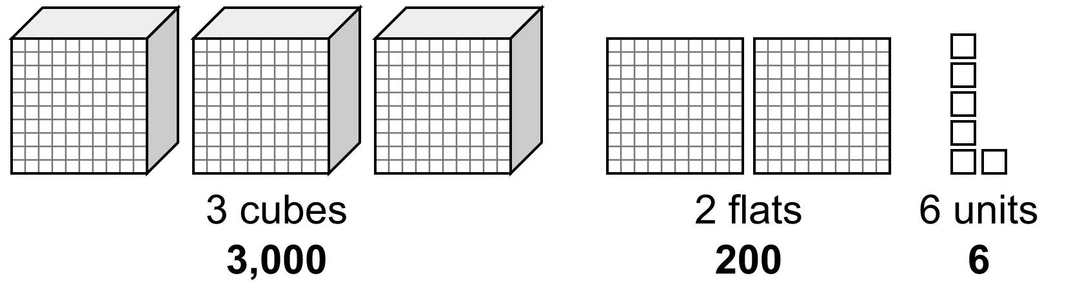 | No rods, so write 0 in the tens place.  Standard form: 3,206  Expanded form: 3,000 + 200 + 6
  thousands | hundreds | tens | ones
  3 | 2 | 0 | 6

Example 2: Standard form to expanded and word form  4,152 → the digits are worth 4,000, 100, 50, and 2.  Expanded form: 4,000 + 100 + 50 + 2  Word form: four thousand, one hundred fifty-two |  | Example 3: Word or expanded form to standard form  “five thousand, seventy-three”  5 thousands, 0 hundreds, 7 tens, 3 ones → 5,073  Expanded form: 5,000 + 70 + 3  6,000 + 400 + 9 → 6 thousands, 4 hundreds, 0 tens, 9 ones → 6,409
Skills Checklist Check off each skill your child can do without help.
☐ Tell what a cube, flat, rod, and unit are worth.  ☐ Write the number shown by base-ten blocks.  ☐ Fill in a place-value chart, using 0 for an empty place. | ☐ Write a number in expanded form.  ☐ Read and write a number in word form.  ☐ Use place value to explain how two numbers are different.

Mathbook · Chapter 2 · Lesson 2-1 Together and On My Own
2-1 Represent 4-Digit Numbers
Name Date
Together Work with your grown-up. Talk about each step.
A. | What number do the base-ten blocks show? Fill in the chart. Then write the number in standard form.  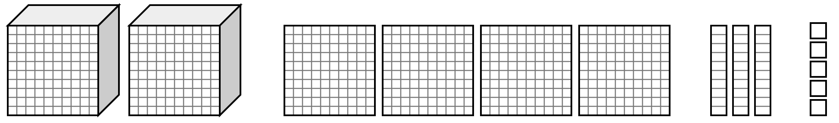  Standard form:
  thousands | hundreds | tens | ones
B. | Write 3,081 in expanded form and in word form.  Expanded form:  Word form:
C. | Write four thousand, six hundred nine in standard form and in expanded form.  Standard form:  Expanded form:
On My Own Try these by yourself. Show your work.
1. | What number do the base-ten blocks show? Fill in the chart.  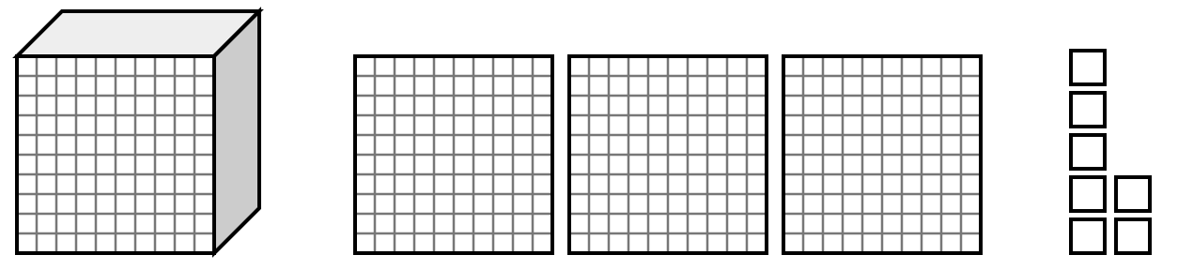  Standard form:
  thousands | hundreds | tens | ones
2. | Show 5,264 in the place-value chart and in expanded form.  Expanded form:
  thousands | hundreds | tens | ones
3. | Write eight thousand, fifty-six in standard form and in expanded form.  Standard form:  Expanded form:
4. | Write the number in standard form.  7,000 + 300 + 8 | 5. | Write the number in standard form.  9,000 + 60 + 4
6. | Write the number shown in standard form and in expanded form.  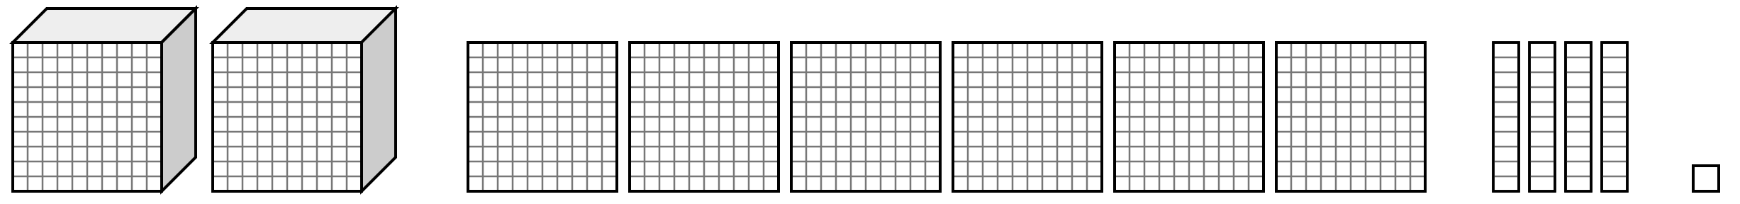  Standard form:  Expanded form:
7. | A library had 2,374 books in May. In June it had 2,474 books. Which digit changed? Use place value to tell how many more books the library had in June.
8. | Use all four digits 6, 4, 9, 4 to write the 4-digit number with the least value. Write it in standard form, expanded form, and word form.  Standard form:  Expanded form:  Word form:

Mathbook · Chapter 2 · Lesson 2-1 Parent Answer Key
2-1 Represent 4-Digit Numbers
Together
A | Chart: 2 | 4 | 3 | 5. Standard form: 2,435  2 cubes = 2,000; 4 flats = 400; 3 rods = 30; 5 units = 5.
B | Expanded form: 3,000 + 80 + 1  Word form: three thousand, eighty-one  There are 0 hundreds, so no hundreds part is written. Also accept 3,000 + 0 + 80 + 1.
C | Standard form: 4,609  Expanded form: 4,000 + 600 + 9  There are 0 tens, so write 0 in the tens place. Also accept 4,000 + 600 + 0 + 9.
On My Own
1 | Chart: 1 | 3 | 0 | 7. Standard form: 1,307  No rods, so the tens digit is 0. If your child writes 137, point to the empty tens place.
2 | Chart: 5 | 2 | 6 | 4  Expanded form: 5,000 + 200 + 60 + 4
3 | Standard form: 8,056  Expanded form: 8,000 + 50 + 6  0 hundreds. Also accept 8,000 + 0 + 50 + 6.
4 | 7,308  No tens, so the tens digit is 0.
5 | 9,064  No hundreds, so the hundreds digit is 0.
6 | Standard form: 2,641  Expanded form: 2,000 + 600 + 40 + 1
7 | The hundreds digit changed from 3 to 4. That is 1 more hundred, so the library had 100 more books in June.  Accept any clear place-value explanation, e.g., “The thousands, tens, and ones are the same. Only the hundreds went up by one, so it is 100 more.”
8 | Standard form: 4,469  Expanded form: 4,000 + 400 + 60 + 9  Word form: four thousand, four hundred sixty-nine  Put the smallest digits in the biggest places: 4, 4, 6, 9.

