Mathbook · Chapter 2 · Lesson 2-4 Parent Learn
2-4 Use Addition Properties to Add
Learning goal: I can change the order of addends or group them in a different way to add more easily, and I know the sum stays the same.
Textbook: pages 47–50. The book adds 27 + 53 + 40 by grouping and by changing the order.
Words to Know
addend | A number you add. In 34 + 66, the addends are 34 and 66.
sum | The answer when you add.
equation | A number sentence with an equal sign. Both sides have the same value.
order property | Switch the order of addends and the sum stays the same: 18 + 36 = 36 + 18. (Grown-up name: Commutative Property.)
grouping property | Choose which addends to add first and the sum stays the same. (Grown-up name: Associative Property.)
friendly pair | Two addends whose sum ends in 0 or 00, like 46 + 54 = 100.
How to Teach It
- Show that order does not matter: 4 + 3 and 3 + 4 are both 7. Then try bigger numbers: 245 + 132 = 132 + 245.
- For a fill-in equation like 245 + 132 = 132 + ___, look at both sides. The same addends must be there, so the blank is 245. No adding is needed.
- With three addends, look for a friendly pair (ones digits that make 10, or numbers that make a hundred). Draw a V from the two addends to their sum.
- Add the friendly pair first, then add the third number. If the pair is not next to each other, switch the order first.
- To check an expression, it must use the same numbers and only addition.
Tip: Ask, “Which two numbers are easy to add together?” Ones digits that make 10 (7 + 3, 8 + 2) are a great clue.
Worked Examples
Example 1: Group a friendly pair  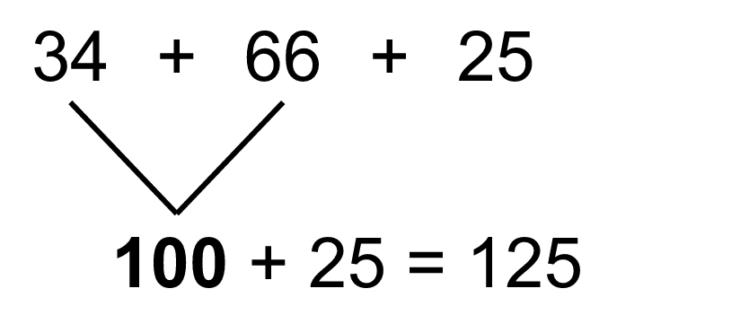  4 + 6 make a ten, so add 34 + 66 = 100 first. Sum: 125. |  | Example 2: Switch the order, then group  Start: 18 + 45 + 82. Switch: 18 + 82 + 45.  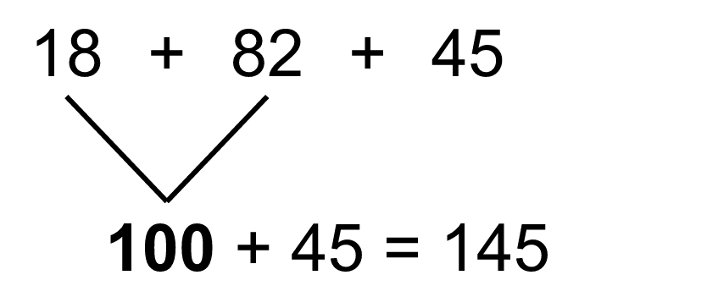  Sum: 145.
Example 3: Make the equation true  245 + 132 = 132 + ___  Both sides need the same addends. 132 is already there, so the blank is 245. |  | Example 4: Which expressions show the total?  Days: 73, 55, 27.  Yes: 27 + 55 + 73 and 73 + 27 + 55 (same numbers, only +).  No: 55 − 27 + 73 (subtracts) and 73 + 55 + 72 (72 is not 27).
Skills Checklist Check off each skill your child can do without help.
☐ Explain that the order of addends does not change the sum.  ☐ Fill in an equation like 324 + 158 = 158 + ___ without adding.  ☐ Find a friendly pair in three addends. | ☐ Group addends to add more easily and find the sum.  ☐ Choose all expressions that give the same total.  ☐ Explain why a way of grouping is easier.

Mathbook · Chapter 2 · Lesson 2-4 Together and On My Own
2-4 Use Addition Properties to Add
Name Date
Together Work with your grown-up. Talk about each step.
A. | Make the equation true. Do you need to add?  436 + 251 = 251 + ________
B. | The table shows how many cans a class collected. Circle all the expressions that find the total.
  A. 36 + 64 + 49  B. 64 + 49 − 36  C. 49 + 36 + 64  D. 64 + 94 + 36
    Day | Cans
    Saturday | 64
    Sunday | 49
    Monday | 36
C. | How can you group the addends to make it easier? Find the sum.  46 + 125 + 54  Sum:
On My Own Try these by yourself. Show your work.
1. | Make the equation true.  347 + 286 = 286 + _______ | 2. | Make the equation true.  518 + _______ = 69 + 518
3. | Make the equation true.  624 + 153 = _______ + 624 | 4. | Make the equation true.  _______ + 87 = 87 + 702
5. | How can you group the addends to make it easier to find the sum? Explain your thinking.  263 + 418 + 137  Sum:
6. | Show one way to group the addends and solve.  165 + 28 + 72 | 7. | Show one way to group the addends and solve.  396 + 204 + 172
8. | Show one way to group the addends and solve.  243 + 316 + 57 | 9. | Show one way to group the addends and solve.  125 + 314 + 175
10. | Sam buys a bike for $276, a helmet for $145, and a lock for $124. How can he group the prices to find the total cost? What is the total?  Total:
11. | Jada says 58 + 39 + 42 is easier if she adds 58 + 42 first. Is she right? Explain, and find the sum.  Sum:

Mathbook · Chapter 2 · Lesson 2-4 Parent Answer Key
2-4 Use Addition Properties to Add
Together
A | 436  No adding needed: both sides must have the same two addends (order property).
B | Circle A and C.  B subtracts. D uses 94 instead of 49. The total is 149.
C | 46 + 54 = 100, then 100 + 125 = 225  6 + 4 make a ten, so 46 and 54 are a friendly pair. Also accept adding left to right if the sum is 225.
On My Own
1 | 347
2 | 69
3 | 153
4 | 702
5 | Group 263 + 137 = 400 first (3 + 7 make a ten). Then 400 + 418 = 818.  Accept any explanation that adds a friendly pair first.
6 | 28 + 72 = 100; 100 + 165 = 265  Items 6–9: accept any grouping with the correct sum; praise a friendly-pair grouping.
7 | 396 + 204 = 600; 600 + 172 = 772
8 | 243 + 57 = 300; 300 + 316 = 616
9 | 125 + 175 = 300; 300 + 314 = 614
10 | Group $276 + $124 = $400 first. Then $400 + $145 = $545.  Other groupings are acceptable if the total is $545.
11 | Yes. 58 + 42 = 100 because 8 + 2 make a ten. Then 100 + 39 = 139.  She can add in any order or grouping and the sum stays the same.

