Mathbook · Chapter 2 · Lesson 2-5 Parent Learn
2-5 Addition Patterns
Learning goal: I can use even and odd patterns to tell whether a sum is even or odd, explain why, and use the patterns to check a sum.
Textbook: pages 51–54. The book shows the three even/odd sum patterns with 3-digit examples.
Words to Know
even number | A number that can be split into pairs with none left over. Its ones digit is 0, 2, 4, 6, or 8.
odd number | A number that has one left over when you make pairs. Its ones digit is 1, 3, 5, 7, or 9.
pattern | Something that happens again and again in the same way.
ones digit | The digit in the ones place. In 427, the ones digit is 7.
sum / addend | The answer when you add / a number that you add.
How to Teach It
- Use small objects. Make pairs. If one is left over, the number is odd. If none are left over, it is even.
- Join two odd groups: the two leftovers make a new pair, so odd + odd = even. Even + even has no leftovers, so it is even. Even + odd still has one leftover, so it is odd.
- For big numbers, look only at the ones digits. Tens and hundreds are made of groups of ten, and ten is even, so they never leave a leftover.
- Before adding, predict: will the sum be even or odd? After adding, check that the sum matches.
- Remember: if the sum does not match the pattern, it is wrong. If it does match, you still need to add to be sure.
Tip: Ask, “What is the ones digit? Will there be a leftover?”
Worked Examples
Example 1: Why odd + odd = even  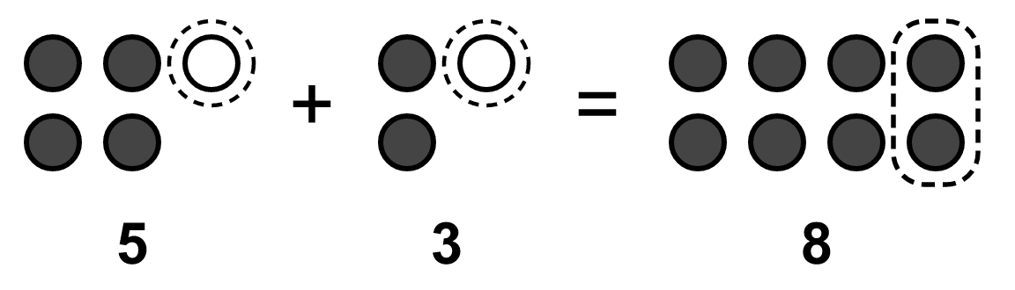  5 and 3 each have one leftover (dashed). Together the leftovers make a pair, so 8 is even. |  | Example 2: The three patterns  even + even = even 214 + 352 = 566  odd + odd = even 135 + 221 = 356  even + odd = odd 412 + 235 = 647  The order does not matter: odd + even = odd too.
Example 3: Only the ones digits matter  627 + 154: look at 7 + 4 = 11, which is odd. So the sum is odd.  Add to find it: 627 + 154 = 781. 781 is odd. ✓ |  | Example 4: Check a sum  Is 316 + 151 = 457 correct?  even + odd = odd, and 457 is odd, so the pattern matches. But we must still add: 316 + 151 = 467. The pattern can catch some mistakes, not all.
Skills Checklist Check off each skill your child can do without help.
☐ Tell if a number is even or odd from its ones digit.  ☐ Say the three sum patterns.  ☐ Explain the patterns with pairs and leftovers. | ☐ Write a 3-digit equation that fits a pattern.  ☐ Predict if a sum is even or odd, then add to check.  ☐ Know that a matching pattern does not prove a sum is right.

Mathbook · Chapter 2 · Lesson 2-5 Together and On My Own
2-5 Addition Patterns
Name Date
Together Work with your grown-up. Talk about each step.
A. | Write even or odd. Then write one equation with 3-digit numbers that fits.  odd + odd = ________  Equation:
B. | Is the sum of 358 + 227 even or odd? Decide before you add. Then find the sum.  Even or odd:  Sum:
C. | Omar writes 243 + 316 = 549. He says it is correct because odd + even = odd. Do you agree? Explain.
On My Own Try these by yourself. Show your work.
1. | Write even or odd. Then write two equations with 3-digit numbers that fit.  ________ = odd + even | 2. | Write even or odd. Then write two equations with 3-digit numbers that fit.  even + even = ________
3. | Write even or odd. Then write two equations with 3-digit numbers that fit.  even + ________ = odd | 4. | Write even or odd. Then write two equations with 3-digit numbers that fit.  odd + ________ = odd
5. | Write even or odd. Then write two equations with 3-digit numbers that fit.  ________ + odd = even | 6. | Write even or odd. Then write two equations with 3-digit numbers that fit.  ________ = odd + odd
7. | Find the sum. Use a pattern to check your answer.  352 + 417 = ________ | 8. | Find the sum. Use a pattern to check your answer.  263 + 525 = ________
9. | Why is the sum of a number with a 5 in the ones place and a number with a 2 in the ones place always odd?
10. | A pet shop has two fish tanks. One tank has 25 fish. How many fish could be in the other tank so that the total number of fish is even? Explain.
11. | Ava reads 121 pages, then 122 pages, then 124 pages. Is the total number of pages even or odd? Explain how you know.

Mathbook · Chapter 2 · Lesson 2-5 Parent Answer Key
2-5 Addition Patterns
Together
A | even. Sample: 135 + 241 = 376  Accept any two odd 3-digit numbers with a correct sum.
B | Odd (8 + 7 = 15, and 15 is odd). Sum: 585  even + odd = odd.
C | No. The pattern is right (the sum should be odd), but 243 + 316 = 559, not 549.  A sum can match the pattern and still be wrong. You have to add to be sure.
On My Own
1 | odd. Samples: 347 = 133 + 214; 527 = 405 + 122  For items 1–6, accept any 3-digit equations that fit the pattern and are added correctly.
2 | even. Samples: 312 + 124 = 436; 250 + 406 = 656
3 | odd. Samples: 132 + 215 = 347; 400 + 301 = 701
4 | even. Samples: 213 + 104 = 317; 121 + 340 = 461
5 | odd. Samples: 123 + 211 = 334; 305 + 105 = 410
6 | even. Samples: 111 + 223 = 334; 455 + 135 = 590
7 | 769. even + odd = odd, and 769 is odd.
8 | 788. odd + odd = even, and 788 is even.
9 | 5 + 2 = 7, which is odd. The tens and hundreds are groups of ten, which are even, so only the ones digits decide.  Also accept a pairs explanation: 5 has one leftover and 2 has none, so one is left over.
10 | Any odd number, such as 13 (25 + 13 = 38) or 25 (25 + 25 = 50).  25 is odd, and odd + odd = even.
11 | Odd. 121 + 122 is odd + even = odd. Then odd + 124 (even) = odd. Total: 367.  Also accept checking the ones digits: 1 + 2 + 4 = 7, which is odd.

