Mathbook · Chapter 2 · Lesson 2-8 Parent Learn
2-8 Adjust Numbers to Add or Subtract
Learning goal: I can change the numbers in an addition or subtraction problem to friendlier numbers and keep the sum or difference the same.
Textbook: pages 63–66. The book adjusts 224 + 109 to 223 + 110 and 333 − 212 to 331 − 210.
Words to Know
adjust | Change the numbers a little to make them easier to work with.
friendly number | A number that is easy to add or subtract, like 200 or 110.
addend | A number you add.
sum / difference | The answer when you add / the answer when you subtract.
equation | A number sentence with an equal sign, like 223 + 110 = 333.
How to Teach It
- Find the number that is close to a ten or hundred (like 198 or 109).
- Adding: take some away from one addend and give the same amount to the other (opposite moves). 224 + 109 → 223 + 110.
- Subtracting: add the same amount to both numbers, or take the same amount from both (same moves). 333 − 212 → 331 − 210.
- Show subtraction on a number line: sliding both numbers the same amount keeps the distance between them.
- If only one number was changed, fix the answer: 645 + 300 = 945 used 2 too many, so take 2 away → 943.
Tip: Use coins for addition (move one coin from one pile to the other: the total stays the same). Ask, “Adding or subtracting? Opposite or same?”
Worked Examples
Example 1: Adjust addition (opposite moves) |  | Example 2: Adjust subtraction (same moves)
  236 | + | 198 | = | ?
  −2 |  | +2
  ↓ |  | ↓
  234 | + | 200 | = | 434
  452 | − | 197 | = | ?
  +3 |  | +3
  ↓ |  | ↓
  455 | − | 200 | = | 255
Example 3: Why subtraction uses the same moves  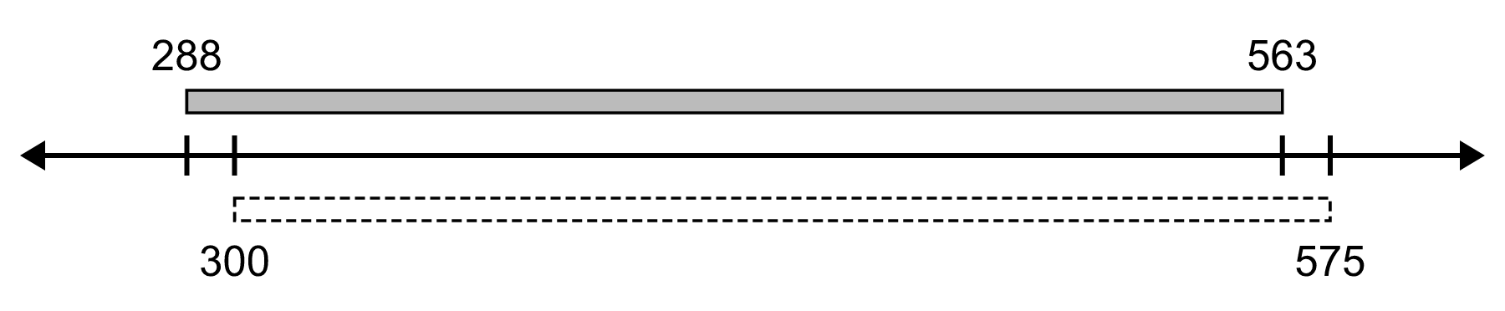  563 − 288 → 575 − 300 = 275. Both moved up 12, so the distance stays the same. |  | Example 4: Mistakes to fix  367 + 196 → 370 + 199? No. Both went up 3, so the sum is 6 too big. Use 363 + 200 = 563.  645 + 298: changed only 298 to 300 → 945. Added 2 extra, so take 2 away: 943.
Skills Checklist Check off each skill your child can do without help.
☐ Adjust an addition problem by moving an amount from one addend to the other.  ☐ Adjust a subtraction problem by changing both numbers the same way.  ☐ Explain how adjusting addition and subtraction are different. | ☐ Show on a number line that the difference stays the same.  ☐ Tell if someone adjusted correctly.  ☐ Fix the answer when only one number was changed.

Mathbook · Chapter 2 · Lesson 2-8 Together and On My Own
2-8 Adjust Numbers to Add or Subtract
Name Date
Together Work with your grown-up. Talk about each step.
A. | Adjust to make a friendly number. Write the change on each arrow. Then add.
  248 | + | 195 | = | ?
  ____ |  | ____
  ↓ |  | ↓
   | + |  | =
B. | Adjust to make a friendly number. Write the change on each arrow. Then subtract.
  364 | − | 198 | = | ?
  ____ |  | ____
  ↓ |  | ↓
   | − |  | =
C. | Rosa adds 538 + 207. She adjusts it to 540 + 209 and finds 749. Do you agree with her strategy? Explain.
On My Own Try these by yourself. Show your work.
1. | Adjust the equation to solve. | 2. | Adjust the equation to solve.
  463 | − | 98 | = | ?
  ____ |  | ____
  ↓ |  | ↓
   | − |  | =
  156 | + | 237 | = | ?
  ____ |  | ____
  ↓ |  | ↓
   | + |  | =
3. | Adjust the equation to solve. | 4. | Adjust the equation to solve.
  769 | − | 412 | = | ?
  ____ |  | ____
  ↓ |  | ↓
   | − |  | =
  499 | + | 286 | = | ?
  ____ |  | ____
  ↓ |  | ↓
   | + |  | =
5. | Adjust the equation to solve. | 6. | Adjust the equation to solve.
  672 | − | 318 | = | ?
  ____ |  | ____
  ↓ |  | ↓
   | − |  | =
  148 | + | 159 | = | ?
  ____ |  | ____
  ↓ |  | ↓
   | + |  | =
7. | Kim changed 208 + 119 = ? to 207 + 120 = ?. Describe how she adjusted the equation. Why do you think she did it that way?
8. | Show how you can adjust 584 − 297. Use the number line to show that the new equation has the same difference.  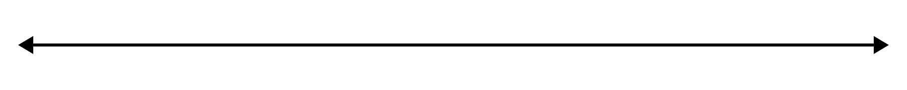  New equation:
9. | You can adjust 345 − 128 in different ways. Explain one way and why it makes the problem easier. | 10. | Tia and Sam find 139 + 268 by adjusting. Tia uses 140 + 269 = 409. Sam uses 140 + 267 = 407. Which sum is correct? Explain.
11. | A library had 674 books last year. Now it has 935 books. How many more books does it have now? Adjust the numbers to solve.  More books:
12. | Jon adds 624 + 199. He changes 199 to 200 but forgets to change 624. He gets 824. How can he fix his sum? Explain.

Mathbook · Chapter 2 · Lesson 2-8 Parent Answer Key
2-8 Adjust Numbers to Add or Subtract
Together
A | Sample: −5 and +5 → 243 + 200 = 443  Accept any adjustment that takes from one addend and gives the same amount to the other (e.g., 250 + 193 = 443).
B | Sample: +2 and +2 → 366 − 200 = 166  Both numbers must change the same way (e.g., 364 − 198 → 366 − 200).
C | No. She added 2 to both numbers, so her sum is 4 too big. In adding, one number goes up and the other goes down: 545 + 200 = 745.
On My Own
1 | +2, +2 → 465 − 100 = 365  Items 1–6: accept any correct adjustment. Addition: opposite moves. Subtraction: same moves.
2 | −3, +3 → 153 + 240 = 393
3 | −2, −2 → 767 − 410 = 357
4 | +1, −1 → 500 + 285 = 785
5 | +2, +2 → 674 − 320 = 354
6 | −1, +1 → 147 + 160 = 307
7 | She took 1 from 208 and gave it to 119. Now 120 is a friendly number, and the sum stays the same: 207 + 120 = 327.
8 | Add 3 to both: 587 − 300 = 287. On the number line, both ends slide 3 to the right, so the distance stays 287.  Accept any correct same-move adjustment drawn on the line (e.g., 584 − 297 → 587 − 300).
9 | Sample: add 2 to both → 347 − 130 = 217. It is easier because 130 is a friendly number.  Accept any same-move adjustment, e.g., 342 − 125 = 217 or 350 − 133 = 217.
10 | Sam (407). Tia added 1 to both numbers, so her sum is 2 too big. Sam took 1 from 268 and gave it to 139.
11 | 935 − 674. Sample: take 4 from both → 931 − 670 = 261 more books.  Also accept 961 − 700 = 261 (add 26 to both) or any correct method.
12 | He added 1 too many (200 instead of 199), so he should subtract 1: 824 − 1 = 823.

