Mathbook · Chapter 2 · Lesson 2-13 Parent Learn
2-13 Compare 4-Digit Numbers
Learning goal: I can compare 4-digit numbers using a number line or place value, and write <, >, =, or ≠.
Textbook: pages 83–86. The book compares 1,324 and 1,249 with a number line and with place value.
Words to Know
compare | Decide which number is greater, which is less, or if they are equal.
greater than (>) | 5,362 > 5,318 means 5,362 is greater than 5,318.
less than (<) | 2,371 < 2,436 means 2,371 is less than 2,436.
equal to (=) | The numbers are the same: every place has the same digit.
not equal to (≠) | The numbers are different: at least one place has a different digit.
place value | The value of a digit because of its place: thousands, hundreds, tens, ones.
How to Teach It
- Number line: numbers get greater to the right. Plot both numbers. The one farther right is greater.
- Place value: line up the numbers. Compare the thousands first. If they are the same, compare the hundreds, then the tens, then the ones.
- Stop at the first place where the digits are different. That place decides.
- A 3-digit number has 0 thousands, so any 4-digit number is greater: 3,158 > 958.
- Read the sentence aloud: “2,814 is less than 2,841.” The open side of < or > faces the greater number.
Tip: Watch for numbers with the same digits in a different order (2,814 and 2,841). They are not equal. Compare place by place.
Worked Examples
Example 1: Use a number line  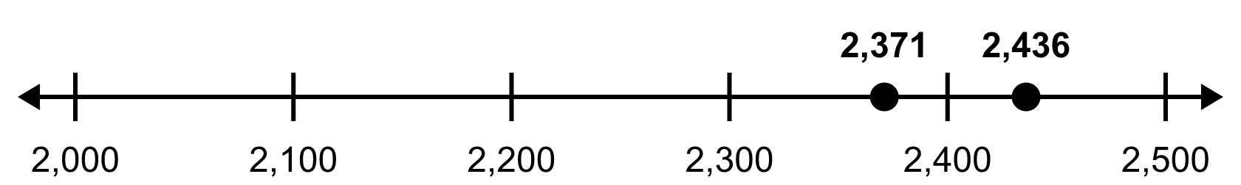  2,436 is farther right, so 2,371 < 2,436. |  | Example 2: Use place value  Thousands and hundreds are the same. Tens: 6 > 1, so 5,362 > 5,318.
   | Th | H | T | O
  5,362 | 5 | 3 | 6 | 2
  5,318 | 5 | 3 | 1 | 8
Example 3: Equal or not equal  6,207 and 6,270: the tens are different (0 and 7).  So 6,207 ≠ 6,270. Also 6,207 < 6,270. |  | Example 4: Different number of digits; order three  3,158 vs 958: think of 958 as 0,958. 3 thousands > 0 thousands, so 3,158 > 958.  Order 4,572, 3,986, 4,519: 3,986 < 4,519 < 4,572.
Skills Checklist Check off each skill your child can do without help.
☐ Plot two numbers on a number line and tell which is greater.  ☐ Compare by place value, starting with the thousands.  ☐ Use = and ≠ correctly. | ☐ Write < and > correctly and read them aloud.  ☐ Compare a 3-digit number with a 4-digit number.  ☐ Order three numbers and solve “which is more” problems.

Mathbook · Chapter 2 · Lesson 2-13 Together and On My Own
2-13 Compare 4-Digit Numbers
Name Date
Together Work with your grown-up. Talk about each step.
A. | Which is greater? Write <, >, or =. Explain your thinking.  6,384 ◯ 6,381
B. | Plot 1,450 and 1,720 on the number line. Then write <, >, or =.  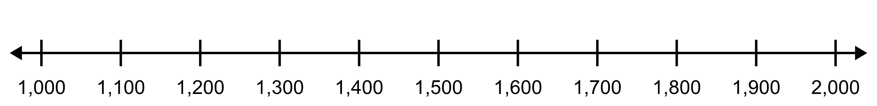  1,450 ◯ 1,720
C. | Are the numbers equal or not equal? Write = or ≠. Explain.  5,269 ◯ 5,296
On My Own Try these by yourself. Show your work.
1. | Plot each number on the number line. Then write <, >, or =.  6,500 ◯ 8,000  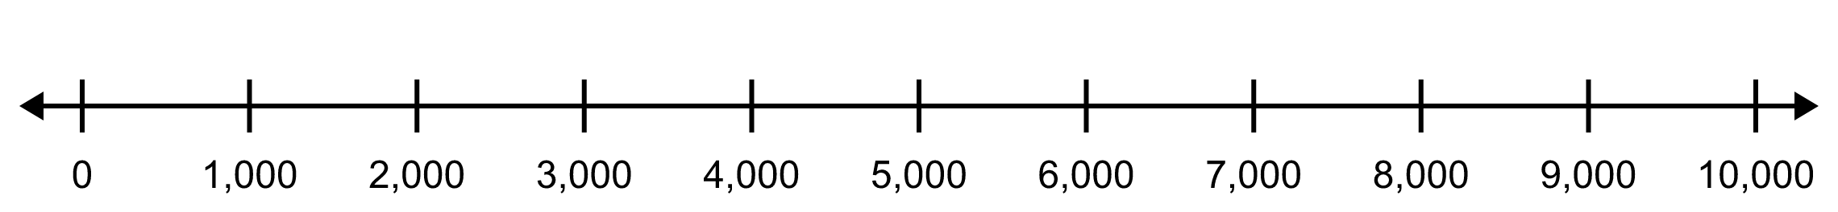
2. | Plot each number on the number line. Then write <, >, or =.  2,945 ◯ 2,610  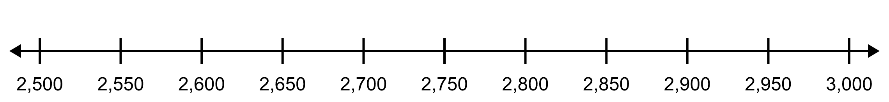
3. | Write = or ≠. Explain.  7,316 ◯ 7,316 | 4. | Write = or ≠. Explain.  4,052 ◯ 4,025
5. | Write < or >. Explain.  6,215 ◯ 5,980 | 6. | Write < or >. Explain.  9,412 ◯ 9,705
7. | Write <, >, or =.  2,567 ◯ 567 | 8. | Write <, >, or =.  4,728 ◯ 4,782
9. | Write <, >, or =.  3,602 ◯ 3,606 | 10. | Write <, >, or =.  836 ◯ 1,059
11. | Oak School has 1,850 books. Pine School has 1,792 books. Which school has more books? How do you know?
12. | Order these numbers from least to greatest: 5,302 4,999 5,230

Mathbook · Chapter 2 · Lesson 2-13 Parent Answer Key
2-13 Compare 4-Digit Numbers
Together
A | 6,384 > 6,381  Thousands, hundreds, and tens are the same. Ones: 4 > 1.
B | 1,450 is halfway between 1,400 and 1,500; 1,720 is between 1,700 and 1,800. 1,450 < 1,720  Accept dots placed close to the right spots; 1,720 must be to the right of 1,450.
C | 5,269 ≠ 5,296  Thousands and hundreds match, but the tens are different (6 and 9). Also 5,269 < 5,296.
On My Own
1 | 6,500 halfway between 6,000 and 7,000; 8,000 on its tick. 6,500 < 8,000
2 | 2,945 just left of 2,950; 2,610 just right of 2,600. 2,945 > 2,610  This line counts by 50s.
3 | 7,316 = 7,316  Every place has the same digit.
4 | 4,052 ≠ 4,025  Same digits, different places: the tens are 5 and 2. Also 4,052 > 4,025.
5 | 6,215 > 5,980  Thousands: 6 > 5. The thousands decide, even though 980 > 215.
6 | 9,412 < 9,705  Thousands are the same. Hundreds: 4 < 7.
7 | 2,567 > 567  567 has 0 thousands.
8 | 4,728 < 4,782  Tens: 2 < 8.
9 | 3,602 < 3,606  Ones: 2 < 6.
10 | 836 < 1,059  836 has 0 thousands.
11 | Oak School. Thousands are the same (1). Hundreds: 8 > 7, so 1,850 > 1,792.
12 | 4,999 < 5,230 < 5,302  4,999 has only 4 thousands. For 5,230 and 5,302, hundreds: 2 < 3.

