Mathbook · Chapter 2 · Lesson 2-7 Parent Learn
2-7 Decompose to Subtract
Learning goal: I can break apart the number I am subtracting and take away the parts one at a time to find the difference.
Textbook: pages 59–62. The book subtracts 353 − 184 by breaking 184 apart in two different ways.
Words to Know
decompose | Break a number into parts. 184 can be 100 + 80 + 4 or 153 + 30 + 1.
part | One of the smaller numbers that add up to the whole number.
difference | The answer when you subtract.
decomposition tree | A picture with the number on top and its parts below.
friendly number | A number that is easy to work with, like 200 or 170.
How to Teach It
- Keep the first number whole. Break apart only the number you are taking away.
- By place value: break it into hundreds, tens, and ones. Take away the hundreds, then the tens, then the ones. Each step starts from the last answer.
- Another way: choose a first part that lands you on a friendly number. For 362 − 175, take away 162 first to land on 200.
- Check the tree: the parts must add back to the number you are taking away.
- The difference is the same for any correct tree, and the parts can be taken away in any order.
Tip: Ask, “Do your parts add back to the number?” and “Can you land on a hundred?”
Worked Examples
Example 1: Decompose by place value |  | Example 2: Decompose another way
  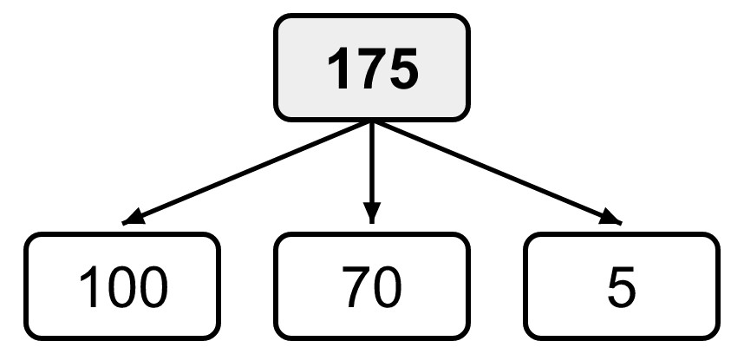 | 362 − 100 = 262  262 − 70 = 192  192 − 5 = 187  362 − 175 = 187
  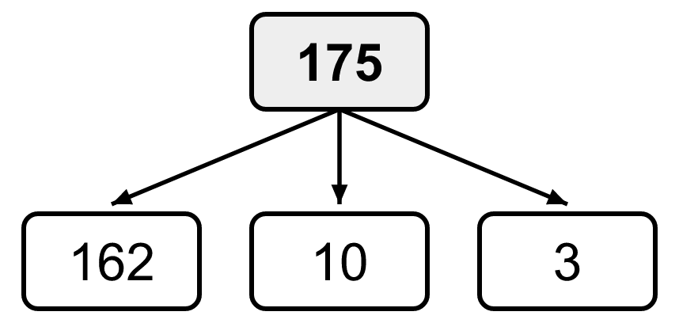 | 362 − 162 = 200  200 − 10 = 190  190 − 3 = 187  Same difference: 187
Example 3: Check the parts  458 − 102: Sam breaks 102 into 100 and 20. But 100 + 20 = 120, not 102.  Use 100 and 2: 458 − 100 = 358, 358 − 2 = 356. |  | Example 4: Any order works  538 − 215 with parts 200, 10, 5.  Ones first: 533, 523, 323.  Hundreds first: 338, 328, 323.
Skills Checklist Check off each skill your child can do without help.
☐ Decompose a 3-digit number in two different ways.  ☐ Subtract the parts by place value.  ☐ Choose parts that land on a friendly number. | ☐ Check that the parts add back to the number.  ☐ Explain why the difference is the same either way.  ☐ Solve word problems and table problems by subtracting.

Mathbook · Chapter 2 · Lesson 2-7 Together and On My Own
2-7 Decompose to Subtract
Name Date
Together Work with your grown-up. Talk about each step.
A. | Decompose 258 in two different ways.
  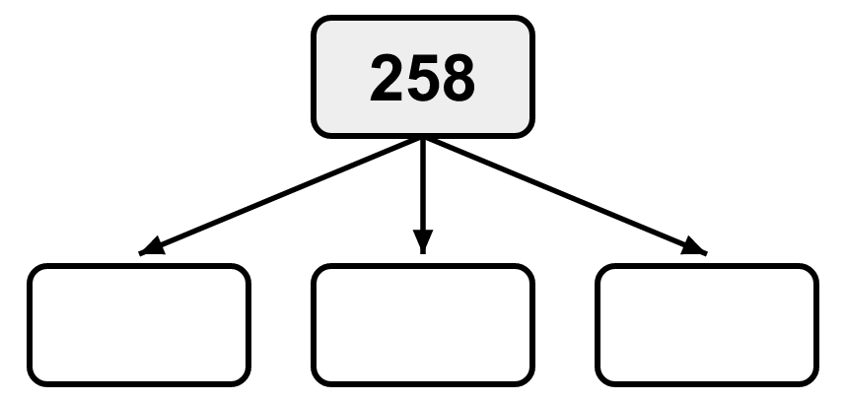
B. | Subtract 462 − 235. Break apart 235 by place value. Take away one part at a time.
  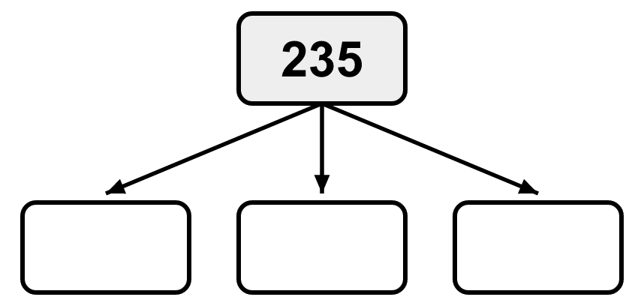
C. | How can you decompose 263 in two different ways to find 541 − 263? Show both ways.  Difference:
On My Own Try these by yourself. Show your work.
1. | Decompose 486 in two different ways.
  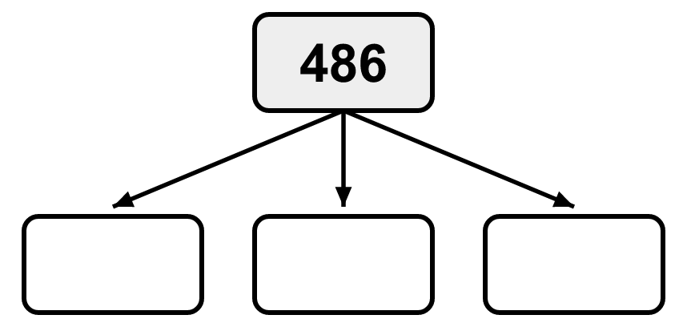
2. | Decompose 735 in two different ways.
  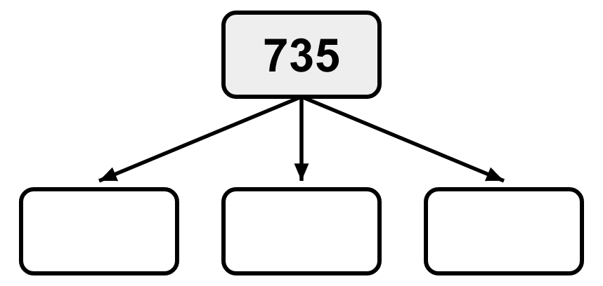
3. | Decompose one number to subtract. Why did you choose that way?  586 − 241  Why: | 4. | Decompose one number to subtract. Why did you choose that way?  728 − 460  Why:
5. | Find the difference. Show the strategy you used.  395 − 172 = ______  Difference: | 6. | Find the difference. Show the strategy you used.  ______ = 442 − 215  Difference:
7. | Find the difference. Show the strategy you used.  603 − 285 = ______  Difference: | 8. | Find the difference. Show the strategy you used.  831 − 547 = ______  Difference:
9. | Leo subtracts 576 − 103. He breaks 103 into 100 and 30. How can you help him understand his mistake? What is the correct difference?  Difference:
10. | The table shows how many books a class read each day. Find the difference between the greatest and least number of books.
   | Difference:
    Day | Books
    Monday | 214
    Tuesday | 187
    Wednesday | 309
    Thursday | 256
11. | Mia has 357 stickers. 168 are star stickers. The rest are heart stickers. How many heart stickers does she have?  Heart stickers:
12. | Ana subtracts 649 − 425. She takes away 5, then 400, then 20. Can she take away the parts in any order? Explain.

Mathbook · Chapter 2 · Lesson 2-7 Parent Answer Key
2-7 Decompose to Subtract
Together
A | Two different trees whose parts add to 258, e.g., 200, 50, 8 and 150, 100, 8.  Accept any 3 parts that add to 258, as long as the two trees use different parts (the same parts in a new order do not count).
B | Tree: 200, 30, 5. 462 − 200 = 262; 262 − 30 = 232; 232 − 5 = 227. Difference: 227
C | Way 1: 263 → 200, 60, 3: 541 − 200 = 341; 341 − 60 = 281; 281 − 3 = 278.  Way 2: 263 → 241, 22: 541 − 241 = 300; 300 − 22 = 278. Difference: 278  Accept any two correct trees that give 278.
On My Own
1 | Sample: 400, 80, 6 and 386, 90, 10  Items 1–2: accept any two trees whose parts add to the number. Reordering the same parts is not a different way.
2 | Sample: 700, 30, 5 and 635, 90, 10
3 | Sample: 241 → 200, 40, 1: 386, 346, 345.  Reason: place-value parts are easy to take away because no regrouping is needed. Accept other correct trees with a sensible reason.
4 | Sample: 460 → 428, 32: 728 − 428 = 300; 300 − 32 = 268. Or 400, 60: 328, 268.  Reason: taking away 428 lands on 300, a friendly number. Accept any sensible reason.
5 | 223 (e.g., 395 − 100 = 295; 295 − 70 = 225; 225 − 2 = 223)
6 | 227 (e.g., 442 − 200 = 242; 242 − 10 = 232; 232 − 5 = 227)
7 | 318 (e.g., 603 − 200 = 403; 403 − 80 = 323; 323 − 5 = 318)
8 | 284 (e.g., 831 − 500 = 331; 331 − 40 = 291; 291 − 7 = 284)
9 | 100 + 30 = 130, not 103. The parts must add back to 103. Use 100 and 3: 576 − 100 = 476; 476 − 3 = 473.
10 | Greatest 309 (Wed), least 187 (Tue). 309 − 187 = 122 books.  Sample: 309 − 100 = 209; 209 − 80 = 129; 129 − 7 = 122. Watch for subtracting the first and last rows instead.
11 | 357 − 168 = 189 heart stickers  Sample: 357 − 100 = 257; 257 − 60 = 197; 197 − 8 = 189.
12 | Yes. 649 − 5 = 644; 644 − 400 = 244; 244 − 20 = 224. She still takes away 425 in all, so the difference, 224, is the same in any order.

