Mathbook · Chapter 2 · Lesson 2-9 Parent Learn
2-9 Use Addition to Subtract
Learning goal: I can use a bar diagram and a related addition equation to solve a subtraction problem.
Textbook: pages 67–70. The book shows 575 − 246 = ? and 246 + ? = 575 with one bar diagram.
Words to Know
bar diagram | A drawing with bars that shows the whole and its parts.
whole / part | The whole is the total amount. The parts are the amounts that make up the whole.
unknown | The number we do not know yet. We write it as ?.
addend | A number you add. In 248 + ? = 563, the ? is an unknown addend.
related equations | Equations that use the same three numbers, like 563 − 248 = 315 and 248 + 315 = 563.
count up | Start at the part and add jumps until you reach the whole.
How to Teach It
- Draw a bar diagram: the whole is the long bar on top. The known part is below it. The dashed piece with ? is the part you need.
- Write the subtraction: whole − part = ?. Then write the related addition: part + ? = whole.
- Solve the addition by counting up from the part: jump to the next ten, then to the next hundred, then to the whole. Add all the jumps.
- Check: part + answer should equal the whole.
- Watch for adding the two numbers (the answer would be bigger than the whole). Ask, “Can the answer be bigger than the whole?”
Tip: Ask, “Which number is the whole? What do you add to the part to get the whole?”
Worked Examples
Example 1: Bar diagram and related equations  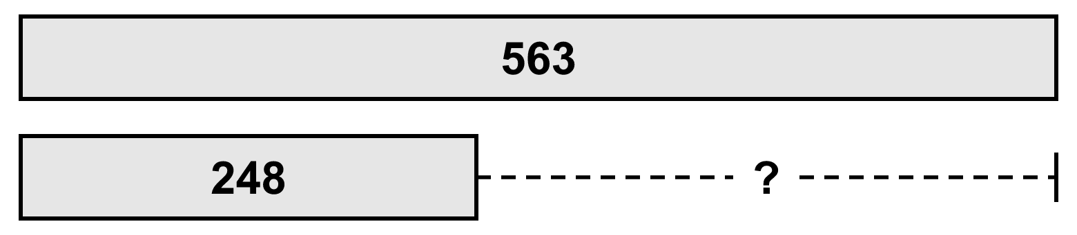  563 − 248 = ? is the same as 248 + ? = 563 |  | Example 2: Count up to solve  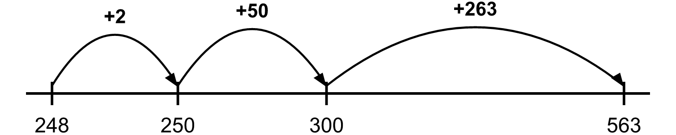  2 + 50 + 263 = 315. Check: 248 + 315 = 563 ✓
Example 3: Subtract across zeros  400 − 153 = ? → 153 + ? = 400  Count up: 153 → 160 (+7) → 200 (+40) → 400 (+200).  7 + 40 + 200 = 247 |  | Example 4: Watch for these mistakes  To find 458 − 302, do not add 302 + 458. Solve 302 + ? = 458 → 156.  452 − ? = 237: the missing number is a part. Solve 237 + ? = 452 → 215.
Skills Checklist Check off each skill your child can do without help.
☐ Fill in a bar diagram for a story.  ☐ Write a related addition equation for a subtraction.  ☐ Count up to find an unknown addend. | ☐ Count up across zeros (like 400 − 153).  ☐ Check a difference with addition.  ☐ Explain why adding the two numbers is wrong.

Mathbook · Chapter 2 · Lesson 2-9 Together and On My Own
2-9 Use Addition to Subtract
Name Date
Together Work with your grown-up. Talk about each step.
A. | Write a related addition equation for 584 − 342 = ?. Then count up to solve.  Addition equation:  Answer:
B. | A book has 500 pages. Ben has read 263 pages. How many pages are left? Label the bar diagram. Then write an addition equation and solve.  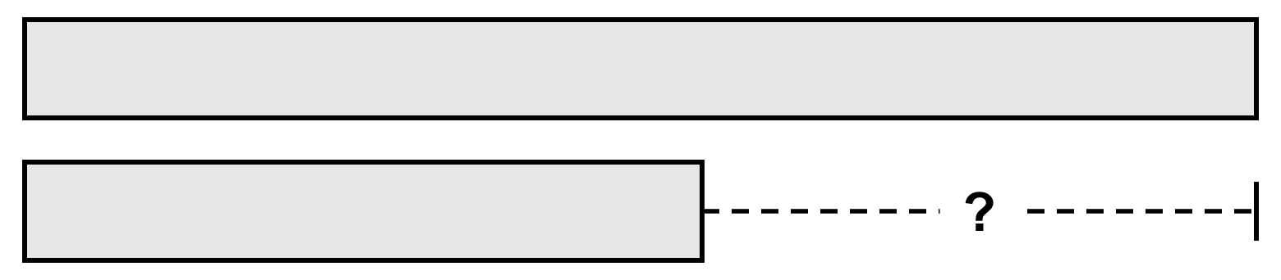  Equation:  Pages left:
C. | Lila wants to use addition to solve 728 − 315 = ?. How can you explain her strategy? What is the answer?  Answer:
On My Own Try these by yourself. Show your work.
1. | Write a related addition equation. Then solve.  847 − 413 = ?  Addition equation:  Answer: | 2. | Write a related addition equation. Then solve.  300 − 162 = ?  Addition equation:  Answer:
3. | Write a related addition equation. Then solve.  936 − 255 = ?  Addition equation:  Answer: | 4. | Omar adds 205 + 638 to find 638 − 205. How can you help him use addition the right way?
5. | On Saturday, 468 people visited the zoo. On Sunday, 735 people visited. How many more people visited on Sunday?
  a. Label the bar diagram.  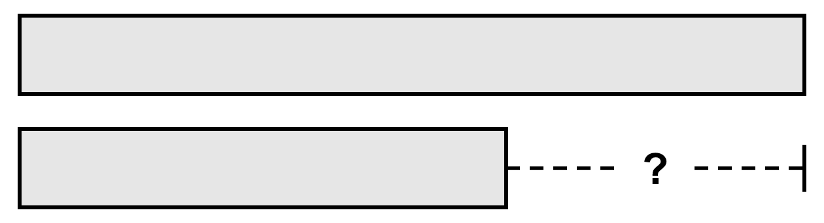 | b. Write an equation with an unknown. Solve.  Equation:  Answer:
6. | Use addition to find the difference.  590 − 347 = ______ | 7. | Use addition to find the difference.  ______ = 600 − 274
8. | Use addition to find the difference.  804 − 368 = ______ | 9. | Use addition to find the difference.  321 − 156 = ______
10. | Mia and Jo picked 400 apples in all. Mia picked 186 apples. How many apples did Jo pick?  Apples: | 11. | A club has $900 for a trip. The bus costs $638. How much money is left?  Money left:
12. | Ray says he can solve 563 − ? = 327 by finding 563 + 327. Do you agree? Explain.

Mathbook · Chapter 2 · Lesson 2-9 Parent Answer Key
2-9 Use Addition to Subtract
Together
A | 342 + ? = 584. Count up: 342 → 384 (+42) → 584 (+200). Answer: 242  Also accept ? + 342 = 584. Any correct counting-up jumps are fine.
B | Whole bar: 500. Part bar: 263. ?: pages left.  263 + ? = 500. 263 → 270 (+7) → 300 (+30) → 500 (+200). 237 pages
C | Think 315 + ? = 728: what do you add to 315 to get 728? Count up: 315 → 328 (+13) → 728 (+400). Answer: 413  Accept any explanation that turns the subtraction into “part + ? = whole.”
On My Own
1 | 413 + ? = 847 → 434  Items 1–3: also accept ? + 413 = 847, etc.
2 | 162 + ? = 300 → 138  162 → 170 (+8) → 200 (+30) → 300 (+100).
3 | 255 + ? = 936 → 681
4 | Adding makes a number bigger than 638, the whole. He should solve 205 + ? = 638. Answer: 433.
5 | a. Whole (long bar): 735. Part: 468. ?: how many more.  b. 468 + ? = 735 (or 735 − 468 = ?). Answer: 267
6 | 243 (347 + 243 = 590)  Items 6–9: check each answer by adding it to the smaller number.
7 | 326 (274 + 326 = 600)
8 | 436 (368 + 436 = 804)
9 | 165 (156 + 165 = 321)
10 | 186 + ? = 400 → 214 apples
11 | 638 + ? = 900 → $262
12 | No. 563 is the whole, so the missing number is a part: 327 + ? = 563. Answer: 236. 563 + 327 = 890 is bigger than the whole.

