

A cross-platform, open source sprite packing program.

*** PLACEHOLDER file -- full guide will arrive soon! ***
If you're testing the app, thanks for any feedback :)

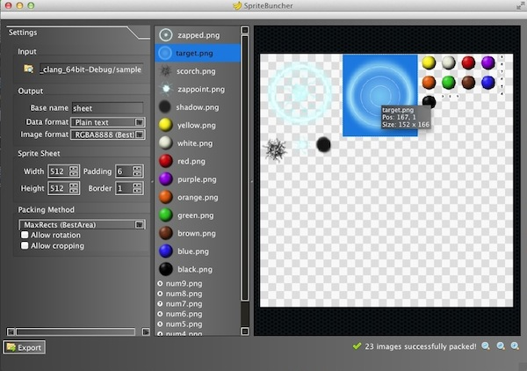

The SpriteBuncher main interface (Mac version).

Quick start guide: open a folder of images using the button in the Input section of the application (or 'drag and drop' a folder onto any part of the application). Use the various settings to produce the desired layout on the sheet – the best packing method is generally MaxRects. Choose the required output format from the drop-down menu. If packing was successful, click the Export button to write the data and image files to disk. The program writes output files to a 'buncher' folder, within the original image folder.

[BRS March 2014]

