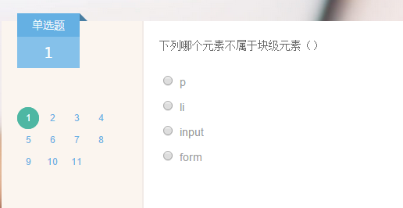
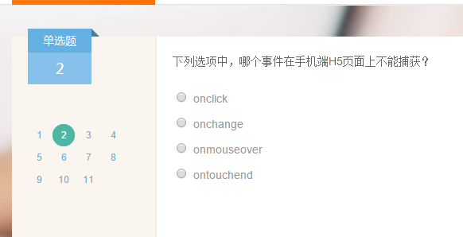
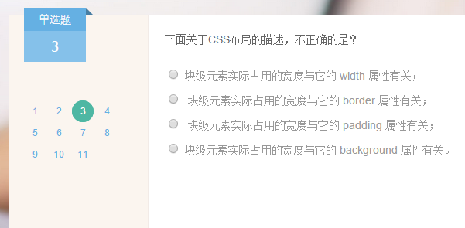


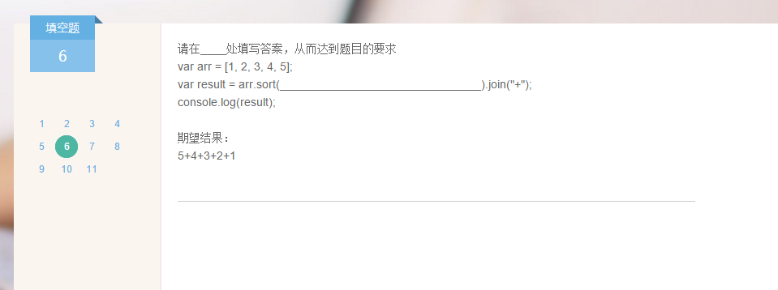
function(a,b){
if(a>b){
return -1;
}
if(a==b){
return 0;
}
else{
return 1;
}
})

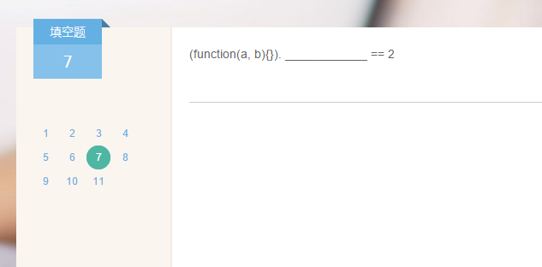

Length
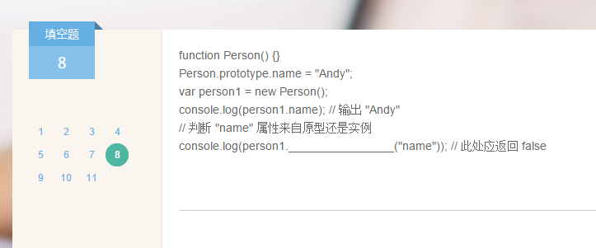
hasOwnProperty

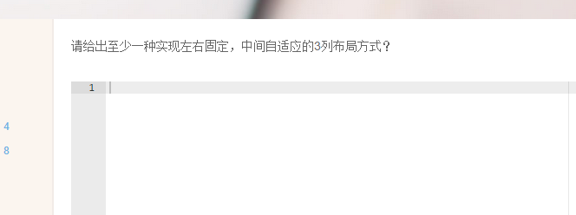

方法一：
css:
.left {
width:100px;height:600px;background:#F00;float:left;
}
.center {
background:#999;height:600px;float:left;
}
.right {
width:100px;height:600px;background:#F0F;float:right;
}
html:
<div class="left"></div>
<div class="center"></div>
<div class="right"></div>
方法二：
CSS:
.left {
width:100px;height:600px;background:#F00;position:absolute;
}
.center {
background:#999;height:600px;position:absolute;left:100px;
}
.right {
width:100px;height:600px;background:#F0F;position:absolute;right:0;
}
HTML:
<div class="left"></div>
<div class="center"></div>
<div class="right"></div>

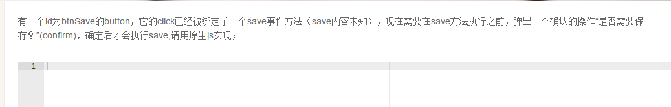
<button id="btnSave" onclick="save();">jj<button>
<script>
var btn = document.getElementById("btnSave");
var click = btn.onclick;
btn.onclick = function () {
if (window.confirm('是否需要保存吗？')) {
click();
}
}
</script>
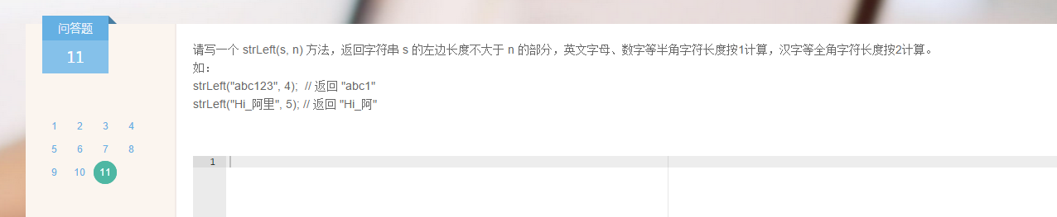
function strLeft(s, n) {
var str = "";
for(var i=0; i<s.length; i++) {
if(n>0) {
str += s.charAt(i);
var strCode = s.charCodeAt(i);
//全角
if(s.charAt(i).match(/[^\x00-\xff]/ig)) {
n = n-2;
}else{ //半角
n = n-1;
}
}
}
return str;
}

