Course: Advanced Databases
Group: A1
Team Members: Tobiasz Bazan, Jakub Kamiński, Adam Ćwikliński
Assignment: Partitions

Objective
The objective of the Partitions phase is to propose a logical and physical data partitioning strategy to further optimize database performance. By dividing large tables into smaller, more manageable segments, we aim to leverage partition pruning and parallel execution to reduce In/Out overhead. This phase focuses on selecting appropriate partitioning methods (Range, List, or Hash) for our specific data distribution to improve the efficiency of both analytical queries and large-scale data modifications.

Proposed Partitioning Strategy

Hash Partition
Query plan 6:
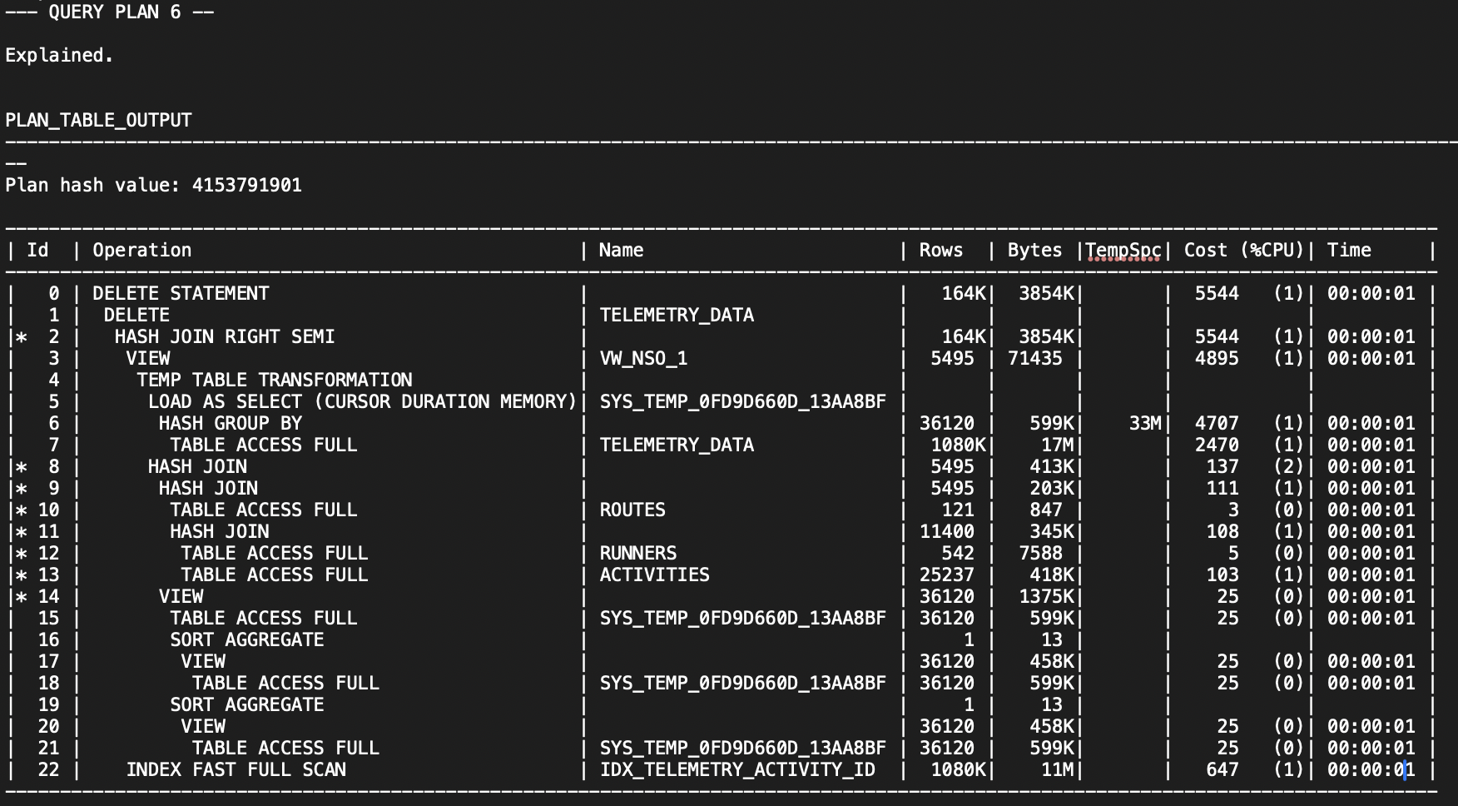

Operations to be optimized by partitions:
TABLE ACCESS FULL | TELEMETRY_DATA | 1080K
HASH GROUP BY | 36120
DELETE | TELEMETRY_DATA
INDEX FAST FULL SCAN | IDX_TELEMETRY_ACTIVITY_ID | 1080K

The Query Plan 6 analysis showed that the TELEMETRY_DATA table is one of the biggest performance bottlenecks in the workload. The database performs TABLE ACCESS FULL on more than 1,080,000 rows and also uses expensive operations such as HASH GROUP BY and INDEX FAST FULL SCAN. This means that Oracle has to process a very large amount of telemetry data during the DELETE transaction.
To improve this operation, HASH partitioning is proposed for the TELEMETRY_DATA table using activity_id as the partition key. Since telemetry records are connected to activities through activity_id, the data can be distributed more evenly across multiple partitions. Thanks to this, Oracle should process smaller parts of the table instead of scanning the whole TELEMETRY_DATA table during the query execution.
Hash partitioning may also improve parallel processing, because different partitions can be read simultaneously by the DBMS. This should reduce the execution cost of DELETE and JOIN operations related to telemetry data.

Range partition

Query plan 5:
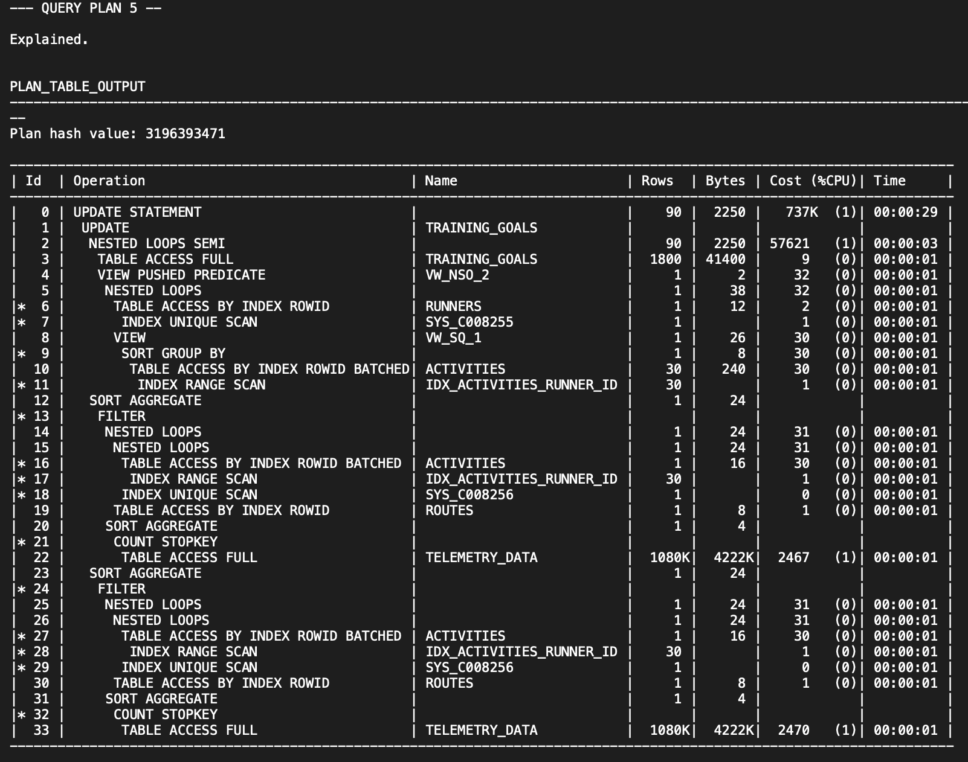

Operations to be optimized by partitions:
| 1 | UPDATE | TRAINING_GOALS | 90 | 2250 | 737K (1) | 00:00:29 |
| 2 | NESTED LOOPS SEMI | | 90 | 2250 | 57621 (1) | 00:00:03 |
| 3 | TABLE ACCESS FULL | TRAINING_GOALS | 1800 | 41400 | 9 (0) | 00:00:01 |

The Query Plan 5 analysis revealed that the UPDATE transaction performs TABLE ACCESS FULL operations on the TRAINING_GOALS table while processing records related to specific time periods and runner goals. The execution plan also contains expensive NESTED LOOPS SEMI operations connected with updating training goals based on activity data.
To optimize this workload, RANGE partitioning is proposed for the TRAINING_GOALS table using the deadline column as the partition key. Since training goals are naturally connected with specific deadline periods, the table can be divided into partitions representing selected time ranges, for example monthly or yearly intervals.
With this approach, Oracle should be able to access only the partitions containing relevant deadline ranges instead of scanning the entire TRAINING_GOALS table. This is expected to reduce the amount of processed data during UPDATE operations and improve the performance of time-based training goal management queries.

Value list partition

Query plan 4:
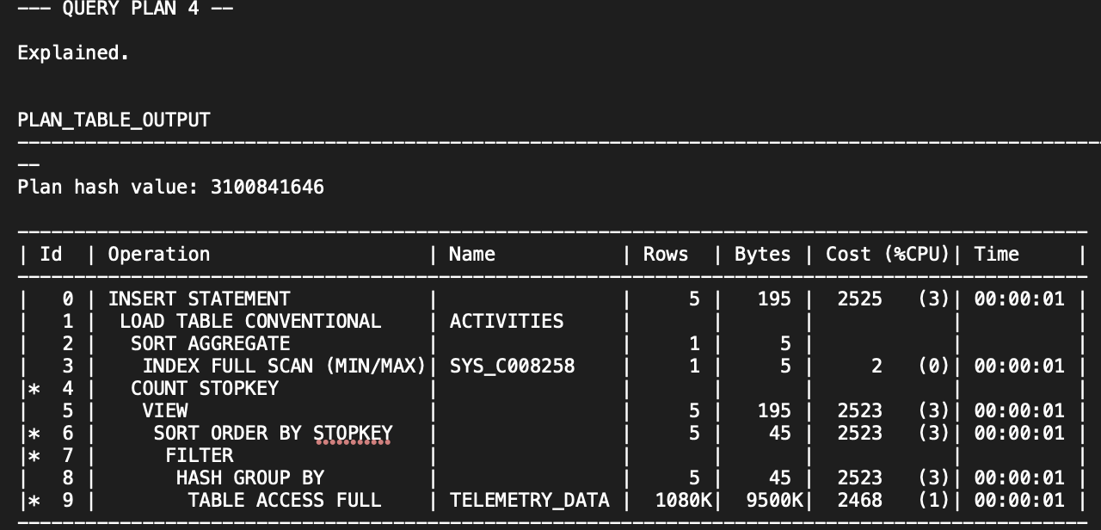

Operations to be optimized by partitions:
| 0 | INSERT STATEMENT | - | 5 | 195 | 2525 (3%) | 00:00:01 |
| 1 | LOAD TABLE CONVENTIONAL | ACTIVITIES | - | - | -
Query Plan 4 shows that the transaction performs an INSERT operation into the ACTIVITIES table. This is represented by the INSERT STATEMENT and LOAD TABLE CONVENTIONAL operations visible in the execution plan.
Based on this query, value list partitioning is proposed for the ACTIVITIES table using the activity_type column as the partition key. The activity_type attribute contains a small number of predefined categorical values, such as Easy Run, Intervals, Long Run, Recovery Run, Smartwatch Sync and Tempo Run, which makes it a suitable candidate for LIST partitioning.

In Query 4, newly inserted rows use the activity type value 'Smartwatch Sync'. With LIST partitioning, Oracle would be able to place these rows directly into the partition assigned to smartwatch synchronization activities. This approach improves the logical organization of the ACTIVITIES table and may also improve future analytical queries filtering activities by their type.

Final list of chosen partitions

Partition Type | Table | Partition Key | Main Query
HASH | TELEMETRY_DATA | activity_id | Q6
RANGE | TRAINING_GOALS | deadline | Q5
LIST | ACTIVITIES | activity_type | Q4

Planned Experiments

- Baseline vs partitioned workload
The first planned experiment will compare the original non-partitioned database with the partitioned versions of the database. The goal of this experiment is to measure the impact of partitioning on the performance of the workload transactions.
In the baseline version, the workload will be executed on the original database structure without any partitions. Afterwards, the same workload will be executed again after applying the selected partitioning strategies, including RANGE partitioning on ACTIVITIES(activity_date), HASH partitioning on TELEMETRY_DATA(activity_id), and LIST partitioning on ACTIVITIES(activity_type).

- RANGE vs HASH for Training_Goals table
An additional experiment is planned to compare RANGE partitioning and HASH partitioning applied to the TRAINING_GOALS table. The purpose of this experiment is to analyze how different partitioning strategies affect the performance of workload transactions operating on training goal data.
The first variant will use RANGE partitioning, which organizes data based on value ranges, such as deadline periods. The second variant will use HASH partitioning, which distributes rows evenly across partitions using a hashing function.
Both approaches will be tested using the same workload transactions. The comparison will include execution times, whole workload execution time and query plan analysis before and after partitioning. The goal of the experiment is to determine which partitioning strategy provides better optimization for the TRAINING_GOALS table under the current workload.
The experiment will mainly focus on Query 5, because this transaction repeatedly accesses and updates records from the TRAINING_GOALS table while processing runner goals and time-based conditions.

- RANGE vs HASH for Telemetry_Data table

An additional experiment is planned to compare HASH partitioning and RANGE partitioning applied to the TELEMETRY_DATA table. The purpose of this experiment is to analyze how different partitioning strategies affect the performance of workload transactions operating on large amounts of telemetry records.
The first variant will use HASH partitioning, which distributes telemetry data evenly across partitions using a hashing function. The second variant will use RANGE partitioning, which organizes telemetry records based on value ranges, such as time-related data.
Both approaches will be tested using the same workload transactions. The comparison will include execution times, whole workload execution time and query plan analysis before and after partitioning. The goal of the experiment is to determine which partitioning strategy provides better optimization for the TELEMETRY_DATA table under the current workload.

