Driving with ALKS in WoZ vehicle | 

Expert: Rutger Verstegen
Coach: Pavlo Bazilinskyy

As per 2021, a UN regulation has been put in place, allowing for the type approval of automated driving systems (ADS) to drive on public roads [1]. One of such ADS currently on the road already is the Automated Lane Keeping System (ALKS), which can take over the entire dynamic driving task whilst driving on the highway under specifically predefined circumstances. This will entail a huge shapeshift in common practices on public roads, as computers will start taking over a major part of the driving task, ushering in less human behaviour on the road. Moreover, also from its human occupant, several shifting behaviours are to be expected, such as monitoring and supervising an autonomously operating machine, requiring novel competences from human drivers not taught during regular driver training. However, most, if not all these behaviours and competences are yet to be researched.
An experiment was concluded with ten examiners of the Centraal Bureau Rijvaardigheidsbewijzen (CBR) in a Wizard-of-Oz (WoZ) vehicle, equipped as presented in Figure 1. They acted as a regular driver of an ALKS-equipped vehicle who needs to take over control safely, and will through this experiment provide expert input on what they do to safely take over. Ultimately, the examiners' task is to formulate a rule-of-thumb to acquire the right (amount of) information before take-over.
We collected 1Tb of (1) video and sound from five GoPro cameras, (2) moments of the change of the state of ALKS, (3) GPS and IMU data. This project will start by evaluating the examiner’s interactions with the ALKS system. Based on this, you are asked to provide design recommendations for ALKS systems and to implement these into a novel ALKS design.
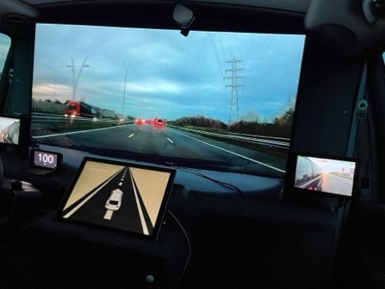
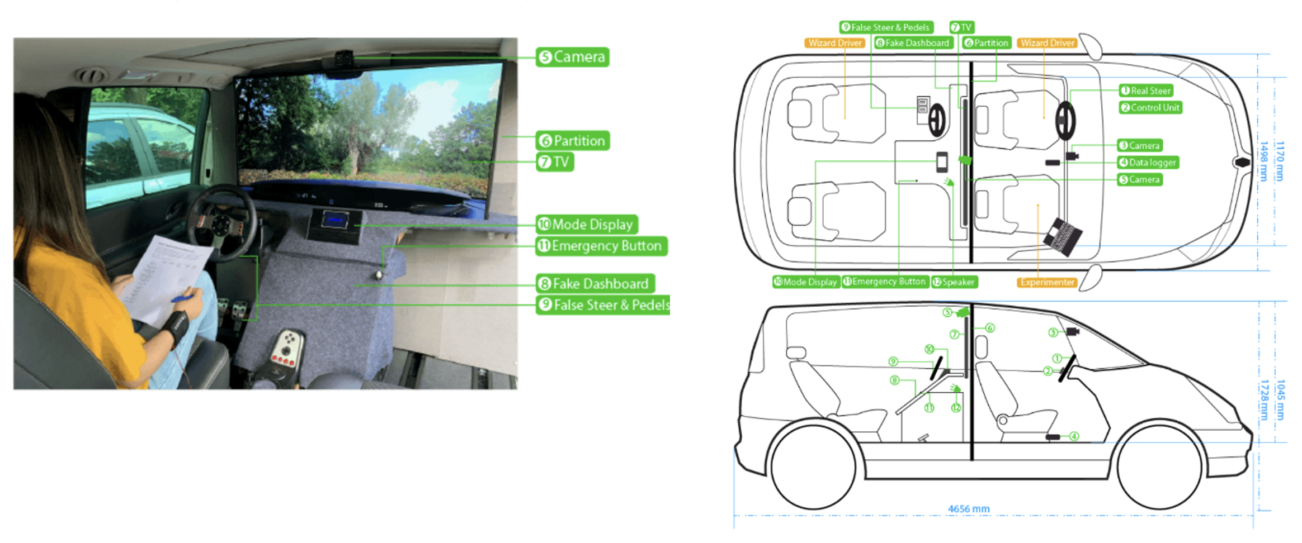
Figure 1. Left: Inside setup of WOz vehicle. Centre: Schematic top and side view. Right. View of the participant during the experiment.

Objectives:
- Analyse the interactions of the CBR examiners with the ALKS
- Provide design recommendations for ALKS systems
- Generate a novel ALKS system, based on the design recommendations

References
[1] United Nations. (2022). Proposal for the 01 series of amendments to UN Regulation
No. 157 (Automated Lane Keeping Systems). (ECE/TRANS/WP.29/2022/59/Rev.1). Retrieved from https://unece.org/sites/default/files/2025-03/ECE_TRANS_WP.29_2022_59_Rev.1e.pdf

