**MOSAiC – CLASP DOCUMENTATION**

**Warning**: do no cycle the power too rapidly. Always leave ~10 seconds after power off before returning power. Rapid power cycling can corrupt the onboard EPROM resulting in random changes to, or erasure of, configuration settings, and in extreme cases corruption of the firmware.

**Serial comms**

CLASP communicates over an RS485 (4 wire) interface at 38400 baud. There is an RS485-to-RS232 converter included in the data/power breakout box to simplify communications – use RS232 connecting to this. Other comms parameters should be left on defaults. Any serial comms software package should be OK (I use MOXA’s ‘pcomm lite’) – note that depending on the terminal mode (VT100, ANSI, dumb terminal) etc you may get junk characters echoed back to screen after hitting ‘return’ when entering configuration values.

The CLASP units have a simple text-based user interface. They can be interrogated and configured via any terminal communications programme. If all goes well you shouldn’t need to change anything.

**Default Operation**

On power up the CLASP’s pump should start – for the first couple of minutes of operation the pump speed will vary as it homes in the configured flow rate. For MOSAiC CLASP is configured to autostart, and after a few seconds for the firmware to boot up, data will be output automatically. For MOSAiC the output is set to ASCII and the sample rate to 10Hz.

If any changes to the configuration are required, then a simple text based user interface allows changes to be made. Sending the command ‘H’ will stop data output and allow other commands to be sent:

***User interface***

The following commands are available:

‘?’ ping the system, it should respond with ‘!’

‘Q’ query system settings, a full-screen display of configuration and status is produced (this might scroll off top of screen depending on terminal programme. See below for typical output.

‘G’ GO…start sampling

‘H’ HALT data sampling (valid only during sampling)

‘F’ enter flow calibration mode – measured flow rate (arbitrary units) is output continuously. Should be used with a flow-meter on the outflow, and (ideally) the pump on an independent variable DC power supply to set a stable flow. Flow calibration can be undertaken using the CLASP user interface to change pump speed, but the active control means it will vary slightly over time.

‘E’ quit flow calibration mode.

‘C’ set a single channel’s lower boundary – system will request channel number and the lower limit to be set (from the 0-1023 range of pulse height analyser’s A-to-D converter)

‘0’..’9’ Set configuration variable number N – the system will prompt for a value or ‘Y’ / ‘N’ for switches. The variables are:

0 sample rate

1 number of bins in size spectra

2 mode: 1 = histogram (normal sampling),

2 = flow-through (calibration mode, Binary),

3 = flow through (ascii)

3 Threshold: peak detector noise threshold

4 target flow rate: the flow rate to balance flow at (in flow sensor output units)

5 target sensor temperature (not used here, but we can add a heater to de-mist optics)

6 Baud rate (enter as baud rate/100, ie 38400 is entered as 384)

7 Binary output switch: enter Y/N to set binary/ascii data output

8 Autostart switch: enter Y/N

9 16-bit option: enter Y/N for 16/8 bit data output (set to 8 bit…much more efficient)

All variables are saved to EPROM immediately when entered. If an invalid (out of range) value is entered, it will be ignored and a warning message given and the existing value will NOT be overwritten.

‘Z’ Clear EPROM of saved settings…use at your own risk! (Don’t risk it!)

**CONFIGURATION FILES**

The CLASP units can be fully configured by sending them an ascii configuration file via the serial terminal communication programmes file transfer facility. With the unit in standby mode (i.e. not sampling) simply transfer the file. For convenience the commands to configure via file transfer ‘K’ and end of config file ‘x’ are already included as first and last lines of config files.

File consists of lines of ASCII

Configuration files are named **CLASPV5Config_XXX.asc**.

The lines within the file follow the format

**A MM XXXX CRLF** (no leading spaces)

where:

**A** is a character **c**,**v** or **x** indicating Channels, Variables or Exit - LOWER CASE

**MM** is a number [0..31] for channels, [0..9] for variables, not used on exit

**XXXX** is the value assigned to either the specified channel or variable

'Boolean' types must have entries of 170 (True) or 55 (False)

There must be a space or a comma between **MM** ing where and when you deploy the unitsupply and the RS485 et and tubing final configuration has been decided on. and **XXXX**

All lines must terminate in CRLF sequence (Char(13) Char(10))

Variables and channels can be mixed up and the entries do not have to be in sequential order (though that does make it easier for people to read them easily)

Individual configuration files are supplied for each unit; these are already loaded and no further configuration ought to be necessary…unless something goes very wrong. (very wrong can include power glitches – notably, if power is cycled too quickly we have sometimes found some settings to get lost (corruption of EPROM?). In severe cases the firmware has been corrupted and the CLASP becomes inoperable until reprogrammed.

**Size Calibration**

Can only be done in the lab – don’t worry about it now.

**Flow Calibration**

CLASP actively controls the flow to maintain it at 3 l/min. This maintains a flow rate through the scatter cell for which the pulse-height analyzer has been optimised. When running the flow rate will typically wander around the set flow velocity a little – you’ll hear the pump changing speed. Changes in the flow rate are measured and the sample volume corrected in processing. The flow controller works on the raw A2D counts from the monitoring circuit. In order to set the target flow rate and calculate the actual flow, we need to calibrate the flow sensor – this is a simple mass flow sensor and is sensitive to air pressure, so calibration needs doing in situ if mean atmospheric pressure is very different from that in the lab in Leeds. For testing, don’t worry about this.

To calibrate, connect the outflow from CLASP to the input of the TSI flow meter (see figure). Connect to CLASP with a serial terminal and stop the data output (send character H). Send a ‘Q’ to get current configuration and check the current ‘set flow’ and ‘measured flow’ (units are A2D counts).

Serial No.WAGES-C-2013-04-18

Mode 1 ASCII 8 bit

Flow [Measured/Set/PWM] 2480 2500 142

Pump Current (mA) 50

Laser Voltage (mV) 3507

Sensor T Meas./Set (C) 24 0 Heater OFF

Housing/Pump T (C) 24 24

Threshold Meas./Set (mV) 47 50

0 Sample Rate Hz 10 1 Channels <32 16

2 Mode 1-3 1 3 Threshold mV 50

4 Flow Rate Bits 2500 5 Cell SetT degC 0

6 Baud/100 bps 384 7 Binary Data Y/N N

8 AutoStart Y/N N 9 16bit Data Y/N N

Channel Lower Bounds (Bits)

0 = 31 1 = 41 2 = 58 3 = 75 4 = 93

5 = 112 6 = 134 7 = 175 8 = 216 9 = 250

10 = 314 11 = 380 12 = 449 13 = 541 14 = 642

15 = 837

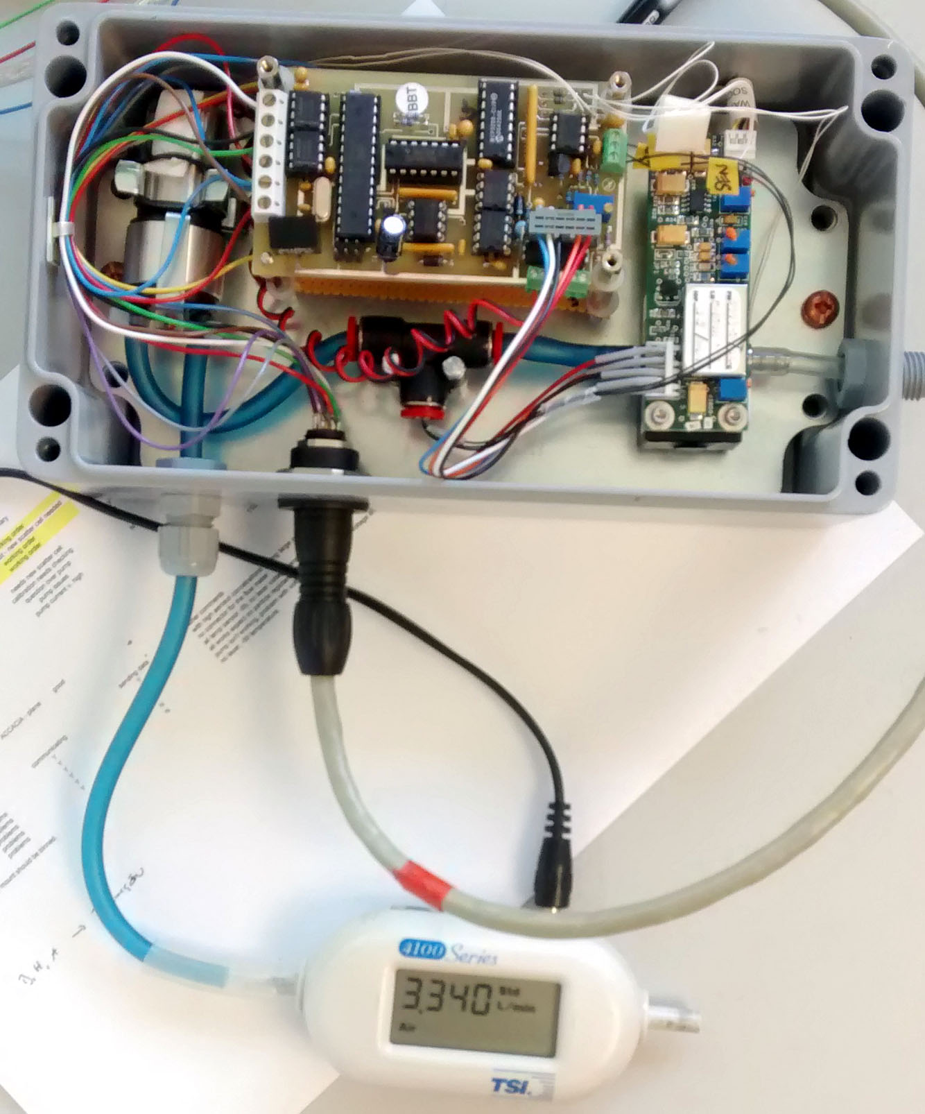

*TSI flow meter connected to outflow of CLASP.*

Adjust the set flow rate in steps and record both the ‘set flow’ and actual flow rate from TSI flow meter – we need a range of values (~10 or so) spanning real flows from about 2-4 l/min. These values should be saved in the ‘realflow’ and ‘TSIflow’ fields of the calibration data structure (see below). Either use a best fit to calculate the final ‘setflow’, or just iterate ‘setflow’ values until the true flow is approximately 3 l/min. Save this value in the ‘setflow’ field of the calibration data structure.

To calibrate the flow:

1. Get the system in the final set up with all inlets, tubing etc in place.
2. Put the CLASP unit it Flow calibration mode ‘F’. This should stream the measured flow rate (arbitrary units) continuously. This isn’t entirely necessary, but allows you to see the range (in arbitrary A2D units) that the flow varies over, which may help judge adjustment increments.
3. With the external TSI flow meter record the true flow rate.
4. Change the set the target flow rate using ‘4’ and either increase or decrease it in increments until the external flow meter records a steady 3 liters/min.   
   (A, perhaps better, alternative is to open CLASP up, disconnect the pump from the PCB, and attach it to a separate, variable power suppy, so that it can be adjusted independently)
5. Use ‘E’ to exit flow calibration when done.

N.B. all settings are saved automatically.

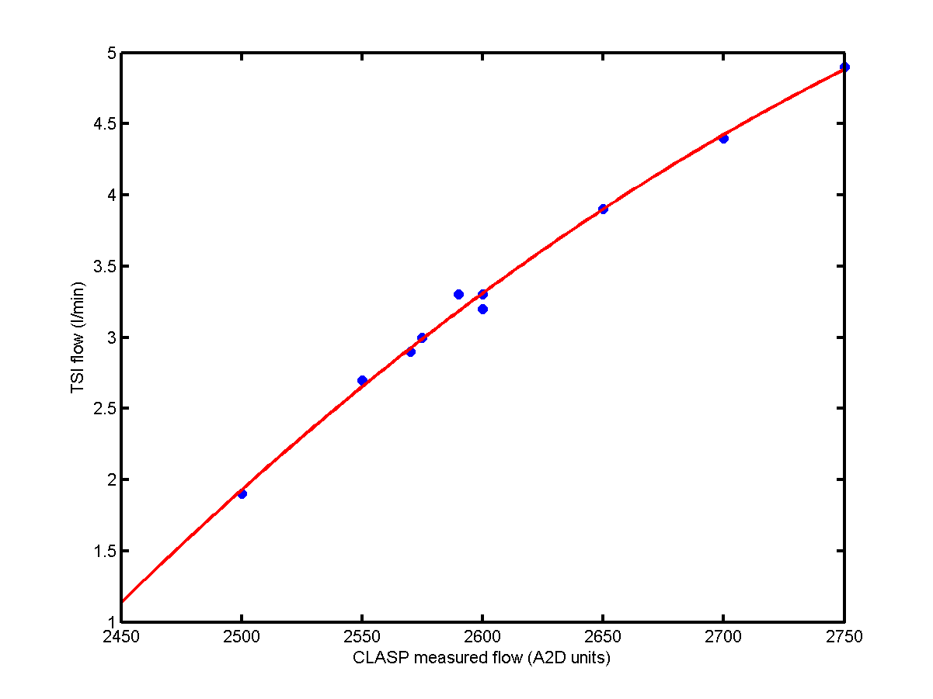

*Example flow calibration with 10 measured flows (blue dots) and fitted polynomial (red line).*

**Calibration file**

Calibration details are stored in a matlab data structure ‘calibr’ saved in a file calibration_unitX_MMMDD.mat, eg:

calibr =

name: 'ICECAPS-ACE - Board F - cell 575090'

caldate: ' - default - '

usedate: '-'

channels: [31 41 58 75 93 112 134 175 216 250 314 380 449 541 642 837 987]

lowerR: [1x17 double]

meanR: [16x1 double]

dr: [16x1 double]

setflow: 2575

TSIflow: [10x1 double]

realflow: [10x1 double]

laser_ref: 1015

The fields are:

calibr =

name: - ‘text field with details of which unit/cell’

caldate: - ‘text field with date of cal’

usedate: - 'text field with date unit used'

channels: - array of AD channel number of boundaries of size bins

lowerR: - array of true radius of channels (micrometers)

meanR: - array of mean radius (micrometers) of each size bin

dr: - array of widths of each size bin (micrometers)

setflow: - A2D value of flow monitor set as target flow

TSIflow: – array of calibration flow rates from TSI flow meter

realflow: - array of measured A2D flow rates matching TSflow

laser_ref: - the laser reference voltage at time of calibration

NB. The flow calibration fields (TSIflow and realflow) and the the setflow value will all need updating after doing the calibration at Summit.

**DATA**

The data is output as ascii:

0 3133 0 65 44 23 13 5 2 2 0 0 0 0 0 1 0 0 0

1 48 0 89 58 32 29 5 7 3 2 0 0 0 0 0 0 0 0

2 2733 0 94 59 35 24 7 9 1 2 0 0 0 0 0 0 0 0

3 252 0 80 50 36 16 15 4 1 0 1 1 0 0 1 0 0 0

4 75 0 81 51 38 19 8 7 4 0 0 0 0 0 0 0 0 0

5 22 0 60 57 35 16 7 9 3 2 0 0 0 0 0 0 0 0

6 23 0 68 50 39 21 7 4 7 0 0 0 0 0 0 0 0 0

7 23 0 64 50 27 20 7 6 4 1 0 1 0 0 0 0 0 0

8 1189 0 60 48 30 12 13 4 5 1 0 0 0 0 0 0 0 0

9 1375 0 73 50 35 14 11 4 2 0 1 1 0 0 0 0 0 0

0 3195 0 61 37 27 13 11 4 2 1 0 1 0 0 0 0 0 0

1 48 0 74 48 31 22 10 3 5 2 0 0 0 0 0 0 0 0

2 2726 0 64 57 45 23 15 5 2 0 0 0 0 0 0 0 0 0

3 235 0 71 41 30 14 12 11 6 0 0 0 0 0 0 0 0 0

4 71 0 64 44 22 16 2 3 2 0 0 1 0 0 0 0 0 0

5 22 0 71 36 35 27 13 4 4 2 0 0 0 0 0 0 0 0

6 23 0 63 45 32 20 11 6 4 3 0 1 0 0 0 0 0 0

7 23 0 75 64 37 23 12 7 4 0 1 0 0 0 0 0 0 0

24 1189 0 75 54 35 19 7 10 3 1 0 0 0 0 0 0 0 0

25 1373 0 80 75 28 22 10 10 5 0 1 0 0 0 0 0 0 0

0 3206 0 56 42 29 22 15 6 3 1 0 0 0 0 0 0 0 0

1 48 0 54 35 36 26 16 7 5 2 0 0 1 0 0 0 0 0

18 2722 0 86 50 36 18 6 5 1 1 1 0 0 0 0 0 0 0

3 228 0 59 49 37 25 9 6 4 1 1 0 0 0 0 0 0 0

4 68 0 66 58 29 16 13 7 3 1 1 0 0 0 0 0 0 0

There are 19 columns, columns 4-19 are the 16 size bins, and contain accumulated particle counts per sample interval. Columns 1-3 are:

1. Status parameter address. The status address cycles through 10 parameters, numbered 0-9. Internally CLASP uses the first 4 bits of a 1-byte integer for this value, and bits 5-7 are used as flags, the data output simply converts the full byte to ascii, hence some of the values above are >9. The import code deals with breaking it down into parameter number and flags.
2. Parameter value – the parameters are as listed in the output from ‘Q’ command (see page 2). The import code parses these out and saves them in a matlab structure.
3. This is the ascii value of a 1-byte integer used as an overflow counter for size channels 1-8. The default counter for each channel is a single byte. The first time channel N overflows the byte (count > 255) then bit N of this integer is set to ‘1’, thus effectively extending the counter for channels 1-8 to 9 bits. This is unlikely to happen at Greenland Summit.

The remainining 16 channels should show decreasing counts from left to right – we expect maximum concentrations at the smallest sizes. Note however that the channel widths increase with mean size in a roughly logarithmic manner. For the upper half of the channels we only expect to see occasional particles, as above (sample of lab air in Leeds)

**Processing**

Processing code is in Matlab. Two functions are provided:

CLASP_read_MOSAiC.m – imports data from ascii file

CLASP_apply_cal_MOSAiC.m – applies flow corrections to convert raw counts to concentrations in particles per ml.

Call as:

CLASPraw = CLASP_read_MOSAic(filename)

CLASPcalibrated = CLASP_apply_cal_MOSAiC(CLASPraw,calibration_file_name)

The output data structures are documented in the matlab functions and copied below:

CLASPraw:

% CLASP - CLASP data structure with fields:

% .counts - [Nx16] raw particle counts in each channel

% .status - CLASP instrument status info structure with fields

% .LaserRef - laser reference voltage (mV)

% .rejects - number of counts rejected as outside channels

% .threshold - noise threshold

% .ThisFlow - measured flow (A2D counts, 0:1023)

% .FlowPWM - pulse width modulation of pump power (0:1023)

% .PumpCurrent - pump current (mA)

% .SensorT - scatter cell temperature (degC)

% .HousingT - housing temperature (degC)

% .PumpT - pump temperature (degC)

% .SupplyV - instrument supply voltage (V)

% .flags - CLASP instrument status flags structure with fields

% .flow - flow within bounds (?)

% .heater - heater on? (1 = true, = = false)

% .sync - sync signal not used here

% .timebits - date and time [YYYY MM DD hh mm ss.ss]

% .mday - date and time as matlab serial day

% .dt - measured mean sample interval (s)

% .dt_nominal - the corresponding nominal sample interval (to .01 s)

CLASPcalibrated:

% CLASP - updated CLASP data structure, with fields

% .counts - [Nx16] raw particle counts in each channel

% .status - CLASP instrument status info structure with fields

% .LaserRef - laser reference voltage (mV)

% .rejects - number of counts rejected as outside channels

% .threshold - noise threshold

% .ThisFlow - measured flow (A2D counts, 0:1023)

% .FlowPWM - pulse width modulation of pump power (0:1023)

% .PumpCurrent - pump current (mA)

% .SensorT - scatter cell temperature (degC)

% .HousingT - housing temperature (degC)

% .PumpT - pump temperature (degC)

% .SupplyV - instrument supply voltage (V)

% .flags - CLASP instrument status flags structure with fields

% .flow - flow within bounds (?)

% .heater - heater on? (1 = true, = = false)

% .sync - sync signal not used here

% .laser - laser reference OK? (1 = true, 0 = false)

% .flow2 - flow within acceptable range? (1 = true, 0 = false)

% .timebits - date and time [YYYY MM DD hh mm ss.ss]

% .mday - date and time as matlab serial day

% .dt - measured mean sample interval (s)

% .dt_nominal - the corresponding nominal sample interval (to .01 s)

% .conc - concentration (counts/cm3) in each channel corrected for

% measured flow rate

% .meanR - mean radius of each channel (um)

% .dR - width of each channel (um)