• Product Name: DC Brushless Motor; Shaft Diameter: 5mm, Number of Poles: 8; Number of Phase: 3;
• Cable: Orange: U; Grey: V; Brown: W; Red: +5V; Black: GND; Yellow: H1; Green: H2; White: H3;
• The DC Brushless Motor Made of 100% pure copper coils, the life of the DC brushless motor is 5 times that of the traditional motor, reducing maintenance and replacement costs;

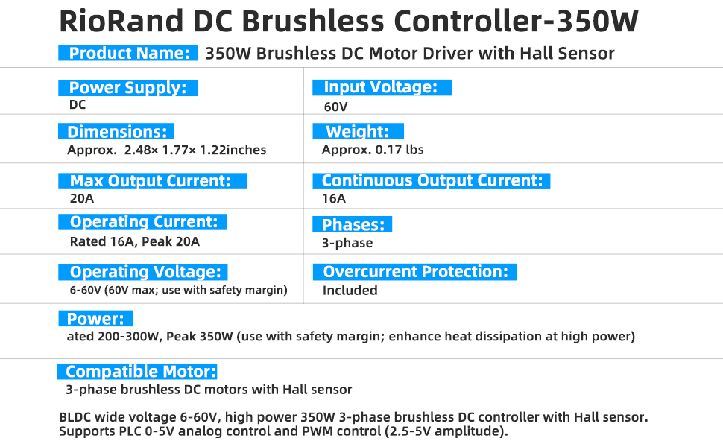
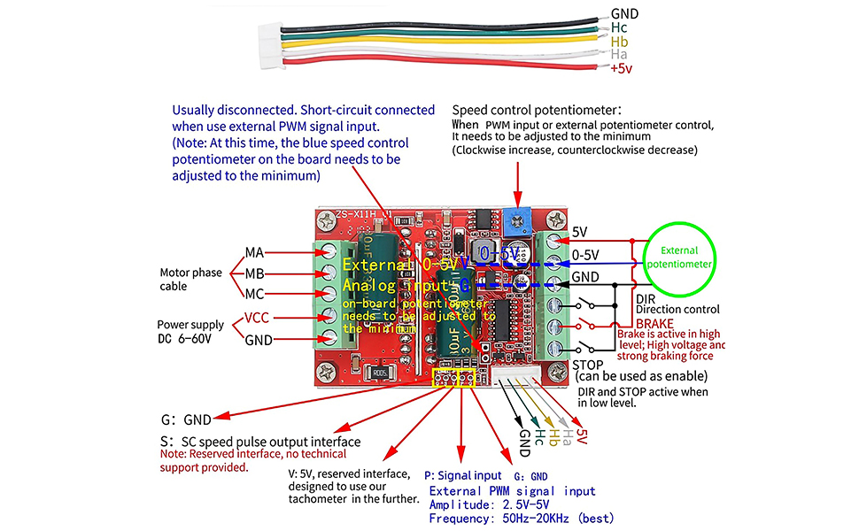
- Special Notes on External Signal Input:
- 1.When connecting external PWM signals via the main board’s P and G ports: Set the on-board potentiometer to minimum, and short-circuit the on-board shorting terminals (see wiring diagram above for reference). Signal amplitude: 2.5–5V; frequency: 50Hz–20kHz.
- 2.For external 0–5V analog input: Connect via the main board’s 2 terminal ports (set the on-board potentiometer to minimum; see dashed lines in the wiring diagram above for reference).
- 3.For external potentiometer speed control: Connect to the main board’s 3 corresponding terminal ports (set the on-board potentiometer to minimum; see potentiometer wiring diagram above for reference).
- 4.Forward/reverse and stop functions: Activate via a switch connected to ground (0V) — active low. External MCU can also send low-level signals. For braking: Activate via a switch connected to 5V (front terminal row) — active high. All front-row terminals accept low-voltage signals directly input to the MCU; do not expose them to high voltage or high current.
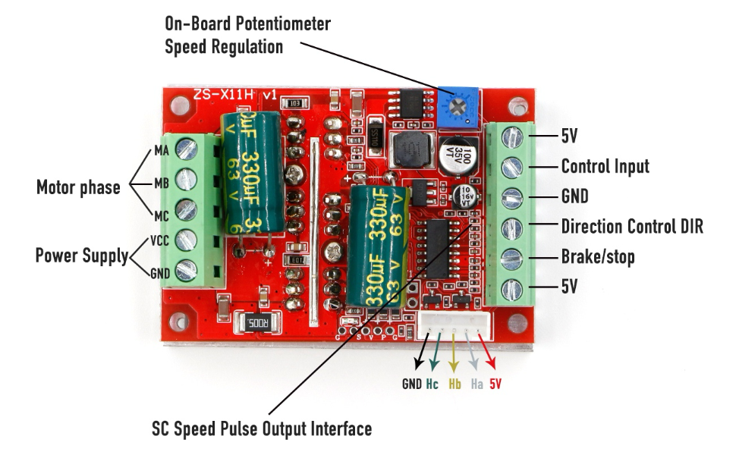
- Interface Description:
- 1.MA, MB, MC (phase outputs) connect to motor
- 2.5V, GND – 5V power from the main board (can supply external devices, max 50mA current)
- 3.VCC, GND – main power supply (external DC power required)
- 4.SC – speed pulse signal output (interface provided, no technical support)
- 5.DIR – direction control (forward/reverse), active low (can connect external switch to GND)
- 6.STOP – stop control, active low (can connect external switch to GND)
- 7.BRAKE – brake control, active high (can connect external switch to 5V)
- 8.Speed control – speed signal input (on-board potentiometer included; also accepts external 0-5V analog or PWM signals)
- 9.Ha, Hb, Hc, +5V, GND – Hall signal & power input (most Hall-equipped motors have these 5 wires)
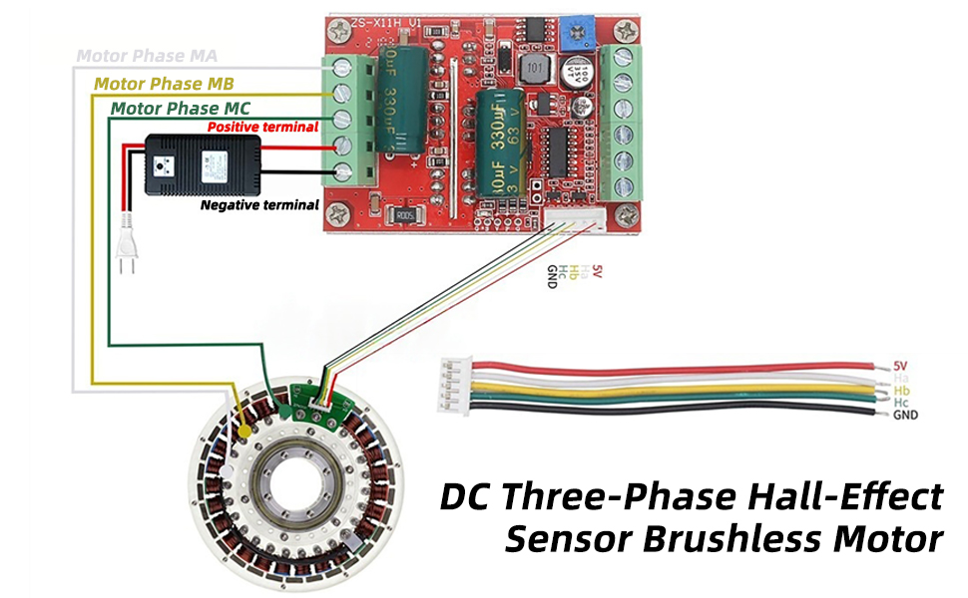
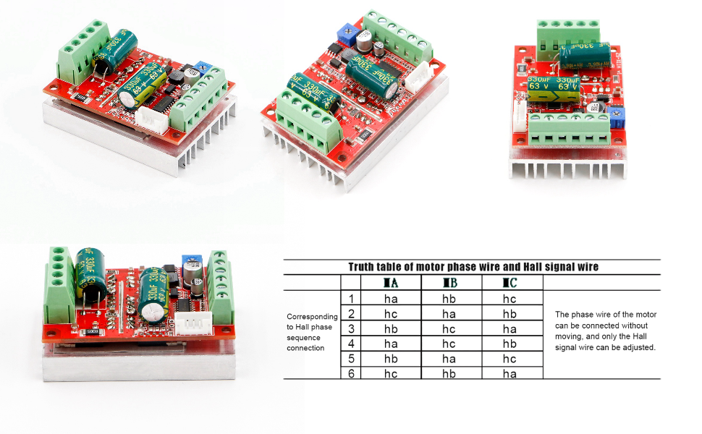
- After receiving the driver board, first confirm whether its interface is compatible with your brushless motor’s interface.
- 1.The brushless motor has 5 Hall wires or a Hall interface. Among them, 2 are Hall power supply wires, and 3 are Hall signal wires—you must distinguish these, especially the Hall power supply wires (usually red and black). The 3 Hall signal wires are generally labeled a(Ha), b(Hb), c(Hc); the driver board also has 3 ports marked Ha, Hb, Hc (or similar). Connect them one-to-one correctly.
- 2.The motor has 3 thick phase wires, and the driver board also has 3 phase wire interfaces—these are typically labeled MA(U), MB(V), MC(W) (or similar). Connect them one-to-one correctly. Once wired accurately, apply the main power, and turn the potentiometer to around 20%—the motor should run smoothly. (If the motor fails to work normally after connecting interfaces according to labels, follow Step 3 below to troubleshoot unclear interface definitions.)
- 3.If you’re unsure about the motor’s phase wire/Hall wire definitions, or if the motor doesn’t work after incorrect wiring, follow these steps to adjust the Hall wire sequence gradually:
- First, connect the motor’s 3 phase wires to the driver board’s phase wire interfaces arbitrarily.
- For the motor’s 5 Hall wires: Connect the 3 Hall signal wires to the driver board’s 3 Hall signal ports arbitrarily. The 2 Hall power supply wires must be connected correctly (the main board provides 5V power; one Hall lead is red for 5V, the other is black for ground—ensure these match the motor’s Hall power supply wires).
- After verifying correct connections, test with low voltage (7-12V) and low current (1-3A) (use a constant-current power supply, low-power power supply with a current-limiting resistor, etc., if available). Turn the board’s built-in potentiometer to ~20% throttle. If the motor doesn’t run or acts abnormally, cut power immediately.
- Next, adjust the sequence of the motor’s 3 phase wires (the driver board’s phase interfaces use terminal blocks for easy wiring, so adjusting the motor’s phase wires is simpler—adjusting the 3 Hall signal wires instead works the same if the motor’s phase wires are fixed). Repeat until the motor runs smoothly when powered on—this means wiring is correct.
- There are 6 possible phase wire sequences. For example, if the current sequence is ABC, the other options are ACB, BAC, BCA, CAB, CBA. Test power after each adjustment—only 1 sequence is correct.
- 4.If wiring is incorrect and the motor malfunctions, never test with high current or high voltage—this risks damaging the driver board. When the 3 motor phase wires are correctly sequenced, the motor will run as smoothly as silk once powered on, with stable low-speed startup and high torque. Incorrect phase wire sequencing typically causes the following issues:
- a. The motor fails to start (no response) or only jerks once without normal rotation.
- b. Minor jitter, difficult startup, faint noise, or requiring manual assistance to start.
- c. The motor runs in one direction but not the other, with faint noise.
- d. Severe startup jitter, weak power, noise, significantly higher current, and overheating of power transistors.
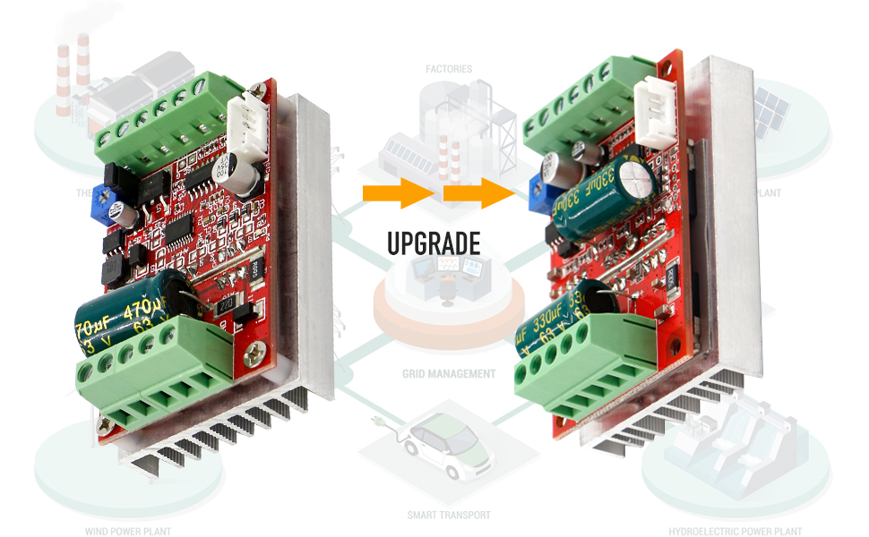
The PWM brushless DC motor speed controller with Hall sensor support accommodates eight-pole motors and features automatic recognition without requiring any adjustments.

